TASK 2
Flowchart: What Happens When You Enter www.zomato.com in a Browser
Understanding the step-by-step journey from URL entry to website display

1. Objective
The objective of this task is to understand what happens behind the scenes when a user types www.zomato.com into a web browser and presses Enter. The flowchart explains the major steps involved, including URL processing, DNS lookup, cache checking, establishing a secure connection, sending an HTTP request, server processing, and rendering the website in the browser.

2. Step-by-Step Explanation
Step 1: Enter URL in Browser
The user types www.zomato.com into the browser's address bar and presses Enter. The browser begins the process of locating and loading the requested website.
Step 2: DNS Lookup
The browser needs the IP address associated with www.zomato.com. DNS (Domain Name System) translates the human-readable domain name into an IP address.
Step 3: Check IP Address in Cache
The browser or operating system may already have the IP address stored in its DNS cache. If a valid cached entry is available, it can be used directly. If not, the browser proceeds to query DNS servers.
Step 4: Get IP from DNS Server
If the address is not available in cache, DNS servers are queried to find the correct IP address for the domain. This can involve recursive DNS resolution, root servers, TLD servers, and authoritative DNS servers.
Step 5: Establish Connection
The browser establishes a connection with the server at the obtained IP address. Because modern websites such as Zomato use HTTPS, a secure connection is normally established using port 443.
Step 6: Send HTTP Request
The browser sends an HTTP request, commonly a GET request, asking the server for the requested web resources.
Step 7: Server Processes Request
The web server receives and processes the request. It sends back the required response and resources, which can include HTML, CSS, JavaScript, images, and other data.
Step 8: Browser Renders the Website
The browser receives the response, processes the HTML, CSS, JavaScript, and other resources, and then renders the Zomato website on the user's screen.
End: Website Displayed
After the resources are processed and rendered, the website becomes visible and interactive in the browser.

3. Flowchart
The following flowchart illustrates the complete sequence from entering www.zomato.com to the website being displayed.
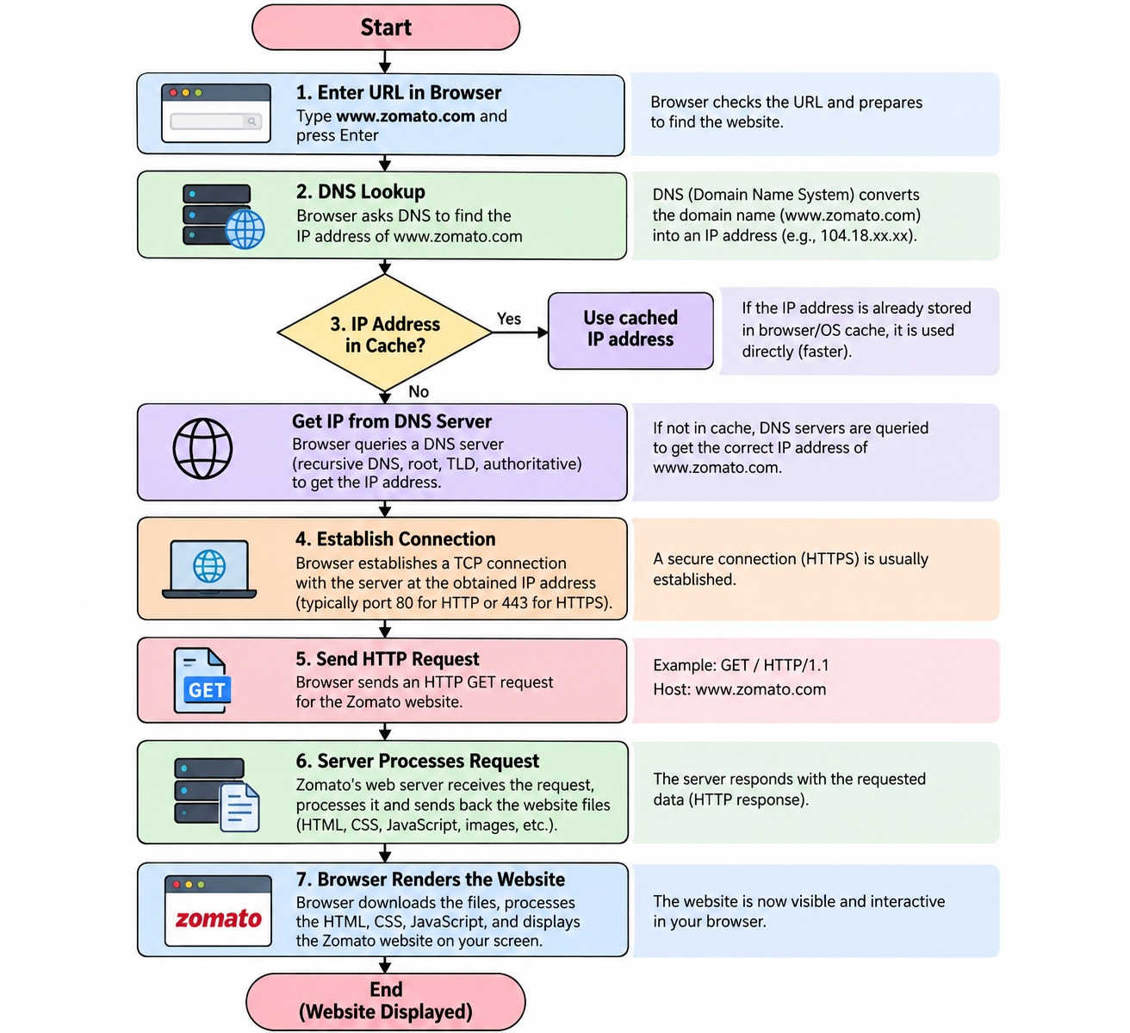
Figure 1: Zomato browser request flowchart.

4. Important Concepts
Concept | Explanation
DNS | DNS stands for Domain Name System. It translates a domain name such as www.zomato.com into an IP address that computers can use to locate the server.
Cache | A cache stores previously obtained information temporarily. A cached DNS entry can reduce the time required to find an IP address.
HTTPS | HTTPS provides a secure connection between the browser and the website server. Modern websites normally use HTTPS over port 443.
HTTP Request | An HTTP request is a message sent by the browser to a server asking for a resource. A GET request is commonly used to retrieve a webpage or other resource.
Server Response | The server responds to the browser with the requested content or information. The browser then processes those resources.
Rendering | Rendering is the process by which the browser interprets HTML, CSS, JavaScript, images, and other resources and displays the webpage.

5. Short Conclusion
When a user enters www.zomato.com and presses Enter, several steps take place before the website appears. The browser identifies the domain, finds its IP address using DNS or a cached DNS entry, establishes a secure connection, sends an HTTP request, receives a response from the server, and finally renders the website. This process demonstrates how browsers, DNS, networks, servers, and web technologies work together to display a website.

6. Submission Checklist
- Save the flowchart image as: Task 2 - Zomato Website Request Flowchart.png
- Keep this Word document as the written explanation for Task 2.
- Upload the image and/or document to your Google Drive repository folder.
- Set the shared link permission to Anyone with the link → Viewer.
- Copy the Google Drive folder or file link.
- Paste the link into the portal's TOPIC REPOSITORY URL field.
- Click Submit.

