TASK 1 – WEB DESIGN PRACTICAL REPORT
VS Code Setup and Basic HTML Webpage
1. Objective
The objective of Task 1 was to set up a basic web-development environment using Visual Studio Code, create a project folder named “MyWebDesigns,” create an index.html file, and display the required heading “Welcome to My Web Design Journey” in a web browser.
2. Software and Technologies Used
- Windows 11 operating system.
- Visual Studio Code for writing and managing the HTML code.
- HTML5 for creating the webpage structure.
- Google Chrome for testing and viewing the webpage output.
- Live Server (127.0.0.1:5500) to preview the webpage locally.
3. Implementation Procedure
1. Created a new folder named MyWebDesigns for the web-design project.
2. Opened the MyWebDesigns folder in Visual Studio Code.
3. Created a new file named index.html.
4. Added the basic HTML5 document structure.
5. Added an <h1> heading with the text “Welcome to My Web Design Journey.”
6. Saved the HTML file.
7. Launched the webpage using Live Server and verified the output in Google Chrome.
4. HTML Code Implemented
<!DOCTYPE html>
<html>
<head>
<title>My Web Design Journey</title>
</head>
<body>
<h1>Welcome to My Web Design Journey</h1>
</body>
</html>
5. Project Structure
MyWebDesigns/
└── index.html
6. Actual Webpage Output
The following is the actual screenshot provided for this task. It shows the completed webpage running locally through Live Server at 127.0.0.1:5500/index.html on a Windows 11 desktop. The required heading is displayed successfully at the top of the webpage.
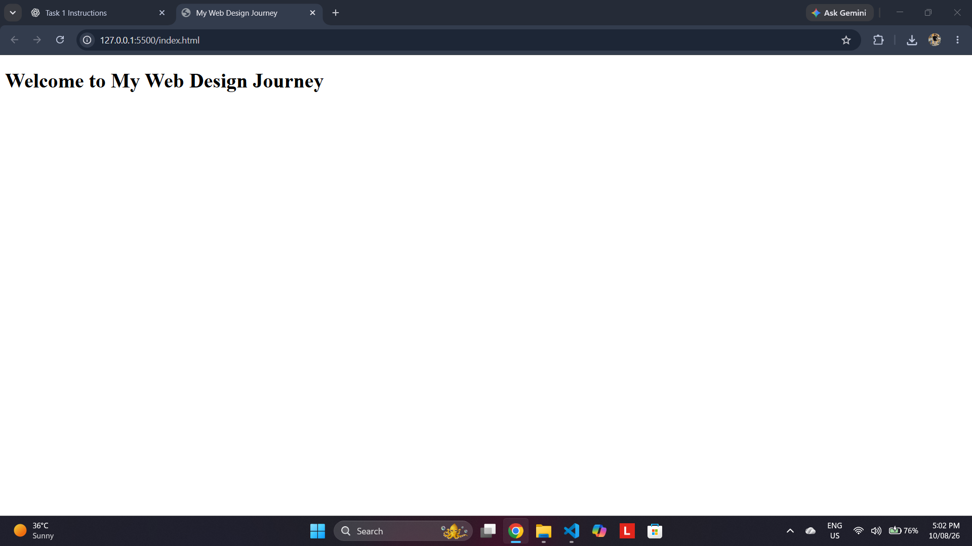
Figure 1: Actual browser output of index.html on Windows 11
7. Output Verification
Verification Item | Result
HTML page loads successfully | Pass
Local Live Server address is accessible | Pass
Required heading is displayed | Pass
Browser output matches the task requirement | Pass
8. Result
The task was successfully completed. The index.html webpage was launched in Google Chrome using Live Server and displayed the required heading: “Welcome to My Web Design Journey.” The screenshot provides evidence of the working webpage in the Windows 11 environment.
9. Conclusion
Task 1 established the fundamental workflow for web development: creating a project directory, writing HTML in Visual Studio Code, saving the webpage, and testing it in a browser. This provides the foundation for the subsequent web-design tasks involving visual design, accessibility, usability, and GitHub.

10. Evidence
- Actual browser screenshot of the completed webpage – included above.
- The screenshot shows the local development address 127.0.0.1:5500/index.html.
- The Windows 11 taskbar and desktop environment are visible in the evidence.
- The required webpage heading is clearly visible.

