TASK 5
Understanding Front-End and Back-End Using the YouTube Search Feature
Example feature: YouTube Search Bar

1. Objective
The objective of this task is to understand the difference between front-end and back-end by examining a real-world application feature. The YouTube search feature is used as an example to explain what happens on the user's device and what happens on the server when a user searches for a video.

2. Feature Selected: YouTube Search
The selected feature is the YouTube Search Bar. For example, a user can type "cricket highlights" into the YouTube search bar and press Enter. The request is sent from the user's device to YouTube's backend services, where the search is processed. The results are then returned and displayed to the user.

3. Front-End
The front-end is the part of an application that the user can see and interact with. It runs primarily in the browser or mobile application and is responsible for the user interface and user interactions.
For the YouTube search feature, the front-end includes:
- Search bar
- Search button
- Text entered by the user
- Search filters and navigation controls
- Video thumbnails
- Video titles
- Search results layout
- Buttons and other visible interface elements
What happens on the front-end:
- The user opens YouTube.
- The search bar is displayed.
- The user types "cricket highlights".
- The user presses Enter or clicks the Search button.
- The front-end sends the search request to the back-end services.
- When results are received, the front-end displays them on the screen.
Simple explanation: Front-end = what the user sees and interacts with.

4. Back-End
The back-end is the server-side part of an application. It receives requests from the front-end, processes data and business logic, and sends an appropriate response back to the user's device.
For the YouTube search feature, the back-end:
- Receives the search request.
- Processes the search term.
- Searches YouTube's available data and services.
- Finds relevant videos.
- Applies search and ranking logic.
- Prepares information such as video titles, thumbnails, and links.
- Sends the results back to the user's device.
Simple explanation: Back-end = what happens behind the scenes on the server.

5. Complete Search Process
The complete process can be summarized as follows:
- User opens YouTube.
- User types "cricket highlights".
- YouTube front-end receives the user's input.
- A search request is sent to YouTube's back-end services.
- Back-end services process the search request.
- Relevant video information is found and prepared.
- Results are sent back to the user's device.
- The front-end displays the matching results.

6. Front-End vs Back-End Comparison
Front-End | Back-End | YouTube Search Example
Runs mainly in the browser/app | Runs on servers/backend services | Search interface vs search processing
Handles user interaction | Processes requests | Accepts the search term vs processes it
Displays information | Finds and prepares information | Displays videos vs finds relevant videos
Controls visual layout | Handles server-side logic and data | Shows thumbnails/titles vs prepares result data
Visible to the user | Mostly happens behind the scenes | Search bar/results vs server processing

7. Diagram / Screenshot
The following diagram illustrates the relationship between the YouTube front-end and back-end during a search.
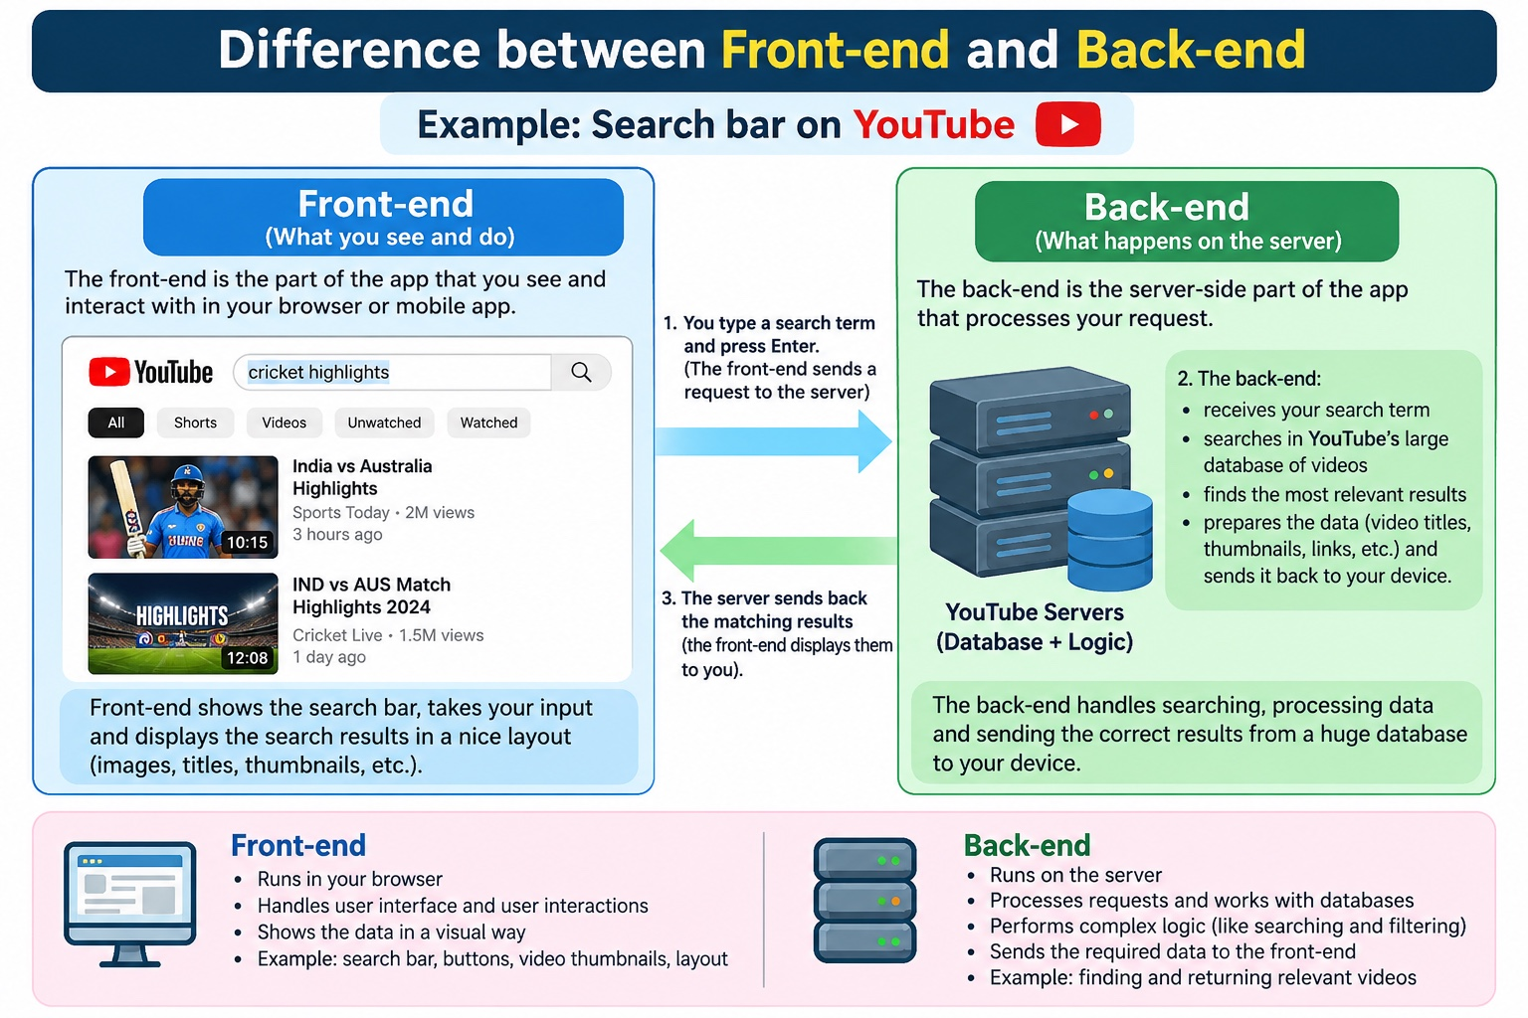
Figure 1: Front-end and back-end explanation using the YouTube Search feature.

8. Conclusion
The YouTube search feature uses both front-end and back-end technologies. The front-end provides the search bar, accepts the user's input, and displays the search results. The back-end receives the search request, processes the search, finds relevant information, and sends the results back to the front-end. Both parts work together to provide a useful and interactive search experience.

