***University of Missouri-Kansas City***

***Subject- Network Routing***

***Router Configuration project (OSPF,EIGRP,BGP,RIP)***

***Submitted to:***

***Dr. Deep Medhi (Network Routing Professor)***

***Submitted by:***

***MIHIR PITALE (16252203)***

**Configuration is shown below in Cisco Packet Tracer-**

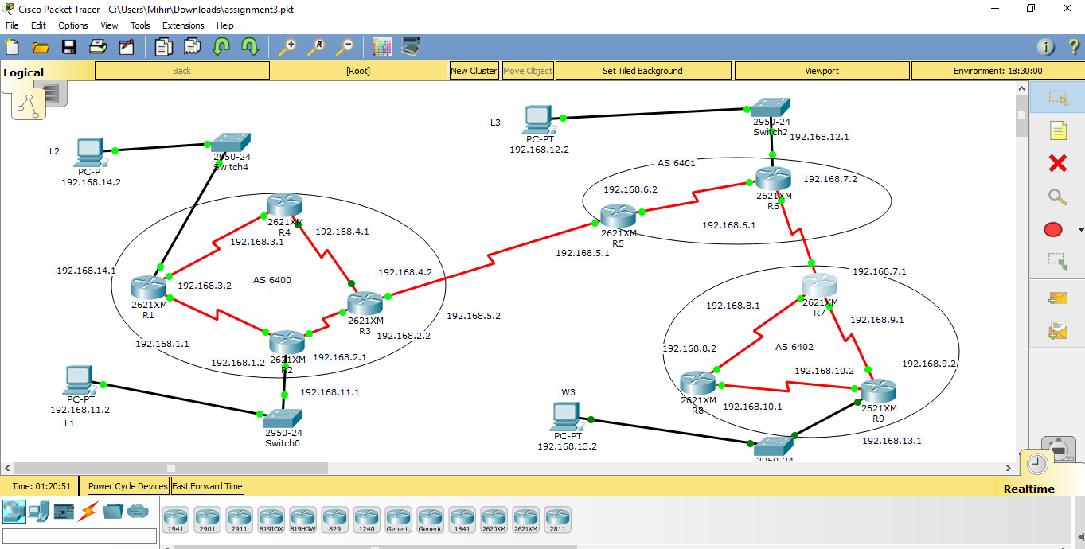

**Configuration files of routers are as follows-**

**Router 1-**

R1>en

R1#sh run

Building configuration...

Current configuration : 998 bytes

!

version 12.2

no service timestamps log datetime msec

no service timestamps debug datetime msec

no service password-encryption

!

hostname R1

!

!

!

!

!

!

!

!

no ip cef

no ipv6 cef

!

!

!

!

!

!

!

!

!

!

!

!

!

!

!

!

!

!

interface FastEthernet0/0

ip address 192.168.14.1 255.255.255.0

duplex auto

speed auto

!

interface FastEthernet0/1

no ip address

duplex auto

speed auto

shutdown

!

interface Serial0/0

no ip address

clock rate 2000000

shutdown

!

interface Serial0/1

ip address 192.18.3.2 255.255.255.0

clock rate 2000000

!

interface Serial0/2

no ip address

clock rate 2000000

shutdown

!

interface Serial0/3

ip address 192.168.1.1 255.255.255.0

!

interface Ethernet1/0

no ip address

duplex auto

speed auto

shutdown

!

router ospf 1

log-adjacency-changes

network 192.168.1.0 0.0.0.255 area 1

network 192.168.3.0 0.0.0.255 area 1

network 192.168.14.0 0.0.0.255 area 1

!

ip classless

!

ip flow-export version 9

!

!

!

!

!

!

!

line con 0

!

line aux 0

!

line vty 0 4

login

!

!

!

End

**Router 2-**

R2>en

R2#sh r

R2#sh running-config

Building configuration...

Current configuration : 999 bytes

!

version 12.2

no service timestamps log datetime msec

no service timestamps debug datetime msec

no service password-encryption

!

hostname R2

!

!

!

!

!

!

!

!

no ip cef

no ipv6 cef

!

!

!

!

!

!

!

!

!

!

!

!

!

!

!

!

!

!

interface FastEthernet0/0

no ip address

duplex auto

speed auto

shutdown

!

interface FastEthernet0/1

ip address 192.168.11.1 255.255.255.0

duplex auto

speed auto

!

interface Serial0/0

no ip address

clock rate 2000000

shutdown

!

interface Serial0/1

ip address 192.168.2.1 255.255.255.0

!

interface Serial0/2

no ip address

clock rate 2000000

shutdown

!

interface Serial0/3

ip address 192.168.1.2 255.255.255.0

clock rate 2000000

!

interface Ethernet1/0

no ip address

duplex auto

speed auto

shutdown

!

router ospf 1

log-adjacency-changes

network 192.168.1.0 0.0.0.255 area 1

network 192.168.2.0 0.0.0.255 area 1

network 192.168.11.0 0.0.0.255 area 1

!

ip classless

!

ip flow-export version 9

!

!

!

!

!

!

!

line con 0

!

line aux 0

!

line vty 0 4

login

!

!

!

End

**Router 3 –**

R3>en

R3#sh run

R3#sh running-config

Building configuration...

Current configuration : 1191 bytes

!

version 12.2

no service timestamps log datetime msec

no service timestamps debug datetime msec

no service password-encryption

!

hostname R3

!

!

!

!

!

!

!

!

no ip cef

no ipv6 cef

!

!

!

!

!

!

!

!

!

!

!

!

!

!

!

!

!

!

interface FastEthernet0/0

no ip address

duplex auto

speed auto

shutdown

!

interface FastEthernet0/1

no ip address

duplex auto

speed auto

shutdown

!

interface Serial0/0

no ip address

clock rate 2000000

shutdown

!

interface Serial0/1

ip address 192.168.2.2 255.255.255.0

clock rate 2000000

!

interface Serial0/2

ip address 192.168.5.2 255.255.255.0

clock rate 2000000

!

interface Serial0/3

ip address 192.168.4.2 255.255.255.0

!

interface Ethernet1/0

no ip address

duplex auto

speed auto

shutdown

!

router ospf 1

log-adjacency-changes

redistribute bgp 6400 metric-type 1 subnets

network 192.168.4.0 0.0.0.255 area 1

network 192.168.2.0 0.0.0.255 area 1

!

router bgp 6400

bgp log-neighbor-changes

no synchronization

neighbor 192.168.5.1 remote-as 6401

network 192.168.2.0

network 192.168.4.0

network 192.168.5.0

redistribute ospf 1

!

ip classless

!

ip flow-export version 9

!

!

!

!

!

!

!

line con 0

!

line aux 0

!

line vty 0 4

login

!

!

!

end

**Router 4-**

R4>en

R4#sh run

R4#sh running-config

Building configuration...

Current configuration : 946 bytes

!

version 12.2

no service timestamps log datetime msec

no service timestamps debug datetime msec

no service password-encryption

!

hostname R4

!

!

!

!

!

!

!

!

no ip cef

no ipv6 cef

!

!

!

!

!

!

!

!

!

!

!

!

!

!

!

!

!

!

interface FastEthernet0/0

no ip address

duplex auto

speed auto

shutdown

!

interface FastEthernet0/1

no ip address

duplex auto

speed auto

shutdown

!

interface Serial0/0

no ip address

clock rate 2000000

shutdown

!

interface Serial0/1

ip address 192.168.3.1 255.255.255.0

!

interface Serial0/2

no ip address

clock rate 2000000

shutdown

!

interface Serial0/3

ip address 192.168.4.1 255.255.255.0

clock rate 2000000

!

interface Ethernet1/0

no ip address

duplex auto

speed auto

shutdown

!

router ospf 1

log-adjacency-changes

network 192.168.3.0 0.0.0.255 area 1

network 192.168.4.0 0.0.0.255 area 1

!

ip classless

!

ip flow-export version 9

!

!

!

!

!

!

!

line con 0

!

line aux 0

!

line vty 0 4

login

!

!

!

End

**Router 5-**

R5>en

R5#sh run

R5#sh running-config

Building configuration...

Current configuration : 1104 bytes

!

version 12.2

no service timestamps log datetime msec

no service timestamps debug datetime msec

no service password-encryption

!

hostname R5

!

!

!

!

!

!

!

!

no ip cef

no ipv6 cef

!

!

!

!

!

!

!

!

!

!

!

!

!

!

!

!

!

!

interface FastEthernet0/0

no ip address

duplex auto

speed auto

shutdown

!

interface FastEthernet0/1

no ip address

duplex auto

speed auto

shutdown

!

interface Serial0/0

no ip address

clock rate 2000000

shutdown

!

interface Serial0/1

ip address 192.168.5.1 255.255.255.0

!

interface Serial0/2

no ip address

clock rate 2000000

shutdown

!

interface Serial0/3

ip address 192.168.6.2 255.255.255.0

clock rate 2000000

!

interface Ethernet1/0

no ip address

duplex auto

speed auto

shutdown

!

router eigrp 100

redistribute bgp 6401 metric 100 1 255 1 1500

network 192.168.6.0

no auto-summary

!

router bgp 6401

bgp log-neighbor-changes

no synchronization

neighbor 192.168.5.2 remote-as 6400

network 192.168.5.0

network 192.168.6.0

redistribute eigrp 100

!

ip classless

!

ip flow-export version 9

!

!

!

!

!

!

!

line con 0

!

line aux 0

!

line vty 0 4

login

!

!

!

end

**Router 6-**

R6>en

R6#sh ru

R6#sh running-config

Building configuration...

Current configuration : 1257 bytes

!

version 12.2

no service timestamps log datetime msec

no service timestamps debug datetime msec

no service password-encryption

!

hostname R6

!

!

!

!

!

!

!

!

no ip cef

no ipv6 cef

!

!

!

!

!

!

!

!

!

!

!

!

!

!

!

!

!

!

interface FastEthernet0/0

ip address 192.168.12.1 255.255.255.0

duplex auto

speed auto

!

interface FastEthernet0/1

no ip address

duplex auto

speed auto

shutdown

!

interface Serial0/0

no ip address

clock rate 2000000

shutdown

!

interface Serial0/1

ip address 192.168.6.1 255.255.255.0

!

interface Serial0/2

no ip address

clock rate 2000000

shutdown

!

interface Serial0/3

ip address 192.168.7.2 255.255.255.0

clock rate 2000000

!

interface Ethernet1/0

no ip address

duplex auto

speed auto

shutdown

!

router eigrp 100

redistribute bgp 6401 metric 100 1 255 1 1500

network 192.168.6.0

network 192.168.12.0

auto-summary

!

router bgp 6401

bgp log-neighbor-changes

no synchronization

neighbor 192.168.7.1 remote-as 6402

network 192.168.12.0

network 192.168.6.0

network 192.168.7.0

redistribute eigrp 100

!

ip classless

ip route 192.168.10.0 255.255.255.0 192.168.7.1

ip route 192.168.13.0 255.255.255.0 192.168.7.1

!

ip flow-export version 9

!

!

!

!

!

!

!

line con 0

!

line aux 0

!

line vty 0 4

login

!

!

!

end

**Router 7-**

**Router 8-**

R8>en

R8#sh ru

R8#sh running-config

Building configuration...

Current configuration : 908 bytes

!

version 12.2

no service timestamps log datetime msec

no service timestamps debug datetime msec

no service password-encryption

!

hostname R8

!

!

!

!

!

!

!

!

no ip cef

no ipv6 cef

!

!

!

!

!

!

!

!

!

!

!

!

!

!

!

!

!

!

interface FastEthernet0/0

no ip address

duplex auto

speed auto

shutdown

!

interface FastEthernet0/1

no ip address

duplex auto

speed auto

shutdown

!

interface Serial0/0

no ip address

clock rate 2000000

shutdown

!

interface Serial0/1

ip address 192.168.8.2 255.255.255.0

clock rate 2000000

!

interface Serial0/2

no ip address

clock rate 2000000

shutdown

!

interface Serial0/3

ip address 192.168.10.1 255.255.255.0

clock rate 2000000

!

interface Ethernet1/0

no ip address

duplex auto

speed auto

shutdown

!

router rip

network 192.168.8.0

network 192.168.10.0

!

ip classless

!

ip flow-export version 9

!

!

!

!

!

!

!

line con 0

!

line aux 0

!

line vty 0 4

login

!

!

!

End

**Router 9-**

Router>en

Router#sh run

Router#sh running-config

Building configuration...

Current configuration : 908 bytes

!

version 12.2

no service timestamps log datetime msec

no service timestamps debug datetime msec

no service password-encryption

!

hostname Router

!

!

!

!

!

!

!

!

no ip cef

no ipv6 cef

!

!

!

!

!

!

!

!

!

!

!

!

!

!

!

!

!

!

interface FastEthernet0/0

ip address 192.168.13.1 255.255.255.0

duplex auto

speed auto

!

interface FastEthernet0/1

no ip address

duplex auto

speed auto

shutdown

!

interface Serial0/0

no ip address

clock rate 2000000

shutdown

!

interface Serial0/1

ip address 192.168.9.2 255.255.255.0

!

interface Serial0/2

no ip address

clock rate 2000000

shutdown

!

interface Serial0/3

ip address 192.168.10.2 255.255.255.0

!

interface Ethernet1/0

no ip address

duplex auto

speed auto

shutdown

!

router rip

network 192.168.9.0

network 192.168.10.0

network 192.168.13.0

!

ip classless

!

ip flow-export version 9

!

!

!

!

!

!

!

line con 0

!

line aux 0

!

line vty 0 4

login

!

!

!

end

**Routing Tables of the routers are given below-**

**Router 1-**

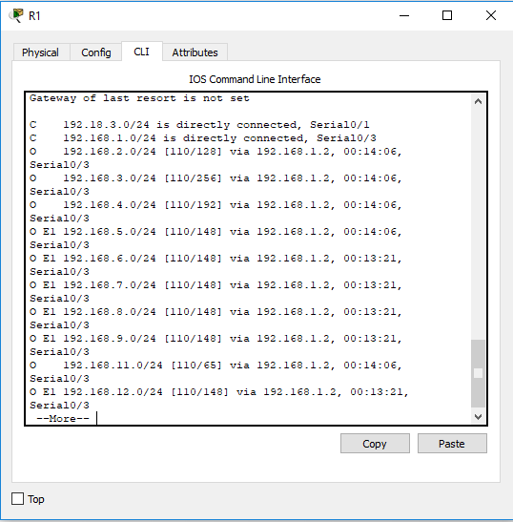

**Router 2-**

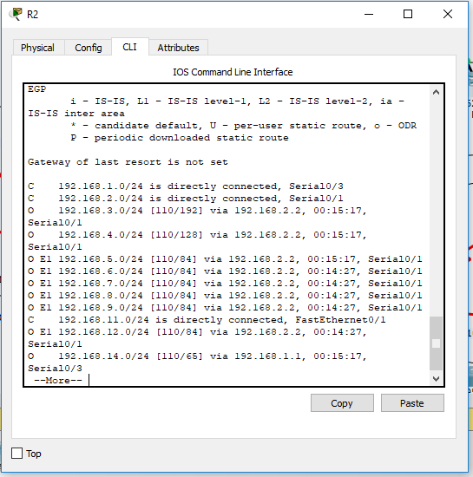

**Router 3-**

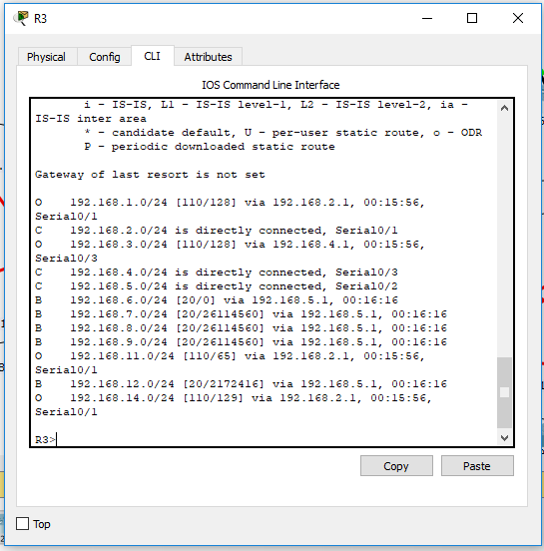

**Router 4-**

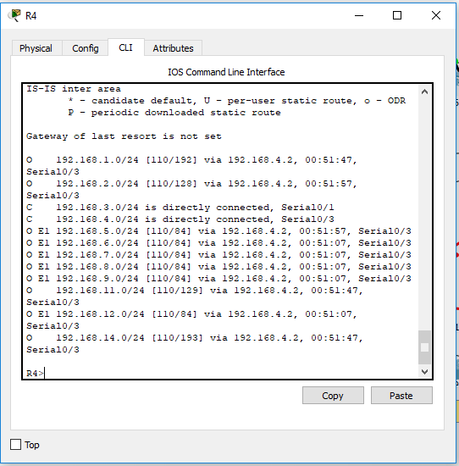

**Router 5-**

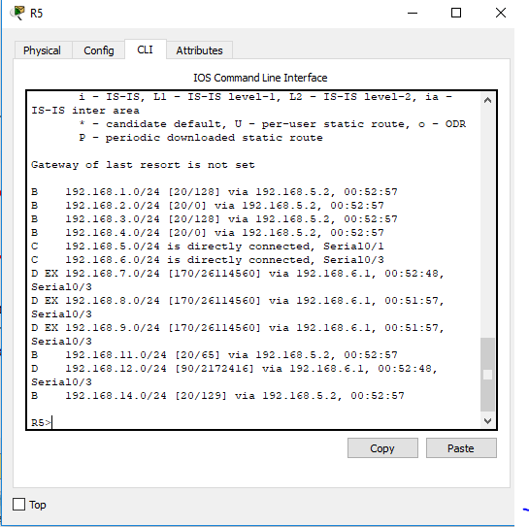

**Router 6-**

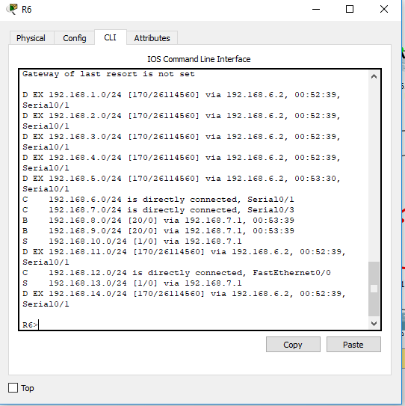

**Router 7-**

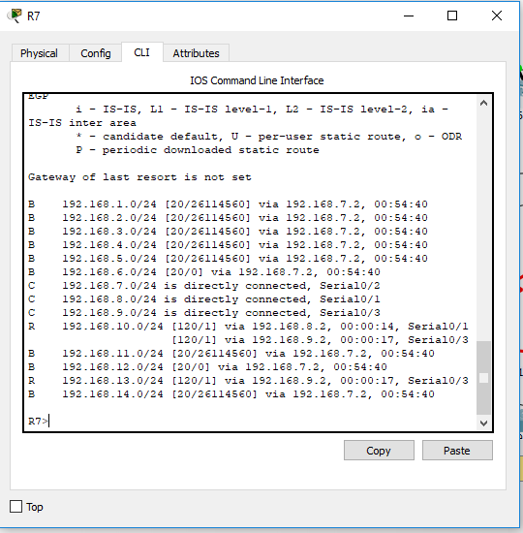

**Router 8-**

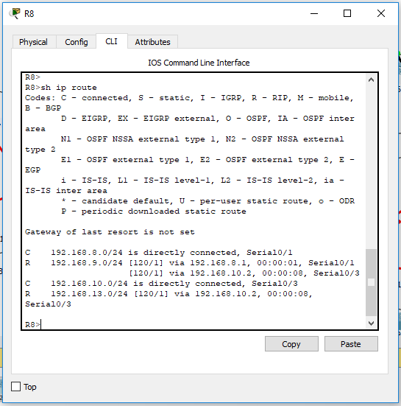

**Router 9-**

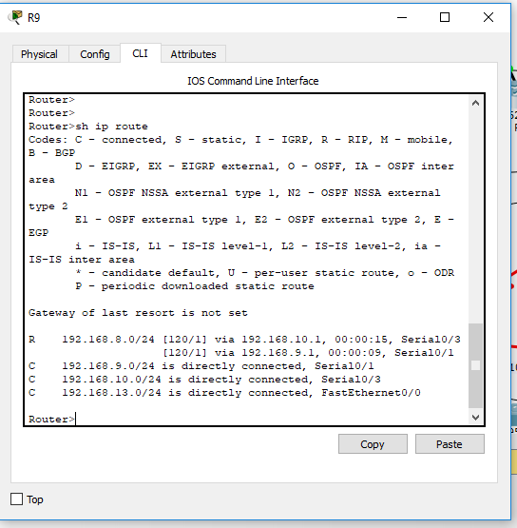

**Traceroute snapshot of terminals are as follows-**

**L1 to L2**

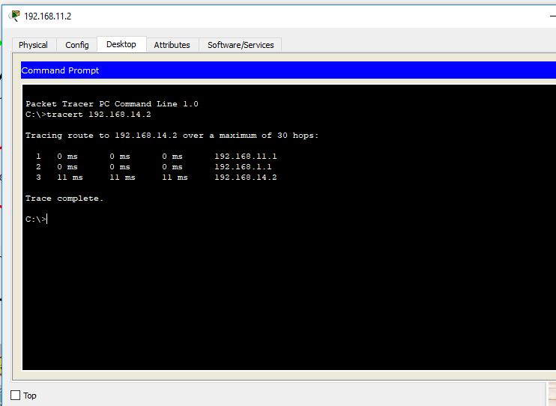

**L1 to L3**

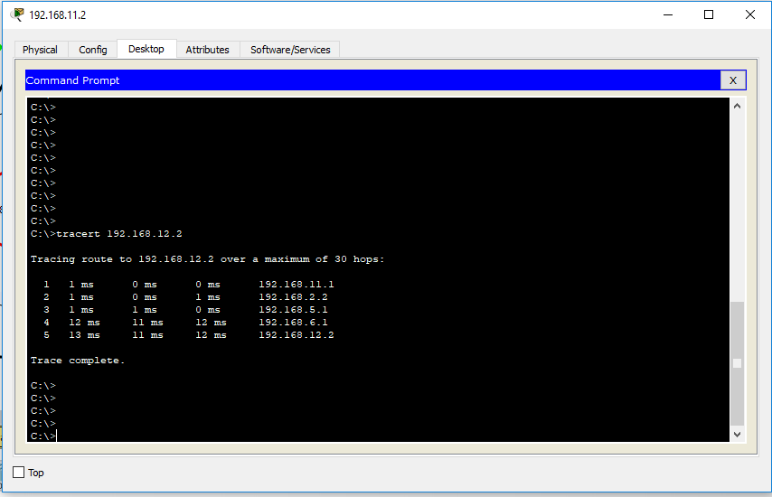

**L1 to W3**

BGP redistribute is not possible to RIP in Cisco Packet tracer.

**L3 to L2**

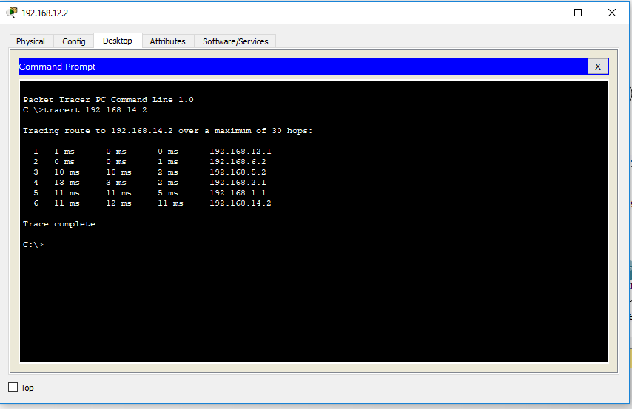

**----------------------------------------x—0—x--------------------------------------------**