1. Elimination of the 5-Level Depth Limit
The previous Oracle DB method had a hardcoded ceiling, capable of handling nesting only up to 5 levels deep (e.g., a[].b[].c[].d[].e[]). Any structure deeper than that would likely fail or require complex, brittle SQL rewrites.

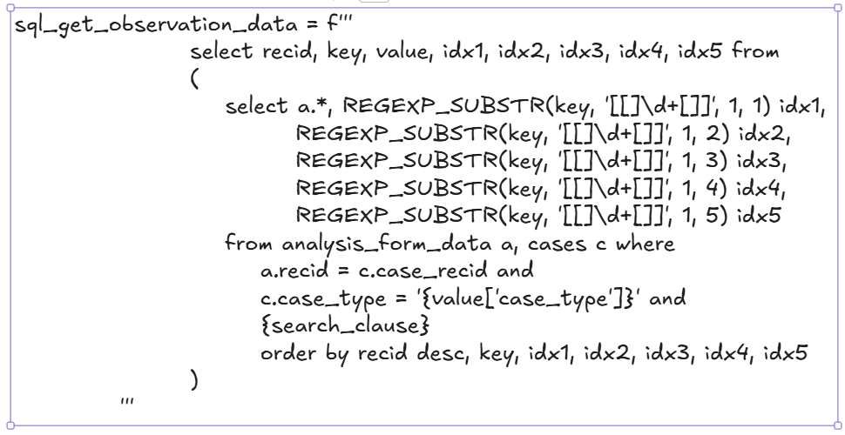
The current Python script has zero inherent depth limitations. It works because of this single, powerful transformation line in the code:

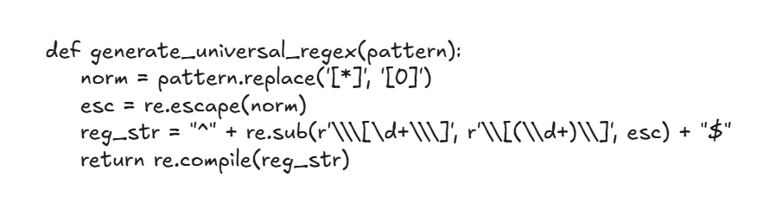

reg_str = "^" + re.sub(r'\\\[\d+\\\]', r'\\[(\\d+)\\]', esc) + "$"

This command globally scans the entire key string—regardless of whether it is 2 levels deep or 100 levels deep—and dynamically converts every single bracket instance into a regex capture group. It natively handles complex, deeply nested structures like a[2].b[5].c[1].d[99].e[0].f[4].g[7]... without needing special handling for different depths.

2. Universal vs. Specific Matching
The previous database approach likely required specific SQL logic to handle different permutations of arrays (e.g., logic for one array vs. logic for five arrays).

The current Python approach uses a universal matching strategy. It takes any template key containing brackets—whether it contains wildcards like [*] or hardcoded indices like [0]—and instantly converts it into a universal regex pattern that will match any actual index number found in the analysis data. This drastically simplifies the code, as one generic function handles every possible data structure variation.

3. Optimized High-Volume Performance
By moving this logic out of the database and into Python, we utilize the optimized in-memory processing pipeline developed in the latest script version. Instead of asking the database to perform complex regex operations on millions of rows during extraction, we fetch the raw data efficiently and perform the high-speed matching in Python memory using prefix-bucketing and native iteration, which has been proven to handle millions of records in seconds.

