**Title: 3D_Maze**



**EXIT**

**START**

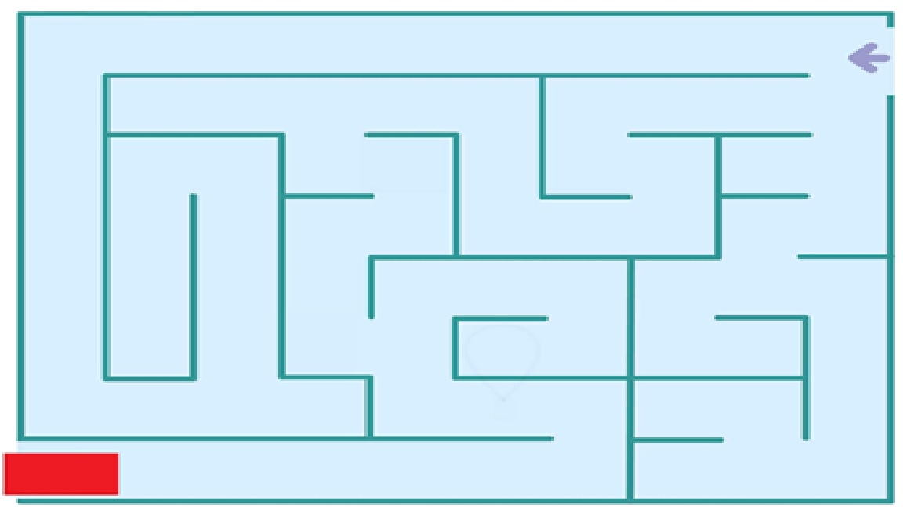

**GOAL:**

The goal of this game is to move around in the maze to find the **EXIT** point using Keyboard and Camera controls.

**CONTROLS:**

* **Keyboard**
  + **W** - Move Forward
  + **S** - Move Backward
  + **A** - Turn Left
  + **D** - Turn Right
* **Camera**
  + Press **“C”** to move the camera into the 4 specified location around the maze