
Shrimand Rajchandra Institute of Management and Computer Application, UTU, FYMCA
Cloud Computing with DevOps
Assignment

MCA 2th Semester
2025-26

Mihir vaidya
202504104610024
SRIMCA, UTU

Certificate

Kubernetes Administrator : Pod & Nodes Troubleshooting & Log Analysis

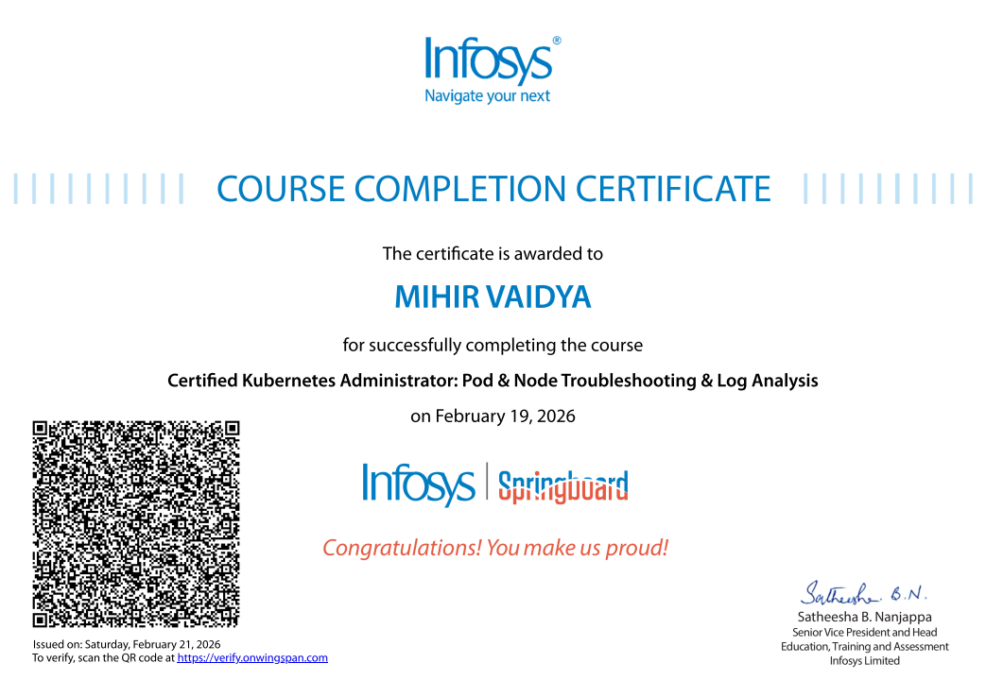

Sr No | Index | Sign
1 | Introduction
2 | Course objective
3 | Course Practical Task / Project work
3.1 | Pod Trouble Shooting
3.2 | Node Trouble Shooting
3.3 | Log Analysis
3.4 | Debugging Real-time Issue
4 | Screenshot
5 | Conclusion

Introduction

The Certified Kubernetes Administrator: Pod & Node Troubleshooting & Log Analysis course is designed to provide in-depth knowledge of Kubernetes cluster management and troubleshooting techniques. Kubernetes is a powerful container orchestration platform widely used in modern cloud-native environments to automate application deployment, scaling, and management.

This course focuses specifically on identifying, analyzing, and resolving issues related to Pods and Nodes within a Kubernetes cluster. It emphasizes hands-on practical learning, where real-time problems such as pod failures, node unavailability, misconfigurations, and log-based errors are diagnosed and resolved using Kubernetes command-line tools.

Through this course, I gained practical experience in:
- Understanding Kubernetes architecture
- Managing cluster components
- Troubleshooting container and node-level issues
- Analyzing logs for debugging
- Using kubectl commands efficiently

Course Objective

The main objectives of this course were:
- To understand Kubernetes cluster architecture
- To troubleshoot Pod-related issues
- To diagnose Node-level failures
- To analyze application and system logs
- To use kubectl debugging commands efficiently
- To resolve CrashLoopBackOff, ImagePull errors, and scheduling issues
- To monitor cluster health

1. To Understand Kubernetes Architecture

To gain a clear understanding of Kubernetes cluster components such as:
- Control Plane
- API Server
- Scheduler
- Controller Manager
- etcd
- Worker Nodes
• To understand how Pods, Deployments, ReplicaSets, and Services interact within the cluster.

2. To Troubleshoot Pod-Level Issues
- To identify common Pod failures such as:
  - CrashLoopBackOff
  - ImagePullBackOff
  - Pending state
  - ContainerCreating issues
- To analyze Pod events and container status.
- To debug misconfigured YAML files.
- To resolve application runtime errors using logs.

3. To Diagnose Node-Level Problems
- To detect node failures such as:
  - Node NotReady
  - Memory or CPU pressure
  - Disk pressure
- To understand node conditions and taints.
- To manage nodes using cordon, drain, and uncordon commands.
- To isolate problematic nodes without affecting cluster stability.

4. To Perform Log Analysis and Monitoring
- To retrieve and analyze container logs.
- To use real-time log monitoring for debugging.
- To identify errors related to:
  - Application configuration
  - Network connectivity
  - Resource limits
- To understand how logs help in root cause analysis.

5. To Use kubectl Effectively
- To master important kubectl commands for:
  - Inspecting cluster resources
  - Debugging Pods and Nodes
  - Viewing events
  - Checking resource utilization
- To improve command-line troubleshooting efficiency.

6. To Simulate and Resolve Real-Time Production Issues
- To practice real-world troubleshooting scenarios.
- To resolve deployment failures.
- To fix incorrect image versions and configuration errors.
- To manage resource allocation and quotas.

7. To Build Problem-Solving and Debugging Skills
- To develop systematic troubleshooting approaches.
- To identify root causes instead of temporary fixes.
- To enhance confidence in handling Kubernetes production environments.

- Screenshots
1. Pod Troubleshooting Basics
Pods are the smallest deployable units in Kubernetes. When a Pod fails, administrators must analyze its status, logs, and events.
Command:
kubectl get pods
Sample Output Screenshot:
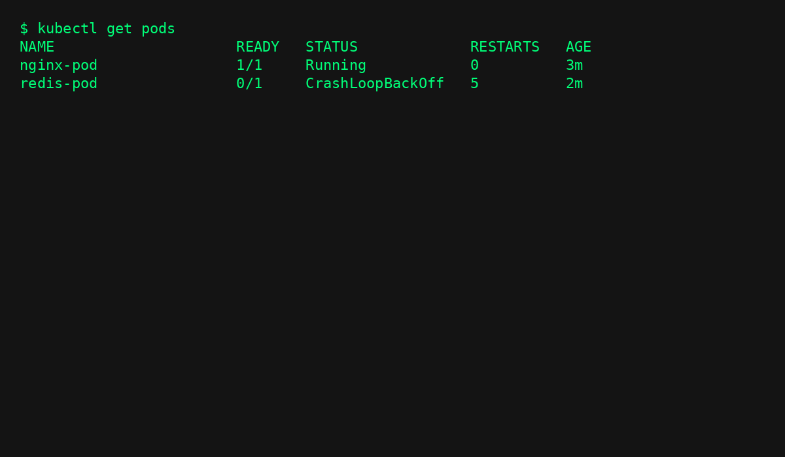

2. Using kubectl describe for debugging
Command: kubectl describe pod redis-pod
Sample Output Screenshot :
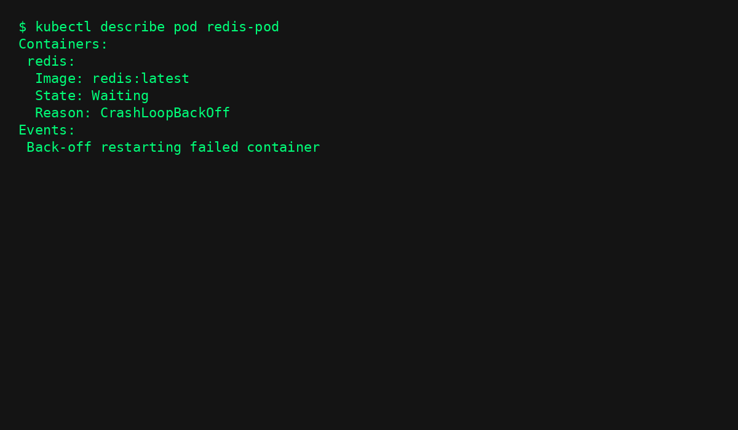
3. Pod Log Analysis
Command: kubectl logs redis-pod
Sample Output Screenshot: 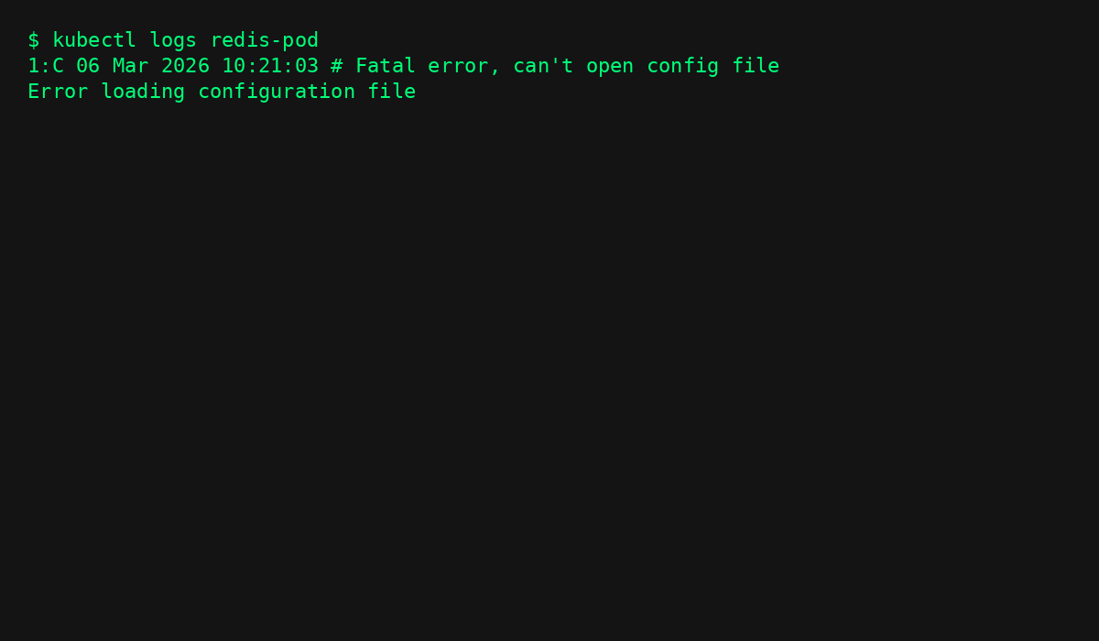
4. Node Troubleshooting Basics
Kubernetes nodes may become NotReady due to network failures, kubelet issues, or resource exhaustion.
Command: kubectl get nodes
Sample Output Screenshot:
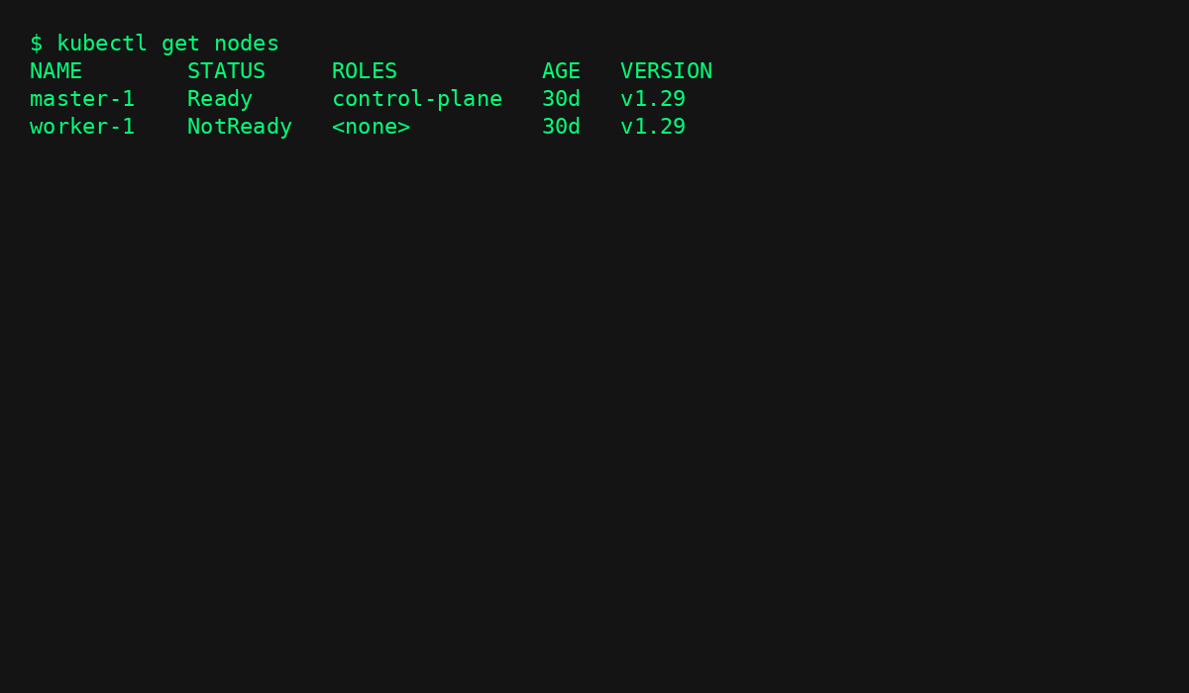5. Checking Node Details
Command: kubectl describe node worker-1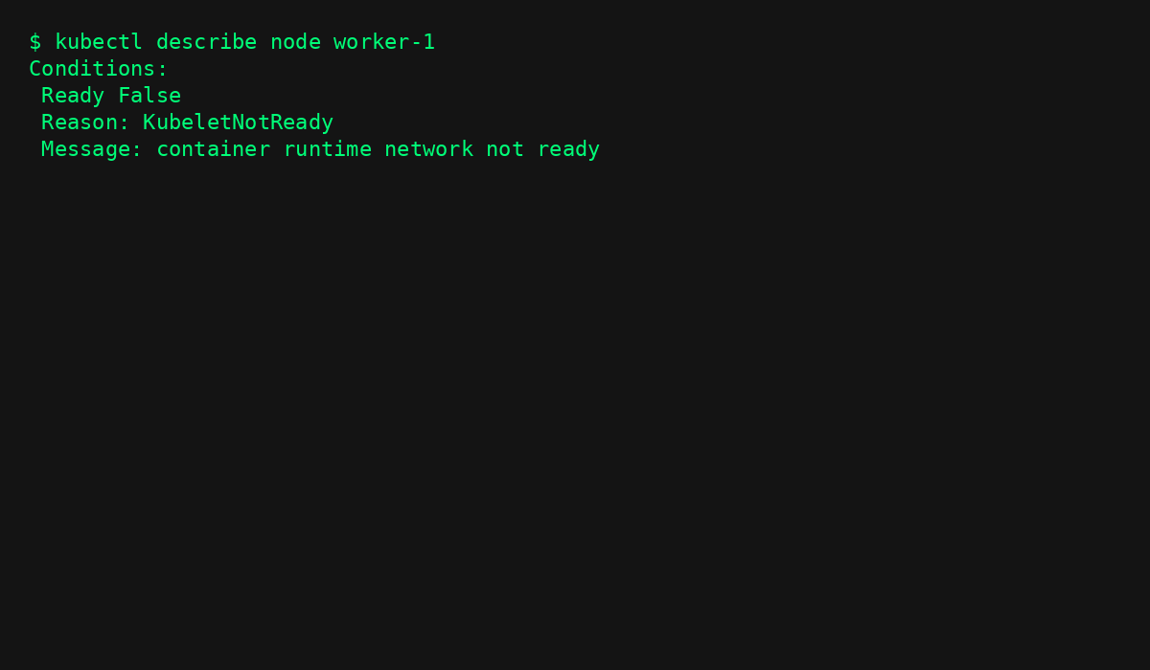
6. Node Log Analysis
Command: journalctl -u kubelet
Sample Output Screenshot:
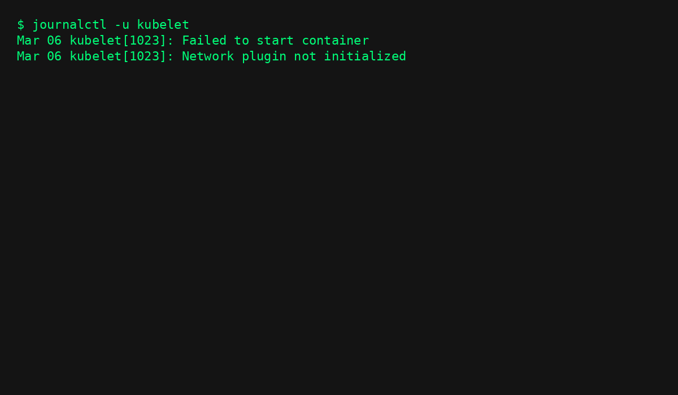

Trouble Shooting

3.1 Pod Trouble Shooting :
In this task, I worked on identifying pod issues such as:
- CrashLoopBackOff
- ImagePullBackOff
- Pending Pods
- Resource limit issues

Commands :
kubectl get pods
kubectl describe pod <pod-name>
kubectl logs <pod-name>
kubectl delete pod <pod-name>

What I Learned:
- How to inspect events
- How to check container status
- How to debug configuration errors
3.2 Node Troubleshooting :
This task involved diagnosing node failures.
Common issues:
- Node NotReady
- Resource exhaustion
- Network issues

Commands :
kubectl get nodes
kubectl describe node <node-name>
kubectl cordon <node-name>
kubectl drain <node-name>

What I Learned:
- How to check node conditions
- How to manage scheduling
- How to isolate problematic nodes

3.3 Log Analysis :
Log analysis is critical for debugging applications running in containers.

Commands :
kubectl logs <pod-name>
kubectl logs <pod-name> -c <container-name>
kubectl logs -f <pod-name>

What I Learned:
- How to analyze application logs
- Identifying runtime errors
- Debugging configuration mistakes
- Monitoring live logs

4.4 Debugging Real-Time Issues
During the practical sessions, I simulated real cluster failures and resolved:
- Misconfigured YAML files
- Incorrect image versions
- Port conflicts
- Resource quota problems
This helped me understand real-world production scenarios.

Conclusion

The Certified Kubernetes Administrator: Pod & Node Troubleshooting & Log Analysis course enhanced my practical knowledge of Kubernetes debugging and cluster management.
Through hands-on exercises, I learned how to:
- Diagnose pod and node failures
- Analyze logs effectively
- Use kubectl troubleshooting commands
- Resolve real-time production issues
This course strengthened my understanding of Kubernetes administration and improved my confidence in handling containerized environments.

