Thực hành 1
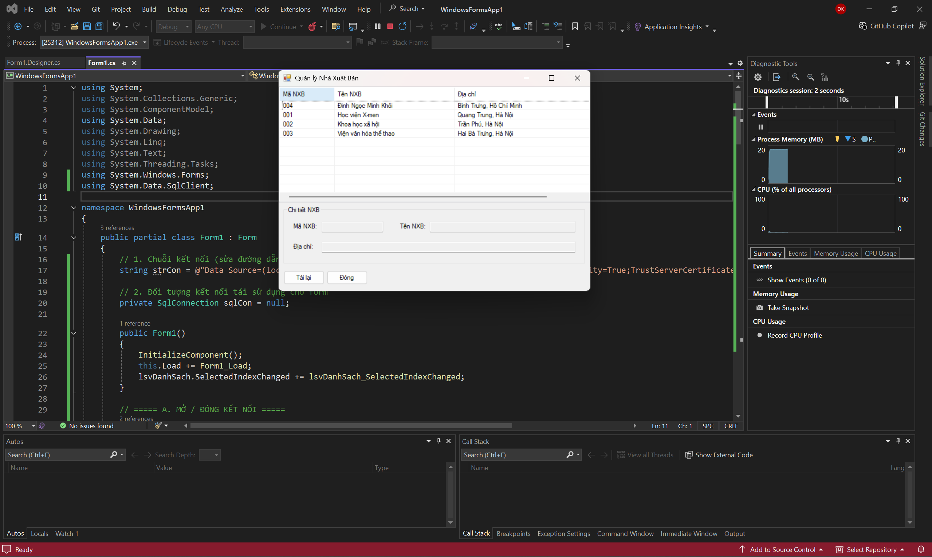
Code design:
Thực hành 1
private System.Windows.Forms.ListView lsvDanhSach;
private System.Windows.Forms.ColumnHeader colMa;
private System.Windows.Forms.ColumnHeader colTen;
private System.Windows.Forms.ColumnHeader colDiaChi;
private System.Windows.Forms.GroupBox gbChiTiet;
private System.Windows.Forms.Label lblMa;
private System.Windows.Forms.Label lblTen;
private System.Windows.Forms.Label lblDiaChi;
private System.Windows.Forms.TextBox txtMaNXB;
private System.Windows.Forms.TextBox txtTenNXB;
private System.Windows.Forms.TextBox txtDiaChi;
private System.Windows.Forms.Button btnReload;
private System.Windows.Forms.Button btnClose;

private void InitializeComponent()
{
this.lsvDanhSach = new System.Windows.Forms.ListView();
this.colMa = new System.Windows.Forms.ColumnHeader();
this.colTen = new System.Windows.Forms.ColumnHeader();
this.colDiaChi = new System.Windows.Forms.ColumnHeader();
this.gbChiTiet = new System.Windows.Forms.GroupBox();
this.txtDiaChi = new System.Windows.Forms.TextBox();
this.txtTenNXB = new System.Windows.Forms.TextBox();
this.txtMaNXB = new System.Windows.Forms.TextBox();
this.lblDiaChi = new System.Windows.Forms.Label();
this.lblTen = new System.Windows.Forms.Label();
this.lblMa = new System.Windows.Forms.Label();
this.btnReload = new System.Windows.Forms.Button();
this.btnClose = new System.Windows.Forms.Button();
this.gbChiTiet.SuspendLayout();
this.SuspendLayout();
//
// lsvDanhSach
//
this.lsvDanhSach.Columns.AddRange(new System.Windows.Forms.ColumnHeader[] {
this.colMa, this.colTen, this.colDiaChi});
this.lsvDanhSach.FullRowSelect = true;
this.lsvDanhSach.GridLines = true;
this.lsvDanhSach.HideSelection = false;
this.lsvDanhSach.Location = new System.Drawing.Point(0, 0);
this.lsvDanhSach.MultiSelect = false;
this.lsvDanhSach.Name = "lsvDanhSach";
this.lsvDanhSach.Size = new System.Drawing.Size(760, 260);
this.lsvDanhSach.TabIndex = 0;
this.lsvDanhSach.UseCompatibleStateImageBehavior = false;
this.lsvDanhSach.View = System.Windows.Forms.View.Details;
this.lsvDanhSach.SelectedIndexChanged += new System.EventHandler(this.lsvDanhSach_SelectedIndexChanged);
//
// colMa
//
this.colMa.Text = "Mã NXB";
this.colMa.Width = 100;
//
// colTen
//
this.colTen.Text = "Tên NXB";
this.colTen.Width = 220;
//
// colDiaChi
//
this.colDiaChi.Text = "Địa chỉ";
this.colDiaChi.Width = 320;
//
// gbChiTiet
//
this.gbChiTiet.Controls.Add(this.txtDiaChi);
this.gbChiTiet.Controls.Add(this.txtTenNXB);
this.gbChiTiet.Controls.Add(this.txtMaNXB);
this.gbChiTiet.Controls.Add(this.lblDiaChi);
this.gbChiTiet.Controls.Add(this.lblTen);
this.gbChiTiet.Controls.Add(this.lblMa);
this.gbChiTiet.Location = new System.Drawing.Point(12, 270);
this.gbChiTiet.Name = "gbChiTiet";
this.gbChiTiet.Size = new System.Drawing.Size(736, 130);
this.gbChiTiet.TabIndex = 1;
this.gbChiTiet.TabStop = false;
this.gbChiTiet.Text = "Chi tiết NXB";
//
// txtDiaChi
//
this.txtDiaChi.Location = new System.Drawing.Point(92, 80);
this.txtDiaChi.Name = "txtDiaChi";
this.txtDiaChi.ReadOnly = true;
this.txtDiaChi.Size = new System.Drawing.Size(620, 22);
this.txtDiaChi.TabIndex = 5;
//
// txtTenNXB
//
this.txtTenNXB.Location = new System.Drawing.Point(356, 34);
this.txtTenNXB.Name = "txtTenNXB";
this.txtTenNXB.ReadOnly = true;
this.txtTenNXB.Size = new System.Drawing.Size(356, 22);
this.txtTenNXB.TabIndex = 4;
//
// txtMaNXB
//
this.txtMaNXB.Location = new System.Drawing.Point(92, 34);
this.txtMaNXB.Name = "txtMaNXB";
this.txtMaNXB.ReadOnly = true;
this.txtMaNXB.Size = new System.Drawing.Size(150, 22);
this.txtMaNXB.TabIndex = 3;
//
// lblDiaChi
//
this.lblDiaChi.AutoSize = true;
this.lblDiaChi.Location = new System.Drawing.Point(20, 83);
this.lblDiaChi.Name = "lblDiaChi";
this.lblDiaChi.Size = new System.Drawing.Size(54, 16);
this.lblDiaChi.TabIndex = 2;
this.lblDiaChi.Text = "Địa chỉ:";
//
// lblTen
//
this.lblTen.AutoSize = true;
this.lblTen.Location = new System.Drawing.Point(280, 37);
this.lblTen.Name = "lblTen";
this.lblTen.Size = new System.Drawing.Size(63, 16);
this.lblTen.TabIndex = 1;
this.lblTen.Text = "Tên NXB:";
//
// lblMa
//
this.lblMa.AutoSize = true;
this.lblMa.Location = new System.Drawing.Point(20, 37);
this.lblMa.Name = "lblMa";
this.lblMa.Size = new System.Drawing.Size(57, 16);
this.lblMa.TabIndex = 0;
this.lblMa.Text = "Mã NXB:";
//
// btnReload
//
this.btnReload.Location = new System.Drawing.Point(12, 415);
this.btnReload.Name = "btnReload";
this.btnReload.Size = new System.Drawing.Size(100, 32);
this.btnReload.TabIndex = 2;
this.btnReload.Text = "Tải lại";
this.btnReload.UseVisualStyleBackColor = true;
this.btnReload.Click += (s, e) => { HienThiDanhSachNXB(); };
//
// btnClose
//
this.btnClose.Location = new System.Drawing.Point(118, 415);
this.btnClose.Name = "btnClose";
this.btnClose.Size = new System.Drawing.Size(100, 32);
this.btnClose.TabIndex = 3;
this.btnClose.Text = "Đóng";
this.btnClose.UseVisualStyleBackColor = true;
this.btnClose.Click += (s, e) => { this.Close(); };
//
// Form1
//
this.AutoScaleDimensions = new System.Drawing.SizeF(8F, 16F);
this.AutoScaleMode = System.Windows.Forms.AutoScaleMode.Font;
this.ClientSize = new System.Drawing.Size(760, 460);
this.Controls.Add(this.btnClose);
this.Controls.Add(this.btnReload);
this.Controls.Add(this.gbChiTiet);
this.Controls.Add(this.lsvDanhSach);
this.Name = "Form1";
this.Text = "Quản lý Nhà Xuất Bản";
this.Load += new System.EventHandler(this.Form1_Load);
this.gbChiTiet.ResumeLayout(false);
this.gbChiTiet.PerformLayout();
this.ResumeLayout(false);
}
Code xử lí:
thực hành 1
// 1. Chuỗi kết nối (sửa đường dẫn .mdf của bạn)
string strCon = @"Data Source=(localdb)\MSSQLLocalDB;Initial Catalog=QuanLyBanSach;Integrated Security=True;TrustServerCertificate=True;Connect Timeout=30";

// 2. Đối tượng kết nối tái sử dụng cho form
private SqlConnection sqlCon = null;

public Form1()
{
InitializeComponent();
this.Load += Form1_Load;
lsvDanhSach.SelectedIndexChanged += lsvDanhSach_SelectedIndexChanged;
}

// ===== A. MỞ / ĐÓNG KẾT NỐI =====
private void MoKetNoi()
{
if (sqlCon == null)
sqlCon = new SqlConnection(strCon);
if (sqlCon.State == ConnectionState.Closed)
sqlCon.Open();
}

private void DongKetNoi()
{
if (sqlCon != null && sqlCon.State == ConnectionState.Open)
sqlCon.Close();
}

// ===== B. CẤU HÌNH LISTVIEW (nếu chưa cấu hình trong Designer) =====
private void InitListView()
{
lsvDanhSach.View = View.Details;
lsvDanhSach.FullRowSelect = true;
lsvDanhSach.GridLines = true;

if (lsvDanhSach.Columns.Count == 0)
{
lsvDanhSach.Columns.Add("Mã NXB", 100);
lsvDanhSach.Columns.Add("Tên NXB", 220);
lsvDanhSach.Columns.Add("Địa chỉ", 300);
}
}

// ===== C. HIỂN THỊ DANH SÁCH NXB =====
private void HienThiDanhSachNXB()
{
try
{
MoKetNoi();
using (SqlCommand cmd = new SqlCommand("HienThiNXB", sqlCon))
{
cmd.CommandType = CommandType.StoredProcedure;
using (SqlDataReader reader = cmd.ExecuteReader())
{
lsvDanhSach.Items.Clear();
while (reader.Read())
{
string maNXB = reader.GetString(0).Trim();
string tenNXB = reader.GetString(1);
string diaChi = reader.IsDBNull(2) ? "" : reader.GetString(2);

ListViewItem lvi = new ListViewItem(maNXB);
lvi.SubItems.Add(tenNXB);
lvi.SubItems.Add(diaChi);
lsvDanhSach.Items.Add(lvi);
}
}
}
}
catch (Exception ex)
{
MessageBox.Show("Lỗi tải danh sách NXB: " + ex.Message);
}
finally
{
DongKetNoi();
}
}

// ===== D. HIỂN THỊ CHI TIẾT THEO MÃ =====
private void HienThiThongTinNXBTheoMa(string maNXB)
{
if (string.IsNullOrWhiteSpace(maNXB)) return;

try
{
MoKetNoi();
using (SqlCommand cmd = new SqlCommand("HienThiChiTietNXB", sqlCon))
{
cmd.CommandType = CommandType.StoredProcedure;
cmd.Parameters.Add(new SqlParameter("@MaNXB", SqlDbType.Char, 10) { Value = maNXB });

using (SqlDataReader reader = cmd.ExecuteReader())
{
txtMaNXB.Text = txtTenNXB.Text = txtDiaChi.Text = "";
if (reader.Read())
{
txtMaNXB.Text = reader.GetString(0).Trim();
txtTenNXB.Text = reader.GetString(1);
txtDiaChi.Text = reader.IsDBNull(2) ? "" : reader.GetString(2);
}
}
}
}
catch (Exception ex)
{
MessageBox.Show("Lỗi tải chi tiết NXB: " + ex.Message);
}
finally
{
DongKetNoi();
}
}

// ===== E. SỰ KIỆN =====
private void Form1_Load(object sender, EventArgs e)
{
InitListView();
HienThiDanhSachNXB();
}

private void lsvDanhSach_SelectedIndexChanged(object sender, EventArgs e)
{
if (lsvDanhSach.SelectedItems.Count == 0) return;
string maNXB = lsvDanhSach.SelectedItems[0].SubItems[0].Text;
HienThiThongTinNXBTheoMa(maNXB);
}
Thực hành 2
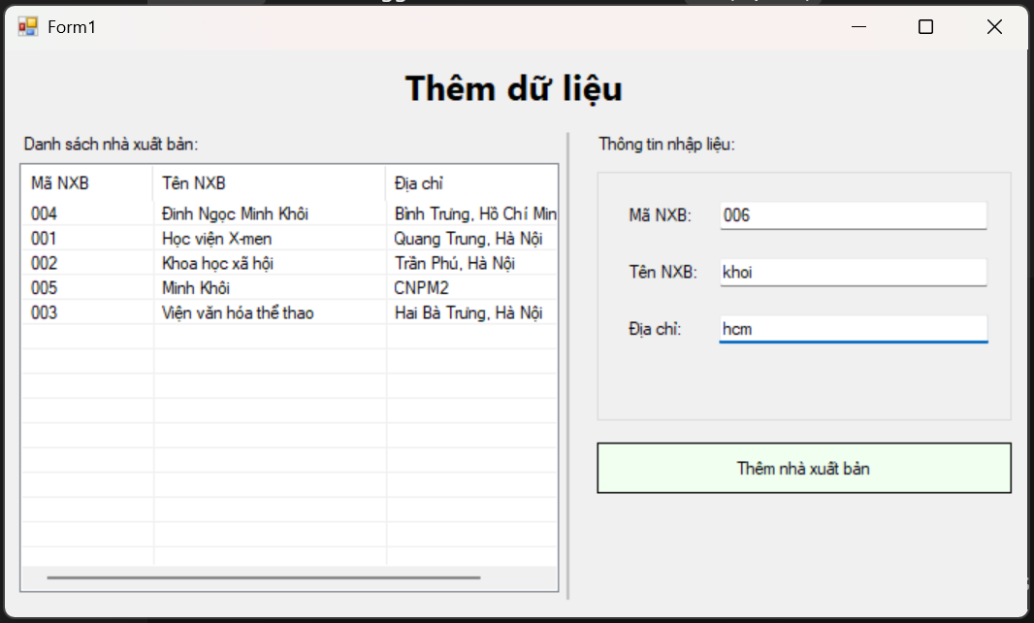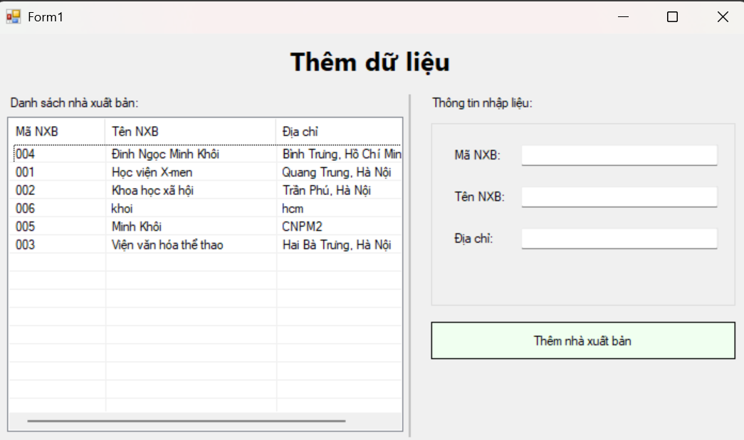
Code design:
Thực hành 2
/ <summary>Required designer variable.</summary>
private System.ComponentModel.IContainer components = null;

/// <summary>Clean up any resources being used.</summary>
protected override void Dispose(bool disposing)
{
if (disposing && (components != null))
components.Dispose();
base.Dispose(disposing);
}

#region Windows Form Designer generated code

private void InitializeComponent()
{
this.lblTitle = new System.Windows.Forms.Label();
this.lblDanhSach = new System.Windows.Forms.Label();
this.lblNhapLieu = new System.Windows.Forms.Label();
this.lsvDanhSach = new System.Windows.Forms.ListView();
this.colMa = ((System.Windows.Forms.ColumnHeader)(new System.Windows.Forms.ColumnHeader()));
this.colTen = ((System.Windows.Forms.ColumnHeader)(new System.Windows.Forms.ColumnHeader()));
this.colDiaChi = ((System.Windows.Forms.ColumnHeader)(new System.Windows.Forms.ColumnHeader()));
this.pnlSplit = new System.Windows.Forms.Panel();
this.grpNhapLieu = new System.Windows.Forms.GroupBox();
this.txtDiaChi = new System.Windows.Forms.TextBox();
this.txtTenNXB = new System.Windows.Forms.TextBox();
this.txtMaNXB = new System.Windows.Forms.TextBox();
this.lblDiaChi = new System.Windows.Forms.Label();
this.lblTen = new System.Windows.Forms.Label();
this.lblMa = new System.Windows.Forms.Label();
this.btnThemDL = new System.Windows.Forms.Button();
this.grpNhapLieu.SuspendLayout();
this.SuspendLayout();
//
// lblTitle
//
this.lblTitle.Dock = System.Windows.Forms.DockStyle.Top;
this.lblTitle.Font = new System.Drawing.Font("Segoe UI", 18F, System.Drawing.FontStyle.Bold);
this.lblTitle.Location = new System.Drawing.Point(0, 0);
this.lblTitle.Name = "lblTitle";
this.lblTitle.Size = new System.Drawing.Size(820, 58);
this.lblTitle.TabIndex = 0;
this.lblTitle.Text = "Thêm dữ liệu";
this.lblTitle.TextAlign = System.Drawing.ContentAlignment.MiddleCenter;
//
// lblDanhSach
//
this.lblDanhSach.AutoSize = true;
this.lblDanhSach.Location = new System.Drawing.Point(12, 67);
this.lblDanhSach.Name = "lblDanhSach";
this.lblDanhSach.Size = new System.Drawing.Size(146, 15);
this.lblDanhSach.TabIndex = 1;
this.lblDanhSach.Text = "Danh sách nhà xuất bản:";
//
// lblNhapLieu
//
this.lblNhapLieu.AutoSize = true;
this.lblNhapLieu.Location = new System.Drawing.Point(472, 67);
this.lblNhapLieu.Name = "lblNhapLieu";
this.lblNhapLieu.Size = new System.Drawing.Size(120, 15);
this.lblNhapLieu.TabIndex = 2;
this.lblNhapLieu.Text = "Thông tin nhập liệu:";
//
// lsvDanhSach
//
this.lsvDanhSach.Columns.AddRange(new System.Windows.Forms.ColumnHeader[] {
this.colMa,
this.colTen,
this.colDiaChi});
this.lsvDanhSach.FullRowSelect = true;
this.lsvDanhSach.GridLines = true;
this.lsvDanhSach.HideSelection = false;
this.lsvDanhSach.Location = new System.Drawing.Point(12, 90);
this.lsvDanhSach.MultiSelect = false;
this.lsvDanhSach.Name = "lsvDanhSach";
this.lsvDanhSach.Size = new System.Drawing.Size(432, 340);
this.lsvDanhSach.TabIndex = 3;
this.lsvDanhSach.UseCompatibleStateImageBehavior = false;
this.lsvDanhSach.View = System.Windows.Forms.View.Details;
//
// colMa
//
this.colMa.Text = "Mã NXB";
this.colMa.Width = 90;
//
// colTen
//
this.colTen.Text = "Tên NXB";
this.colTen.Width = 160;
//
// colDiaChi
//
this.colDiaChi.Text = "Địa chỉ";
this.colDiaChi.Width = 160;
//
// pnlSplit
//
this.pnlSplit.BackColor = System.Drawing.Color.Silver;
this.pnlSplit.Location = new System.Drawing.Point(450, 66);
this.pnlSplit.Name = "pnlSplit";
this.pnlSplit.Size = new System.Drawing.Size(2, 370);
this.pnlSplit.TabIndex = 4;
//
// grpNhapLieu
//
this.grpNhapLieu.Controls.Add(this.txtDiaChi);
this.grpNhapLieu.Controls.Add(this.txtTenNXB);
this.grpNhapLieu.Controls.Add(this.txtMaNXB);
this.grpNhapLieu.Controls.Add(this.lblDiaChi);
this.grpNhapLieu.Controls.Add(this.lblTen);
this.grpNhapLieu.Controls.Add(this.lblMa);
this.grpNhapLieu.Location = new System.Drawing.Point(475, 90);
this.grpNhapLieu.Name = "grpNhapLieu";
this.grpNhapLieu.Size = new System.Drawing.Size(333, 205);
this.grpNhapLieu.TabIndex = 5;
this.grpNhapLieu.TabStop = false;
//
// txtDiaChi
//
this.txtDiaChi.Location = new System.Drawing.Point(98, 120);
this.txtDiaChi.Name = "txtDiaChi";
this.txtDiaChi.Size = new System.Drawing.Size(215, 23);
this.txtDiaChi.TabIndex = 5;
//
// txtTenNXB
//
this.txtTenNXB.Location = new System.Drawing.Point(98, 75);
this.txtTenNXB.Name = "txtTenNXB";
this.txtTenNXB.Size = new System.Drawing.Size(215, 23);
this.txtTenNXB.TabIndex = 3;
//
// txtMaNXB
//
this.txtMaNXB.Location = new System.Drawing.Point(98, 30);
this.txtMaNXB.MaxLength = 10;
this.txtMaNXB.Name = "txtMaNXB";
this.txtMaNXB.Size = new System.Drawing.Size(215, 23);
this.txtMaNXB.TabIndex = 1;
//
// lblDiaChi
//
this.lblDiaChi.AutoSize = true;
this.lblDiaChi.Location = new System.Drawing.Point(22, 123);
this.lblDiaChi.Name = "lblDiaChi";
this.lblDiaChi.Size = new System.Drawing.Size(50, 15);
this.lblDiaChi.TabIndex = 4;
this.lblDiaChi.Text = "Địa chỉ:";
//
// lblTen
//
this.lblTen.AutoSize = true;
this.lblTen.Location = new System.Drawing.Point(22, 78);
this.lblTen.Name = "lblTen";
this.lblTen.Size = new System.Drawing.Size(59, 15);
this.lblTen.TabIndex = 2;
this.lblTen.Text = "Tên NXB:";
//
// lblMa
//
this.lblMa.AutoSize = true;
this.lblMa.Location = new System.Drawing.Point(22, 33);
this.lblMa.Name = "lblMa";
this.lblMa.Size = new System.Drawing.Size(53, 15);
this.lblMa.TabIndex = 0;
this.lblMa.Text = "Mã NXB:";
//
// btnThemDL
//
this.btnThemDL.BackColor = System.Drawing.Color.Honeydew;
this.btnThemDL.FlatStyle = System.Windows.Forms.FlatStyle.Flat;
this.btnThemDL.Location = new System.Drawing.Point(475, 312);
this.btnThemDL.Name = "btnThemDL";
this.btnThemDL.Size = new System.Drawing.Size(333, 40);
this.btnThemDL.TabIndex = 6;
this.btnThemDL.Text = "Thêm nhà xuất bản";
this.btnThemDL.UseVisualStyleBackColor = false;
//
// Form1
//
this.AutoScaleDimensions = new System.Drawing.SizeF(7F, 15F);
this.AutoScaleMode = System.Windows.Forms.AutoScaleMode.Font;
this.ClientSize = new System.Drawing.Size(820, 450);
this.Controls.Add(this.btnThemDL);
this.Controls.Add(this.grpNhapLieu);
this.Controls.Add(this.pnlSplit);
this.Controls.Add(this.lsvDanhSach);
this.Controls.Add(this.lblNhapLieu);
this.Controls.Add(this.lblDanhSach);
this.Controls.Add(this.lblTitle);
this.Name = "Form1";
this.StartPosition = System.Windows.Forms.FormStartPosition.CenterScreen;
this.Text = "Form1";
this.grpNhapLieu.ResumeLayout(false);
this.grpNhapLieu.PerformLayout();
this.ResumeLayout(false);
this.PerformLayout();
}

#endregion

private System.Windows.Forms.Label lblTitle;
private System.Windows.Forms.Label lblDanhSach;
private System.Windows.Forms.Label lblNhapLieu;
private System.Windows.Forms.ListView lsvDanhSach;
private System.Windows.Forms.ColumnHeader colMa;
private System.Windows.Forms.ColumnHeader colTen;
private System.Windows.Forms.ColumnHeader colDiaChi;
private System.Windows.Forms.Panel pnlSplit;
private System.Windows.Forms.GroupBox grpNhapLieu;
private System.Windows.Forms.TextBox txtDiaChi;
private System.Windows.Forms.TextBox txtTenNXB;
private System.Windows.Forms.TextBox txtMaNXB;
private System.Windows.Forms.Label lblDiaChi;
private System.Windows.Forms.Label lblTen;
private System.Windows.Forms.Label lblMa;
private System.Windows.Forms.Button btnThemDL;
Code xử lí:
Thực hành 2
==== Connection string ====
Sửa lại đường dẫn.mdf cho đúng máy bạn,
hoặc thay bằng chuỗi dùng Initial Catalog= QuanLySach nếu DB đã attach trên SQL Server.
string strCon = @"Data Source=(localdb)\MSSQLLocalDB;Initial Catalog=QuanLyBanSach;Integrated Security=True;TrustServerCertificate=True;Connect Timeout=30";

private SqlConnection sqlCon;

public Form1()
{
InitializeComponent();

// Gắn sự kiện ở code-behind để Designer gọn, tránh trùng
this.Load += Form1_Load;
lsvDanhSach.SelectedIndexChanged += lsvDanhSach_SelectedIndexChanged;
btnThemDL.Click += btnThemDL_Click;
}

// ===== A. Mở / Đóng kết nối =====
private void MoKetNoi()
{
if (sqlCon == null) sqlCon = new SqlConnection(strCon);
if (sqlCon.State == ConnectionState.Closed) sqlCon.Open();
}

private void DongKetNoi()
{
if (sqlCon != null && sqlCon.State == ConnectionState.Open)
sqlCon.Close();
}

// ===== B. Hiển thị danh sách NXB =====
private void HienThiDanhSachNXB()
{
try
{
MoKetNoi();
using (var cmd = new SqlCommand("HienThiNXB", sqlCon))
{
cmd.CommandType = CommandType.StoredProcedure;
using (var reader = cmd.ExecuteReader())
{
lsvDanhSach.Items.Clear();
while (reader.Read())
{
string ma = reader.GetString(0).Trim();
string ten = reader.GetString(1);
string dia = reader.IsDBNull(2) ? "" : reader.GetString(2);

var lvi = new ListViewItem(ma);
lvi.SubItems.Add(ten);
lvi.SubItems.Add(dia);
lsvDanhSach.Items.Add(lvi);
}
}
}
}
catch (Exception ex)
{
MessageBox.Show("Lỗi tải danh sách: " + ex.Message);
}
finally { DongKetNoi(); }
}

// ===== C. Sự kiện Load =====
private void Form1_Load(object sender, EventArgs e)
{
HienThiDanhSachNXB();
txtMaNXB.Focus();
}

// ===== D. Chọn dòng để xem nhanh vào TextBox =====
private void lsvDanhSach_SelectedIndexChanged(object sender, EventArgs e)
{
if (lsvDanhSach.SelectedItems.Count == 0) return;
var it = lsvDanhSach.SelectedItems[0];
txtMaNXB.Text = it.SubItems[0].Text;
txtTenNXB.Text = it.SubItems[1].Text;
txtDiaChi.Text = it.SubItems[2].Text;
}

// ===== E. Nút Thêm nhà xuất bản =====
private void btnThemDL_Click(object sender, EventArgs e)
{
string ma = (txtMaNXB.Text ?? "").Trim();
string ten = (txtTenNXB.Text ?? "").Trim();
string dia = (txtDiaChi.Text ?? "").Trim();

if (string.IsNullOrEmpty(ma)) { MessageBox.Show("Vui lòng nhập Mã NXB."); txtMaNXB.Focus(); return; }
if (ma.Length > 10) { MessageBox.Show("Mã NXB tối đa 10 ký tự."); txtMaNXB.Focus(); return; }
if (string.IsNullOrEmpty(ten)) { MessageBox.Show("Vui lòng nhập Tên NXB."); txtTenNXB.Focus(); return; }

try
{
MoKetNoi();
using (var cmd = new SqlCommand("ThemNhaXuatBan", sqlCon))
{
cmd.CommandType = CommandType.StoredProcedure;
cmd.Parameters.Add(new SqlParameter("@NXB", SqlDbType.Char, 10) { Value = ma });
cmd.Parameters.Add(new SqlParameter("@TenNXB", SqlDbType.NVarChar, 100) { Value = ten });
cmd.Parameters.Add(new SqlParameter("@DiaChi", SqlDbType.NVarChar, 500) { Value = (object)dia ?? DBNull.Value });

int kq = cmd.ExecuteNonQuery();
if (kq > 0)
{
MessageBox.Show("Thêm dữ liệu thành công!");
HienThiDanhSachNXB();
txtMaNXB.Clear(); txtTenNXB.Clear(); txtDiaChi.Clear();
txtMaNXB.Focus();
}
else
{
MessageBox.Show("Không có bản ghi nào được thêm.");
}
}
}
catch (SqlException ex) when (ex.Number == 2627 || ex.Number == 2601) // trùng khóa
{
MessageBox.Show("Mã NXB đã tồn tại. Vui lòng nhập mã khác.");
txtMaNXB.Focus();
}
catch (Exception ex)
{
MessageBox.Show("Lỗi thêm dữ liệu: " + ex.Message);
}
finally { DongKetNoi(); }
}
thực hành 3
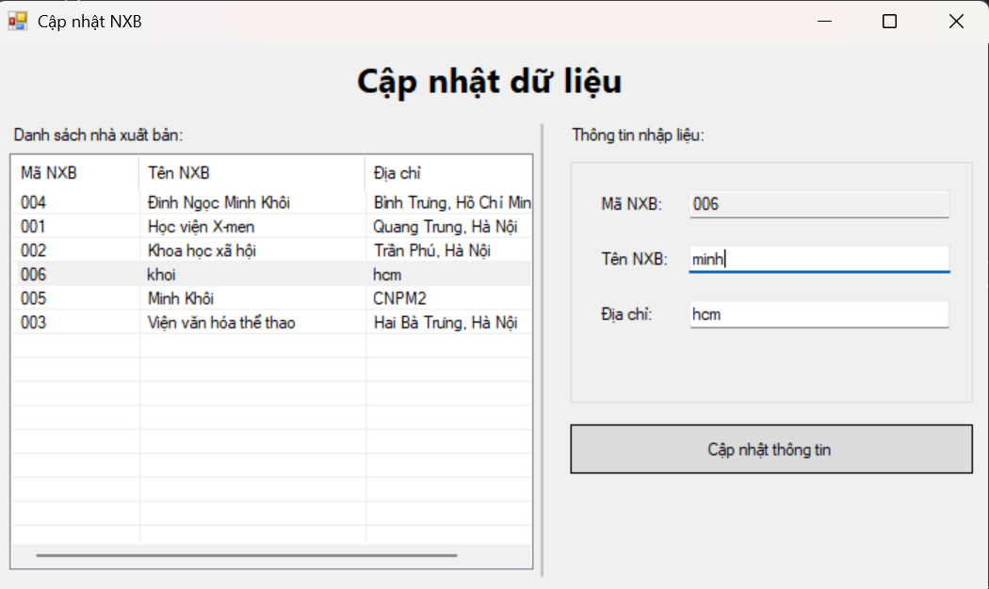
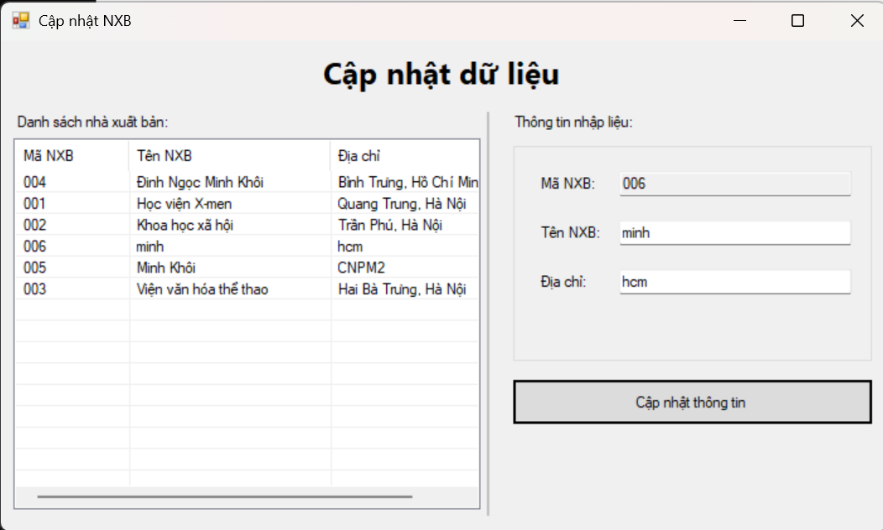
Code design:
Thực hành 3
private System.ComponentModel.IContainer components = null;

private System.Windows.Forms.Label lblTitle;
private System.Windows.Forms.Label lblDanhSach;
private System.Windows.Forms.Label lblNhapLieu;
private System.Windows.Forms.ListView lsvDanhSach;
private System.Windows.Forms.ColumnHeader colMa;
private System.Windows.Forms.ColumnHeader colTen;
private System.Windows.Forms.ColumnHeader colDiaChi;
private System.Windows.Forms.Panel pnlSplit;
private System.Windows.Forms.GroupBox grpNhapLieu;
private System.Windows.Forms.TextBox txtMaNXB;
private System.Windows.Forms.TextBox txtTenNXB;
private System.Windows.Forms.TextBox txtDiaChi;
private System.Windows.Forms.Label lblMa;
private System.Windows.Forms.Label lblTen;
private System.Windows.Forms.Label lblDiaChi;
private System.Windows.Forms.Button btnCapNhat;

protected override void Dispose(bool disposing)
{
if (disposing && (components != null)) components.Dispose();
base.Dispose(disposing);
}

#region Windows Form Designer generated code
private void InitializeComponent()
{
this.lblTitle = new System.Windows.Forms.Label();
this.lblDanhSach = new System.Windows.Forms.Label();
this.lblNhapLieu = new System.Windows.Forms.Label();
this.lsvDanhSach = new System.Windows.Forms.ListView();
this.colMa = ((System.Windows.Forms.ColumnHeader)(new System.Windows.Forms.ColumnHeader()));
this.colTen = ((System.Windows.Forms.ColumnHeader)(new System.Windows.Forms.ColumnHeader()));
this.colDiaChi = ((System.Windows.Forms.ColumnHeader)(new System.Windows.Forms.ColumnHeader()));
this.pnlSplit = new System.Windows.Forms.Panel();
this.grpNhapLieu = new System.Windows.Forms.GroupBox();
this.txtDiaChi = new System.Windows.Forms.TextBox();
this.txtTenNXB = new System.Windows.Forms.TextBox();
this.txtMaNXB = new System.Windows.Forms.TextBox();
this.lblDiaChi = new System.Windows.Forms.Label();
this.lblTen = new System.Windows.Forms.Label();
this.lblMa = new System.Windows.Forms.Label();
this.btnCapNhat = new System.Windows.Forms.Button();
this.grpNhapLieu.SuspendLayout();
this.SuspendLayout();
//
// lblTitle
//
this.lblTitle.Dock = System.Windows.Forms.DockStyle.Top;
this.lblTitle.Font = new System.Drawing.Font("Segoe UI", 18F, System.Drawing.FontStyle.Bold);
this.lblTitle.Location = new System.Drawing.Point(0, 0);
this.lblTitle.Name = "lblTitle";
this.lblTitle.Size = new System.Drawing.Size(820, 58);
this.lblTitle.TabIndex = 0;
this.lblTitle.Text = "Cập nhật dữ liệu";
this.lblTitle.TextAlign = System.Drawing.ContentAlignment.MiddleCenter;
//
// lblDanhSach
//
this.lblDanhSach.AutoSize = true;
this.lblDanhSach.Location = new System.Drawing.Point(12, 67);
this.lblDanhSach.Name = "lblDanhSach";
this.lblDanhSach.Size = new System.Drawing.Size(146, 15);
this.lblDanhSach.TabIndex = 1;
this.lblDanhSach.Text = "Danh sách nhà xuất bản:";
//
// lblNhapLieu
//
this.lblNhapLieu.AutoSize = true;
this.lblNhapLieu.Location = new System.Drawing.Point(472, 67);
this.lblNhapLieu.Name = "lblNhapLieu";
this.lblNhapLieu.Size = new System.Drawing.Size(120, 15);
this.lblNhapLieu.TabIndex = 2;
this.lblNhapLieu.Text = "Thông tin nhập liệu:";
//
// lsvDanhSach
//
this.lsvDanhSach.Columns.AddRange(new System.Windows.Forms.ColumnHeader[] {
this.colMa,
this.colTen,
this.colDiaChi});
this.lsvDanhSach.FullRowSelect = true;
this.lsvDanhSach.GridLines = true;
this.lsvDanhSach.HideSelection = false;
this.lsvDanhSach.Location = new System.Drawing.Point(12, 90);
this.lsvDanhSach.MultiSelect = false;
this.lsvDanhSach.Name = "lsvDanhSach";
this.lsvDanhSach.Size = new System.Drawing.Size(432, 340);
this.lsvDanhSach.TabIndex = 3;
this.lsvDanhSach.UseCompatibleStateImageBehavior = false;
this.lsvDanhSach.View = System.Windows.Forms.View.Details;
//
// colMa
//
this.colMa.Text = "Mã NXB";
this.colMa.Width = 90;
//
// colTen
//
this.colTen.Text = "Tên NXB";
this.colTen.Width = 160;
//
// colDiaChi
//
this.colDiaChi.Text = "Địa chỉ";
this.colDiaChi.Width = 160;
//
// pnlSplit
//
this.pnlSplit.BackColor = System.Drawing.Color.Silver;
this.pnlSplit.Location = new System.Drawing.Point(450, 66);
this.pnlSplit.Name = "pnlSplit";
this.pnlSplit.Size = new System.Drawing.Size(2, 370);
this.pnlSplit.TabIndex = 4;
//
// grpNhapLieu
//
this.grpNhapLieu.Controls.Add(this.txtDiaChi);
this.grpNhapLieu.Controls.Add(this.txtTenNXB);
this.grpNhapLieu.Controls.Add(this.txtMaNXB);
this.grpNhapLieu.Controls.Add(this.lblDiaChi);
this.grpNhapLieu.Controls.Add(this.lblTen);
this.grpNhapLieu.Controls.Add(this.lblMa);
this.grpNhapLieu.Location = new System.Drawing.Point(475, 90);
this.grpNhapLieu.Name = "grpNhapLieu";
this.grpNhapLieu.Size = new System.Drawing.Size(333, 205);
this.grpNhapLieu.TabIndex = 5;
this.grpNhapLieu.TabStop = false;
//
// txtDiaChi
//
this.txtDiaChi.Location = new System.Drawing.Point(98, 120);
this.txtDiaChi.Name = "txtDiaChi";
this.txtDiaChi.Size = new System.Drawing.Size(215, 23);
this.txtDiaChi.TabIndex = 5;
//
// txtTenNXB
//
this.txtTenNXB.Location = new System.Drawing.Point(98, 75);
this.txtTenNXB.Name = "txtTenNXB";
this.txtTenNXB.Size = new System.Drawing.Size(215, 23);
this.txtTenNXB.TabIndex = 3;
//
// txtMaNXB
//
this.txtMaNXB.Location = new System.Drawing.Point(98, 30);
this.txtMaNXB.MaxLength = 10;
this.txtMaNXB.Name = "txtMaNXB";
this.txtMaNXB.ReadOnly = true; // cập nhật theo dòng chọn
this.txtMaNXB.Size = new System.Drawing.Size(215, 23);
this.txtMaNXB.TabIndex = 1;
//
// lblDiaChi
//
this.lblDiaChi.AutoSize = true;
this.lblDiaChi.Location = new System.Drawing.Point(22, 123);
this.lblDiaChi.Name = "lblDiaChi";
this.lblDiaChi.Size = new System.Drawing.Size(50, 15);
this.lblDiaChi.TabIndex = 4;
this.lblDiaChi.Text = "Địa chỉ:";
//
// lblTen
//
this.lblTen.AutoSize = true;
this.lblTen.Location = new System.Drawing.Point(22, 78);
this.lblTen.Name = "lblTen";
this.lblTen.Size = new System.Drawing.Size(59, 15);
this.lblTen.TabIndex = 2;
this.lblTen.Text = "Tên NXB:";
//
// lblMa
//
this.lblMa.AutoSize = true;
this.lblMa.Location = new System.Drawing.Point(22, 33);
this.lblMa.Name = "lblMa";
this.lblMa.Size = new System.Drawing.Size(53, 15);
this.lblMa.TabIndex = 0;
this.lblMa.Text = "Mã NXB:";
//
// btnCapNhat
//
this.btnCapNhat.BackColor = System.Drawing.Color.Gainsboro;
this.btnCapNhat.Enabled = false;
this.btnCapNhat.FlatStyle = System.Windows.Forms.FlatStyle.Flat;
this.btnCapNhat.Location = new System.Drawing.Point(475, 312);
this.btnCapNhat.Name = "btnCapNhat";
this.btnCapNhat.Size = new System.Drawing.Size(333, 40);
this.btnCapNhat.TabIndex = 6;
this.btnCapNhat.Text = "Cập nhật thông tin";
this.btnCapNhat.UseVisualStyleBackColor = false;
//
// Form1
//
this.AutoScaleDimensions = new System.Drawing.SizeF(7F, 15F);
this.AutoScaleMode = System.Windows.Forms.AutoScaleMode.Font;
this.ClientSize = new System.Drawing.Size(820, 450);
this.Controls.Add(this.btnCapNhat);
this.Controls.Add(this.grpNhapLieu);
this.Controls.Add(this.pnlSplit);
this.Controls.Add(this.lsvDanhSach);
this.Controls.Add(this.lblNhapLieu);
this.Controls.Add(this.lblDanhSach);
this.Controls.Add(this.lblTitle);
this.Name = "Form1";
this.StartPosition = System.Windows.Forms.FormStartPosition.CenterScreen;
this.Text = "Cập nhật NXB";
this.grpNhapLieu.ResumeLayout(false);
this.grpNhapLieu.PerformLayout();
this.ResumeLayout(false);
this.PerformLayout();
}
#endregion
Code xử lí:
Thực hành 3
=== Connection string ===
Cách 1: LocalDB gắn file.mdf(đổi đường dẫn cho đúng)
string strCon = @"Data Source=(localdb)\MSSQLLocalDB;Initial Catalog=QuanLyBanSach;Integrated Security=True;TrustServerCertificate=True;Connect Timeout=30";

// Cách 2 (khuyên dùng nếu DB đã attach): dùng Initial Catalog (bỏ dòng trên, bỏ comment dòng dưới)
// private readonly string strCon =
// @"Data Source=.\SQLEXPRESS;Initial Catalog=QuanLySach;Integrated Security=True;TrustServerCertificate=True;Connect Timeout=30";

private SqlConnection sqlCon;

public Form1()
{
InitializeComponent();

this.Load += Form1_Load;
lsvDanhSach.SelectedIndexChanged += lsvDanhSach_SelectedIndexChanged;
btnCapNhat.Click += btnCapNhat_Click;
}

// ===== A. Kết nối =====
private void MoKetNoi()
{
if (sqlCon == null) sqlCon = new SqlConnection(strCon);
if (sqlCon.State == ConnectionState.Closed) sqlCon.Open();
}
private void DongKetNoi()
{
if (sqlCon != null && sqlCon.State == ConnectionState.Open)
sqlCon.Close();
}

// ===== B. Hiển thị danh sách =====
private void HienThiDanhSachNXB()
{
try
{
MoKetNoi();
using (var cmd = new SqlCommand("HienThiNXB", sqlCon))
{
cmd.CommandType = CommandType.StoredProcedure;
using (var rd = cmd.ExecuteReader())
{
lsvDanhSach.BeginUpdate();
lsvDanhSach.Items.Clear();
while (rd.Read())
{
string ma = rd.GetString(0).Trim();
string ten = rd.GetString(1);
string dia = rd.IsDBNull(2) ? "" : rd.GetString(2);

var it = new ListViewItem(ma);
it.SubItems.Add(ten);
it.SubItems.Add(dia);
lsvDanhSach.Items.Add(it);
}
lsvDanhSach.EndUpdate();
}
}
}
catch (Exception ex)
{
MessageBox.Show("Lỗi tải danh sách: " + ex.Message);
}
finally { DongKetNoi(); }
}

// ===== C. Load form =====
private void Form1_Load(object sender, EventArgs e)
{
HienThiDanhSachNXB();
txtMaNXB.ReadOnly = true; // cập nhật theo mã đang chọn
btnCapNhat.Enabled = false; // chỉ bật khi chọn 1 dòng
}

// ===== D. Chọn 1 dòng để nạp vào ô nhập =====
private void lsvDanhSach_SelectedIndexChanged(object sender, EventArgs e)
{
if (lsvDanhSach.SelectedItems.Count == 0)
{
txtMaNXB.Clear(); txtTenNXB.Clear(); txtDiaChi.Clear();
btnCapNhat.Enabled = false;
return;
}

var it = lsvDanhSach.SelectedItems[0];
txtMaNXB.Text = it.SubItems[0].Text;
txtTenNXB.Text = it.SubItems[1].Text;
txtDiaChi.Text = it.SubItems[2].Text;
btnCapNhat.Enabled = true;
}

// ===== E. Nút CẬP NHẬT =====
private void btnCapNhat_Click(object sender, EventArgs e)
{
string ma = (txtMaNXB.Text ?? "").Trim();
string ten = (txtTenNXB.Text ?? "").Trim();
string dia = (txtDiaChi.Text ?? "").Trim();

if (string.IsNullOrEmpty(ma)) { MessageBox.Show("Chưa chọn bản ghi."); return; }
if (string.IsNullOrEmpty(ten)) { MessageBox.Show("Vui lòng nhập Tên NXB."); txtTenNXB.Focus(); return; }

try
{
MoKetNoi();
using (var cmd = new SqlCommand("CapNhatNhaXuatBan", sqlCon))
{
cmd.CommandType = CommandType.StoredProcedure;
cmd.Parameters.Add(new SqlParameter("@NXB", SqlDbType.Char, 10) { Value = ma });
cmd.Parameters.Add(new SqlParameter("@TenNXB", SqlDbType.NVarChar, 100) { Value = ten });
cmd.Parameters.Add(new SqlParameter("@DiaChi", SqlDbType.NVarChar, 500) { Value = (object)dia ?? DBNull.Value });

int kq = cmd.ExecuteNonQuery(); // có thể trả -1 nếu NOCOUNT
HienThiDanhSachNXB(); // luôn refresh sau khi cập nhật

MessageBox.Show("Cập nhật xong (kết quả: " + kq + ").");
}
}
catch (Exception ex)
{
MessageBox.Show("Lỗi cập nhật: " + ex.Message);
}
finally { DongKetNoi(); }
}
Thực hành 4
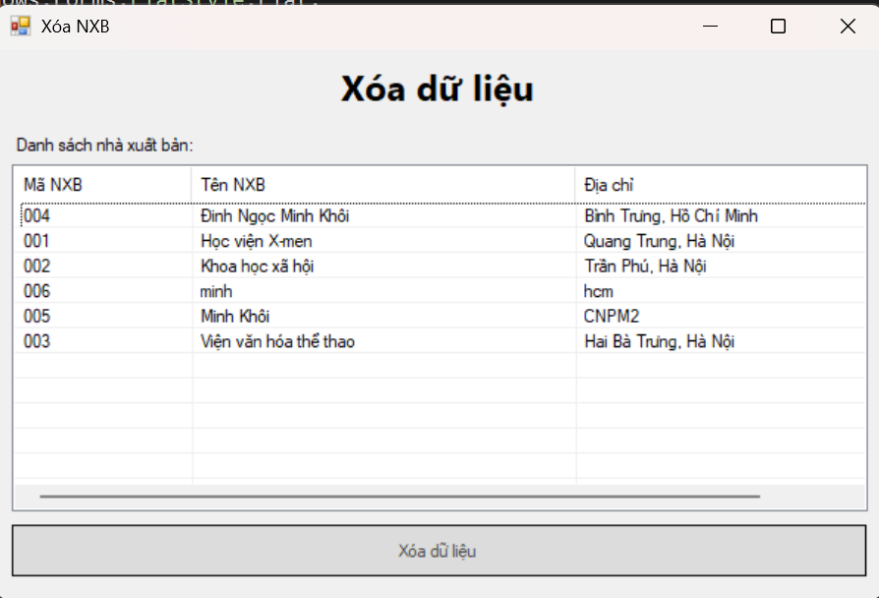
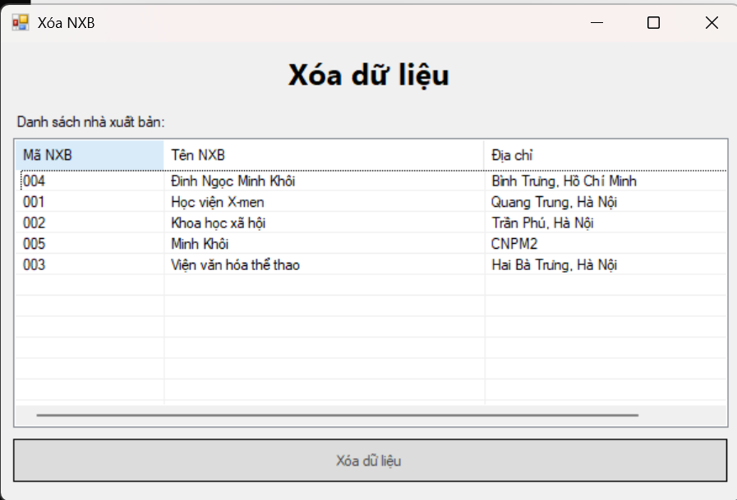
Code desgin:
//Thực hành 4
private System.ComponentModel.IContainer components = null;

private System.Windows.Forms.Label lblTitle;
private System.Windows.Forms.Label lblDanhSach;
private System.Windows.Forms.ListView lsvDanhSach;
private System.Windows.Forms.ColumnHeader colMa;
private System.Windows.Forms.ColumnHeader colTen;
private System.Windows.Forms.ColumnHeader colDiaChi;
private System.Windows.Forms.Button btnXoa;

protected override void Dispose(bool disposing)
{
if (disposing && (components != null)) components.Dispose();
base.Dispose(disposing);
}

#region Windows Form Designer generated code
private void InitializeComponent()
{
this.lblTitle = new System.Windows.Forms.Label();
this.lblDanhSach = new System.Windows.Forms.Label();
this.lsvDanhSach = new System.Windows.Forms.ListView();
this.colMa = ((System.Windows.Forms.ColumnHeader)(new System.Windows.Forms.ColumnHeader()));
this.colTen = ((System.Windows.Forms.ColumnHeader)(new System.Windows.Forms.ColumnHeader()));
this.colDiaChi = ((System.Windows.Forms.ColumnHeader)(new System.Windows.Forms.ColumnHeader()));
this.btnXoa = new System.Windows.Forms.Button();
this.SuspendLayout();
//
// lblTitle
//
this.lblTitle.Dock = System.Windows.Forms.DockStyle.Top;
this.lblTitle.Font = new System.Drawing.Font("Segoe UI", 18F, System.Drawing.FontStyle.Bold);
this.lblTitle.Location = new System.Drawing.Point(0, 0);
this.lblTitle.Name = "lblTitle";
this.lblTitle.Size = new System.Drawing.Size(700, 58);
this.lblTitle.TabIndex = 0;
this.lblTitle.Text = "Xóa dữ liệu";
this.lblTitle.TextAlign = System.Drawing.ContentAlignment.MiddleCenter;
//
// lblDanhSach
//
this.lblDanhSach.AutoSize = true;
this.lblDanhSach.Location = new System.Drawing.Point(12, 67);
this.lblDanhSach.Name = "lblDanhSach";
this.lblDanhSach.Size = new System.Drawing.Size(146, 15);
this.lblDanhSach.TabIndex = 1;
this.lblDanhSach.Text = "Danh sách nhà xuất bản:";
//
// lsvDanhSach
//
this.lsvDanhSach.Columns.AddRange(new System.Windows.Forms.ColumnHeader[] {
this.colMa,
this.colTen,
this.colDiaChi});
this.lsvDanhSach.FullRowSelect = true;
this.lsvDanhSach.GridLines = true;
this.lsvDanhSach.HideSelection = false;
this.lsvDanhSach.Location = new System.Drawing.Point(12, 90);
this.lsvDanhSach.MultiSelect = false;
this.lsvDanhSach.Name = "lsvDanhSach";
this.lsvDanhSach.Size = new System.Drawing.Size(676, 270);
this.lsvDanhSach.TabIndex = 2;
this.lsvDanhSach.UseCompatibleStateImageBehavior = false;
this.lsvDanhSach.View = System.Windows.Forms.View.Details;
//
// colMa
//
this.colMa.Text = "Mã NXB";
this.colMa.Width = 120;
//
// colTen
//
this.colTen.Text = "Tên NXB";
this.colTen.Width = 260;
//
// colDiaChi
//
this.colDiaChi.Text = "Địa chỉ";
this.colDiaChi.Width = 260;
//
// btnXoa
//
this.btnXoa.Anchor = ((System.Windows.Forms.AnchorStyles)(((System.Windows.Forms.AnchorStyles.Bottom | System.Windows.Forms.AnchorStyles.Left)
| System.Windows.Forms.AnchorStyles.Right)));
this.btnXoa.BackColor = System.Drawing.Color.Gainsboro;
this.btnXoa.Enabled = false;
this.btnXoa.FlatStyle = System.Windows.Forms.FlatStyle.Flat;
this.btnXoa.Location = new System.Drawing.Point(12, 372);
this.btnXoa.Name = "btnXoa";
this.btnXoa.Size = new System.Drawing.Size(676, 40);
this.btnXoa.TabIndex = 3;
this.btnXoa.Text = "Xóa dữ liệu";
this.btnXoa.UseVisualStyleBackColor = false;
//
// Form1
//
this.AutoScaleDimensions = new System.Drawing.SizeF(7F, 15F);
this.AutoScaleMode = System.Windows.Forms.AutoScaleMode.Font;
this.ClientSize = new System.Drawing.Size(700, 430);
this.Controls.Add(this.btnXoa);
this.Controls.Add(this.lsvDanhSach);
this.Controls.Add(this.lblDanhSach);
this.Controls.Add(this.lblTitle);
this.Name = "Form1";
this.StartPosition = System.Windows.Forms.FormStartPosition.CenterScreen;
this.Text = "Xóa NXB";
this.ResumeLayout(false);
this.PerformLayout();
}
#endregion
Code xử lí:
//Thực hành 4
// ===== Connection string theo yêu cầu =====
private readonly string strCon =
@"Data Source=(localdb)\MSSQLLocalDB;Initial Catalog=QuanLyBanSach;Integrated Security=True;TrustServerCertificate=True;Connect Timeout=30";

private SqlConnection sqlCon;

public Form1()
{
InitializeComponent();

this.Load += Form1_Load;
lsvDanhSach.SelectedIndexChanged += lsvDanhSach_SelectedIndexChanged;
btnXoa.Click += btnXoa_Click;
}

// ==== Kết nối ====
private void MoKetNoi()
{
if (sqlCon == null) sqlCon = new SqlConnection(strCon);
if (sqlCon.State == ConnectionState.Closed) sqlCon.Open();
}
private void DongKetNoi()
{
if (sqlCon != null && sqlCon.State == ConnectionState.Open)
sqlCon.Close();
}

// ==== Hiển thị danh sách NXB ====
private void HienThiDanhSachNXB()
{
try
{
MoKetNoi();
using (var cmd = new SqlCommand("HienThiNXB", sqlCon))
{
cmd.CommandType = CommandType.StoredProcedure;
using (var rd = cmd.ExecuteReader())
{
lsvDanhSach.BeginUpdate();
lsvDanhSach.Items.Clear();
while (rd.Read())
{
string ma = rd.GetString(0).Trim();
string ten = rd.GetString(1);
string dia = rd.IsDBNull(2) ? "" : rd.GetString(2);

var it = new ListViewItem(ma);
it.SubItems.Add(ten);
it.SubItems.Add(dia);
lsvDanhSach.Items.Add(it);
}
lsvDanhSach.EndUpdate();
}
}
}
catch (Exception ex)
{
MessageBox.Show("Lỗi tải danh sách: " + ex.Message);
}
finally { DongKetNoi(); }
}

// ==== Form Load ====
private void Form1_Load(object sender, EventArgs e)
{
HienThiDanhSachNXB();
btnXoa.Enabled = false; // chỉ bật khi chọn 1 dòng
}

// ==== Chọn dòng ====
private void lsvDanhSach_SelectedIndexChanged(object sender, EventArgs e)
{
btnXoa.Enabled = lsvDanhSach.SelectedItems.Count > 0;
}

// ==== Nút XÓA ====
private void btnXoa_Click(object sender, EventArgs e)
{
if (lsvDanhSach.SelectedItems.Count == 0) return;

var it = lsvDanhSach.SelectedItems[0];
string ma = it.SubItems[0].Text;
string ten = it.SubItems[1].Text;

var confirm = MessageBox.Show(
$"Bạn chắc chắn muốn xoá NXB '{ten}' (Mã: {ma})?",
"Xác nhận xoá",
MessageBoxButtons.YesNo, MessageBoxIcon.Warning);

if (confirm != DialogResult.Yes) return;

try
{
MoKetNoi();
using (var cmd = new SqlCommand("XoaNhaXuatBan", sqlCon))
{
cmd.CommandType = CommandType.StoredProcedure;
cmd.Parameters.Add(new SqlParameter("@NXB", SqlDbType.Char, 10) { Value = ma });

int kq = cmd.ExecuteNonQuery(); // có thể trả -1 nếu NOCOUNT
HienThiDanhSachNXB(); // luôn refresh
btnXoa.Enabled = false;

MessageBox.Show("Đã xử lý xoá (kết quả: " + kq + ").");
}
}
catch (SqlException ex) when (ex.Number == 547) // FK constraint
{
MessageBox.Show("Không thể xoá vì NXB đang được tham chiếu bởi bảng khác (ví dụ: Sách).");
}
catch (Exception ex)
{
MessageBox.Show("Lỗi xoá: " + ex.Message);
}
finally { DongKetNoi(); }
}

