Lab 7
Thực hành 1
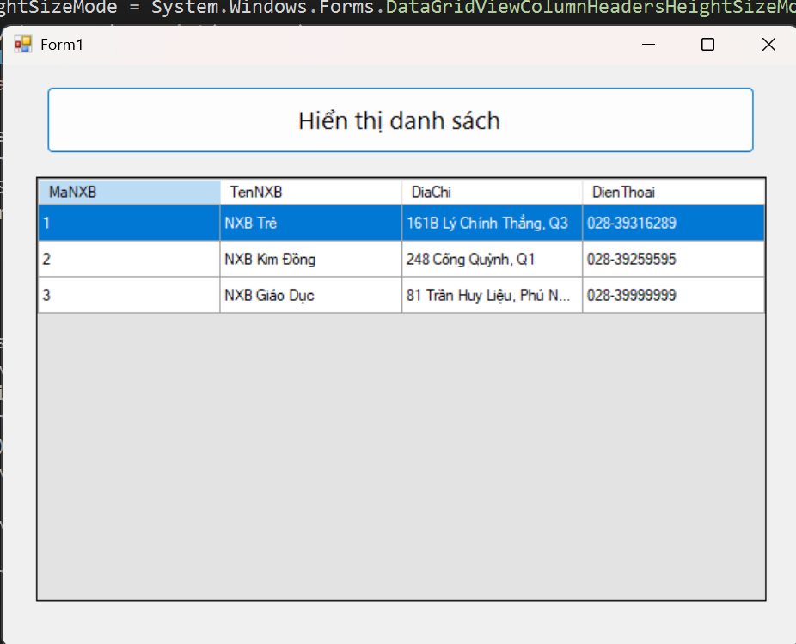
Code xử lí:
using System;
using System.Collections.Generic;
using System.ComponentModel;
using System.Data;
using System.Data.SqlClient;
using System.Drawing;
using System.Linq;
using System.Text;
using System.Threading.Tasks;
using System.Windows.Forms;

namespace th1
{
public partial class Form1 : Form
{
// ===== Chuỗi kết nối: CHỌN A hoặc B như mục (3) ở trên =====
private readonly string strCon = @"Data Source=(localdb)\MSSQLLocalDB;
Initial Catalog=QuanLyBanSach;
Integrated Security=True;TrustServerCertificate=True;Connect Timeout=30";

private SqlConnection sqlCon; // có thể để null, mở khi cần

public Form1()
{
InitializeComponent();

// Khuyến nghị một vài thuộc tính DataGridView
dgvDanhSach.AutoSizeColumnsMode = DataGridViewAutoSizeColumnsMode.Fill;
dgvDanhSach.ReadOnly = true;
dgvDanhSach.AllowUserToAddRows = false;

btnHienThi.Click += btnHienThi_Click;
}

private void MoKetNoi()
{
if (sqlCon == null)
sqlCon = new SqlConnection(strCon);

if (sqlCon.State == ConnectionState.Closed)
sqlCon.Open();
}

private void DongKetNoi()
{
if (sqlCon != null && sqlCon.State == ConnectionState.Open)
sqlCon.Close();
}

private void TaiDanhSach()
{
// DÙNG using để tự giải phóng adapter/command
string sql = "SELECT MaNXB, TenNXB, DiaChi, DienThoai FROM dbo.NhaXuatBan";

using (var cmd = new SqlCommand(sql, sqlCon))
using (var adapter = new SqlDataAdapter(cmd))
{
var ds = new DataSet();
adapter.Fill(ds, "NhaXuatBan");
dgvDanhSach.DataSource = ds.Tables["NhaXuatBan"];
}
}

private void btnHienThi_Click(object sender, EventArgs e)
{
try
{
MoKetNoi();
TaiDanhSach();
}
catch (Exception ex)
{
MessageBox.Show("Lỗi khi tải dữ liệu: " + ex.Message,
"Thông báo", MessageBoxButtons.OK, MessageBoxIcon.Error);
}
finally
{
DongKetNoi();
}
}
}
}

Code design:
namespace th1
{
partial class Form1
{
/// <summary>
/// Required designer variable.
/// </summary>
private System.ComponentModel.IContainer components = null;

/// <summary>
/// Clean up any resources being used.
/// </summary>
protected override void Dispose(bool disposing)
{
if (disposing && (components != null))
{
components.Dispose();
}
base.Dispose(disposing);
}

#region Windows Form Designer generated code

/// <summary>
/// Required method for Designer support - do not modify
/// the contents of this method with the code editor.
/// </summary>
private void InitializeComponent()
{
this.btnHienThi = new System.Windows.Forms.Button();
this.dgvDanhSach = new System.Windows.Forms.DataGridView();
((System.ComponentModel.ISupportInitialize)(this.dgvDanhSach)).BeginInit();
this.SuspendLayout();
//
// btnHienThi
//
this.btnHienThi.Anchor = ((System.Windows.Forms.AnchorStyles)(((System.Windows.Forms.AnchorStyles.Top | System.Windows.Forms.AnchorStyles.Left)
| System.Windows.Forms.AnchorStyles.Right)));
this.btnHienThi.Font = new System.Drawing.Font("Segoe UI", 14.25F, System.Drawing.FontStyle.Regular, System.Drawing.GraphicsUnit.Point);
this.btnHienThi.Location = new System.Drawing.Point(40, 20);
this.btnHienThi.Name = "btnHienThi";
this.btnHienThi.Size = new System.Drawing.Size(640, 60);
this.btnHienThi.TabIndex = 0;
this.btnHienThi.Text = "Hiển thị danh sách";
this.btnHienThi.UseVisualStyleBackColor = true;
this.btnHienThi.Click += new System.EventHandler(this.btnHienThi_Click);
//
// dgvDanhSach
//
this.dgvDanhSach.AllowUserToAddRows = false;
this.dgvDanhSach.AllowUserToDeleteRows = false;
this.dgvDanhSach.Anchor = ((System.Windows.Forms.AnchorStyles)((((System.Windows.Forms.AnchorStyles.Top | System.Windows.Forms.AnchorStyles.Bottom)
| System.Windows.Forms.AnchorStyles.Left)
| System.Windows.Forms.AnchorStyles.Right)));
this.dgvDanhSach.AutoSizeColumnsMode = System.Windows.Forms.DataGridViewAutoSizeColumnsMode.Fill;
this.dgvDanhSach.BackgroundColor = System.Drawing.SystemColors.ControlLight;
this.dgvDanhSach.ColumnHeadersHeightSizeMode = System.Windows.Forms.DataGridViewColumnHeadersHeightSizeMode.AutoSize;
this.dgvDanhSach.Location = new System.Drawing.Point(30, 100);
this.dgvDanhSach.MultiSelect = false;
this.dgvDanhSach.Name = "dgvDanhSach";
this.dgvDanhSach.ReadOnly = true;
this.dgvDanhSach.RowHeadersVisible = false;
this.dgvDanhSach.RowTemplate.Height = 28;
this.dgvDanhSach.SelectionMode = System.Windows.Forms.DataGridViewSelectionMode.FullRowSelect;
this.dgvDanhSach.Size = new System.Drawing.Size(660, 380);
this.dgvDanhSach.TabIndex = 1;
//
// Form1
//
this.AutoScaleDimensions = new System.Drawing.SizeF(7F, 15F);
this.AutoScaleMode = System.Windows.Forms.AutoScaleMode.Font;
this.ClientSize = new System.Drawing.Size(720, 520);
this.Controls.Add(this.dgvDanhSach);
this.Controls.Add(this.btnHienThi);
this.MinimumSize = new System.Drawing.Size(600, 400);
this.Name = "Form1";
this.StartPosition = System.Windows.Forms.FormStartPosition.CenterScreen;
this.Text = "Form1";
((System.ComponentModel.ISupportInitialize)(this.dgvDanhSach)).EndInit();
this.ResumeLayout(false);

}

#endregion

private System.Windows.Forms.Button btnHienThi;
private System.Windows.Forms.DataGridView dgvDanhSach;
}
}
Thực hành 2
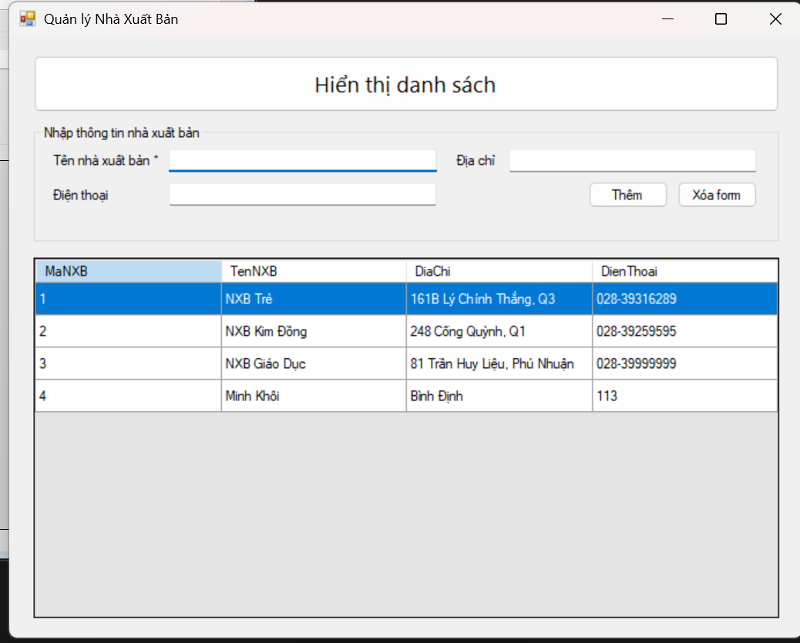
Code xử lí:
using System;
using System.Collections.Generic;
using System.ComponentModel;
using System.Data;
using System.Data.SqlClient;
using System.Drawing;
using System.Linq;
using System.Text;
using System.Threading.Tasks;
using System.Windows.Forms;

namespace th2
{
public partial class Form1 : Form
{
// Chuỗi kết nối – dùng Catalog cho dễ
private readonly string strCon = @"Data Source=(localdb)\MSSQLLocalDB;
Initial Catalog=QuanLyBanSach;
Integrated Security=True;TrustServerCertificate=True;Connect Timeout=30";

private SqlConnection sqlCon;

public Form1()
{
InitializeComponent();
dgvDanhSach.AutoSizeColumnsMode = DataGridViewAutoSizeColumnsMode.Fill;
dgvDanhSach.ReadOnly = true;
dgvDanhSach.AllowUserToAddRows = false;

// có sẵn sự kiện btnHienThi_Click từ bài 1
}

private void MoKetNoi()
{
if (sqlCon == null) sqlCon = new SqlConnection(strCon);
if (sqlCon.State == ConnectionState.Closed) sqlCon.Open();
}
private void DongKetNoi()
{
if (sqlCon != null && sqlCon.State == ConnectionState.Open) sqlCon.Close();
}

private void HienThiDuLieu()
{
MoKetNoi();
string sql = "SELECT MaNXB, TenNXB, DiaChi, DienThoai FROM dbo.NhaXuatBan";
using (var da = new SqlDataAdapter(sql, sqlCon))
{
var dt = new DataTable();
da.Fill(dt);
dgvDanhSach.DataSource = dt;
}
DongKetNoi();
}

private void btnHienThi_Click(object sender, EventArgs e)
{
try { HienThiDuLieu(); }
catch (Exception ex) { MessageBox.Show("Lỗi tải dữ liệu: " + ex.Message); }
}

private void btnThem_Click(object sender, EventArgs e)
{
// Kiểm tra dữ liệu nhập
if (string.IsNullOrWhiteSpace(txtTenXB.Text))
{
MessageBox.Show("Vui lòng nhập Tên nhà xuất bản");
txtTenXB.Focus();
return;
}

try
{
MoKetNoi();
string insertSql = @"INSERT INTO dbo.NhaXuatBan(TenNXB, DiaChi, DienThoai)
VALUES (@Ten, @DiaChi, @DienThoai)";

using (var cmd = new SqlCommand(insertSql, sqlCon))
{
cmd.Parameters.AddWithValue("@Ten", txtTenXB.Text.Trim());
cmd.Parameters.AddWithValue("@DiaChi", (object?)txtDiaChi.Text.Trim() ?? DBNull.Value);
cmd.Parameters.AddWithValue("@DienThoai", (object?)txtDienThoai.Text.Trim() ?? DBNull.Value);

int kq = cmd.ExecuteNonQuery();
if (kq > 0)
{
MessageBox.Show("Thêm dữ liệu thành công!");
HienThiDuLieu();
XoaForm();
}
else
{
MessageBox.Show("Thêm dữ liệu không thành công!");
}
}
}
catch (Exception ex)
{
MessageBox.Show("Lỗi khi thêm: " + ex.Message);
}
finally
{
DongKetNoi();
}
}

private void btnClear_Click(object sender, EventArgs e) => XoaForm();

private void XoaForm()
{
txtTenXB.Text = "";
txtDiaChi.Text = "";
txtDienThoai.Text = "";
txtTenXB.Focus();
}
}
}
Code design:
using System.Windows.Forms;

namespace th2
{
partial class Form1
{
private System.ComponentModel.IContainer components = null;

// Controls
private Button btnHienThi;
private DataGridView dgvDanhSach;
private Label lblTen;
private Label lblDiaChi;
private Label lblDienThoai;
private TextBox txtTenXB;
private TextBox txtDiaChi;
private TextBox txtDienThoai;
private Button btnThem;
private Button btnClear;
private GroupBox grpNhap;

protected override void Dispose(bool disposing)
{
if (disposing && (components != null))
components.Dispose();
base.Dispose(disposing);
}

#region Windows Form Designer generated code

private void InitializeComponent()
{
this.btnHienThi = new System.Windows.Forms.Button();
this.dgvDanhSach = new System.Windows.Forms.DataGridView();
this.grpNhap = new System.Windows.Forms.GroupBox();
this.lblTen = new System.Windows.Forms.Label();
this.txtTenXB = new System.Windows.Forms.TextBox();
this.lblDiaChi = new System.Windows.Forms.Label();
this.txtDiaChi = new System.Windows.Forms.TextBox();
this.lblDienThoai = new System.Windows.Forms.Label();
this.txtDienThoai = new System.Windows.Forms.TextBox();
this.btnThem = new System.Windows.Forms.Button();
this.btnClear = new System.Windows.Forms.Button();
((System.ComponentModel.ISupportInitialize)(this.dgvDanhSach)).BeginInit();
this.grpNhap.SuspendLayout();
this.SuspendLayout();
//
// btnHienThi
//
this.btnHienThi.Anchor = ((System.Windows.Forms.AnchorStyles)(((System.Windows.Forms.AnchorStyles.Top | System.Windows.Forms.AnchorStyles.Left)
| System.Windows.Forms.AnchorStyles.Right)));
this.btnHienThi.Font = new System.Drawing.Font("Segoe UI", 14.25F, System.Drawing.FontStyle.Regular, System.Drawing.GraphicsUnit.Point);
this.btnHienThi.Location = new System.Drawing.Point(24, 18);
this.btnHienThi.Name = "btnHienThi";
this.btnHienThi.Size = new System.Drawing.Size(752, 56);
this.btnHienThi.TabIndex = 0;
this.btnHienThi.Text = "Hiển thị danh sách";
this.btnHienThi.UseVisualStyleBackColor = true;
this.btnHienThi.Click += new System.EventHandler(this.btnHienThi_Click);
//
// grpNhap
//
this.grpNhap.Anchor = ((System.Windows.Forms.AnchorStyles)(((System.Windows.Forms.AnchorStyles.Top | System.Windows.Forms.AnchorStyles.Left)
| System.Windows.Forms.AnchorStyles.Right)));
this.grpNhap.Controls.Add(this.lblTen);
this.grpNhap.Controls.Add(this.txtTenXB);
this.grpNhap.Controls.Add(this.lblDiaChi);
this.grpNhap.Controls.Add(this.txtDiaChi);
this.grpNhap.Controls.Add(this.lblDienThoai);
this.grpNhap.Controls.Add(this.txtDienThoai);
this.grpNhap.Controls.Add(this.btnThem);
this.grpNhap.Controls.Add(this.btnClear);
this.grpNhap.Location = new System.Drawing.Point(24, 88);
this.grpNhap.Name = "grpNhap";
this.grpNhap.Size = new System.Drawing.Size(752, 118);
this.grpNhap.TabIndex = 1;
this.grpNhap.TabStop = false;
this.grpNhap.Text = "Nhập thông tin nhà xuất bản";
//
// lblTen
//
this.lblTen.AutoSize = true;
this.lblTen.Location = new System.Drawing.Point(16, 28);
this.lblTen.Name = "lblTen";
this.lblTen.Size = new System.Drawing.Size(109, 15);
this.lblTen.TabIndex = 0;
this.lblTen.Text = "Tên nhà xuất bản *";
//
// txtTenXB
//
this.txtTenXB.Location = new System.Drawing.Point(136, 24);
this.txtTenXB.Name = "txtTenXB";
this.txtTenXB.Size = new System.Drawing.Size(270, 23);
this.txtTenXB.TabIndex = 1;
//
// lblDiaChi
//
this.lblDiaChi.AutoSize = true;
this.lblDiaChi.Location = new System.Drawing.Point(424, 28);
this.lblDiaChi.Name = "lblDiaChi";
this.lblDiaChi.Size = new System.Drawing.Size(47, 15);
this.lblDiaChi.TabIndex = 2;
this.lblDiaChi.Text = "Địa chỉ";
//
// txtDiaChi
//
this.txtDiaChi.Location = new System.Drawing.Point(480, 24);
this.txtDiaChi.Name = "txtDiaChi";
this.txtDiaChi.Size = new System.Drawing.Size(250, 23);
this.txtDiaChi.TabIndex = 3;
//
// lblDienThoai
//
this.lblDienThoai.AutoSize = true;
this.lblDienThoai.Location = new System.Drawing.Point(16, 62);
this.lblDienThoai.Name = "lblDienThoai";
this.lblDienThoai.Size = new System.Drawing.Size(69, 15);
this.lblDienThoai.TabIndex = 4;
this.lblDienThoai.Text = "Điện thoại";
//
// txtDienThoai
//
this.txtDienThoai.Location = new System.Drawing.Point(136, 58);
this.txtDienThoai.Name = "txtDienThoai";
this.txtDienThoai.Size = new System.Drawing.Size(270, 23);
this.txtDienThoai.TabIndex = 5;
//
// btnThem
//
this.btnThem.Anchor = ((System.Windows.Forms.AnchorStyles)((System.Windows.Forms.AnchorStyles.Top | System.Windows.Forms.AnchorStyles.Right)));
this.btnThem.Location = new System.Drawing.Point(560, 56);
this.btnThem.Name = "btnThem";
this.btnThem.Size = new System.Drawing.Size(80, 27);
this.btnThem.TabIndex = 6;
this.btnThem.Text = "Thêm";
this.btnThem.UseVisualStyleBackColor = true;
this.btnThem.Click += new System.EventHandler(this.btnThem_Click);
//
// btnClear
//
this.btnClear.Anchor = ((System.Windows.Forms.AnchorStyles)((System.Windows.Forms.AnchorStyles.Top | System.Windows.Forms.AnchorStyles.Right)));
this.btnClear.Location = new System.Drawing.Point(650, 56);
this.btnClear.Name = "btnClear";
this.btnClear.Size = new System.Drawing.Size(80, 27);
this.btnClear.TabIndex = 7;
this.btnClear.Text = "Xóa form";
this.btnClear.UseVisualStyleBackColor = true;
this.btnClear.Click += new System.EventHandler(this.btnClear_Click);
//
// dgvDanhSach
//
this.dgvDanhSach.AllowUserToAddRows = false;
this.dgvDanhSach.AllowUserToDeleteRows = false;
this.dgvDanhSach.Anchor = ((System.Windows.Forms.AnchorStyles)((((System.Windows.Forms.AnchorStyles.Top | System.Windows.Forms.AnchorStyles.Bottom)
| System.Windows.Forms.AnchorStyles.Left)
| System.Windows.Forms.AnchorStyles.Right)));
this.dgvDanhSach.AutoSizeColumnsMode = System.Windows.Forms.DataGridViewAutoSizeColumnsMode.Fill;
this.dgvDanhSach.BackgroundColor = System.Drawing.SystemColors.ControlLight;
this.dgvDanhSach.ColumnHeadersHeightSizeMode = System.Windows.Forms.DataGridViewColumnHeadersHeightSizeMode.AutoSize;
this.dgvDanhSach.Location = new System.Drawing.Point(24, 220);
this.dgvDanhSach.MultiSelect = false;
this.dgvDanhSach.Name = "dgvDanhSach";
this.dgvDanhSach.ReadOnly = true;
this.dgvDanhSach.RowHeadersVisible = false;
this.dgvDanhSach.RowTemplate.Height = 28;
this.dgvDanhSach.SelectionMode = System.Windows.Forms.DataGridViewSelectionMode.FullRowSelect;
this.dgvDanhSach.Size = new System.Drawing.Size(752, 360);
this.dgvDanhSach.TabIndex = 2;
//
// Form1
//
this.AutoScaleDimensions = new System.Drawing.SizeF(7F, 15F);
this.AutoScaleMode = System.Windows.Forms.AutoScaleMode.Font;
this.ClientSize = new System.Drawing.Size(800, 600);
this.Controls.Add(this.dgvDanhSach);
this.Controls.Add(this.grpNhap);
this.Controls.Add(this.btnHienThi);
this.MinimumSize = new System.Drawing.Size(720, 480);
this.Name = "Form1";
this.StartPosition = System.Windows.Forms.FormStartPosition.CenterScreen;
this.Text = "Quản lý Nhà Xuất Bản";
((System.ComponentModel.ISupportInitialize)(this.dgvDanhSach)).EndInit();
this.grpNhap.ResumeLayout(false);
this.grpNhap.PerformLayout();
this.ResumeLayout(false);
}

#endregion
}
}

Thực hành 3

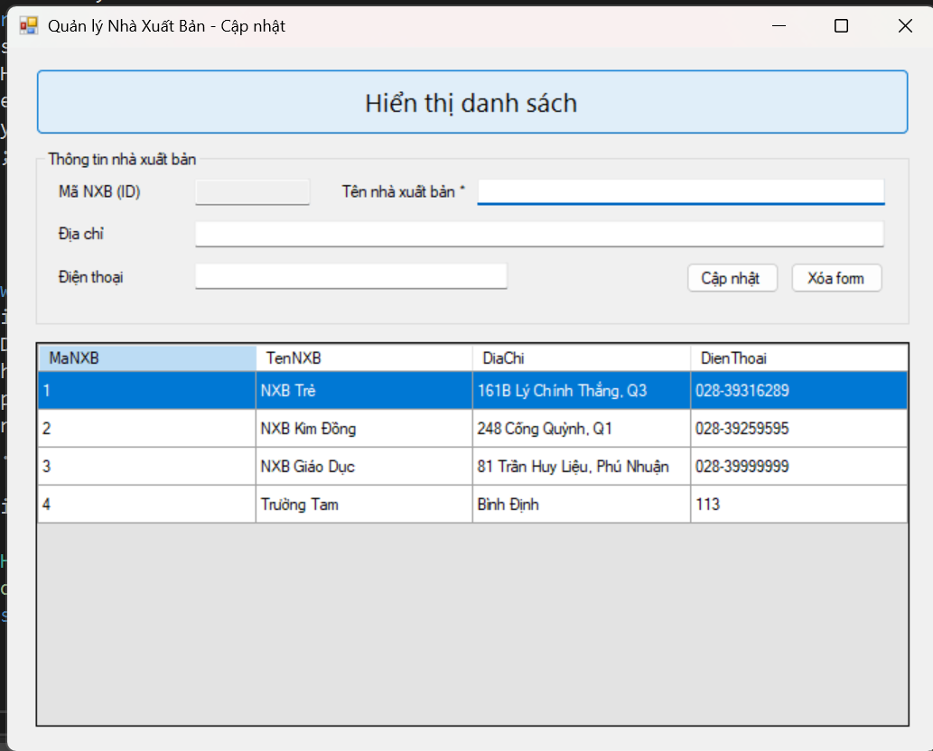
Code xử lí:
using System;
using System.Collections.Generic;
using System.ComponentModel;
using System.Data;
using System.Data.SqlClient;
using System.Drawing;
using System.Linq;
using System.Text;
using System.Threading.Tasks;
using System.Windows.Forms;

namespace th3
{
public partial class Form1 : Form
{
private readonly string strCon = @"Data Source=(localdb)\MSSQLLocalDB;
Initial Catalog=QuanLyBanSach;
Integrated Security=True;TrustServerCertificate=True;Connect Timeout=30";

private SqlConnection sqlCon;

public Form1()
{
InitializeComponent();

dgvDanhSach.AutoSizeColumnsMode = DataGridViewAutoSizeColumnsMode.Fill;
dgvDanhSach.ReadOnly = true;
dgvDanhSach.AllowUserToAddRows = false;
}

private void Form1_Load(object sender, EventArgs e)
{
try { HienThiDuLieu(); }
catch (Exception ex) { MessageBox.Show("Lỗi tải dữ liệu: " + ex.Message); }
}

private void MoKetNoi()
{
if (sqlCon == null) sqlCon = new SqlConnection(strCon);
if (sqlCon.State == ConnectionState.Closed) sqlCon.Open();
}
private void DongKetNoi()
{
if (sqlCon != null && sqlCon.State == ConnectionState.Open) sqlCon.Close();
}

private void HienThiDuLieu()
{
MoKetNoi();
using (var da = new SqlDataAdapter(
"SELECT MaNXB, TenNXB, DiaChi, DienThoai FROM dbo.NhaXuatBan", sqlCon))
{
var dt = new DataTable();
da.Fill(dt);
dgvDanhSach.DataSource = dt;
}
DongKetNoi();
}

private void btnHienThi_Click(object sender, EventArgs e) => HienThiDuLieu();

private void dgvDanhSach_CellClick(object sender, DataGridViewCellEventArgs e)
{
if (e.RowIndex < 0) return; // click tiêu đề cột
var row = dgvDanhSach.Rows[e.RowIndex];
txtMaXB.Text = Convert.ToString(row.Cells["MaNXB"].Value);
txtTenXB.Text = Convert.ToString(row.Cells["TenNXB"].Value);
txtDiaChi.Text = Convert.ToString(row.Cells["DiaChi"].Value);
txtDienThoai.Text = Convert.ToString(row.Cells["DienThoai"].Value);
}

private void btnCapNhat_Click(object sender, EventArgs e)
{
if (string.IsNullOrWhiteSpace(txtMaXB.Text))
{
MessageBox.Show("Hãy chọn 1 dòng trong bảng trước khi cập nhật!");
return;
}
if (string.IsNullOrWhiteSpace(txtTenXB.Text))
{
MessageBox.Show("Tên nhà xuất bản không được để trống!");
txtTenXB.Focus();
return;
}

try
{
MoKetNoi();

string sql = @"UPDATE dbo.NhaXuatBan
SET TenNXB = @Ten, DiaChi = @DiaChi, DienThoai = @DienThoai
WHERE MaNXB = @Ma";

using (var cmd = new SqlCommand(sql, sqlCon))
{
cmd.Parameters.Add("@Ma", SqlDbType.Int).Value = int.Parse(txtMaXB.Text.Trim());
var pTen = cmd.Parameters.Add("@Ten", SqlDbType.NVarChar, 200);
pTen.Value = txtTenXB.Text.Trim();

var pDiaChi = cmd.Parameters.Add("@DiaChi", SqlDbType.NVarChar, 300);
pDiaChi.Value = string.IsNullOrWhiteSpace(txtDiaChi.Text) ? (object)DBNull.Value : txtDiaChi.Text.Trim();

var pDT = cmd.Parameters.Add("@DienThoai", SqlDbType.NVarChar, 50);
pDT.Value = string.IsNullOrWhiteSpace(txtDienThoai.Text) ? (object)DBNull.Value : txtDienThoai.Text.Trim();

int kq = cmd.ExecuteNonQuery();
if (kq > 0)
{
MessageBox.Show("Cập nhật thành công!");
HienThiDuLieu();
XoaForm();
}
else
{
MessageBox.Show("Không có bản ghi nào được cập nhật!");
}
}
}
catch (Exception ex)
{
MessageBox.Show("Lỗi cập nhật: " + ex.Message);
}
finally
{
DongKetNoi();
}
}

private void btnClear_Click(object sender, EventArgs e) => XoaForm();

private void XoaForm()
{
txtMaXB.Text = "";
txtTenXB.Text = "";
txtDiaChi.Text = "";
txtDienThoai.Text = "";
txtTenXB.Focus();
}
}
}
Code design:
using System.Windows.Forms;

namespace th3
{
partial class Form1
{
private System.ComponentModel.IContainer components = null;

private Button btnHienThi;
private DataGridView dgvDanhSach;
private GroupBox grpNhap;
private Label lblMa;
private Label lblTen;
private Label lblDiaChi;
private Label lblDienThoai;
private TextBox txtMaXB;
private TextBox txtTenXB;
private TextBox txtDiaChi;
private TextBox txtDienThoai;
private Button btnCapNhat;
private Button btnClear;

protected override void Dispose(bool disposing)
{
if (disposing && (components != null)) components.Dispose();
base.Dispose(disposing);
}

#region Windows Form Designer generated code
private void InitializeComponent()
{
this.btnHienThi = new System.Windows.Forms.Button();
this.dgvDanhSach = new System.Windows.Forms.DataGridView();
this.grpNhap = new System.Windows.Forms.GroupBox();
this.lblMa = new System.Windows.Forms.Label();
this.txtMaXB = new System.Windows.Forms.TextBox();
this.lblTen = new System.Windows.Forms.Label();
this.txtTenXB = new System.Windows.Forms.TextBox();
this.lblDiaChi = new System.Windows.Forms.Label();
this.txtDiaChi = new System.Windows.Forms.TextBox();
this.lblDienThoai = new System.Windows.Forms.Label();
this.txtDienThoai = new System.Windows.Forms.TextBox();
this.btnCapNhat = new System.Windows.Forms.Button();
this.btnClear = new System.Windows.Forms.Button();
((System.ComponentModel.ISupportInitialize)(this.dgvDanhSach)).BeginInit();
this.grpNhap.SuspendLayout();
this.SuspendLayout();
//
// btnHienThi
//
this.btnHienThi.Anchor = ((AnchorStyles)(((AnchorStyles.Top | AnchorStyles.Left) | AnchorStyles.Right)));
this.btnHienThi.Font = new System.Drawing.Font("Segoe UI", 14.25F, System.Drawing.FontStyle.Regular, System.Drawing.GraphicsUnit.Point);
this.btnHienThi.Location = new System.Drawing.Point(24, 18);
this.btnHienThi.Name = "btnHienThi";
this.btnHienThi.Size = new System.Drawing.Size(752, 56);
this.btnHienThi.TabIndex = 0;
this.btnHienThi.Text = "Hiển thị danh sách";
this.btnHienThi.UseVisualStyleBackColor = true;
this.btnHienThi.Click += new System.EventHandler(this.btnHienThi_Click);
//
// grpNhap
//
this.grpNhap.Anchor = ((AnchorStyles)(((AnchorStyles.Top | AnchorStyles.Left) | AnchorStyles.Right)));
this.grpNhap.Controls.Add(this.lblMa);
this.grpNhap.Controls.Add(this.txtMaXB);
this.grpNhap.Controls.Add(this.lblTen);
this.grpNhap.Controls.Add(this.txtTenXB);
this.grpNhap.Controls.Add(this.lblDiaChi);
this.grpNhap.Controls.Add(this.txtDiaChi);
this.grpNhap.Controls.Add(this.lblDienThoai);
this.grpNhap.Controls.Add(this.txtDienThoai);
this.grpNhap.Controls.Add(this.btnCapNhat);
this.grpNhap.Controls.Add(this.btnClear);
this.grpNhap.Location = new System.Drawing.Point(24, 88);
this.grpNhap.Name = "grpNhap";
this.grpNhap.Size = new System.Drawing.Size(752, 150);
this.grpNhap.TabIndex = 1;
this.grpNhap.TabStop = false;
this.grpNhap.Text = "Thông tin nhà xuất bản";
//
// lblMa
//
this.lblMa.AutoSize = true;
this.lblMa.Location = new System.Drawing.Point(16, 28);
this.lblMa.Name = "lblMa";
this.lblMa.Size = new System.Drawing.Size(79, 15);
this.lblMa.TabIndex = 0;
this.lblMa.Text = "Mã NXB (ID)";
//
// txtMaXB
//
this.txtMaXB.Location = new System.Drawing.Point(136, 24);
this.txtMaXB.Name = "txtMaXB";
this.txtMaXB.ReadOnly = true; // IDENTITY -> không cho sửa
this.txtMaXB.Size = new System.Drawing.Size(100, 23);
this.txtMaXB.TabIndex = 1;
//
// lblTen
//
this.lblTen.AutoSize = true;
this.lblTen.Location = new System.Drawing.Point(260, 28);
this.lblTen.Name = "lblTen";
this.lblTen.Size = new System.Drawing.Size(109, 15);
this.lblTen.TabIndex = 2;
this.lblTen.Text = "Tên nhà xuất bản *";
//
// txtTenXB
//
this.txtTenXB.Location = new System.Drawing.Point(380, 24);
this.txtTenXB.Name = "txtTenXB";
this.txtTenXB.Size = new System.Drawing.Size(350, 23);
this.txtTenXB.TabIndex = 3;
//
// lblDiaChi
//
this.lblDiaChi.AutoSize = true;
this.lblDiaChi.Location = new System.Drawing.Point(16, 64);
this.lblDiaChi.Name = "lblDiaChi";
this.lblDiaChi.Size = new System.Drawing.Size(47, 15);
this.lblDiaChi.TabIndex = 4;
this.lblDiaChi.Text = "Địa chỉ";
//
// txtDiaChi
//
this.txtDiaChi.Location = new System.Drawing.Point(136, 60);
this.txtDiaChi.Name = "txtDiaChi";
this.txtDiaChi.Size = new System.Drawing.Size(594, 23);
this.txtDiaChi.TabIndex = 5;
//
// lblDienThoai
//
this.lblDienThoai.AutoSize = true;
this.lblDienThoai.Location = new System.Drawing.Point(16, 100);
this.lblDienThoai.Name = "lblDienThoai";
this.lblDienThoai.Size = new System.Drawing.Size(69, 15);
this.lblDienThoai.TabIndex = 6;
this.lblDienThoai.Text = "Điện thoại";
//
// txtDienThoai
//
this.txtDienThoai.Location = new System.Drawing.Point(136, 96);
this.txtDienThoai.Name = "txtDienThoai";
this.txtDienThoai.Size = new System.Drawing.Size(270, 23);
this.txtDienThoai.TabIndex = 7;
//
// btnCapNhat
//
this.btnCapNhat.Anchor = ((AnchorStyles)((AnchorStyles.Top | AnchorStyles.Right)));
this.btnCapNhat.Location = new System.Drawing.Point(560, 96);
this.btnCapNhat.Name = "btnCapNhat";
this.btnCapNhat.Size = new System.Drawing.Size(80, 27);
this.btnCapNhat.TabIndex = 8;
this.btnCapNhat.Text = "Cập nhật";
this.btnCapNhat.UseVisualStyleBackColor = true;
this.btnCapNhat.Click += new System.EventHandler(this.btnCapNhat_Click);
//
// btnClear
//
this.btnClear.Anchor = ((AnchorStyles)((AnchorStyles.Top | AnchorStyles.Right)));
this.btnClear.Location = new System.Drawing.Point(650, 96);
this.btnClear.Name = "btnClear";
this.btnClear.Size = new System.Drawing.Size(80, 27);
this.btnClear.TabIndex = 9;
this.btnClear.Text = "Xóa form";
this.btnClear.UseVisualStyleBackColor = true;
this.btnClear.Click += new System.EventHandler(this.btnClear_Click);
//
// dgvDanhSach
//
this.dgvDanhSach.AllowUserToAddRows = false;
this.dgvDanhSach.AllowUserToDeleteRows = false;
this.dgvDanhSach.Anchor = ((AnchorStyles)((((AnchorStyles.Top | AnchorStyles.Bottom) | AnchorStyles.Left) | AnchorStyles.Right)));
this.dgvDanhSach.AutoSizeColumnsMode = System.Windows.Forms.DataGridViewAutoSizeColumnsMode.Fill;
this.dgvDanhSach.BackgroundColor = System.Drawing.SystemColors.ControlLight;
this.dgvDanhSach.ColumnHeadersHeightSizeMode = System.Windows.Forms.DataGridViewColumnHeadersHeightSizeMode.AutoSize;
this.dgvDanhSach.Location = new System.Drawing.Point(24, 252);
this.dgvDanhSach.MultiSelect = false;
this.dgvDanhSach.Name = "dgvDanhSach";
this.dgvDanhSach.ReadOnly = true;
this.dgvDanhSach.RowHeadersVisible = false;
this.dgvDanhSach.RowTemplate.Height = 28;
this.dgvDanhSach.SelectionMode = System.Windows.Forms.DataGridViewSelectionMode.FullRowSelect;
this.dgvDanhSach.Size = new System.Drawing.Size(752, 328);
this.dgvDanhSach.TabIndex = 2;
this.dgvDanhSach.CellClick += new System.Windows.Forms.DataGridViewCellEventHandler(this.dgvDanhSach_CellClick);
//
// Form1
//
this.AutoScaleDimensions = new System.Drawing.SizeF(7F, 15F);
this.AutoScaleMode = System.Windows.Forms.AutoScaleMode.Font;
this.ClientSize = new System.Drawing.Size(800, 600);
this.Controls.Add(this.dgvDanhSach);
this.Controls.Add(this.grpNhap);
this.Controls.Add(this.btnHienThi);
this.MinimumSize = new System.Drawing.Size(720, 480);
this.Name = "Form1";
this.StartPosition = System.Windows.Forms.FormStartPosition.CenterScreen;
this.Text = "Quản lý Nhà Xuất Bản - Cập nhật";
this.Load += new System.EventHandler(this.Form1_Load);
((System.ComponentModel.ISupportInitialize)(this.dgvDanhSach)).EndInit();
this.grpNhap.ResumeLayout(false);
this.grpNhap.PerformLayout();
this.ResumeLayout(false);
}
#endregion
}
}

Thực hành 4
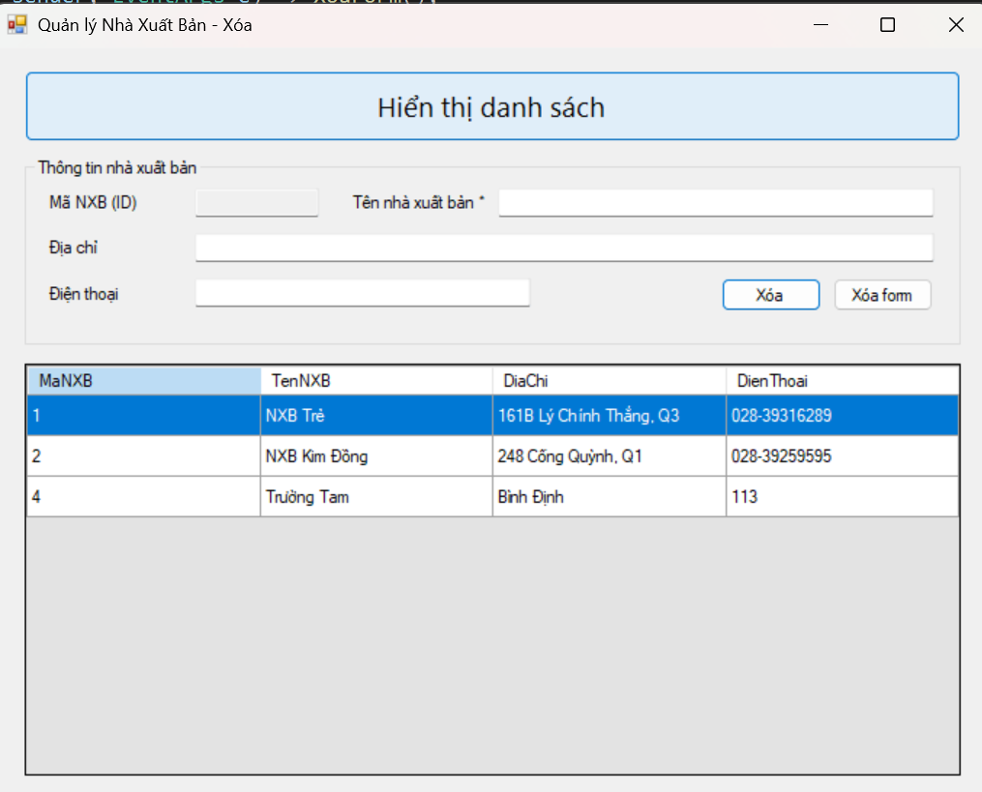
Code xử lí:
using System;
using System.Collections.Generic;
using System.ComponentModel;
using System.Data;
using System.Data.SqlClient;
using System.Drawing;
using System.Linq;
using System.Text;
using System.Threading.Tasks;
using System.Windows.Forms;

namespace th4
{
public partial class Form1 : Form
{
private readonly string strCon = @"Data Source=(localdb)\MSSQLLocalDB;
Initial Catalog=QuanLyBanSach;
Integrated Security=True;TrustServerCertificate=True;Connect Timeout=30";
private SqlConnection sqlCon;

public Form1()
{
InitializeComponent();
dgvDanhSach.AutoSizeColumnsMode = DataGridViewAutoSizeColumnsMode.Fill;
dgvDanhSach.ReadOnly = true;
dgvDanhSach.AllowUserToAddRows = false;
}

private void Form1_Load(object sender, EventArgs e)
{
try { HienThiDuLieu(); }
catch (Exception ex) { MessageBox.Show("Lỗi tải dữ liệu: " + ex.Message); }
}

private void MoKetNoi()
{
if (sqlCon == null) sqlCon = new SqlConnection(strCon);
if (sqlCon.State == ConnectionState.Closed) sqlCon.Open();
}
private void DongKetNoi()
{
if (sqlCon != null && sqlCon.State == ConnectionState.Open) sqlCon.Close();
}

private void HienThiDuLieu()
{
MoKetNoi();
using (var da = new SqlDataAdapter(
"SELECT MaNXB, TenNXB, DiaChi, DienThoai FROM dbo.NhaXuatBan", sqlCon))
{
var dt = new DataTable();
da.Fill(dt);
dgvDanhSach.DataSource = dt;
}
DongKetNoi();
}

private void btnHienThi_Click(object sender, EventArgs e) => HienThiDuLieu();

private void dgvDanhSach_CellClick(object sender, DataGridViewCellEventArgs e)
{
if (e.RowIndex < 0) return; // header
var row = dgvDanhSach.Rows[e.RowIndex];
txtMaXB.Text = Convert.ToString(row.Cells["MaNXB"].Value);
txtTenXB.Text = Convert.ToString(row.Cells["TenNXB"].Value);
txtDiaChi.Text = Convert.ToString(row.Cells["DiaChi"].Value);
txtDienThoai.Text = Convert.ToString(row.Cells["DienThoai"].Value);
}

private void btnXoa_Click(object sender, EventArgs e)
{
if (string.IsNullOrWhiteSpace(txtMaXB.Text))
{
MessageBox.Show("Bạn chưa chọn dòng nào để xóa!");
return;
}

// Hỏi xác nhận
var confirm = MessageBox.Show(
"Bạn có chắc chắn muốn xóa bản ghi này?",
"Cảnh báo", MessageBoxButtons.YesNo, MessageBoxIcon.Warning);

if (confirm != DialogResult.Yes) return;

try
{
MoKetNoi();

string sql = "DELETE FROM dbo.NhaXuatBan WHERE MaNXB = @Ma";
using (var cmd = new SqlCommand(sql, sqlCon))
{
cmd.Parameters.Add("@Ma", SqlDbType.Int).Value = int.Parse(txtMaXB.Text.Trim());
int kq = cmd.ExecuteNonQuery();

if (kq > 0)
{
MessageBox.Show("Xóa dữ liệu thành công!");
HienThiDuLieu();
XoaForm();
}
else
{
MessageBox.Show("Không có bản ghi nào bị xóa!");
}
}
}
catch (SqlException ex)
{
// Nếu có khóa ngoại ở bảng Sách tham chiếu NXB thì ở đây sẽ ném lỗi
MessageBox.Show("Không thể xóa do ràng buộc dữ liệu: " + ex.Message);
}
catch (Exception ex)
{
MessageBox.Show("Lỗi xóa: " + ex.Message);
}
finally
{
DongKetNoi();
}
}

private void btnClear_Click(object sender, EventArgs e) => XoaForm();

private void XoaForm()
{
txtMaXB.Text = "";
txtTenXB.Text = "";
txtDiaChi.Text = "";
txtDienThoai.Text = "";
}
}
}
Code design:
using System.Windows.Forms;

namespace th4
{
partial class Form1
{
private System.ComponentModel.IContainer components = null;

private Button btnHienThi;
private DataGridView dgvDanhSach;
private GroupBox grpNhap;
private Label lblMa;
private Label lblTen;
private Label lblDiaChi;
private Label lblDienThoai;
private TextBox txtMaXB;
private TextBox txtTenXB;
private TextBox txtDiaChi;
private TextBox txtDienThoai;
private Button btnXoa;
private Button btnClear;

protected override void Dispose(bool disposing)
{
if (disposing && (components != null)) components.Dispose();
base.Dispose(disposing);
}

#region Windows Form Designer generated code
private void InitializeComponent()
{
this.btnHienThi = new System.Windows.Forms.Button();
this.dgvDanhSach = new System.Windows.Forms.DataGridView();
this.grpNhap = new System.Windows.Forms.GroupBox();
this.lblMa = new System.Windows.Forms.Label();
this.txtMaXB = new System.Windows.Forms.TextBox();
this.lblTen = new System.Windows.Forms.Label();
this.txtTenXB = new System.Windows.Forms.TextBox();
this.lblDiaChi = new System.Windows.Forms.Label();
this.txtDiaChi = new System.Windows.Forms.TextBox();
this.lblDienThoai = new System.Windows.Forms.Label();
this.txtDienThoai = new System.Windows.Forms.TextBox();
this.btnXoa = new System.Windows.Forms.Button();
this.btnClear = new System.Windows.Forms.Button();
((System.ComponentModel.ISupportInitialize)(this.dgvDanhSach)).BeginInit();
this.grpNhap.SuspendLayout();
this.SuspendLayout();
//
// btnHienThi
//
this.btnHienThi.Anchor = ((AnchorStyles)(((AnchorStyles.Top | AnchorStyles.Left) | AnchorStyles.Right)));
this.btnHienThi.Font = new System.Drawing.Font("Segoe UI", 14.25F);
this.btnHienThi.Location = new System.Drawing.Point(24, 18);
this.btnHienThi.Name = "btnHienThi";
this.btnHienThi.Size = new System.Drawing.Size(752, 56);
this.btnHienThi.TabIndex = 0;
this.btnHienThi.Text = "Hiển thị danh sách";
this.btnHienThi.UseVisualStyleBackColor = true;
this.btnHienThi.Click += new System.EventHandler(this.btnHienThi_Click);
//
// grpNhap
//
this.grpNhap.Anchor = ((AnchorStyles)(((AnchorStyles.Top | AnchorStyles.Left) | AnchorStyles.Right)));
this.grpNhap.Controls.Add(this.lblMa);
this.grpNhap.Controls.Add(this.txtMaXB);
this.grpNhap.Controls.Add(this.lblTen);
this.grpNhap.Controls.Add(this.txtTenXB);
this.grpNhap.Controls.Add(this.lblDiaChi);
this.grpNhap.Controls.Add(this.txtDiaChi);
this.grpNhap.Controls.Add(this.lblDienThoai);
this.grpNhap.Controls.Add(this.txtDienThoai);
this.grpNhap.Controls.Add(this.btnXoa);
this.grpNhap.Controls.Add(this.btnClear);
this.grpNhap.Location = new System.Drawing.Point(24, 88);
this.grpNhap.Name = "grpNhap";
this.grpNhap.Size = new System.Drawing.Size(752, 150);
this.grpNhap.TabIndex = 1;
this.grpNhap.TabStop = false;
this.grpNhap.Text = "Thông tin nhà xuất bản";
//
// lblMa
//
this.lblMa.AutoSize = true;
this.lblMa.Location = new System.Drawing.Point(16, 28);
this.lblMa.Name = "lblMa";
this.lblMa.Size = new System.Drawing.Size(79, 15);
this.lblMa.TabIndex = 0;
this.lblMa.Text = "Mã NXB (ID)";
//
// txtMaXB
//
this.txtMaXB.Location = new System.Drawing.Point(136, 24);
this.txtMaXB.Name = "txtMaXB";
this.txtMaXB.ReadOnly = true; // IDENTITY -> không cho sửa
this.txtMaXB.Size = new System.Drawing.Size(100, 23);
this.txtMaXB.TabIndex = 1;
//
// lblTen
//
this.lblTen.AutoSize = true;
this.lblTen.Location = new System.Drawing.Point(260, 28);
this.lblTen.Name = "lblTen";
this.lblTen.Size = new System.Drawing.Size(109, 15);
this.lblTen.TabIndex = 2;
this.lblTen.Text = "Tên nhà xuất bản *";
//
// txtTenXB
//
this.txtTenXB.Location = new System.Drawing.Point(380, 24);
this.txtTenXB.Name = "txtTenXB";
this.txtTenXB.Size = new System.Drawing.Size(350, 23);
this.txtTenXB.TabIndex = 3;
//
// lblDiaChi
//
this.lblDiaChi.AutoSize = true;
this.lblDiaChi.Location = new System.Drawing.Point(16, 64);
this.lblDiaChi.Name = "lblDiaChi";
this.lblDiaChi.Size = new System.Drawing.Size(47, 15);
this.lblDiaChi.TabIndex = 4;
this.lblDiaChi.Text = "Địa chỉ";
//
// txtDiaChi
//
this.txtDiaChi.Location = new System.Drawing.Point(136, 60);
this.txtDiaChi.Name = "txtDiaChi";
this.txtDiaChi.Size = new System.Drawing.Size(594, 23);
this.txtDiaChi.TabIndex = 5;
//
// lblDienThoai
//
this.lblDienThoai.AutoSize = true;
this.lblDienThoai.Location = new System.Drawing.Point(16, 100);
this.lblDienThoai.Name = "lblDienThoai";
this.lblDienThoai.Size = new System.Drawing.Size(69, 15);
this.lblDienThoai.TabIndex = 6;
this.lblDienThoai.Text = "Điện thoại";
//
// txtDienThoai
//
this.txtDienThoai.Location = new System.Drawing.Point(136, 96);
this.txtDienThoai.Name = "txtDienThoai";
this.txtDienThoai.Size = new System.Drawing.Size(270, 23);
this.txtDienThoai.TabIndex = 7;
//
// btnXoa
//
this.btnXoa.Anchor = ((AnchorStyles)((AnchorStyles.Top | AnchorStyles.Right)));
this.btnXoa.Location = new System.Drawing.Point(560, 96);
this.btnXoa.Name = "btnXoa";
this.btnXoa.Size = new System.Drawing.Size(80, 27);
this.btnXoa.TabIndex = 8;
this.btnXoa.Text = "Xóa";
this.btnXoa.UseVisualStyleBackColor = true;
this.btnXoa.Click += new System.EventHandler(this.btnXoa_Click);
//
// btnClear
//
this.btnClear.Anchor = ((AnchorStyles)((AnchorStyles.Top | AnchorStyles.Right)));
this.btnClear.Location = new System.Drawing.Point(650, 96);
this.btnClear.Name = "btnClear";
this.btnClear.Size = new System.Drawing.Size(80, 27);
this.btnClear.TabIndex = 9;
this.btnClear.Text = "Xóa form";
this.btnClear.UseVisualStyleBackColor = true;
this.btnClear.Click += new System.EventHandler(this.btnClear_Click);
//
// dgvDanhSach
//
this.dgvDanhSach.AllowUserToAddRows = false;
this.dgvDanhSach.AllowUserToDeleteRows = false;
this.dgvDanhSach.Anchor = ((AnchorStyles)((((AnchorStyles.Top | AnchorStyles.Bottom) | AnchorStyles.Left) | AnchorStyles.Right)));
this.dgvDanhSach.AutoSizeColumnsMode = System.Windows.Forms.DataGridViewAutoSizeColumnsMode.Fill;
this.dgvDanhSach.BackgroundColor = System.Drawing.SystemColors.ControlLight;
this.dgvDanhSach.ColumnHeadersHeightSizeMode = System.Windows.Forms.DataGridViewColumnHeadersHeightSizeMode.AutoSize;
this.dgvDanhSach.Location = new System.Drawing.Point(24, 252);
this.dgvDanhSach.MultiSelect = false;
this.dgvDanhSach.Name = "dgvDanhSach";
this.dgvDanhSach.ReadOnly = true;
this.dgvDanhSach.RowHeadersVisible = false;
this.dgvDanhSach.RowTemplate.Height = 28;
this.dgvDanhSach.SelectionMode = System.Windows.Forms.DataGridViewSelectionMode.FullRowSelect;
this.dgvDanhSach.Size = new System.Drawing.Size(752, 328);
this.dgvDanhSach.TabIndex = 2;
this.dgvDanhSach.CellClick += new System.Windows.Forms.DataGridViewCellEventHandler(this.dgvDanhSach_CellClick);
//
// Form1
//
this.AutoScaleDimensions = new System.Drawing.SizeF(7F, 15F);
this.AutoScaleMode = System.Windows.Forms.AutoScaleMode.Font;
this.ClientSize = new System.Drawing.Size(800, 600);
this.Controls.Add(this.dgvDanhSach);
this.Controls.Add(this.grpNhap);
this.Controls.Add(this.btnHienThi);
this.MinimumSize = new System.Drawing.Size(720, 480);
this.Name = "Form1";
this.StartPosition = System.Windows.Forms.FormStartPosition.CenterScreen;
this.Text = "Quản lý Nhà Xuất Bản - Xóa";
this.Load += new System.EventHandler(this.Form1_Load);
((System.ComponentModel.ISupportInitialize)(this.dgvDanhSach)).EndInit();
this.grpNhap.ResumeLayout(false);
this.grpNhap.PerformLayout();
this.ResumeLayout(false);
}
#endregion
}
}
Lab 8
Thực hành 1
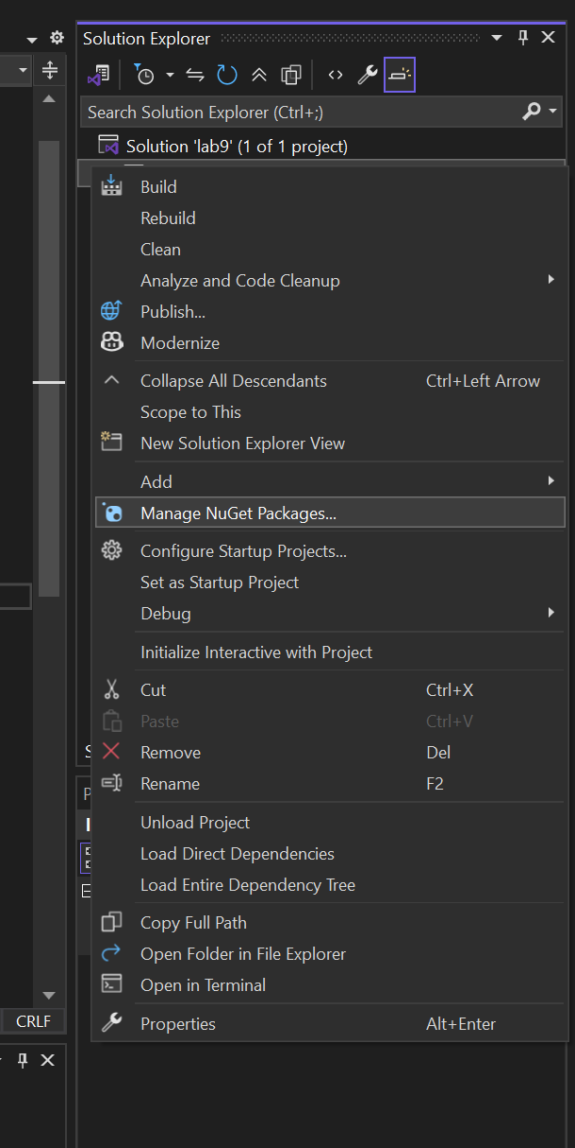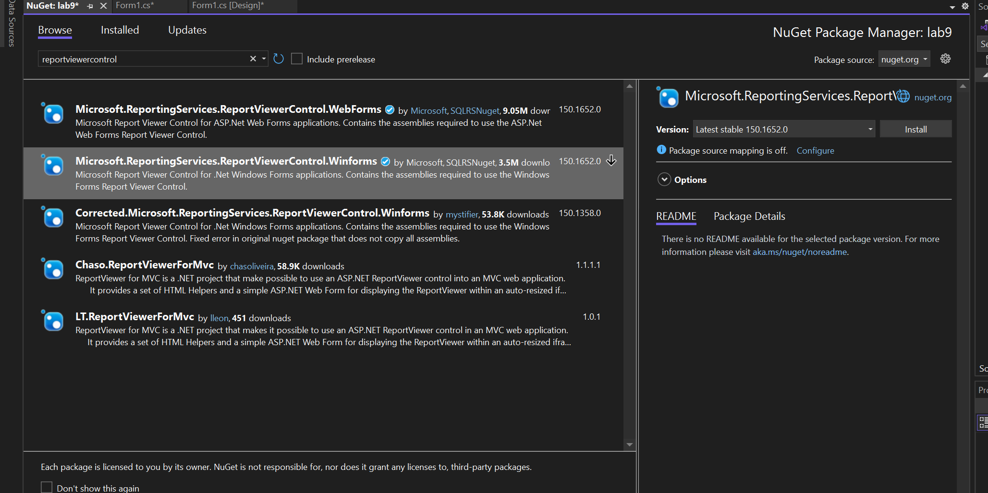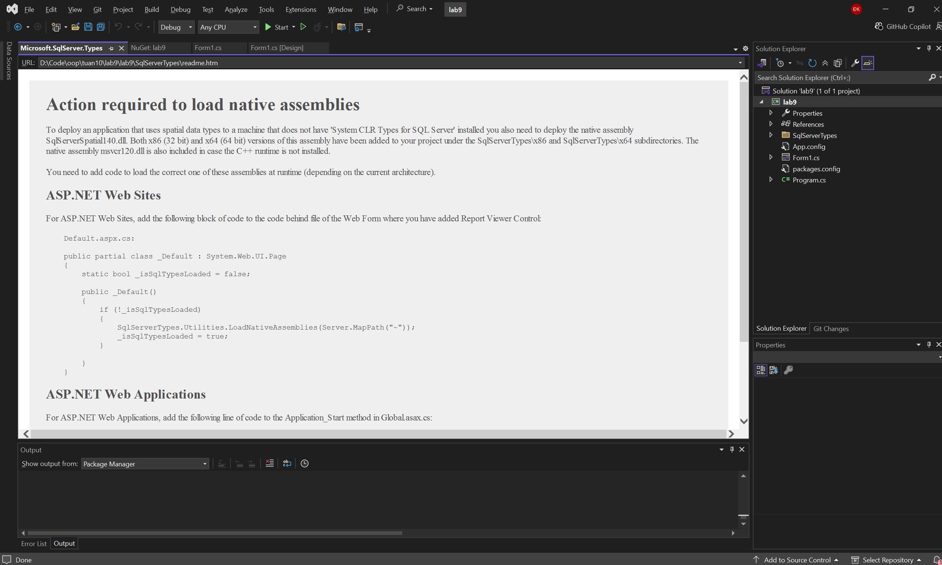
Thực hành 2
