A

I  
1.

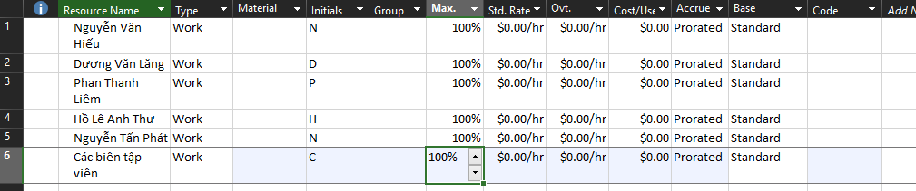

2.

3.

4.

5

6.

II

1.

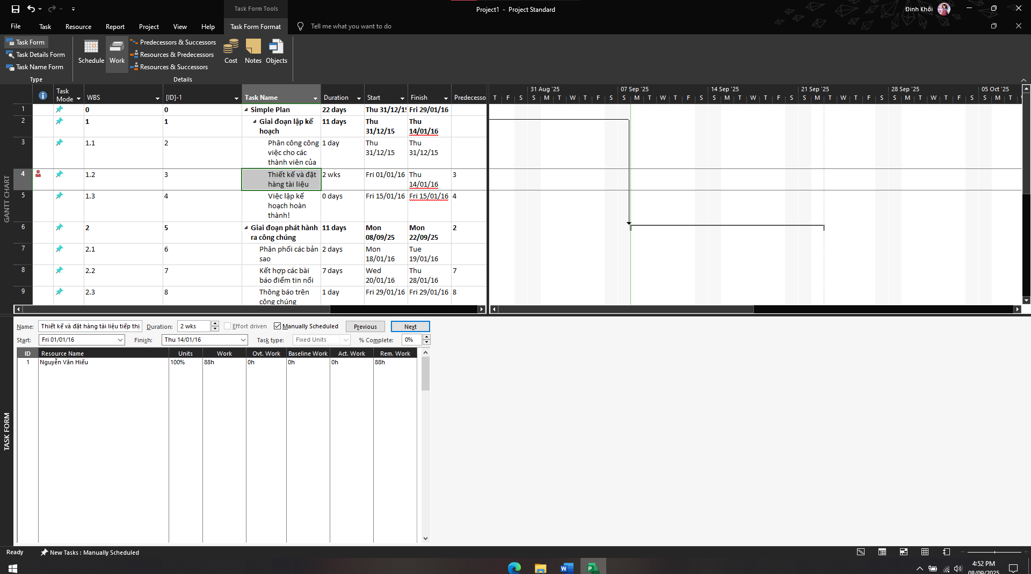

2

3

4.

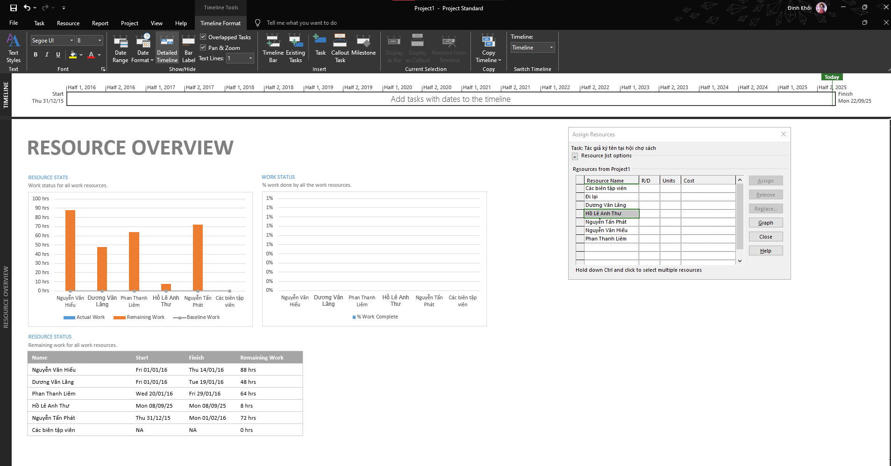

B

I

1.

2.

3.