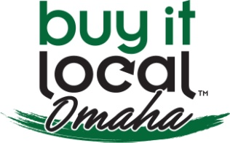 BUY IT LOCAL OMAHA

For Office use only:

* Accepted: ______________
* Website: ______________
* Notified: ______________
* Welcome: ______________

MEMBERSHIP APPLICATION

COMPANY INFORMATION

Date:

Company Name:

State of Iowa or Nebraska Corporate ID #:

Keywords to describe your company: (list three):

Name:       Position:

Owner’s Name (if different from above):

Company Email:

Company Website:

Company Address:

City:       State:  ZIP Code:

Work Phone:       Cell Phone:

Referred by:

**OTHER INFORMATION**

# of Employees:       Business privately held?

Do majority owner(s) live in Douglas, Sarpy, Washington, Dodge, Pottawattamie or Mills Counties?

Franchised:  If yes, is franchisor privately held?

Describe franchise agreement:

Do you control and pay for local marketing:

*Membership Fees: (See pages 2-4 and make checks payable to: **Buy It Local Omaha**)

Check one for the type of membership you are seeking: (Simple memberships are for one (1) year only)

Simple Membership (1 Year)  Standard Membership  Sustaining Membership

Committee(s) you would be interested in joining (Standard or Sustaining Members only):

|  |  |
| --- | --- |
| Marketing/Advertising Products | Membership |
| Events | Education |
| Business/Finance | Other |

Talents/skills or materials you would be willing to contribute to Buy It Local Omaha:

Mail application & fees to: BILO, Attn: Mike Gerst, 20214 Veterans Drive, Omaha, NE 68022

SIGNATURE

Buy It Local Omaha is a non-profit organization with a mission to educate consumers on advantages of buying local, to connect small businesses with the local consumers and seek to promote locally owned, privately held businesses. I understand that Buy It Local Omaha will be verifying the eligibility of my application in order to maintain the integrity of the organization.

Signature of applicant:       Date:

(You may print this application, sign it, scan it and send it back to us or simply type your name)

Buy It Local Omaha—Membership Overview

Available for all privately held, locally owned businesses

Simple Membership--FREE!

Counter cards describing BILO and BILO window decals

Monthly member networking meeting attendance

Name of company listed on the BILO website with link back to member website

**Standard Membership**—includes all simple membership & cooperative advertising benefits

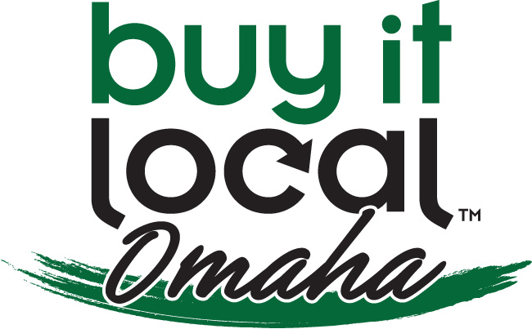$75 - 1 – 5 employees

$125 - 6 – 10 employees

$175 - 11- 20 employees

$225 - 21 – 30 employees

$275 - 31+ employees

$100 - Non-profit organizations

All Simple Membership Benefits included & cooperative advertising

Name of company listed on the BILO website with link back to member website

Annual presentation of business for 3 minutes with exhibit space

**Sustaining Memberships** *15% discounts on A La Carte items purchased in addition to Membership Packages, see information below.*

$500 – Copper: (Includes annual membership with all member benefits) ($700 value)

All Simple and Standard Membership benefits included

Acknowledgment in BILO brochure throughout the year in Copper category

Copper new media package (see below)

**$1,000 – Bronze: *(Includes annual membership with the following member benefits)*** *($1,250 value)*

All Simple Membership Benefits included

Acknowledgment in BILO brochure throughout the year in Bronze category

Recognition sign in registration area

Bronze New Media Package (see below)

**$2,500 – Silver: *(Includes annual membership with the following member benefits)*** *($2,850 value)*

All Simple and Standard Membership benefits included

Acknowledgment in BILO brochure throughout the year in Silver category

Special signage at monthly member meeting and BILO events

Silver New Media Package (see below)

**$5,000 – Gold: *(Includes annual membership with the following member benefits)*** *($5,300 value)*

All Simple and Standard Membership benefits included

Acknowledgment in BILO brochure throughout the year in Gold category

Donor recognition at all BILO events with exhibit space for literature

Gold New Media Package (see below)

$10,000 – Platinum: (Includes annual membership with the following member benefits)

All Simple and Standard Membership benefits included

Acknowledgment in BILO brochure throughout the year in Platinum category

Large sign at BILO member meeting and BILO events listing company and logo

Complimentary mailing list of all BILO meeting BILO event attendees

Use of BILO mailing list to promote exhibit booths or other events

Platinum New Media Package (see below)

**Event Sponsor** *(Events occur 2-4 four times annually)*

$100 /event (All members may sponsor an event from any level membership)

Name of company/logo on website as a host/sponsor of stated event

Name/logo on all materials purchased distributed at the event

Donor recognition on all advertising materials purchased for event

New Media Packages for Sustaining Members:

$500 – Copper New Media Package ($700 value)

(1) Profile Video approximately 1:00 minute in length

(1) BILO Standard FACEBOOK “Welcome Page” that allows Videos to play in the “Welcome” and is personalized with Member-provided image or logo

Additional: Creation of basic FACEBOOK, YouTube, and TWITTER pages (no charge)

**$1,000 – Bronze New Media Package** *($1,250 value)*

(1) Video approximately 2:00-2:30 minutes in length

(1) BILO Standard FACEBOOK “Welcome Page” that allows Videos to play in the “Welcome”

(1) Custom YouTube background without “Sky Scraper”

(1) All sites personalized with Member-provided image or logo

Additional: Creation of basic FACEBOOK, YouTube, and TWITTER pages (no charge)

**$2,500 – Silver New Media Package** *($2,850 value)*

(2) Videos approximately 1:00 minute in length

(1) Video approximately 2:00-2:30 minutes in length

(1) Custom FACEBOOK “Welcome Page” that allows Videos to play in the “Welcome”

(1) Custom TWITTER background WITH “Sky Scraper”

(1) Custom YouTube background WITH “Sky Scraper”

(1) Sites personalized with Member-provided image or logo

(1) Custom Email template

Additional: Creation of basic FACEBOOK, YouTube, and TWITTER pages (no charge)

**$5,000 – Gold New Media Package** *($5,300 value)*

(3) Videos approximately 1:00 minute in length

(2) Videos approximately 2:00-2:30 minutes in length

(1) Custom FACEBOOK “Welcome Page” that allows Videos to play in the “Welcome”

(1) Custom TWITTER background WITH “Sky Scraper”

(1) Custom YouTube background WITH “Sky Scraper”

(1) SEO Enhanced Blogsite custom design and build-out

(1) Sites personalized with Member-provided image or logo

(1) Custom Email template

Additional: Creation of basic FACEBOOK, YouTube, and TWITTER pages (no charge)

$10,000 – Platinum New Media Package

All elements of the GOLD PACKAGE are included, along with $5,000 of additional engagement strategies utilizing multiple services from the A La Carte menu (see below).

Additional customized Video promotions on social media sites to be determined according to the member’s marketing needs on Facebook, Twitter and LinkedIn

A La Carte Packages available to all Members: *\*Volume discounts available*

|  |  |
| --- | --- |
| VIDEO for MEMBERS | BUY IT LOCAL OMAHA Membership Pricing Schedule |
| $750 (1) Video approximately 2:00-2:30 minutes in length | $400 (1) Video approximately 1:00 minute in length. |
| On FACEBOOK... | DESIGN WORK for NEW MEDIA PLATFORMS for BILO MEMBERS |
| $100 Custom “Sky Scraper” profile image | $100 BILO Standard “Welcome Page” |
| $300 BILO Standard “Welcome Page” that allows Videos to play in the “Welcome” | $250 Custom “Welcome Page” |
| On TWITTER... | $500 Custom “Welcome Page” that allows Videos to play in the “Welcome” |
| $300 Custom background WITH “Sky Scraper” | $200 Custom background without “Sky Scraper” |
| $200 Custom background without “Sky Scraper” | On YouTube... |
| ADDITIONAL DESIGN OFFERING(S) FOR MEMBERS... | $300 Custom background WITH “Sky Scraper” |
| $200 Custom Email Template | NC Creation of basic FACEBOOK, YouTube, and TWITTER pages (no charge) |
| *Content strategies are custom designed for Members | NEW MEDIA ENGAGEMENT STRATEGIES FOR MEMBERS |
| $100 Email Marketing Campaigns | $25 Facebook Status Updates (Price is per update) |
| SEARCH ENGINE OPTIMIZATION (SEO) & MARKETING | $100 Edit-Only Video Option (Member provides the video footage for a 1:00 minute video) |
| *Custom pricing for ongoing, monthly SEO enhanced blogging | $1500 SEO Enhanced Blogsite custom design and build-out |

A LA CARTE PRICING SUBJECT TO CHANGE WITH 30-DAY NOTICE TO BILO.

1. 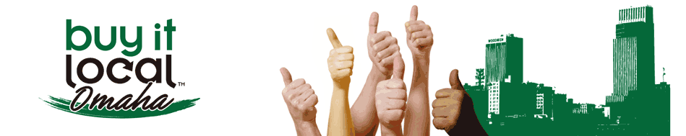What is the Buy It Local Omaha organization? Buy It Local Omaha (BILO) exists to boost our economy and build local business. We are a non-profit organization designed to both (a) educate the local consumer on the advantages of buying products and services from a local business, and to (b) connect the local consumer and business.
2. Members will generate solidarity and a presence in the local community through cooperative advertising. We offer exclusive membership directory services on the BILO web site, local website search tools for member products and services. Networking is possible once each month (September – May) for higher visibility to the consumers. We offer membership kits to include campaign stickers and promotional material, loyalty programs for Business-to-Business and Business-to-Consumer, and a centralized voice for small business advocacy rights within governmental agencies.
3. By joining BILO, you show your support and identify yourself as a local business owner to the community and the local consumers.
4. Any business or organization that is privately held, and a majority of the ownership is in Douglas, Sarpy, Washington, Dodge, Pottawattamie or Mills Counties, collectively can join. The Board of Directors and/or membership committee may elect to impose additional requirements.
5. To remain a member, you must maintain good standing in the local business community. Also, members are encouraged to promote the BILO mission with their peers and customers, and to participate in internal and public meetings.
6. BILO is different than any other networking or local municipality. BILO believes local businesses are a positive driving force in the community’s economy and through cooperative efforts; the business community can positively influence consumers towards a higher economic yield. The organization will ensure public involvement and support through consumer networking, loyalty programs and promotions, consumer aided tools to make informed buying decisions, and higher local business visibility.