fay150 USBhay emorymay ickstay – Userhay uidegay

Starting Access Standard 2

Login 3

Logout 5

Change Password 6

Opening and Saving Files 9

## artingstay Accesshay andardstay

1. onnectcay ethay USBhay emorymay ickstay otay ouryay omputercay.
2. Openhay “myay omputercay”.
3. oubleday- ickclay ethay ivedray amednay “Applicationhay”. isthay illway openhay ethay applicationhay artitionpay onhay ethay USBhay emorymay ickstay.
4. oubleday-ickclay artstay .exehay ilefay (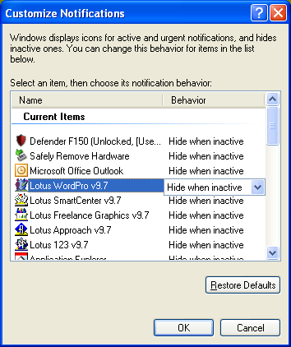artstay) omfray ethay ootray irectoryday onhay ethay applicationhay artitionpay.
5. ethay  iconhay illway appearhay onhay ethay otificationnay areahay athay ethay arfay ightray ofhay ethay askbartay.

## 

## oginlay

ethodmay 1

1. omfray ethay otificationnay areahay, athay ethay ightray ofhay ethay askbartay, ightray-ickclay ethay  iconhay andhay ickclay **oginlay.**

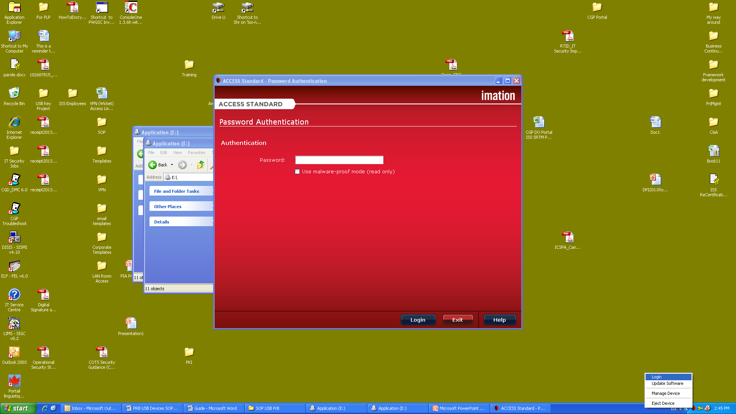

1. Enterhay ethay asswordpay andhay esspray ethay “oginlay” uttonbay.

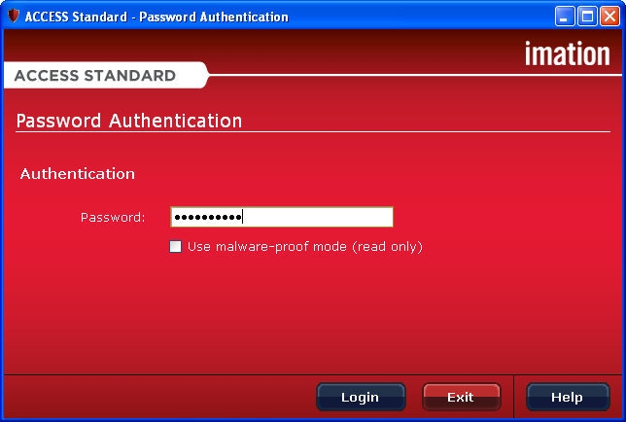

ethodmay 2

1. omfray ethay otificationnay areahay, athay ethay ightray ofhay ethay askbartay, ightray-ickclay ethay  iconhay andhay enthay ickclay **anagemay eviceday.**

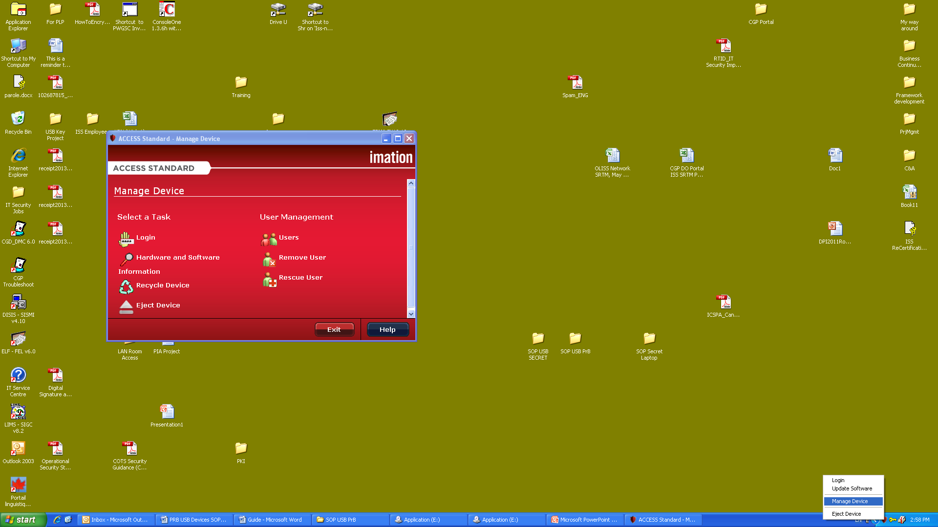

1. electsay ethay **oginlay** uttonbay.
2. Enterhay asswordpay andhay ickclay ethay “oginlay uttonbay”.



## ogoutlay

ethodmay 1

omfray ethay otificationnay areahay, athay ethay ightray ofhay ethay askbartay, ightray-ickclay ethay  iconhay andhay enthay ickclay **ogoutlay.**

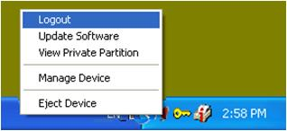

ethodmay 2

omfray ethay anagemay eviceday indowway electsay **ogoutlay** orhay **Ejecthay eviceday.**

## angechay asswordpay

Uponhay ethay irstfay utilizationhay ofhay ethay eviceday, ouyay eednay otay angechay ethay emporarytay asswordpay assignedhay otay ouyay byay ethay Administratorhay.

1. onnectcay ethay eviceday otay ahay USBhay ortpay andhay aunchlay ethay Accesshay andardstay interfacehay applicationhay (eesay artingstay Accesshay andardstay Applicationhay - agepay 2).
2. omfray ethay otificationnay areahay, athay ethay ightray ofhay ethay askbartay, ightray-ickclay ethay  iconhay andhay ickclay **oginlay.**



1. Enterhay ethay urrentcay (emporarytay) asswordpay andhay esspray ethay **oginlay** uttonbay.



1. omfray ethay otificationnay areahay, athay ethay ightray ofhay ethay askbartay, ightray-ickclay ethay  iconhay andhay enthay ickclay “anagemay eviceday”. isthay illway openhay ethay anagemay eviceday indowway.



1. Onhay ethay “anagemay eviceday” indowway, electsay ethay **angechay ouryay asswordpay** uttonbay. isthay illway openhay ethay userhay authenticationhay indowway.
2. Inserthay ethay urrentcay (emporarytay) asswordpay inhay ethay asswordpay erificationvay oppay-uphay indowway andhay enthay esspray **erifyvay** uttonbay. isthay illway openhay ethay **angechay asswordpay** indowway.

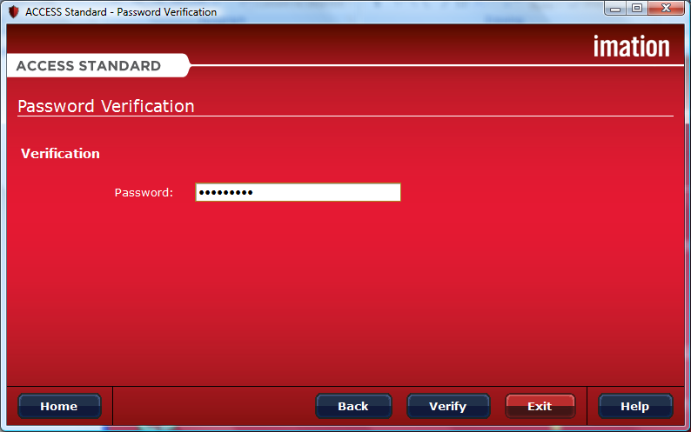

1. Inhay ethay **angechay asswordpay** indowway enterhay ahay ewnay asswordpay andhay enthay ickclay **extnay.**

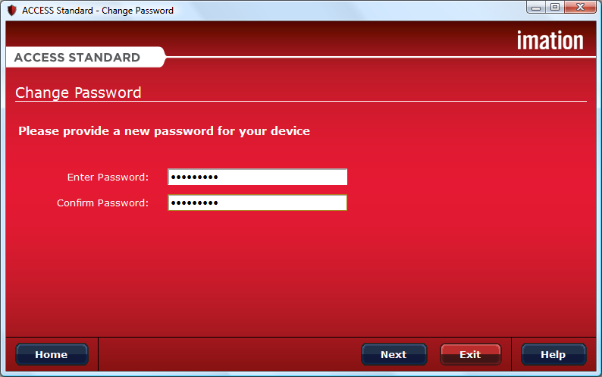

1. enwhay ethay angechay asswordpay operationhay ishay ompletecay esspray ethay **OKhay** uttonbay otay eturnray otay ethay **anagemay eviceday** indowway.

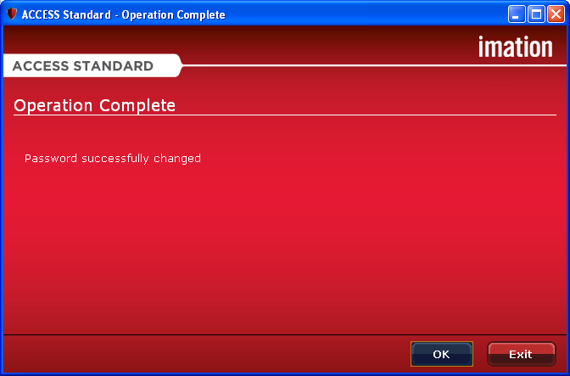

## Openinghay andhay avingsay ilesfay

ethay eviceday ontainscay otway artitionspay, ethay Applicationhay artitionpay andhay ethay ivatepray artitionpay. ouryay omputercay ecognizesray eachhay artitionpay ashay ahay eparatesay ivedray.

ethay Applicationhay artitionpay ontainscay einstalledpray applicationshay uchsay ashay Accesshay andardstay. ouyay annotcay avesay ataday orhay eleteday ataday omfray ethay Applicationhay artitionpay.

ethay ivatepray artitionpay oresstay ouryay ataday andhay **ancay ebay accessedhay onlyhay afterhay ouyay oglay intohay ethay eviceday**.

Openinghay ilesfay

Oncehay ouyay oglay intohay ethay eviceday, ouyay ancay openhay ilesfay onhay ethay ivatepray artitionpay usinghay ethay appropriatehay ogrampray orhay ahay ilefay anagermay ogrampray (uchsay ashay indowsway® Explorerhay). Alternativelyhay, ouyay ancay accesshay ethay ivatepray artitionpay byay ightray-ickclay ethay  iconhay onhay ethay otificationnay areahay ofhay ethay askbartay andhay enthay electsay **iewvay ivatepray artitionpay**.



avingsay ilesfay

Afterhay ouyay oglay intohay eviceday, ouyay ancay avesay ataday inhay ethay ivatepray artitionpay. enwhay ouyay avesay ataday otay ethay ivatepray artitionpay ethay eviceday encryptshay ethay ataday. ataday ishay automaticallyhay ecryptedday enwhay ouyay openhay ethay ilefay.