ettysburggay Addresshay

ourfay orescay andhay evensay earsyay agohay ourhay athersfay oughtbray orthfay onhay isthay ontinentcay ahay ewnay ationnay, onceivedcay inhay ibertylay, andhay edicatedday otay ethay opositionpray atthay allhay enmay arehay eatedcray equalhay.

nay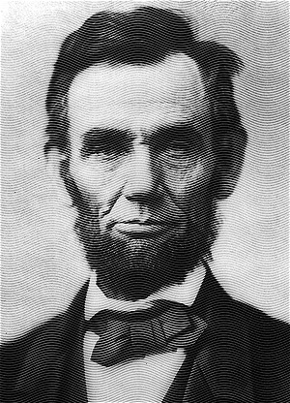owhay eway arehay engagedhay inhay ahay eatgray ivilcay arway, estingtay etherwhay atthay ationnay, orhay anyhay ationnay, osay onceivedcay andhay osay edicatedday, ancay onglay endurehay. eway arehay etmay onhay ahay eatgray attlebay-ieldfay ofhay atthay arway. eway avehay omecay otay edicateday ahay ortionpay ofhay atthay ieldfay, ashay ahay inalfay estingray aceplay orfay osethay owhay erehay avegay eirthay iveslay atthay atthay ationnay ightmay ivelay. Ithay ishay altogetherhay ittingfay andhay operpray atthay eway ouldshay oday isthay.

utbay, inhay ahay argerlay ensesay, eway annotcay edicateday...eway annotcay onsecratecay...eway annotcay allowhay isthay oundgray. ethay avebray enmay, ivinglay andhay eadday, owhay uggledstray erehay, avehay onsecratedcay ithay, arfay abovehay ourhay oorpay owerpay otay addhay orhay etractday. ethay orldway illway ittlelay otenay, ornay onglay ememberray atwhay eway aysay erehay, utbay ithay ancay evernay orgetfay atwhay eythay idday erehay. Ithay ishay orfay ushay ethay ivinglay, atherray, otay ebay edicatedday erehay otay ethay unfinishedhay orkway ichwhay eythay owhay oughtfay erehay avehay usthay arfay osay oblynay advancedhay. Ithay ishay atherray orfay ushay otay ebay erehay edicatedday otay ethay eatgray asktay emainingray eforebay ushay—atthay omfray esethay onoredhay eadday eway aketay increasedhay evotionday otay atthay ausecay orfay ichwhay eythay avegay ethay astlay ullfay easuremay ofhay evotionday—atthay eway erehay ighlyhay esolveray atthay esethay eadday allshay otnay avehay iedday inhay ainvay—atthay isthay ationnay, underhay odgay, allshay avehay ahay ewnay irthbay ofhay eedomfray—andhay atthay overnmentgay: ofhay ethay eoplepay, byay ethay eoplepay, orfay ethay eoplepay, allshay otnay erishpay omfray ethay earthhay.