, , Guelph: 519-836-8111 □ Kitchener (Greenbrook Dr.): 519-743-2323 u Kitchener (Frederick St.): 519-742-9494 u Simcoe: 519-426-3818 □ Waterloo: 519-896-2654 □ □ □ □ □ □

### Why Us?+ How We Can Help+ Locations+ Hearing Health Resources+ Contact+

Adoption Plan Home/ Adoption Plan



# You're Invited To The Arnold Hearing Family Even If You Purchased Your Hearing Device Elsewhere



Monoging hearing loss involves more than just fitting you with an advanced technology hearing device. In truth, ongoing core and expert support ore even more valuable when it comes to being able to enjoy a rich ond independent lifestyle in full sound.

The Arnold Hearing Centres family is concerned about a development that is becoming more and more common. Because many people are purchasing their hearing devices online, through a big box store, or from a hearing device dispenser, they·re discovering that they're left out in the cold when it comes to ongoing service or support.

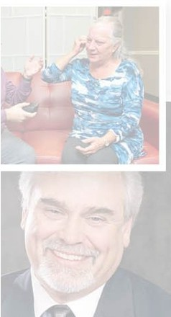

Can you relate to this problem? Do you find it difficult or next to impossible to get the troubleshooting, programming, adjustment, maintenance and ongoing support you need in order to get the most benefit from your hearing aids?

Because we're really big on family helping family, Arnold Hearing Centres would like to adopt you into our family of hearing aid users, which is why we set up a specialized treatment plan just for you. We call it our Adoption Plan.

We've made it possible for people like you who have bought their hearing devices elsewhere but who want and need access to the advanced hearing care, technical support, and professional expertise of a doctor of audiology to get exactly what they need.

A major benefit that comes along with our Adoption Plan is the priority treatment you're given by our team of hearing experts, meaning you will receive ongoing care, treatment, and support by a local provider in order to ensure that your hearing devices deliver their best performance day in, day out.

To meet the unique hearing care needs, preferences, and budget of everyone who joins our family, we offer DNo Adoption Plan options.



This option is available to individuals who purchased their hearing aids elsewhere, but they're not programmed to address their specific hearing loss needs.

INCLUDES:

* Comprehensive Hearing Assessment - used to gather the information necessary to program your device
* 17-Point fitting Process - we use this to ensure that every patient is completely satisfied and gets the most benefit from their device
* 2 follow-up appointments - to ensure you're getting on just fine
* Quarterly hearing device performance check and cleanings for one year - ensures that your device is performing as designed

$500/Hearing Aid



Those who purchased their hearing device elsewhere that were programmed to address their specific hearing loss can take advantage of this option, which involves providing support service for the device itself.

INCLUDES:

* Hearing instrument cleanings
* Hearing instrument programming and adjustments
* Hearing instrument firmware updates
* In-office repairs, including earmold tubing, microphone covers, wax guards, receiver domes, and battery doors
* Annual hearing assessment

$120/Year for Each Hearing Aid

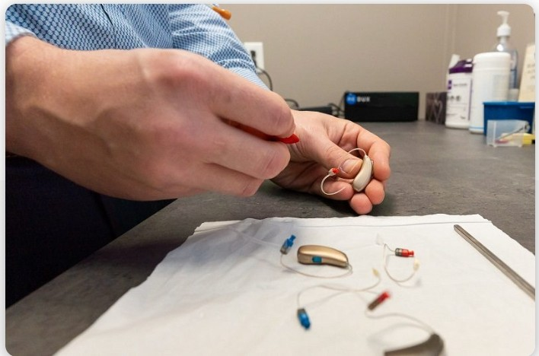

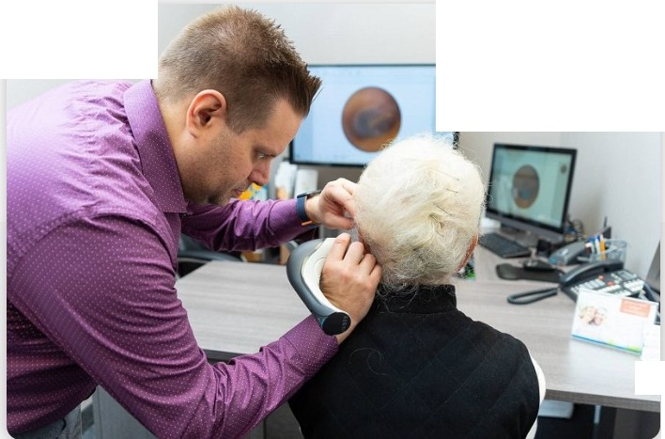

I

•

-

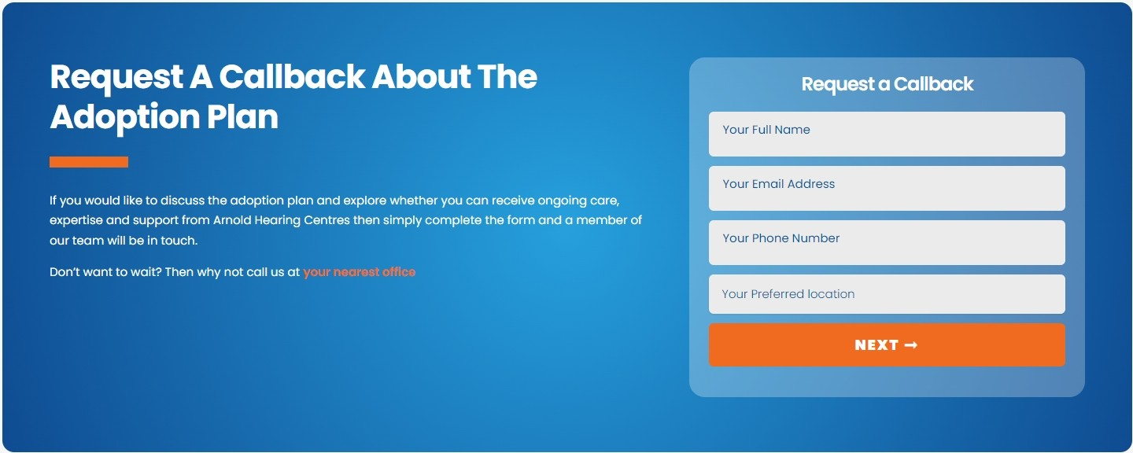

## Professional, Caring, Respectful, and Honest. I have always been extremely pleased with the quality of service from a long-time Family ran Business. It can be a very stressful feeling to need a hearing test, and I felt very comfortable throughout the process. I also needed to obtain short term service for one of my children, which is another stressful event, but the care provided at Arnold Hearing Centre's put me completely at ease. I would happily recommend Arnold Hearing Centre's to any of my Family, Friends, or Co­ workers

''

### Laura R.

Patient Stories

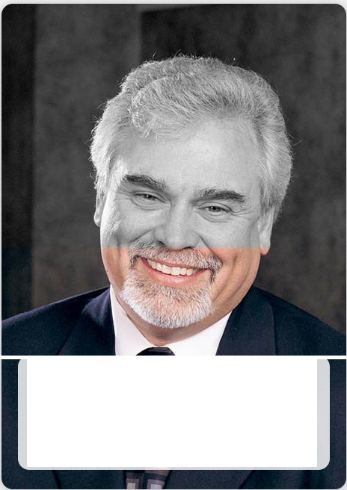

All of the audiologists I've had at Arnold have been really good at customer service. It may be in part because there has been so much improvement in technology, but my most recent audiologist was simply extraordinary

-LarryMartin

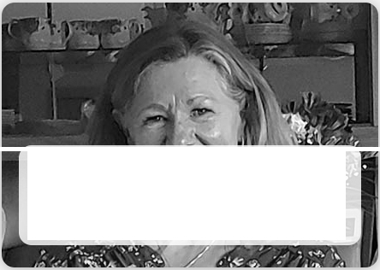

The professional staff are there for you and are willing to answer any questions and to work with you to make the most of your ability.

-DonnaU.



Arnold will take care of you the moment you step through the doors. They're knowledgeable and patient

* you will become one of the family.
* NatalieCarruthers

# Your Hearing Health Resources

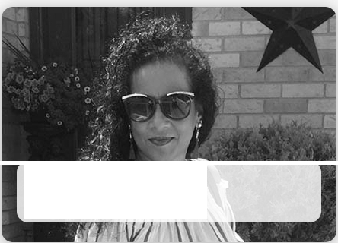

finally feels like I have *my* life back

- Shelly Resendes

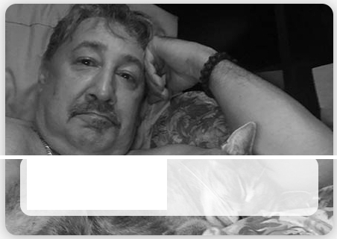

Go get it checked out I did.

- FronkFazekas



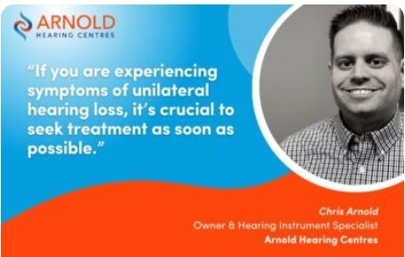

## LoveLocal: MelvilleCafe:Where Coffee, Pizza, and River Views Meet!

As you probably know by now, I love being able to live in such a wonderful area of Canada. There are some truly great businesses...

## We've Got Five Ontarian Winners for our 2022Hear for the Holidays Giveaway!

We understand the importance of supporting locally­ focused businesses that are deeply rooted in their communities. At Arnold...

## What IsUnilateral Hearing LossandHow CanYou Treat It?

If you've ever suffered !ram a water-clogged ear after a swim, you know what it feels like ta have a unilateral hearing loss...

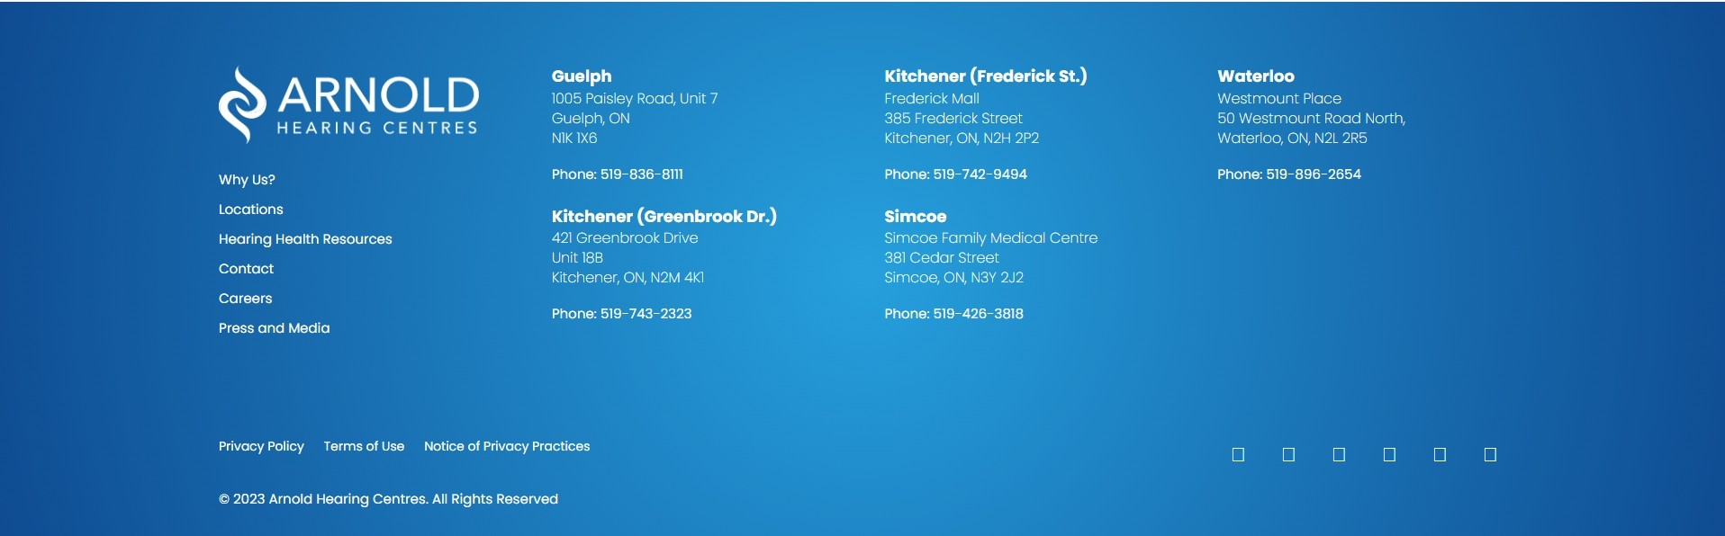READ MORE READ MORE READ MORE