Experiment No:01

Experiment Name: Linux setup(**Ubuntu 16.10**)

Aim and Objectives:

Just like Windows XP, Windows 7, Windows 8, and Mac OS X, Linux is an operating system. An operating system is software that manages all of the hardware resources associated with our desktop or laptop.

• Linux is a command line interface, used by most large, powerful computers.

• Linux is very stable - computers running Linux almost never crash • Linux is very efficient which can smoothly manage extremely huge amounts of data.

• Most new bioinformatics software is created for Linux - its easy for the programmers.

Experiment Setup:

Step 1:

At first burn the ubuntu file in pendrive. Then press esc and boot pendrive. Once the media boot-up a new grub screen should appear on monitor. From the menu select **Install Ubuntu** and hit **Enter** to continue.



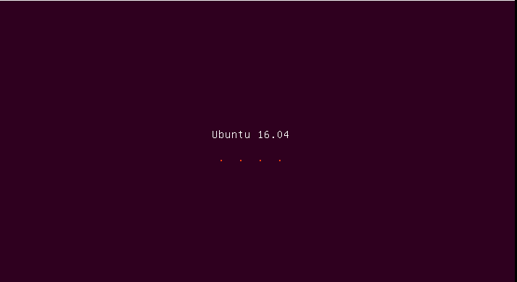

Step 2:

After the boot media finishes loading into RAM it will end-up with a completely functional Ubuntu system running in live-mode.

On the Launcher hit on the second icon from top, **Install Ubuntu 16.04 LTS**, and the installer utility will start. Choose the language wish to perform the installation and click on **Continue** button to proceed further.

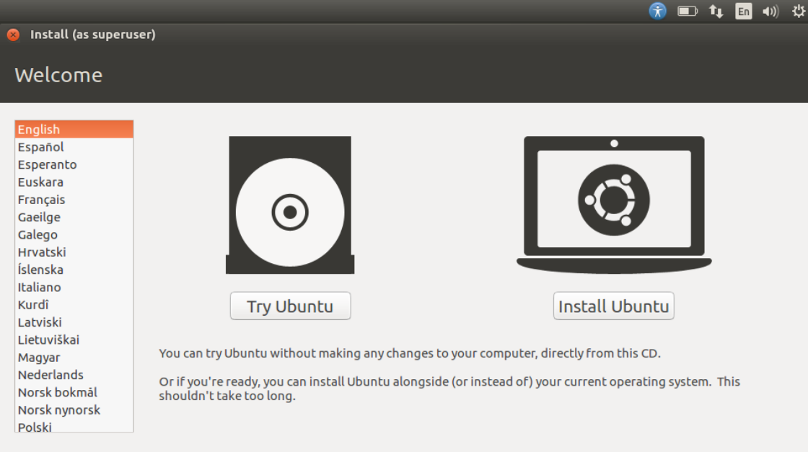

Step 3:

Next, leave both options from **Preparing to Install Ubuntu** unchecked and hit on **Continue** button again.

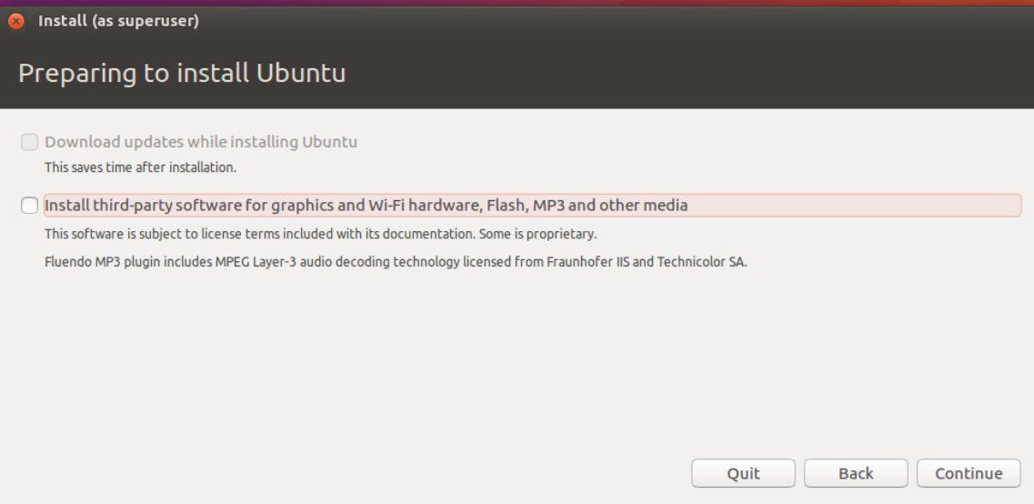

Step 4:

choose to **Install Ubuntu** alongside **Windows Boot Manager**, option that will automatically take care of all the partition steps.

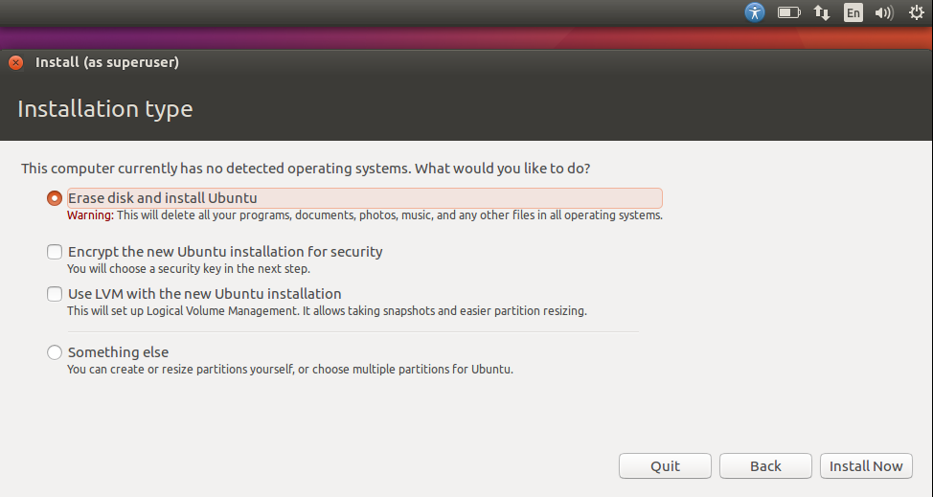

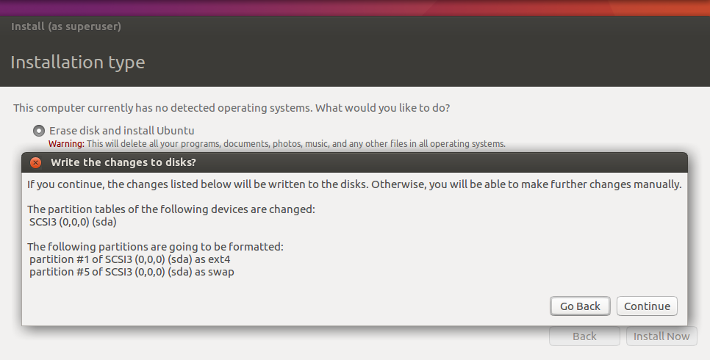

Step 5:

On the next screen adjust machine physical location by selecting a city nearby from the map. When done hit **Continue** to move ahead.

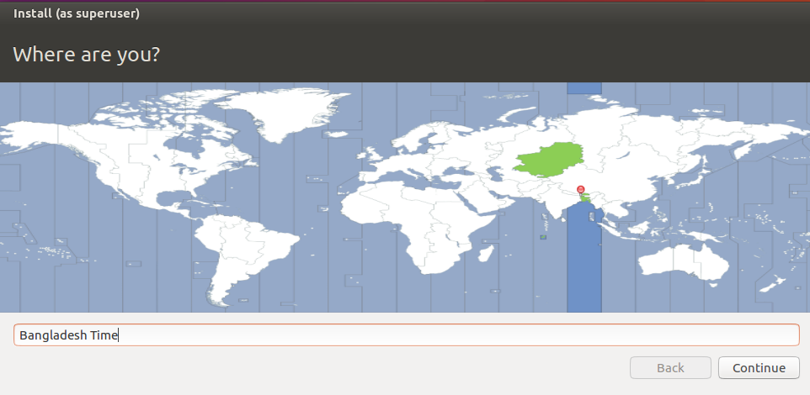

Step 6:

Next, select your **keyboard** layout and click on **Continue** button.

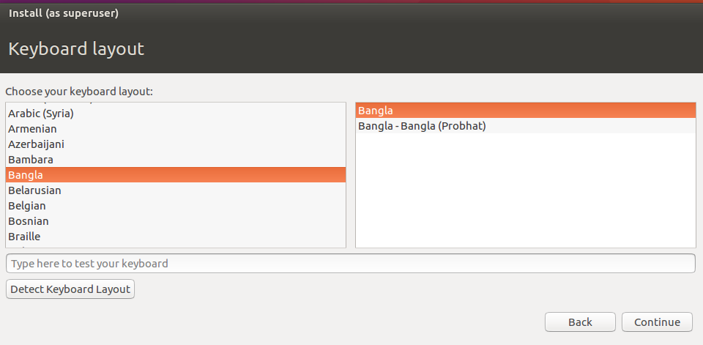

Step 7:

Pick up a username and password for administrative **sudo** account, enter a descriptive name for computer and hit **Continue** to finalize the installation.

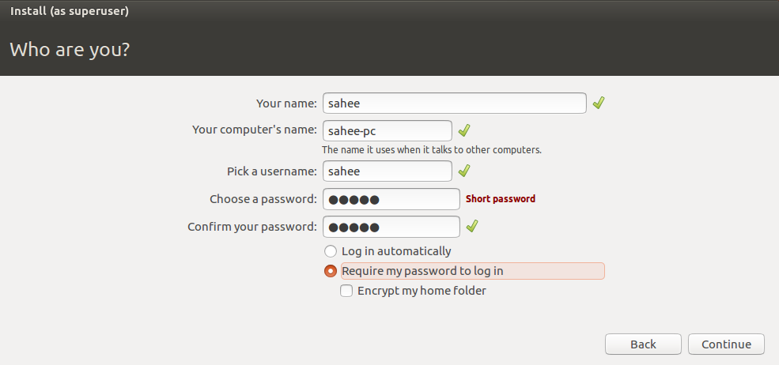

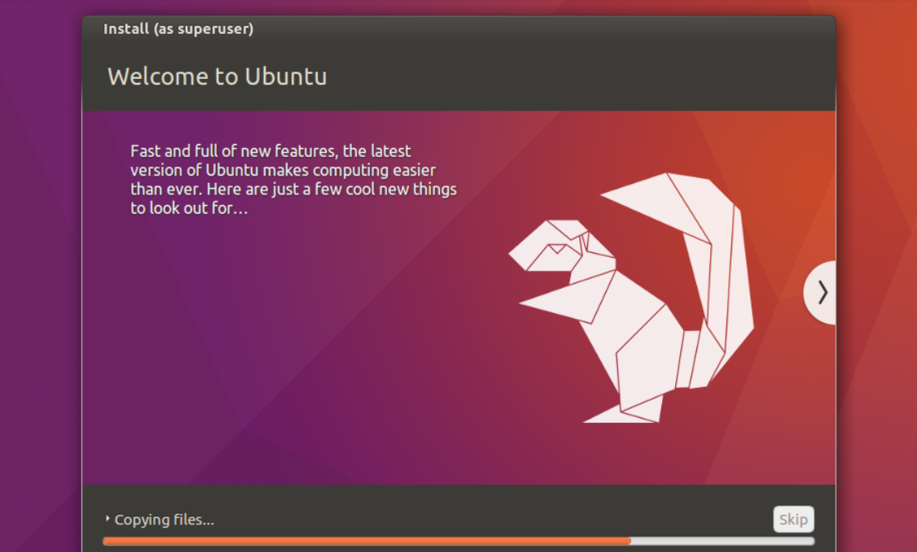

Step 8:

After the installation process reaches its end hit on **Restart Now** button in order to complete the installation.

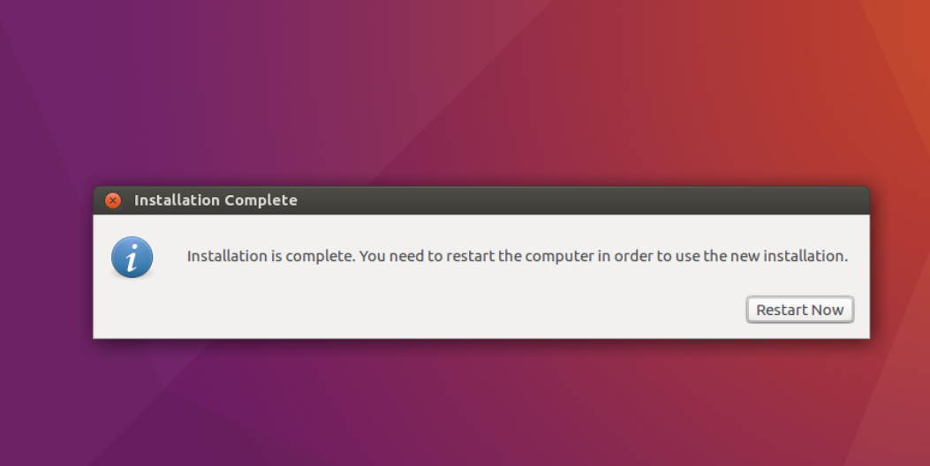

Step 9:

Installation is complete.

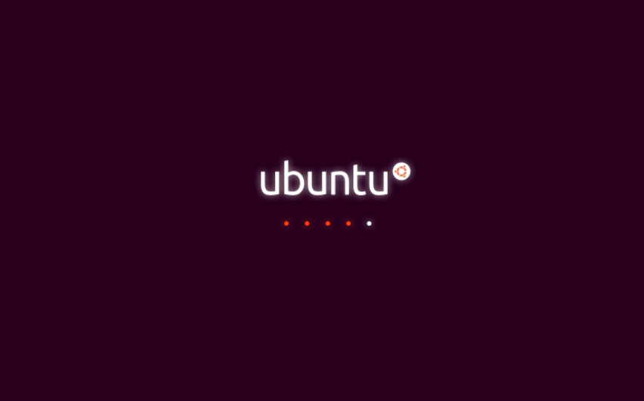

Step 10:

Now open the terminal and see that my username display. Then we write many command for specific work.

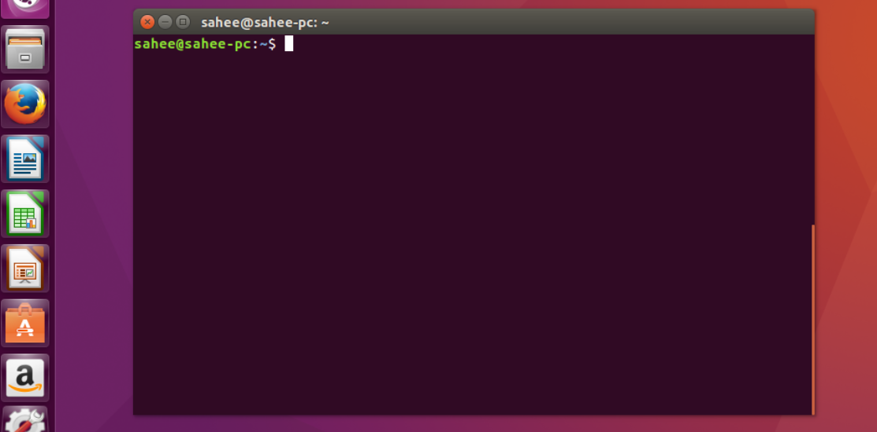

Conclusion:

Linux was not designed with some specific purpose in mind but now serves as a reliable open-source and free operating system for desktops, servers, mobile phones, lot of IoT devices and embedded devices. Linux distros are everywhere as open-source and free operating systems. So installing Linux is very much important for our programming studies and future career.