Experiment No:02

Experiment Name: Basic commands of Linux Operating System.

Aim and Objectives:

* Linux is the kernel of an operating system . In family of the UNIX operating systems.
* Linux began as a command line OS – Most applications are run from command line – type a command with or without parameters – contrasts with a GUI-driven operating system.
* Shell is a program that receives commands from the user and gives it to the OS to process and it shows the output. Linux’s shell is its main part. Its distros come in GUI(Graphical User Interface) but basically, Linux has a CLI (Command Line Interface). In this tutorial, we are going to cover the Basic Commands that we use in the Shell of Linux.

Commands:

1.whoami: This command prints the [username](https://www.computerhope.com/jargon/u/username.htm) associated with the current effective user ID.

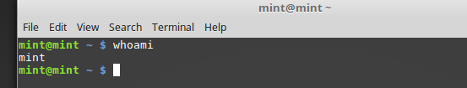

2:hostname: It tells on which machine it is.

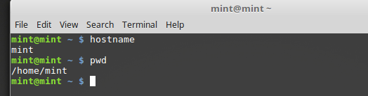

3.pwd:  Short for print working directory, pwd is a Linux, Unix, and FTP command to print the [directory](https://www.computerhope.com/jargon/d/director.htm) you're currently working in when at the command line.

4.ls:  Command used in [Linux](https://www.computerhope.com/jargon/l/linux.htm), [Unix](https://www.computerhope.com/jargon/u/unix.htm), and their respected variants that lists the files and directories in the current directory.

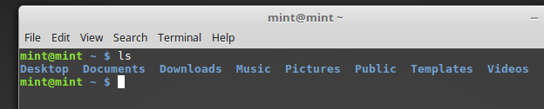

5.Cd: Short for Change Directory, cd is a command commonly used to change the directory in a command line [operating system](https://www.computerhope.com/jargon/os.htm).

6.mkdir: Short for make directory, mkdir is a command used in Linux, Unix, Windows command line, as well as FTP sessions to create new directories.

7.cd ..: moves one directory up

8.cd ../../: moves two directories up

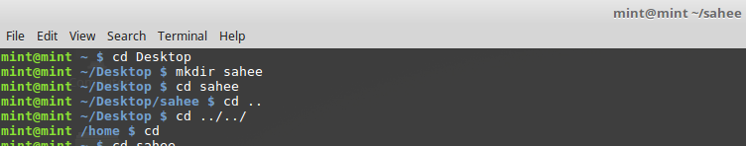

9.mv: The mv command moves, or [renames](https://www.computerhope.com/jargon/r/rename.htm), files and directories on your [filesystem](https://www.computerhope.com/jargon/f/filesyst.htm).

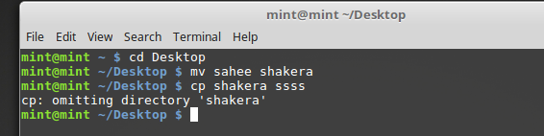

10.cp: The cp command is used to make copies of files and directories.

11.locate: The locate command finds files by name.

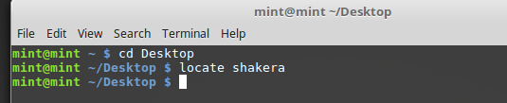

12.touch:touch changes file [timestamps](https://www.computerhope.com/jargon/t/timestam.htm). It is also an easy way to create empty files.

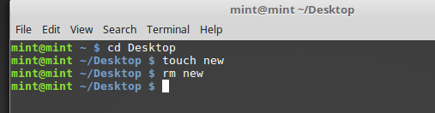

13.rm: The rm command removes ([deletes](https://www.computerhope.com/jargon/d/delete.htm)) [files](https://www.computerhope.com/jargon/f/file.htm) or[directories](https://www.computerhope.com/jargon/d/director.htm).

14.rmdir: Abbreviation for remove directory, rmdir is a command line command used to remove a directory and its contents.

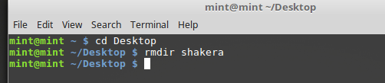

Conclusion: In this lab we learn about the basic commands of linux operating system. The basic idea of Linux is to utilize a simple easy to use operating system. We write these commands for desire output. Every command we write in terminal. We must learn basic commands because these are very important for our future study of operating system.