Experiment No:03

Experiment Name: File operation and permission in linux operating system.

Objective:

For many users of Linux, getting used to file permissions and ownership can be a bit of a challenge.

Linux, like other operating systems, organizes itself using directories and files that can potentially be accessed, altered, or executed. To prevent internal anarchy, Linux gives different levels of permission for interacting with those files and directories.

Command:

Ls -l:

The ls command is the main way to browse directory contents on UNIX and Linux. While it can be used with no options there are several options which will customize the output.

It shows the all file permission .

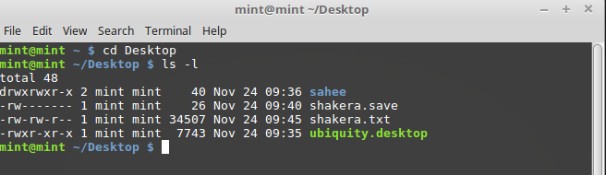

It shows the only one file permission.

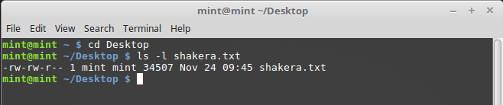

Chmod:

chmod is a Linux command that will let permissions( assign who can read/write/execute) on a file.

chmod permissions file

or

chmod permission1_permission2_permission3 file

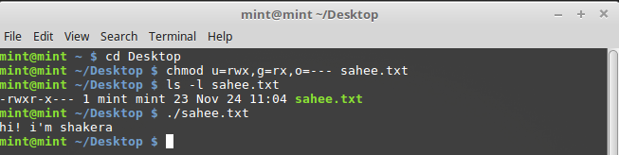

there are three types of Linux users .

Owner-u  
Group-g  
World-o

There is one that is ‘all’ means all type of users.

There are three types of permissions that Linux allows for each file.  
  
read-r  
write-w  
execute-x

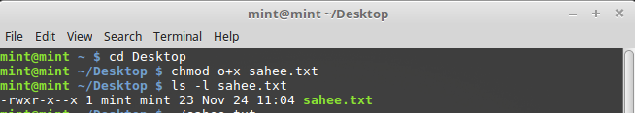

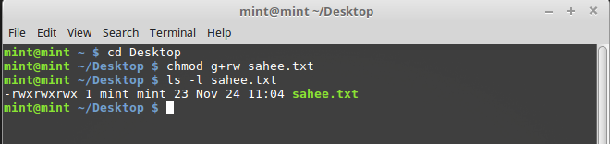

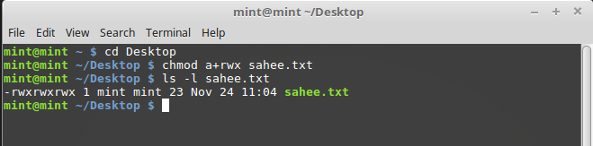

So, in laymen terms, if we wanted a file to be readable by everyone, and writable by only me, we would write the chmod command with the following structure.  
  
COMMAND : OWNER : GROUP : WORLD : PATH  
  
chmod read & write read read FileName.

we will need to convert the word read or write or execute into the numeric equivalent (octal) based on the table below.  
  
4 read (r)  
2 write (w)  
1 execute (x)

7 = 4+2+1 (read/write/execute)  
6 = 4+2 (read/write)  
5 = 4+1 (read/execute)  
4 = 4 (read)  
3 = 2+1 (write/execute)  
2 = 2 (write)  
1 = 1 (execute)

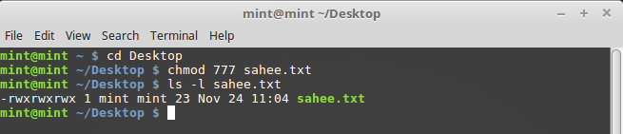

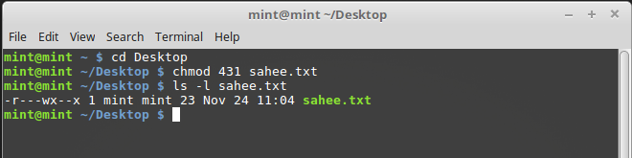

nano:

this nano command use for displaying the inside of file.

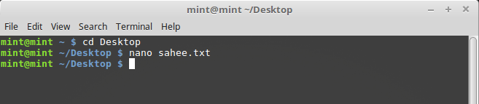

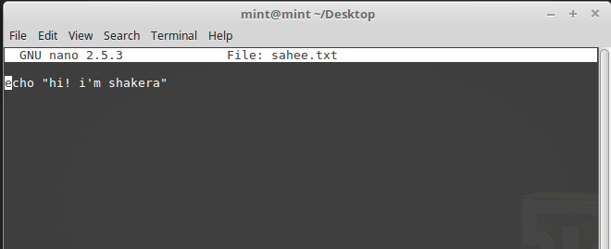

Conclusion:

This lab we learn about the file permission in linux operating system. We know that [chmod](https://en.wikipedia.org/wiki/chmod) is a command in Linux and other Unix-like operating systems that allows to *ch*ange the permissions of a file or directory. This lab helpful to learn security in linux operating system.