Experiment Number:04

Experiment Name: Process Handling in Linux

Objective:

A program is a series of instructions that tell the computer what to do. When we run a program, those instructions are copied into memory and space is allocated for variables and other stuff required to manage its execution. This running instance of a program is called a process and it's processes which we manage.

Process state codes:

* R running or runnable (on run queue)
* D uninterruptible sleep (usually IO)
* S interruptible sleep (waiting for an event to complete)
* Z defunct/zombie, terminated but not reaped by its parent
* T stopped, either by a job control signal or because it is being traced

Command:

1.ps aux:

The ps command comes with an unusual set of 2 syntax styles. That is BSD and UNIX both.This example is BSD. The following command will give a full list of processes.

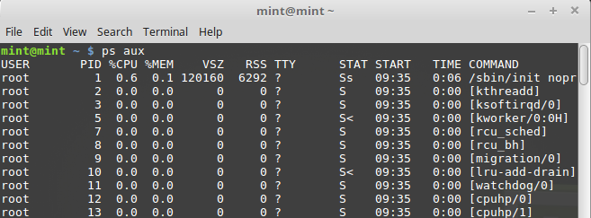

2.kill/killall/xkill

Kill offending process. The kill [command](http://www.linfo.org/command.html) is used on [Linux](http://www.linfo.org/linuxdef.html) and other [Unix-like](http://www.linfo.org/unix-like.html) [operating systems](http://www.linfo.org/operating_systems_list.html) to terminate [processe*s*](http://www.linfo.org/process.html) without having to log out or reboot (i.e., restart) the computer. Thus, it is particularly important to the stability of such systems.

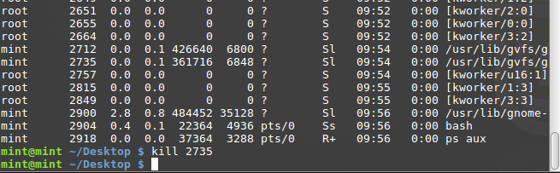

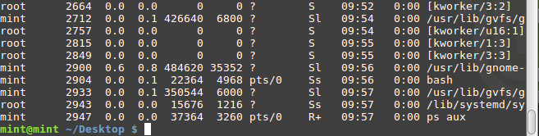

* **killall program**  Killall kills *by name* all instances of said program.  If there are for example 3 firefox sessions open, killall firefoxwill do just that; kill all firefox sessions.  kill would simply take the specified PID of the offending firefox process you wish to kill, and kill that one only.

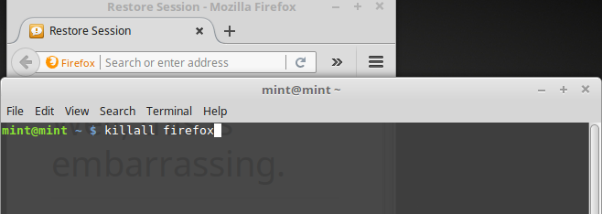

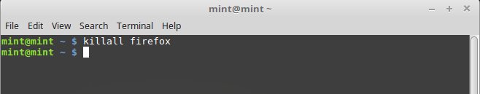

*xkill is a GUI way to click and kill windows. Typing in xkill should present a skull-and-crossbones icon and the next window clicked on will be killed.

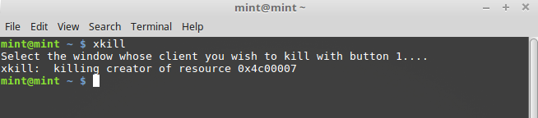

3.> and >> redirectors

ps aux > file, the output of ps aux will be written to file and if a file named file was already present, its contents will be overwritten.

ps aux >> file, the output of ps aux will be written to file and if the file named file was already present, the file will now contain its previous contents and also the contents of ps aux, written after its older contents of file.

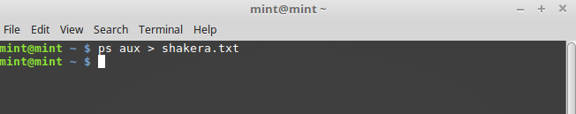

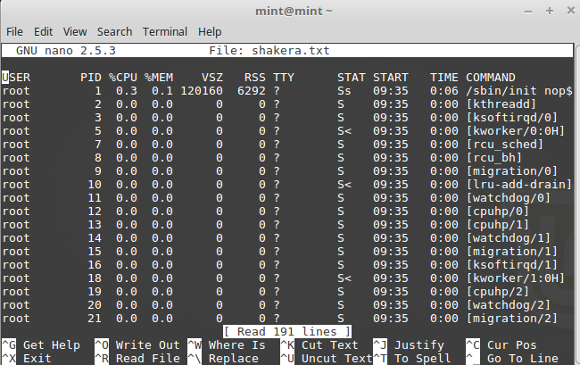

4.Pipes:

 A pipe is a form of redirection that is used in Linux and other Unix-like operating systems to send the output of one program to another program for further processing. It is represented by ’ | ‘ symbol.

5. tee

Tee command is used to store and view (both at the same time) the output of any other command. tee copies data from standard input to each FILE, and also to standard output. In effect,tee duplicates its input, routing it to multiple outputs at once.

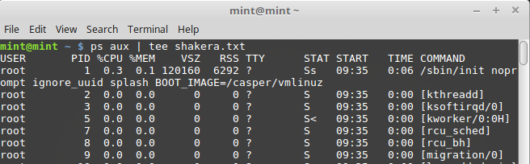

Conclusion:

This lab , we learn about the process handling in linux. The commands described above are just a small part of everything the command line interface has to offer. These commands are very useful for our future work with linux.