Experiment Number:05

Experiment Name: First Come First Serve scheduling Algorithm

Objective:

First in, first out (FIFO), also known as first come, first served (FCFS), is the simplest scheduling algorithm. FIFO simply queues processes in the order that they arrive in the ready queue.In this, the process that comes first will be executed first and next process starts only after the previous gets fully executed.

Code:

#include<stdio.h>

main()

{

int n,a[10],b[10],t[10],w[10],g[10],i,m;

float att=0,awt=0;

for(i=0;i<10;i++)

{

a[i]=0; b[i]=0; w[i]=0; g[i]=0;

}

printf("enter the number of process");

scanf("%d",&n);

printf("enter the burst times");

for(i=0;i<n;i++)

scanf("%d",&b[i]);

printf("\nenter the arrival times");

for(i=0;i<n;i++)

scanf("%d",&a[i]);

g[0]=0;

for(i=0;i<10;i++)

g[i+1]=g[i]+b[i];

for(i=0;i<n;i++)

{

w[i]=g[i]-a[i];

t[i]=g[i+1]-a[i];

awt=awt+w[i];

att=att+t[i];

}

awt =awt/n;

att=att/n;

printf("\n\tprocess\twaiting time\tturn arround time\n");

for(i=0;i<n;i++)

{

printf("\tp%d\t\t%d\t\t%d\n",i,w[i],t[i]);

}

printf("the average waiting time is %f\n",awt);

printf("the average turn around time is %f\n",att);

}

Output:

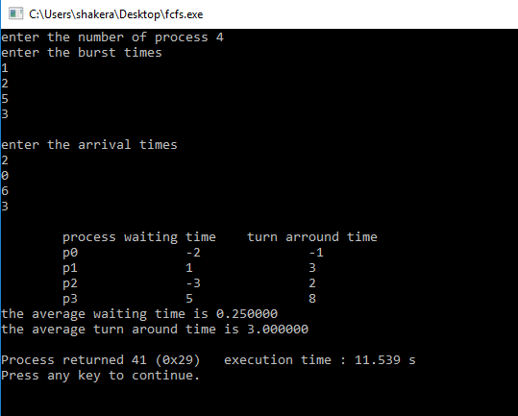

Discussion:

In this lab we learn about cpu scheduling fcfs. This is the very first scheduling that we are learn. FIFO simply queues processes in the order they arrive in the ready queue. Here, the process that comes first will be executed first and next process will start only after the previous gets fully executed.