Experiment No:08

Experiment Name: Priority scheduling algorithm

Aim and Objectives:

Priority scheduling is a non-preemptive algorithm and one of the most common **s**cheduling algorithms in batch systems. Each process is assigned apriority. Process with the highest priority is to be executed first and so on. Processes with the same priority are executed on first come first served basis.

Code:

#include<stdio.h>

int main()

{

int bt[20],p[20],wt[20],tat[20],pr[20],i,j,n,total=0,pos,temp,avg_wt,avg_tat;

printf("Enter Total Number of Process:");

scanf("%d",&n);

printf("\nEnter Burst Time and Priority\n");

for(i=0;i<n;i++)

{

printf("\nP[%d]\n",i+1);

printf("Burst Time:");

scanf("%d",&bt[i]);

printf("Priority:");

scanf("%d",&pr[i]);

p[i]=i+1; //contains process number

}

//sorting burst time, priority and process number in ascending order using selection sort

for(i=0;i<n;i++)

{

pos=i;

for(j=i+1;j<n;j++)

{

if(pr[j]<pr[pos])

pos=j;

}

temp=pr[i];

pr[i]=pr[pos];

pr[pos]=temp;

temp=bt[i];

bt[i]=bt[pos];

bt[pos]=temp;

temp=p[i];

p[i]=p[pos];

p[pos]=temp;

}

wt[0]=0; //waiting time for first process is zero

//calculate waiting time

for(i=1;i<n;i++)

{

wt[i]=0;

for(j=0;j<i;j++)

wt[i]+=bt[j];

total+=wt[i];

}

avg_wt=total/n; //average waiting time

total=0;

printf("\nProcess\t Burst Time \tWaiting Time\tTurnaround Time");

for(i=0;i<n;i++)

{

tat[i]=bt[i]+wt[i]; //calculate turnaround time

total+=tat[i];

printf("\nP[%d]\t\t %d\t\t %d\t\t\t%d",p[i],bt[i],wt[i],tat[i]);

}

avg_tat=total/n; //average turnaround time

printf("\n\nAverage Waiting Time=%d",avg_wt);

printf("\nAverage Turnaround Time=%d\n",avg_tat);

return 0;

}

Output:

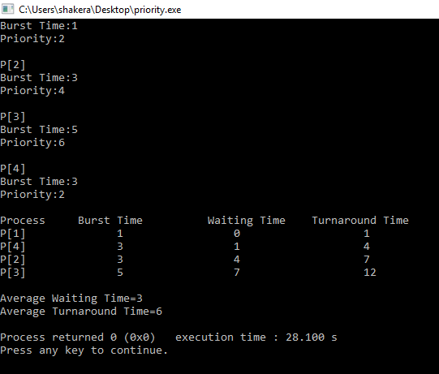

Discussion:

In this lab we learn about priority scheduling algorithm. First input the processes with their arrival time, burst time and priority.Sort the processes, according to arrival time if two process arrival time is same then sort according process priority if two process priority are same then sort according to process number.Now simply apply FCFS algorithm.