Experiment No:09

Experiment Name: Round Robin scheduling Algorithm

Aim and Objectives:

Round-robin (RR) is one of the algorithms employed by process and network schedulers in computing. As the term is generally used, time slices (also known as time quanta) are assigned to each process in equal portions and in circular order, handling all processes without priority (also known as cyclic executive).

Code:

#include<stdio.h>

int main()

{

int count,j,n,time,remain,flag=0,time_quantum;

int wait_time=0,turnaround_time=0,at[10],bt[10],rt[10];

printf("Enter Total Process:\t ");

scanf("%d",&n);

remain=n;

for(count=0;count<n;count++)

{

printf("Enter Arrival Time and Burst Time for Process Process Number %d :",count+1);

scanf("%d",&at[count]);

scanf("%d",&bt[count]);

rt[count]=bt[count];

}

printf("Enter Time Quantum:\t");

scanf("%d",&time_quantum);

printf("\n\nProcess\t|Turnaround Time|Waiting Time\n\n");

for(time=0,count=0;remain!=0;)

{

if(rt[count]<=time_quantum && rt[count]>0)

{

time+=rt[count];

rt[count]=0;

flag=1;

}

else if(rt[count]>0)

{

rt[count]-=time_quantum;

time+=time_quantum;

}

if(rt[count]==0 && flag==1)

{

remain--;

printf("P[%d]\t|\t%d\t|\t%d\n",count+1,time-at[count],time-at[count]-bt[count]);

wait_time+=time-at[count]-bt[count];

turnaround_time+=time-at[count];

flag=0;

}

if(count==n-1)

count=0;

else if(at[count+1]<=time)

count++;

else

count=0;

}

printf("\nAverage Waiting Time= %f\n",wait_time*1.0/n);

printf("Avg Turnaround Time = %f",turnaround_time*1.0/n);

return 0;

}

Output:

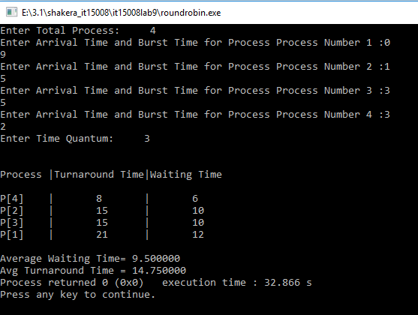

Discussion:

In this lab we learn about round robin scheduling algorithm. It is also known as cyclic executive .The main advantage of round robin algorithm over[first come first serve algorithm](http://javahungry.blogspot.com/2013/04/scheduling-algorithm-first-come-first.html) is that it is  starvation free **.**Every process will be executed by CPU for fixed interval of time (which is set as time slice ) . So in this way no process left waiting for its turn to be executed by the CPU .Round robin algorithm is simple and easy to implement .