Distributed computer system to manage student projects

# User Manual

Version 1.0

15/01/2019

Table of Contents

1. Introduction 1

2. Overview 2

2.1 Conventions 3

2.2 Cautions & Warnings 3

3. Getting Started 4

3.1 Set-up Considerations 4

3.2 User Access Considerations 4

4. Using the System 5

4.1 Student Access 5

4.2 Teacher Access 11

5. Troubleshooting & Support 11

## Introduction

The distributed system for projects is intended for teachers and students. The system will allow for students to upload projects for a specific class to the web server and for teachers to evaluate them. The information system includes an user interface (web browser ), a database where the informations about users, grades, projects, classes will be store and an server application which manages students, projects, grades, classes. The users have access to service only through the web browser. The system will provide the following facilities to students and teachers after they are successfully authenticate [password and identifier]:

- viewing account informations

- editing the account

- students have the possibility to see the courses for selected classes

- students have the possibility to download the courses

- uploading projects by the students and providing the required informations

- a teacher is able to create/delete courses on the platform and upload materials for it(in pdf format)

- a teacher is able to create/delete projects for a specific course, providing for the students details about what they should do for the given project and the deadline for that project

- visualization by the teacher of the source code + documentation for each project uploaded by a student

- teachers are able to give grades and feedback for the viewed projects

Depending on the type of authentication (student, teacher) the user will be allowed some functionality. A student can be enrolled to several courses and work on project for each course and a teacher can coordinate several projects and courses.

## Overview

The application is intended exclusively for teachers and students, only if they create an account. It is an e-learning platform, so it should be used only for educational purposes, not having other goals!

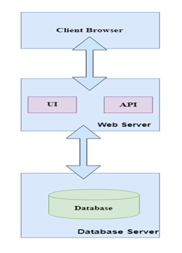

The major functions the product must perform or must let the user perform:

- viewing and editing account informations

- viewing courses created by teachers and downloading the digital files for each course

- viewing specific projects for each course and the requirement document

- uploading projects by the students

- visualization by teacher of the project’s source code + documentation and related informations about upoad of the project: date, student name

-teachers can create/delete courses and projects

- teacher give grades and feedback for viewed projects

### Conventions

|  |  |
| --- | --- |
| **Term** | **Definition** |
| User | Someone interacting with the application. |
| Admin/Administrator | The system administrator who has the specific permission to manage and control the system. |
| C# | A programming language used for application. |
| HTML | HyperText Markup Language |
| CSS | *Cascading Style Sheets* |
| * | Required field |

### Cautions & Warnings

Not applicable

## Getting Started

### Set-up Considerations

Operating System: Windows Vista, Windows 7, Windows 8, Windows 10

Browsers: Google Chrome, Firefox, Internet Explorer, Microsoft Edge, Opera

### User Access Considerations

There are two types of users interacting with the system: students and teachers. Each of these two types of users has a different use of the system, so each of them has different requirements.

Students are able to authenticate in application, can upload projects, edit profiles, change the password, can view courses, can register to a course.

Teachers are able to authenticate in application, edit profile, give grades and leave comments, add/remove courses, add/remove projects, view the projects files and related dates as a student.

## Using the System

### Student Access

#### Register

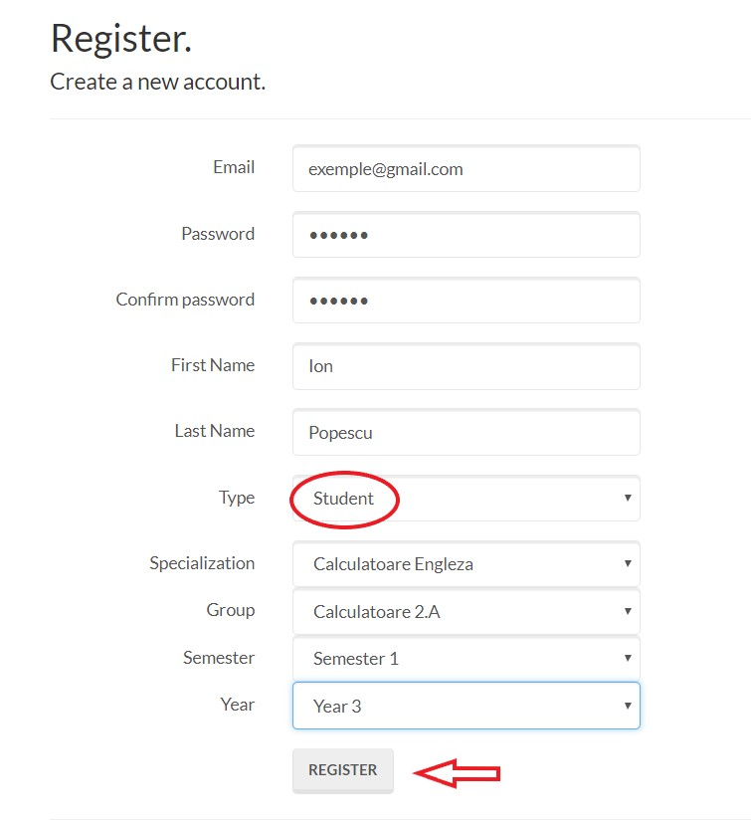

#### Log in

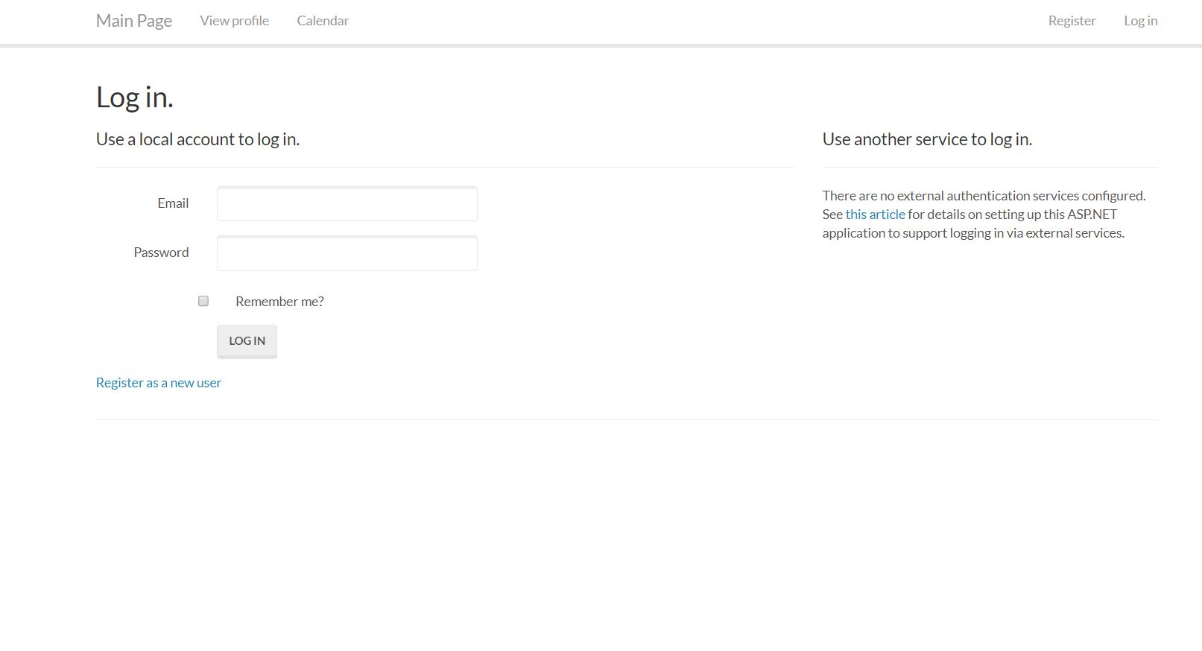

#### Reset Password

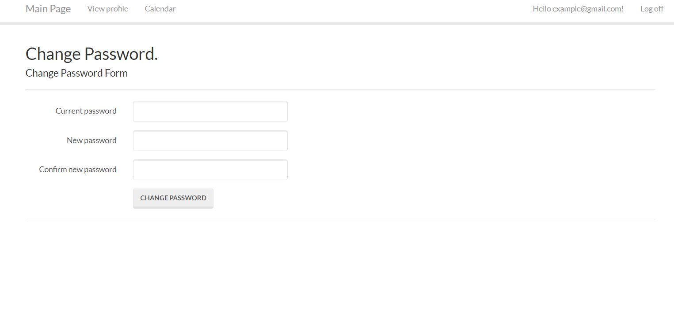

#### Profile edit

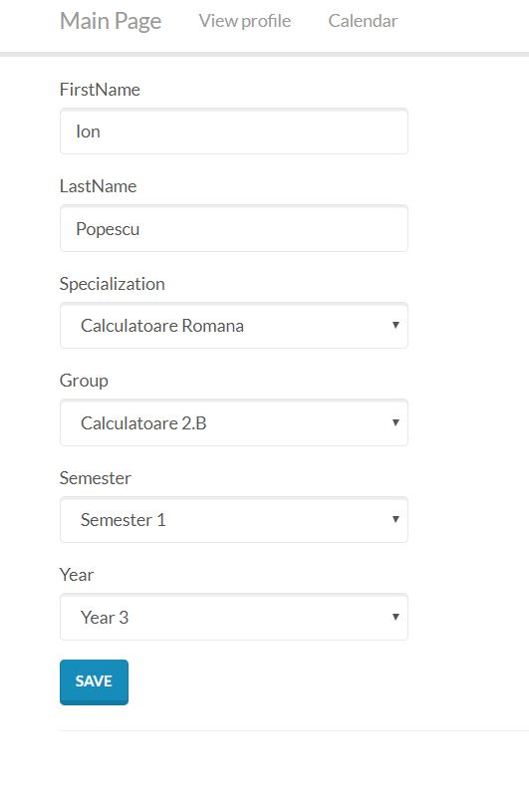

#### Register to a course

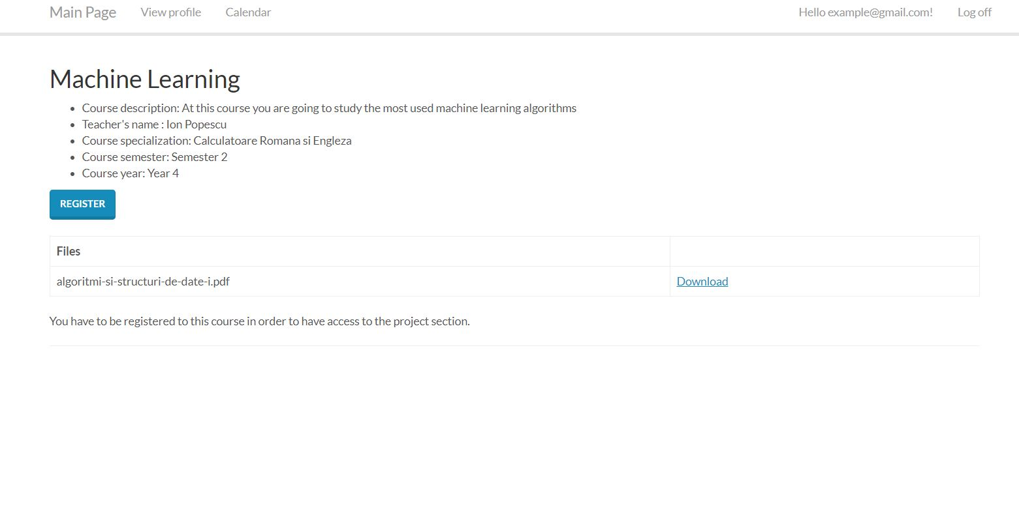

#### View pages of a course after register

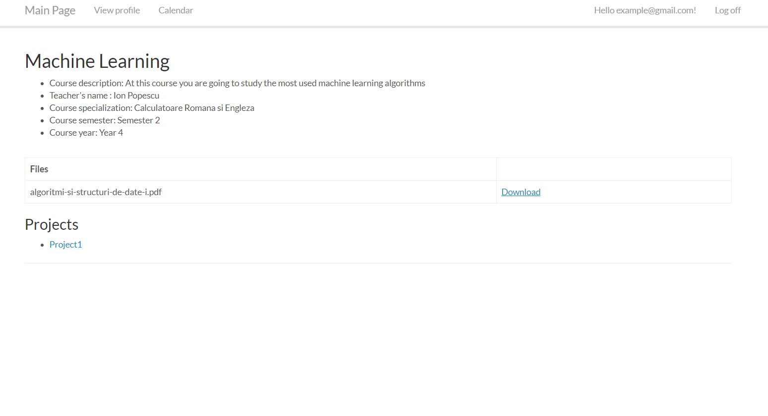

#### View project information

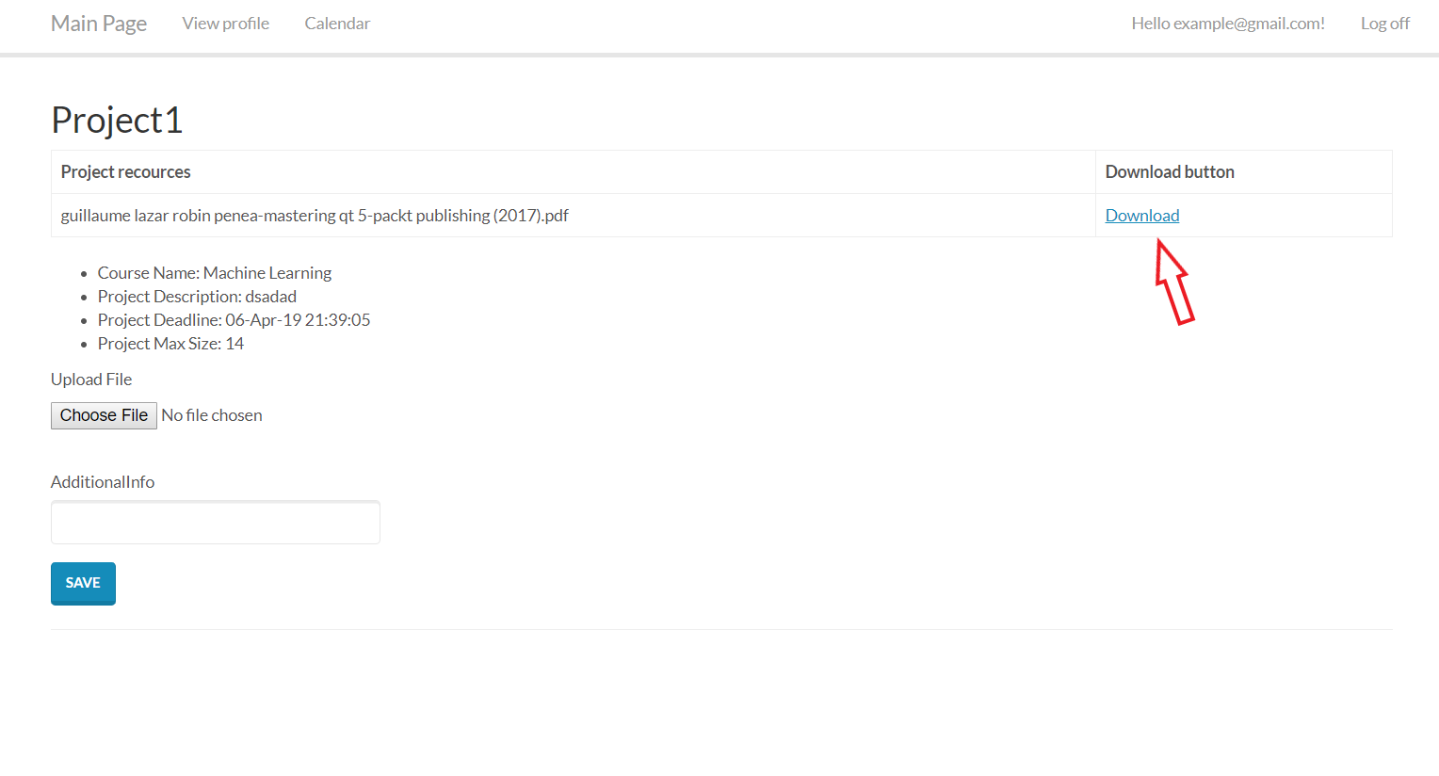

#### Uploading the project

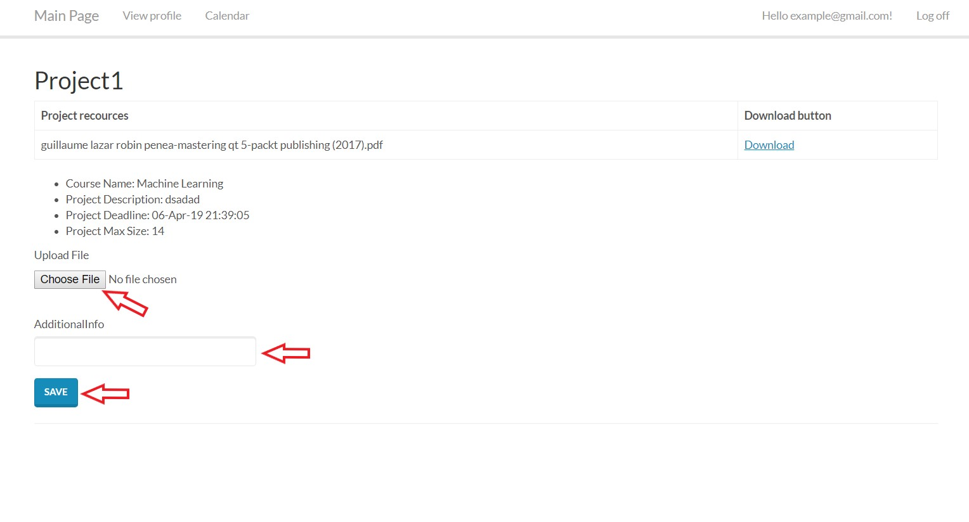

#### Calendar

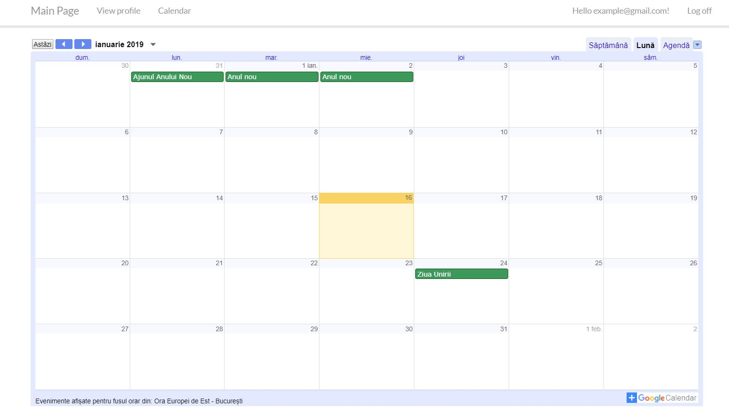

### Teacher Access

#### Register

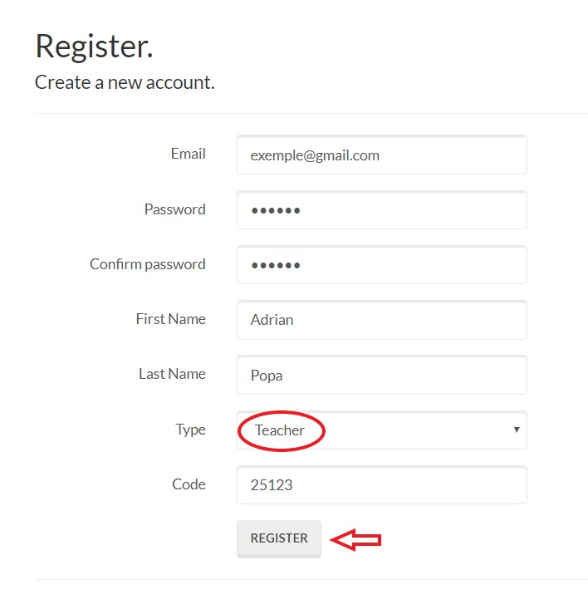

#### Add Course

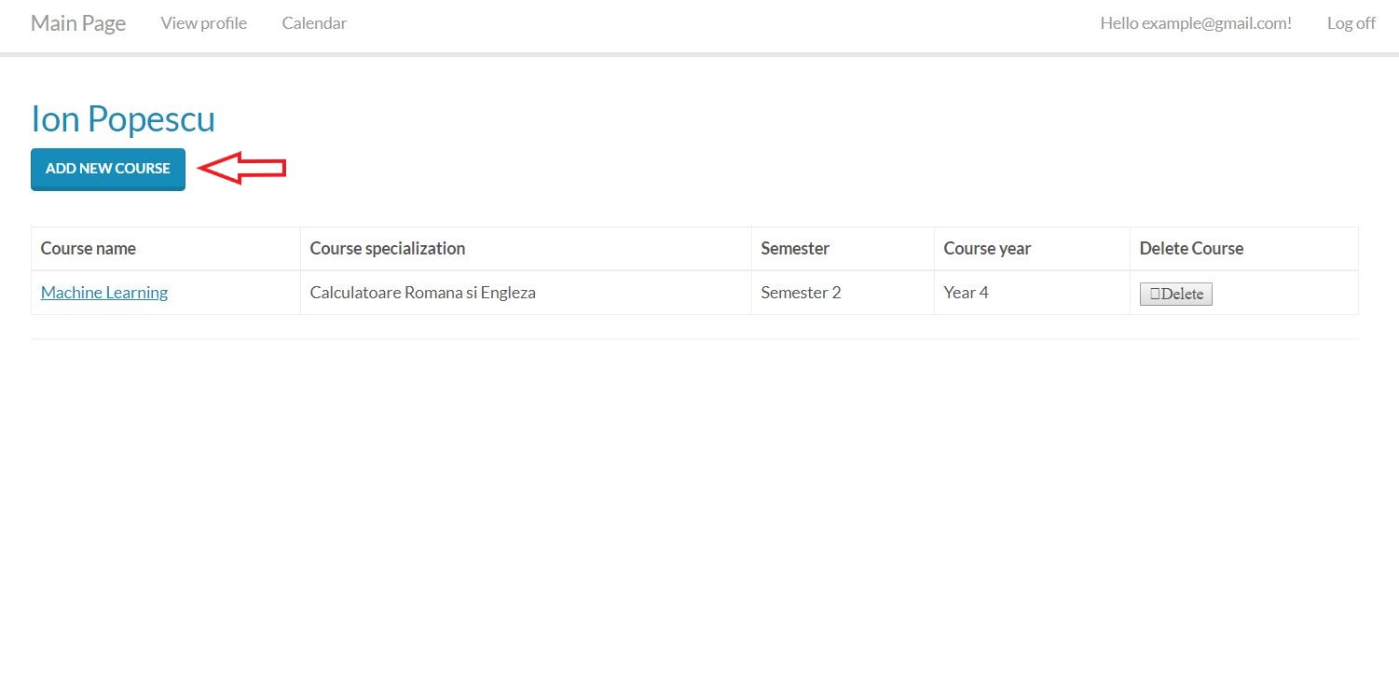

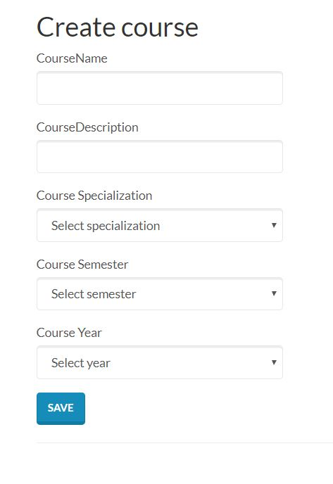

#### Creating a project

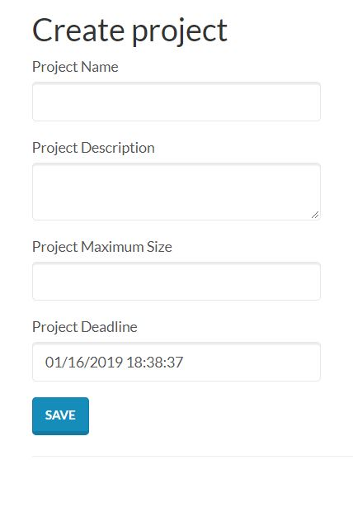

Obs. : Login, reset password and profile edit are the same as at the student.

## Troubleshooting & Support

If you have any further questions that are not in our guide please

contact Support Department.

EMAIL dcs@suppordepartment.com

ROMANIA 1300 145 747