Software Requirements Specification
for
Distributed computer system
to manage student projects

Version 1.0 approved
Malea Cristina
Mihut Lorenzo
Ticusi-Harsovescu Luca
Faculty of Automation, Computers and Electronics
29.10.2018
Table of Contents
Table of Contents ii
Revision History ii
1. Introduction 1
1.1 Purpose 1
1.2 Document Conventions 1
1.3 Intended Audience and Reading Suggestions 1
1.4 Product Scope 2
1.5 References 2
2. Overall Description 2
2.1 Product Perspective 2
2.2 Product Functions 3
2.3 User Classes and Characteristics 3
2.4 Operating Environment 3
2.5 Design and Implementation Constraints 3
2.6 User Documentation 3
2.7 Assumptions and Dependencies 3
3. External Interface Requirements 4
3.1 User Interfaces 4
3.2 Hardware Interfaces 6
3.3 Software Interfaces 6
3.4 Communications Interfaces 6
4. System Features 6
4.1 System Feature 1 7
4.2 System Feature 2 (and so on) 7
5. Other Nonfunctional Requirements 21
5.1 Performance Requirements 21
5.2 Safety Requirements 21
5.3 Security Requirements 21
5.4 Software Quality Attributes 21
5.5 Business Rules 21
6. Other Requirements 22
Appendix A: Glossary 22
Appendix B: Analysis Models 22
Appendix C: To Be Determined List 23

Revision History
Name | Date | Reason For Changes | Version
Malea Cristina Mihut Lorenzo  Ticusi-Harsovescu Luca | 29.10.2018 | - | 1.0
Malea Cristina Mihut Lorenzo
Ticusi-Harsovescu Luca

Introduction

Purpose
The computer system will allow students to submit on-line projects to teachers (upload facility) and teachers to evaluate them. The information system includes a user interface (web browser or dedicated application), a database server that stores information about students, students, notes, application server that manages students, projects, notes and a Web server. The user has access to service only through the user interface. The system will provide facilities for students and teachers after they successfully authenticate [password and identifier] (identifier and password already known):
- viewing account information
- changing the password
- uploading projects by the student and entering the required information
- visualization by the teacher of the project files and related information, date, student name
- teacher notes and comments projects of students
Depending on the type of authentication (student, teacher) the user will be allowed some functionality. A student can have several projects and a teacher can coordinate several projects.

Document Conventions
- the document is written in Times New Roman font and font size of 12
- high-level requirements are written with Heading 1, and those inherited with Heading 2

Intended Audience and Reading Suggestions
The document is intended for developers, project managers, users, testers, and documentation writers. The rest of this document includes 5 chapters:

- Overall Description: provides a general overview of the functionality of the application. This chapter also introduces different types of users and their interaction with the application. Moreover, the chapter also mentions the constraints of the application.

- External Interface Requirements: describes the different interfaces used in the application(User Interface, Hardware Interface, Software Interface and Communication Interfaces)

- System Features: this chapter describes requirements used in application

- Other Nonfunctional Requirements: includes performance, safety and security requirements, software quality attributes and business rules

- Other Requirements: describes all the terms necessary to properly interpret the SRS, including acronyms and abbreviations, class diagrams.

Product Scope
The distributed computer system is intended for teachers and students. All the system is stored in a database that is located on a web server (IIS from Microsoft integrated in Visual Studio Comunity).
The system will provide facilities for students and teachers after they successfully authenticate [password and identifier] (identifier and password already known):
- viewing account information
- changing the password
- uploading projects by the student and entering the required information
- visualization by the teacher of the project files and related information, date, student name
- teacher notes and comments projects of students

References
[1] http://didactica.ucv.ro/
[2] https://www.pluralsight.com/
[3] https://www.udemy.com/
[4] https://www.safaribooksonline.com/
[5] https://stackoverflow.com/

Overall Description

Product Perspective
This application is a replacement for a certain existing system ( http://didactica.ucv.ro/ ).
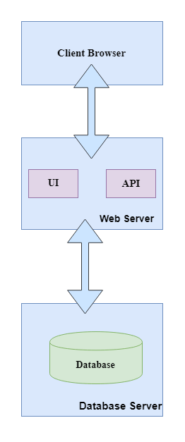

Product Functions
The major functions the product must perform or must let the user perform:
- viewing account information
- changing the password
- uploading projects by the student and entering the required information
- visualization by the teacher of the project files and related information, date, student name
- teacher notes and comments projects of students

User Classes and Characteristics
There are two types of users interacting with the system: students and teachers. Each of these two types of users has a different use of the system, so each of them has different requirements.

Students can log in application, can upload projects, edit profile, change the password, can view courses, log out in the platform.

Teachers can log in, edit profile, give notes and comments, add curses, and view the project files and related dates as a student name.

Operating Environment
Operating System: Windows Vista, Windows 7, Windows 8, Windows 10
Browsers: Google Chrome, Firefox, Internet Explorer, Microsoft Edge, Opera

Design and Implementation Constraints
Programming environment: Visual Studio Community
Programming language (back-end): C#, ASP.NET MVC
Front-end: HTML5, CSS3, Bootstrap, jQuery
Data base: SQL Server by Microsoft

The client (Faculty of Automation, Computers and Electronics) will be responsible for maintaining the delivered software.

User Documentation
Document delivered at the end: IEEE Software Requirements Specifications instead user manul.

Assumptions and Dependencies
The uploaded document must be RAR and have 8MB.

External Interface Requirements

User Interfaces
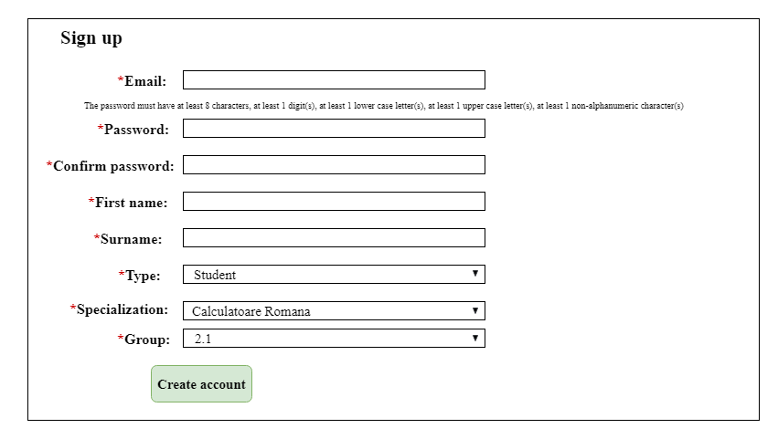

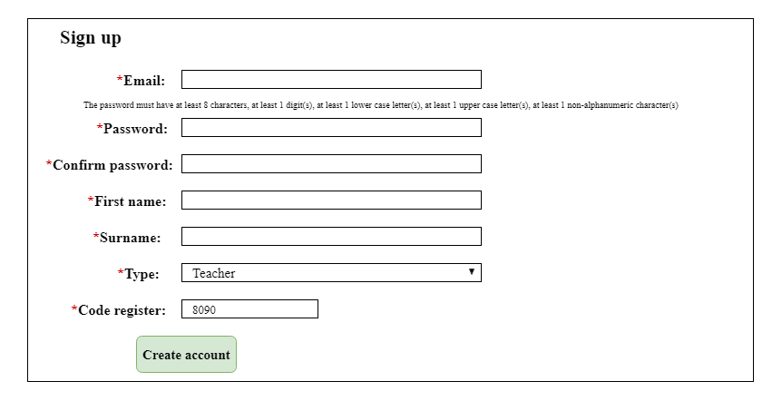

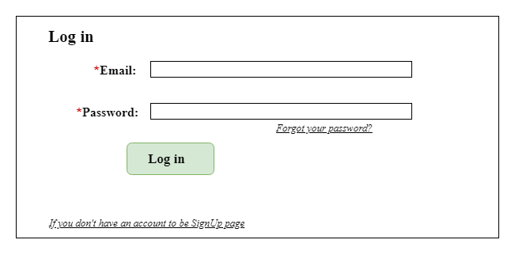
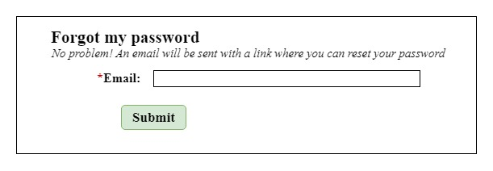
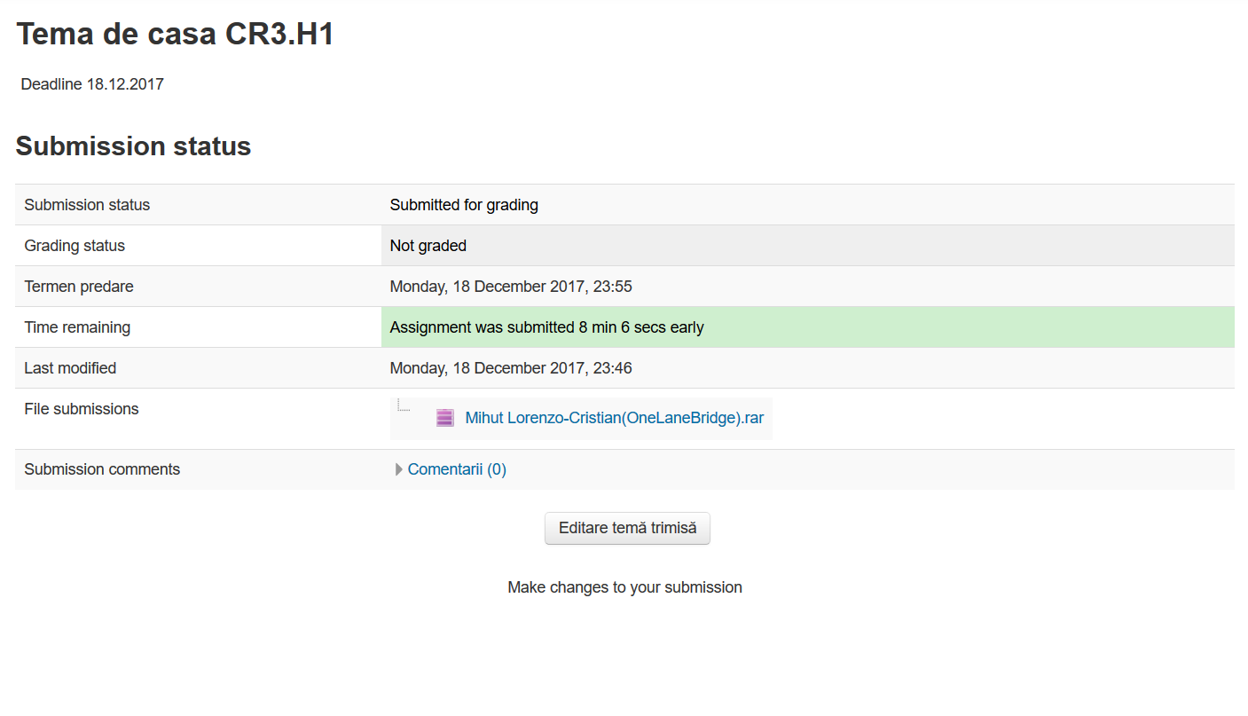

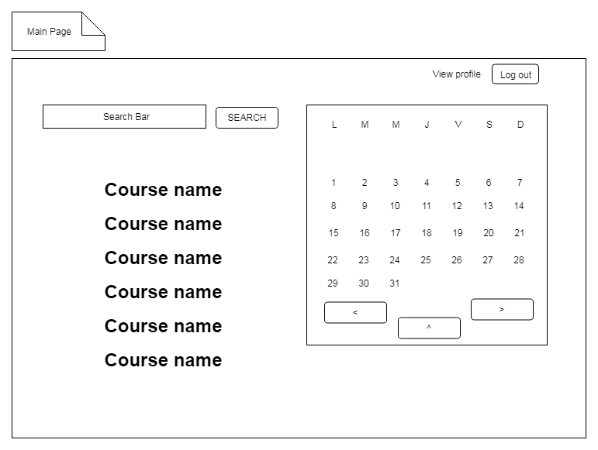
Hardware Interfaces

Software Interfaces
The communication between the database and the application consists in the operation of reading, deleting and modifying data.

Data base: SQL Server by Microsoft
Programming environment: Visual Studio Community
Programming language (back-end): C#, ASP.NET MVC
Front-end: HTML5, CSS3, Bootstrap, jQuery

Communications Interfaces
Hypertext Transfer Protocol (HTTP) is the most commonly used method for accessing Internet information that is stored on World Wide Web (WWW) servers.
On the server side we will use ASP.NET, using as C # programming language.

System Features

Requirements for student

Sign up
4.1.1 Description and Priority
Sign up is a functionality that allows the student to create a user account that will be stored in the database in the 'Student' table through which he / she will log in later. The dropdown on that page must have the selection The student account is made up of the student's first and last name, the email address through which he or she can log in the system or change his / her password if he / she forgot it, the password of the account, the reconfirmation password, student specialization, and group. Priority of this functionality on a scale of 1 to 10 is 10.
4.1.2 Stimulus/Response Sequences
Inputs: In the sign up page you will find text-fields that have to be filled in with the following information: name, first name, email address, password, confirmation of the password and specialization, group, and a dropdown in which it is selected as 'Student' which click the 'Save' button.
Output: If all text-fields are completed, after pressing the 'Save' button, the log-in page will appear. In the negative case, an error will be displayed with the fields to be filled in.
4.1.3 Functional Requirements
REQ-1: Validates each of the textfields on the page using the 'Public ActionResult ValidateSignUp ()' prototype that will redraw the textfields that do not have the right value for validation.

REQ-2: Call the function with the 'Public ActionResult SignUp (Student Student)' prototype that will take student information from the text-pages of 'SignUp' if any student information is specified.

REQ-3: Use a validation function for the existence of a user with the same email
address that has the public boolean ExistAnotherUser (string email) prototype that will check whether there is a record in the 'Students' table that has the same email as the the student. If no match is found, the student will be added to the Students' database using the 'DbContext' class' Add (student) 'followed by the' SaveChange () 'function. an error message.

Log in
4.2.1 Description and Priority
Logon functionality allows the student to log on to the platform if the student already has a user account and can log in using the email address and password. The priority of this functionality on a scale of 1 to 10 is 10.
4.2.2 Stimulus/Response Sequences
Inputs: In the stunning login page you must enter the name of your email address and password and click on the 'Log in' button.
Output: If the student enters the correct email address and password, the 'MainPage' page of the account is uploaded or an error message is displayed in the event.
4.2.3 Functional Requirements
REQ-4: Validates each of the textfields on the page using the 'Public ActionResult ValidateLogIn ()' prototype that will redraw the textfields that do not have the right value for validation.

REQ-5: Use a comparison function that has the 'Public ActionResult CompareWithPassword (Student student)' public prototype that will truly return if there is a record in the table that has the same email and password as those given. If there is a match 'MainPage' is loaded, and in case of error 'Email or password is incorrect'.

Reset password
4.3.1 Description and Priority
Password reset functionality gives the student the possibility to reset the password if he does not remember it. In the 'Log in' window, he will find a link to 'Forgot your password?' Which, if you access will redirect it to the password reset window where you will need to enter your email address and press the submit button to send it to your email address with a link containing the password reset page. The student must enter your personal email address, access the link that will open the 'ResetPassword' window, where the user will enter the new password and confirm it, then click the submit button to change the password in the database corresponding to the email address. The priority of this functionality on a scale of 1 to 10 is 5.
4.3.2 Stimulus/Response Sequences
Inputs: Access the link in the 'Forgot your password' log that will redirect you to the password reset page. Enter the user address in the text-field and click Submit to send an email to that address with the password reset page link. Access the email address and click the link to open the 'ResetParola' window. The user enters the new password and reconfirm it.
Output: In the 'Student' table, the student's password is changed to that specified by the student, and the user can try again to log in.
4.3.3 Functional Requirements
REQ-6: Access the 'Forgot your password?' Link using the 'Html.ActionLink (..)' function in the 'LogIn' view to open the password reset window.

REQ-7: In the 'ForgotPassword' window enter the student's email address through which log in the system and click the 'Submit' button. so it will call the function that has the public void SendEmailToChangeStudentPassword (string email) prototype that will send an email with the link page 'ResetPassword' and will search the student's database with the appropriate email address. If he finds it, send the student to the 'ResetParola' view. If the email address is not found in the table, it displays a 'Student not having an account with that email address' error message.

REQ-8: After entering the email address and accessing the link, in the 'ResetParola' window the student enters the new password and confirms it, then click on the 'Submit' button that accesses the public action ActionResult ResetPassword (Student student ) which will update the database with the student's new password.

Profile edit
4.4.1 Description and Priority
Profile editing functionality offers the student the ability to edit account data, such as changing the name, surname, password, as well as the specialization and the section to which it belongs. The priority of this functionality on a scale of 1 to 10 is 3.
4.4.2 Stimulus/Response Sequences
Inputs: The student accesses the link on the 'StudentProfile' page for 'Edit profile' which opens the data change page where it can change the name, surname, password, specialization, and group.
Output: Student profile data is changed.
4.4.3 Functional Requirements
REQ-9: Validate the student input of the new data profile values.

REQ-10: Call the function with the 'Public ActionResult UpdateStudentProfile (Student Student)' public prototype that interrogates the database to extract the student's data, which is replaced with new student input values ​​in the graphical interface, followed by storing new values ​​in the base data.

4.5 View profile
4.5.1 Description and Priority

The profile visualization functionality gives the student the opportunity to view information about profile data, view the list of courses the student enrolls, as well as the information about the projects the student has uploaded to this platform. The priority of this functionality on a scale of 1 to 10 is 5.

4.5.2 Stimulus / Response Sequences

Inputs: The student accesses the link at the top right of the page that leads him to the personal information page of the student

Output: The student has the opportunity to view the profile data, the courses to which he / she is enrolled and the status of the projects he has uploaded to some subjects.

4.5.3 Functional Requirements

REQ-11: The function is called with the 'Public ActionResult GetStudentProfileInformation ()' prototype that interrogates the database using the sql query to obtain the student's student data, and then they are sent 'StudentProfile' pages.

REQ-12: The function is called with the 'Public ActionResult GetStudentRegisteredCourses ()' prototype that interrogates the database using the sql query to get links to the course pages to which the student is enrolled, if found, 'StudentProfile' pages are found.

REQ-13: The function is called with the 'Public ActionResult GetStudentProjectInformations ()' prototype that interrogates the database using a sql query to get information about the projects that the student has uploaded to various courses, if found, they are sent ' StudentProfile '.

Search courses in the main page
4.6.1 Description and Priority

Search functionality for 'MainPage' courses gives the student the opportunity to find the course you are looking for if he exists and possibly to access the course page. The priority of this functionality on a scale of 1 to 10 is 4.

4.6.2 Stimulus / Response Sequences

Inputs: Being in the main page, the student enters the name of the course you are looking for in the search bar and click the 'Search' button for search

Output: If the course with the student's name is found, it is displayed on the page

4.6.3 Functional Requirements
REQ-14: The function called the Public ActionResult GetCourseByName prototype (string courseName) which queries the database to find the course with the desired name.If the course exists, it is displayed on the main page and in the opposite case is displayed message 'The course with the name <courseName> does not exist'.

4.7 Viewing pages of a course
4.7.1 Description and Priority

The functionality of viewing pages of a course has two cases. If the student is enrolled in the course he / she has the possibility that after finding a course and accessing the link that leads him to the course page, the student can view informatiille as: the name of the course, the name of the teacher teaching the course, a short a description of the course, a link to the teacher's personal page where the student can find the courses the teacher handles, additional files attached to the course, such as project notes or the project requirements document, as well as links to the student groups who they have this course through which students can upload their projects. If the student is not enrolled in the course, only the name of the course is displayed, the teacher teaching the course and a brief description of the course, as well as the option to enroll in course. The priority of this functionality on a scale of 1 to 10 is 7.

4.7.2 Stimulus / Response Sequences

Inputs: From the 'MainPage' page, the student accesses the course link x.

Output: The 'Mainpage' page is open and the student can view the course information.

4.7.3 Functional Requirements

REQ-15: The function is called with the prototype 'pubic bool IsStudentRegisteredAt (int coursed) which checks in the database through a sql query if the student is enrolled in the course.

REQ-16: The function is called with the public prototype ActionResult GetCourseInfo (int courseId) who interrogates the database to find the course with id == courseId from where, if the student is enrolled in this course, the name of the course is extracted, the name of the teacher teaching the course, a link to the teacher's page, a brief description of the course, additional files attached to the course, and links to the groups of students who have this course, and if the student is not enrolled, the name of the course is displayed, the name of the teacher, a short description of the course and a button for the student to be able to enroll in the course.

4.8 Enrollment in the course
4.8.1 Description and Priority

Student enrollment functionality offers the student the opportunity to enroll in the course, thus having the opportunity to read the courses, the professor's files, and upload the projects on the platform. The priority of this functionality on a scale of 1 to 10 is 10.

4.8.2 Stimulus / Response Sequences

Inputs: From the 'Mainpage / Curriculum' page, the student enters the course enrollment button.

Output: The student is shown the 'Course registration succeded' message, and the page is refreshed with all the details of the course.

4.8.3 Functional Requirements

REQ-17: Clicking the 'Register' button calls the function with the public 'ActionResult RegisterToCourse' (int course, string email) prototype that sets the registration flag to this course on 'true' and saves it in the database.

REQ-18: The 'MainPage / CourseName' page is reloaded, the student having access to all course details.

4.9 Log out from the course
4.9.1 Description and Priority

The de-registration functionality of a course offers the student the option of not being enrolled in the course. . Priority of this functionality on a scale of 1 to 10 is 2.

4.9.2 Stimulus / Response Sequences

Inputs: From the 'MainPage / StudentProfile' page, the student accesses the 'Unregistered' button displayed on the right of the link for each course displaying a dialog to ask the student 'Are you sure you want to unregistered from this course?'.

Output: The student is not enrolled in the course.

4.9.3 Functional Requirements

REQ-19: Clicking the 'Unregister' button opens the dialog box that displays 'Are you sure you want to unregistered from this course?'.

REQ-20: If the student chooses the 'Yes' option in the dialog box, the 'CourseRegister' flag is set to 'false'. Otherwise, nothing happens

4.10 View calendar
4.10.1 Description and Priority

Calendar view functionality offers the student the opportunity to view the current date as well as the weekly distribution of the current month or the selection of another month using the left-right arrows at the bottom of the calendar. The current day will have the red border. which teacher adds a project to a subject and the student enrolls at that course, the day for the deadline for that project will appear in the calendar and will have the red contour to help the student to recall the project. was the deadline passed, then that day will be no longer marked. The priority of this functionality on a scale of 1 to 10 is 6.

4.10.2 Stimulus / Response Sequences
Inputs: When you press the left arrow at the bottom of the calendar, you select the previous month and when selecting the right arrow the next month is selected. These operations can be applied recursively.

Output: The student will see all the days of the current month and the information (if any) about the month

4.10.3 Functional Requirements

REQ-21: Clicking the '<' button will call the function with the public 'ActionResult PreviewMonth ()' prototype that will display the previous month in the calendar.

REQ-22: Pressing the arrow button '>' will call the function with the public 'ActionResult NextMonth ()' prototype that will display in the calendar the following month.

REQ-23: Clicking on a day in the calendar calls the 'public ActionResult GetCalendarDayDetail (Data Date)' function that will open a small text window where information about these days will appear if they exist, such as project information and its deadline.

4.11 View project information
4.11.1 Description and Priority
The functionality of viewing the project information gives the student the opportunity to see information such as: the homework name for the 'x' group, the deadline, whether the project was accepted or not, the student's grade on the project, the date on which it was the last time uploaded, the time remaining until the deadline and the download of the project files for viewing and the comments left by the teacher on the project. The priority of this functionality on a scale of 1 to 10 is 9.

4.11.2 Stimulus / Response Sequences

Inputs: From the 'MainPage / CourseXPage' page, the student selects the link to the name of the group to which he / she is enrolled.

Output: The student is shown the details of the project, as well as the possibility to download the archive with the project if it has been uploaded with a simple click on it.

4.11.3 Functional Requirements

REQ-24: When loading the 'MainPage / CourseName /GroupName / ProjectDetails' pages, the existing project details are extracted from the database using the 'Public ActionResult geProjectDetails (int id)' function that displays the project information on the page.

REQ-25: Clicking on the project name link will call the function with the 'public void SendProject ()' prototype that sends the archive to the student through the Internet.

4.12 Uploading the project / re-uploading the site
4.12.1 Description and Priority

The functionality of uploading the project is made from the 'MainPageCourseName / ProjectDetails' page by clicking on the 'Browse' button that allows us to select the project archive from the computer, then click the 'Upload / Re-upload' button that loads the projection on the server The project can not be loaded after the deadline, the Upload / Re-upload button becomes inactive after the time remaining up to the deadline becomes 0. The priority of this functionality on a the scale of 1 to 10 is 10.

4.12.2 Stimulus / Response Sequences

Inputs: The student selects the project he / she wants to upload to the server.

Output: The student has the project on the server and can be evaluated by the teacher if the dealine has expired or can be edited by the student if the deadline has not expired.

4.12.3 Functional Requirements

REQ-26: When the 'Upload / Re-upload' button is clicked, the function is called 'public bool ValidateProjectType' which checks if our project is archived with the extension '* .rar'. Otherwise, the project is not uploaded displays the error message 'The project could not be uploaded because it is not a rar file'.

REQ-27: When you click the 'Upload / Re-upload' button, the function is called with the 'public bool ValidateProjectDimension ()' prototype that checks that the project size is less than 5MB. Otherwise, the project is not uploaded and the error message 'The project could not be uploaded because it is larger than 5MB' is displayed.

REQ-28: If the student still has a project uploaded to the server, it is overwritten by the current project. Verifying the existence of a project on the site is done through the function with the prototype 'public bool ProjectForStudentExist ()' which will delete the new old project, and the new one will be loaded into the project folder.

REQ-29: Using the function with the prototype 'public void AddProject (string path, int Id, string courseName)', a new database entry will be made, memorizing 'path' that is the path to the student id project with id who uploaded it to 'courseName'.

REQ-30: Use the 'public ActionResult AddReferenceToProject ()' function that will make the link to the project name on the web page an anchor that will reference the path to the project from the database.

REQ-31: When clicking on the project name link on the '... CourseName / ProjectDetails' page, you will call the 'public void DownloadProject (string path)' function, which will download the project from the application server to the student device on which has accessed the link.

4.13 Log out
4.13.1 Description and Priority

The logout functionality makes the student log out of the application, and on a new visit, the logon page will open to enter login data. The priority of this functionality on a scale of 1 to 10 is 10.

4.13.2 Stimulus / Response Sequences

Inputs: Any page where the student is.

Output: Log out page

4.13.3 Functional Requirements

REQ-32: When clicking the 'Log out' button, call the public void LogOut () function '
REQ-33: Call the function with the public prototype 'ActionResult GetLoginPage ()'
which will give you the login page.

Requirements for teacher

4.14 Sign up
4.14.1 Description and Priority

Sign up is a feature that allows the teacher to create a user account that will be stored in the database in the 'Teachers' table through which the user will log in later. The dropdown on that page must have the selection The 'User' consists of the teacher's first and last name, the email address through which he or she can log in or change his password if he forgot it, the password of the account , the reconfirmation of the password, and a code that the teacher receives from the platform administrator to prevent students from being able to account for their teacher. Priority of this functionality on a scale of 1 to 10 is 10.

4.14.2 Stimulus / Response Sequences

Inputs: On the sign-up page you will find text-fields that have to be filled in with the following information: name, first name, email address, password, password confirmation, code received from the administrator and a dropdown in which it is selected as' then click the 'Save' button.

Output: If all text-fields are completed, after pressing the 'Save' button, the log-in page will appear. In the negative case, an error will be displayed with the fields to be filled in.

4.14.3 Functional Requirements

REQ-34: Validates each of the textfields on the page using the 'Public ActionResult ValidateSignUpForProfesor ()' function, which will redraw the textfields that do not have the right value for validation.

REQ-35: Call the function with the 'public bool IsProfesorCodeCorect' (ProfessorCode) 'prototype that compares the teacher code entered on the sign-up page with the database. If the codes are the same one goes, and in otherwise the error message 'Teacher code is incorrect!'

REQ-36: Use a validation function for the existence of a user with the same email address that has the public boolean ExistAnotherUser (string email) prototype that will check if the Profesors tab has a record that has the same email as the teacher. If no match is found, the teacher will be added to the 'Profesors' table through the 'DbContext' class 'Add (student)' followed by the 'SaveChange ()' function. an error message.

REQ-37: Call the function with the 'Public ActionResult SignUp' (Teacher Professor) public prototype that will take the student information from the text-pages of 'SignUp' if each teacher's information is specified.

4.15 Log in
4.15.1 Description and Priority

Logon functionality gives the teacher the opportunity to log on to the platform, if the teacher already has a user account, it can log in using the email address and password. The priority of this functionality on a scale of 1 to 10 is 10.

4.15.2 Stimulus / Response Sequences

Inputs: In the log page, the teacher must enter the name of the email address and password and then click on the 'Log in' button.

Output: If the teacher inserts the correct email address and password, the 'MainPageProfesor' account's page is loaded, or an error message is displayed in the event.

4.15.3 Functional Requirements

REQ-38: Validates each of the textfields on the page using the 'Public ActionResult ValidateLogIn ()' prototype that will redraw the textfields that do not have the right value for validation.

REQ-39: Use a comparison function that has the 'Public ActionResult CompareWithPassword (Professor Professor)' public prototype that will truly return if there is a record in the table that has the same email and password as those given. If there is a match "MainPageProfessor" is loaded, and in case of error message 'Email or password is incorrect'.

4.16 Reset Password
4.16.1 Description and Priority

Password reset functionality gives the teacher the ability to reset the password if he does not remember it. In the 'Log in' window, it will find a link to 'Forgot your password?' Which, if you access will redirect it to the password reset window where you will need to enter the email address and press the submit button to send it to its email address with a link containing the password reset page.The teacher must enter your personal email address, access the link that will open the 'ResetPassword' window, where the user will enter the new password and confirm it, then click the submit button to change the password in the database corresponding to the email address. The priority of this functionality on a scale of 1 to 10 is 5.

4.16.2 Stimulus / Response Sequences

Inputs: Access the link in the 'Forgot your password' log that will redirect you to the password reset page. Enter the user address in the text-field and click Submit to send an email to that address with the password reset page link. Access the email address and click the link to open the 'ResetParola' window. The user enters the new password and reconfirm it.

Output: In the 'Professors' table, the teacher's password is changed and the user can try again.

4.16.3 Functional Requirements

REQ-40: Access the 'Forgot your password?' Link using the 'Html.ActionLink (..)' function in the 'LogIn' view to open the password reset window.

REQ-41: In the 'ForgotPassword' window enter the email address of the teacher through which you log in to the system and click the 'Submit' button. so we will call the function that has the public void SendEmailToChangeProfessorPassword (string email) prototype that will send an email with the link page 'ResetPassword' and will search the teacher with the corresponding email address in the database. If he finds it, Send the 'ResetareParola' professor's view. If the email address is not found in the table, an error message 'Profesors does not have an account with that email address' is displayed.

REQ-42: After entering the email address and accessing the link, in the 'ResetParola' window the student enters the new password and confirms it, then click on the 'Submit' button that accesses the public action ActionResult ResetPassword (Student student ) which will update the database with the student's new password.

4.17 Edit profile
4.17.1 Description and Priority

Profile editing functionality offers the teacher the ability to edit account data, such as changing the name, surname, and password. The priority of this functionality on a scale of 1 to 10 is 3.

4.17.2 Stimulus / Response Sequences

Inputs: The teacher accesses the link on the 'MainPageProfessor / ProfessorProfile' page for 'Edit profile' which opens the data change page where it can change the name, surname, password

Output: Teacher profile data is changed.

4.17.3 Functional Requirements

REQ-43: Validate the information entered by the student corresponding to the new values ​​of the profile data.

REQ-44: Calls to the public prototype 'ActionResult UpdateProfessorProfile (Professor Professor)' which interrogates the database to extract the student's data, which is replaced by the student's new values ​​in the graphical interface followed by storing the new values ​​in the data.

4.18 View profile
4.18.1 Description and Priority

Profile visualization functionality provides the teacher with the opportunity to view information about profile data, view the list of courses he / she teaches and possibly create / edit / delete new courses, as well as the ability to view the projects submitted by the students grouped after the course, the specialization of the students and the group they belong to. The priority of this functionality on a scale of 1 to 10 is 10.

4.18.2 Stimulus / Response Sequences

Inputs: The teacher is on the login page.

Output: The teacher has the opportunity to view the profile data, the courses he / she teaches and the projects he / she has received.

4.18.3 Functional Requirements

REQ-44: The function is called with the public 'ActionResult GetProffesorProfileInformation ()' prototype that interrogates the database using the sql query to obtain the teacher's user data and then they are sent pages.

REQ-44: The function is called with the 'Public ActionResult GetProfessorCourses ()' prototype that interrogates the database using a sql query to get links to the courses that the teacher teaches.

REQ-45: The function is called with the 'public ActionResult GetProjects ()' prototype that interrogates the database using a sql query to obtain information about the projects received from the student, which will be sorted by the course name, the specialization to which taught the course and the group of students.

4.19 Add Course
4.19.1 Description and Priority

The course add-on functionality gives the teacher the opportunity to go from the main page and by clicking the 'Add Course' button, the teacher creates a new course, providing the information needed to describe the course as: course name, teacher name, course description, link to personal page page course as well as the possibility of adding additional course files. The priority of this functionality on a scale of 1 to 10 is 8.

4.19.2 Stimulus / Response Sequences
Inputs: The teacher is in the main page, accesses the button to create a course and opens the course creation page, where it should add the course information.

Output: After adding all the information about a course, the teacher click on the 'Add' button to add the course to the database.

4.19.3 Functional Requirements

REQ-46: The function is called with the public 'ActionResult AddCourse ()' prototype that loads the course creation page.

REQ-47: The function is called with the 'Public ActionResult SaveCourse ()' prototype that validates as the inputs given by the teacher and then takes the course information and saves it in the database.

4.20 Delete Course
4.20.1 Description and Priority

The course deletion function offers the teacher the opportunity to delete a course if he / she does not teach at the faculty. Deleting the course will also delete the projects at that course. The priority of this functionality on a scale of 1 to 10 is 6.

4.20.2 Stimulus / Response Sequences

Inputs: The teacher is in the main page, access the button attached right to each course to delete.

Output: A dialog box is displayed with a dropdown with the name of all the teacher's courses, and by selecting a course and clicking on the 'Delete' button, any record in the database related to that course is deleted.

4.20.3 Functional Requirements

REQ-48: The function is called with the public 'ActionResult DeleteCourse ()' prototype that loads the course deletion page.

REQ-49: The function is called with the 'Public ActionResult DeleteCourse (string courseName)' prototype that searches the course that belongs to the teacher with the name of the courseName and through a sql command is deleted that record and all the records that are related to it .

4.21 Creating a project at a particular course
4.21.1 Description and Priority

The project creation functionality offers the teacher the opportunity to create a page where students can load their projects for a specific curse. At the creation of the project, the teacher must specify the name of the course to which the project is designed, a pdf file with project requirements, of the project. The priority of this functionality on a scale of 1 to 10 is 9.

4.21.2 Stimulus / Response Sequences

Inputs: The teacher is in the main page, access the button attached at the top right to create the project.

Output: A new page is opened where the teacher has to enter the course name of the project, load the pdf file with requirements and specify the deadline for that project.

4.21.3 Functional Requirements

REQ-50: The function is called with the 'public ActionResult CreateProject ()' prototype that loads the course deletion page.

REQ-51: The function is called with the 'public ProjectResult CreateAProject (Project projectName)' prototype that presses the 'CreateProject' button to create a new project database.

4.22 Granting notes to projects submitted by students
4.22.1 Description and Priority

Note-giving functionality gives the teacher the opportunity to note, after viewing the projects from students, a score of 1 to 10. The priority of this functionality on a scale of 1 to 10 is 9.

4.22.2 Stimulus / Response Sequences

Inputs: The teacher is on the main page, searches the student with the x name in the project table, and in the column with the grade, writes the grade he / she wishes to give to the student.

Output: After writing the note and pressing enter, a function is written that writes the note in the database, and the note will be displayed in the teacher's table as well as in the student

4.22.3 Functional Requirements

REQ-52: The function is called with the 'Public ActionResult SetAMarkToProject (Project projectName)' prototype that writes in the database 'Projects', the grade the teacher assigned to the student.

4.23 Log out
4.23.1 Description and Priority

The logout functionality makes the teacher de-logged out of the application, and on a new visit, the log-in page will open to enter login data. The priority of this functionality on a scale of 1 to 10 is 10.

4.23.2 Stimulus / Response Sequences

Inputs: Teacher's home page.

Output: Log out page

4.23.3 Functional Requirements

REQ-53: When you click the 'Log out' button, call the function with the public void LogOut () 'prototype'
REQ-54: Call function with public prototype ActionResult GetLoginPage () '
which will give you the login page.

- Other Nonfunctional Requirements
  - Performance Requirements
- CPU minimum 1 GHz
- minimum 2 GB RAM
  - Safety Requirements
Not applicable
  - Security Requirements
SQL injection is a code injection technique that might destroy your database and it is one of the most common web hacking techniques. SQL injection is the placement of malicious code in SQL statements, via web page input.
Using prepared statements and Object-Relational Mapping (ORM) is a good way to defend against SQL injection.
  - Software Quality Attributes
1. Braces shall be used to indicate and match the structure in the non-zero initialisation of arrays and structures.
2. The statement forming the body of a switch, while, do … while or for statement shall be a compound statement. (enclosed within braces)
3. All exit paths from a function with non-void return type shall have an explicit return statement with an expression.
4. All automatic variables shall have been assigned a value before being used.
5. All if … else if constructs shall be terminated with an else clause.
6. The increment (++) and decrement (--) operators should not be mixed with other operators in an expression.
7. The controlling expression of a for statement shall not contain any objects of floating type.
8. For any iteration statement there shall be at most one break statement used for loop termination.
9. An if (expression) construct shall be followed by a compound statement. The else keyword shall be followed by either a compound statement, or another if statement.
10. Functions with no parameters shall be declared and defined with the parameter list void.
  - Business Rules
The application is intended exclusively for teachers and students, only if they create an account. It is an e-learning platform, so it should be used only for educational purposes, not having other goals!
- Other Requirements
Appendix A: Glossary

Term | Definition
User | Someone interacting with the application.
Admin/Administrator | The system administrator who has the specific permission to manage and control the system.
C# | A programming language which use for application.
HTML | HyperText Markup Language
CSS | Cascading Style Sheets
* | Required field

Appendix B: Analysis Models
Use case 1

Title: Register for courses
Description: Student access the system and various the courses currently available for him to register according with the study year of the student. Then he select the course and register for it
Primary Actor: Student
Preconditions: Student is logged into system
Postconditions: Student It's registered to course and can see information about it and upload project
Main Succes Scenario:1. Student select register new course from the menu
2. System displays list of the courses available for registering
3. Student select the course that he want to register
4. Student select register button
5. System register student for the selected course and display a confirmation message
Extension: 1. No courses are 10 available for student
2. System display a message that there is no course any available for the system.
Frequency of use: A few time every quarter.

Use case 2

Title: Project the system
Description: student access the course that he want to upload homework
Primary Actor: Student
Preconditions: Student is enrolled at his course
Postconditions: Student project is upload to system can be show by teacher and also student have possibility to re-upload the homework
Main Succes Scenario: 1. Student select the course that he want to upload homework
2. System displays the page of this course
3. Student select upload homework button
4. Student write specific information about project and select to upload the project from PC
5. Project is uploaded
Extension: 1. The current date is greater than deadline
2. System display an error message and student cannot upload his project
Frequency of use: Few time every semester

Use case 3

Title: Download project from the system
Description: Teacher access the project section from the course that he teaching to see the student projects
Primary Actor: Teacher
Preconditions: Teacher is logged into system
Postconditions: Teacher show and now can give a mark
Main Succes Scenario:1. Teacher select specific course to see the projects
2. Teacher calendar project that he wants to saw
3. Teacher saw the code to the project
4. Teacher give a mark to that project and "submit"
Extension: 1. the grade must be between 1 and 10 ..... an error message occur
Frequency of use: Few time every semester

Use case 4
Title: Teacher can let comment to student homework
Description: Teacher access the project section from his course, write a comment in the area of the page and then submit the comment
Primary Actor: Teacher
Preconditions: Student has uploaded his project
Postconditions: Teacher let a comment to the student project
Main Succes Scenario: 1. Teacher select one of his course
2. From the list of project, teacher select the project that he want to leave a comment
3. Teacher write the comment
4. Click submit
Extension: 1.
Frequency of use: Few time every semester

Appendix C: To Be Determined List
<Collect a numbered list of the TBD (to be determined) references that remain in the SRS so they can be tracked to closure.>

