Brittany Chiang

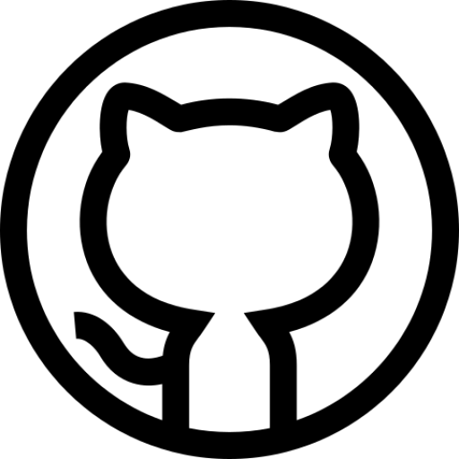*Front-End Software Engineer*

[*brittany.chiang@gmail.com*](mailto:brittany.chiang@gmail.com)

*914-960-3665*

*brittanychiang.com*

*github.com/bchiang7*

# Relevant Experience

## Engineer @ Upstatement

*May 2018 - Present // Boston, MA*

▹ Write modern, performant, and robust code for a diverse array of client and internal projects

▹ Work with a variety of different languages, frameworks, and content management systems such as JavaScript, TypeScript, React, Vue, NativeScript, Node.js, Craft, Prismic, etc.

▹ Communicate and collaborate with multi-disciplinary teams of engineers, designers, producers, clients, and stakeholders on a daily basis

## Studio Developer @ Scout

*Jan - April 2018 // Boston, MA*

▹ Worked with a team of three designers to build a marketing website and e-commerce platform for blistabloc, an ambitious venture originating from Northeastern

▹ Helped solidify a brand direction for blistabloc to span across print, packaging, and web

▹ Interfaced with clients on a weekly basis, providing technological expertise and knowledge

## UI Engineer Co-op @ Apple

*July - Dec 2017 // Cupertino, CA*

▹ Developed and shipped highly interactive web applications for Apple Music using Ember

▹ Built and shipped the Apple Music Extension within Facebook Messenger leveraging third- party and internal APIs

▹ Architected and implemented the front-end of Apple Music's embeddable web player widget, which lets users log in and listen to full songs in the browser

▹ Contributed extensively to MusicKit.js, a JavaScript framework that allows developers to add an Apple Music player to their web apps

## Studio Developer @ Scout

*Jan - June 2017 // Boston, MA*

▹ Collaborated with a small team of student designers to spearhead a new brand and design system for Scout’s inaugural student-led design conference at Northeastern

▹ Worked closely with designers and management team to develop, document, and manage the conference’s marketing website using Jekyll, Sass, and JavaScript

## Software Engineer Co-op @ Starry

*July - Dec 2016 // Boston, MA*

▹ Engineered and maintained major features of Starry's customer-facing web app using ES6, Handlebars, Backbone, Marionette, and CSS

▹ Proposed and implemented scalable solutions to issues identified with cloud services and applications responsible for communicating with Starry Station

▹ Interfaced with user experience designers and other developers to ensure thoughtful and coherent user experiences across Starry’s iOS and Android mobile apps

## Creative Technologist Co-op @ MullenLowe U.S.

*July - Dec 2015 // Boston, MA*

▹ Developed and maintained code for in-house and client websites primarily using HTML, CSS, Sass, JavaScript, and jQuery

▹ Tested sites in various browsers and devices to ensure cross-browser compatibility and mobile responsiveness

▹ Clients included JetBlue, Lovesac, U.S. Cellular, U.S. Department of Defense, and more

# Skills

## Programming Languages

JavaScript (ES6), TypeScript, HTML, CSS/Sass, GraphQL, Python, R, PHP

## Libraries & Frameworks

jQuery, React, Gatsby, Vue, Node.js, Express, Jekyll, Timber, NativeScript

## Tools & Platforms

Git, Gulp, Webpack, Netlify, Heroku, Prismic, Contentful, Craft, Wordpress, Docker, Firebase

## Design

Sketch, InVision, InDesign

# Education

## Northeastern University

*2013 - 2018 // Boston, MA*

Bachelor of Science in Information Science Human Computer Interaction Concentration Minors in Interaction & Experience Design

## Study Abroad

*Summer 2016 // Budapest, Hungary*

Experience Design of Travel Dialogue

# Projects

## Spotify Profile

Web app built with React, Node.js, and Express for visualizing personalized Spotify data such as top artists, tracks, recommendations, and audio features

## Halcyon Theme

Minimal, dark blue theme for VS Code, Sublime Text, Atom, and more published to Visual Studio Marketplace, Package Control, Atom Package Manager, and NPM

# Interests

Snowboarding, swimming, traveling, reading, hiking