**A-** Get data from class flag sheet (only with check n 23 ad 24)

**A-.1** If there wasn’t any check number 23 or 24🡺Alert (there is no 23 or 24 Check No°)🡺refresh.

If exist then:

If only One JH1 file isn’t matched

Go to:

**B-**Take Multi-Prd# and DC/Code of excel file (first sheet: Data Check Result List)

**B.1-**And compare with Multi-Prd# and DC/Code in JH1 files (line 8 & 9, both in position are 9)

**B.1.1-**if matched then (loop file)

**B.1.1.1-**Search for SWS Part N°. (That is already taken from excel) in JH1 file

**1-**If you find it, take operation number (position: current index+2)

**2-**if you didn’t find it in all files; search for the next SWS Part N°.

**B.1.2-** if not matched 🡺Alert (Unmatched Multi-Prd# and DC/Code)🡺refresh.

If the case is **B** and everything is good: you will have two cases (before comparing with database)

**\***the user doesn’t need to see the highlighted data in yellow

**Case 1**

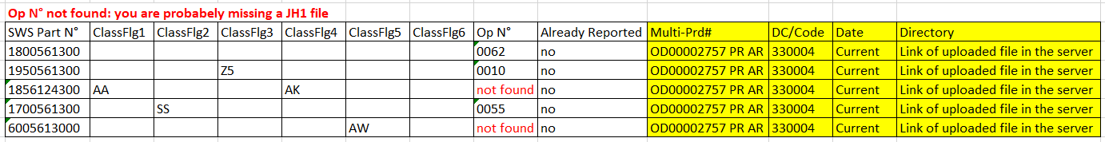

**Case 2**

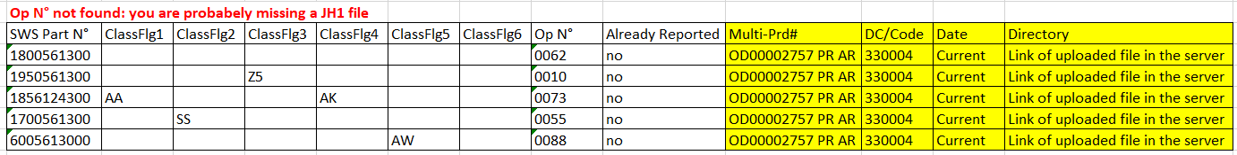

Don’t show anything to the user yet

**\*\***in both cases we will select the table **Er_Wr** from data base and compare with our data (in case 1 or 2)

1-if any of our data already exist in data base🡺switch the value of Already Reported to yes

2-then show the final result to the user the highlighted data in yellow

3-insert in the data base only the data not already reported and have an Op N then send it by email