Multimorbidity report
09/01/2026
Table of contents

Data overview

Demographic
Table shows the demographic profile of the CIMHA cohort that had whatever the conditions required for them to be included in the dataset.
Characteristic | % (n) cohort
Total number of people | 194,936
Age (median) | 38
Sex
Male | 50.3% (n = 97,438)
Female | 50.2% (n = 97,379)
Aboriginal and Torres Strait Islander origin status
Neither aboriginal nor torres strait islander origin | 84.9% (n = 164,503)
Aboriginal and/or torres strait islander | 15.7% (n = 30,433)
NDIS
Never ndis | 96.2% (n = 186,490)
Ndis participant once | 4.4% (n = 8,446)
Education level
Secondary education | 46.7% (n = 90,509)
Primary education | 7.6% (n = 14,767)
Vocational education & training (vet) & bridging level | 6.3% (n = 12,166)
Higher education | 4.3% (n = 8,364)
No education | 0.3% (n = 546)
Accomodation type
Private housing | 72.3% (n = 140,165)
Institutional housing or correctional facility | 2.8% (n = 5,414)
Hospital/residential facility | 1.8% (n = 3,509)
Social, temporary & affordable housing | 1.8% (n = 3,452)
Homelessness and/or marginalised housing | 1.6% (n = 3,027)

Completeness of data sources
- What are the numbers:
  - Table shows the number of people and the proportion of the CIMHA cohort that has at least one data point in each of the linked data sources.
  - All data sources are counted across the entire 3.5 year study period. All analyses are also conducted on the entire data period unless stated otherwise.
- Results
  - Majority of people had a record in the hospitals (ED and/or QHAPDC). Most likely due to the conditions required for people to be included in the cohort.
  - Low Numbers in the registry (Noocs, QCR and QDR)
Data sourcce | Number of people | % of cohort
Emergency data collection  (EDC) | 172,304 | 88.9%
Queensland Hospital  Admitted Patient  Data Collection  (QHAPDC) | 149,704 | 77.2%
Notifiable condition system  (NoCs) | 20,612 | 10.6%
Perinatal data collection  (PDC) | 15,969 | 8.2%
Death registry  (DR) | 7,451 | 3.8%
Queensland cancer registry  (QCR) | 3,006 | 1.6%

1. Aim 1
To compare the health condition profile of consumers with mental and behavioural disorders, between CIMHA and other Queensland Health records
- Noting working definitions here because we both confused last time:
  - Singular condition = health condition
  - Multiple condition = multimorbidity

1.1 RQ 1: Consistency in detecting health conditions
Q: How consistent is the detection of health conditions between CIMHA and other Queensland Health datasets?
- No modifications to this question
This question/section looks at the consistency of detecting health conditions in CIMHA compared to other Queensland health datasets. It starts by looking at conditions identified by ICD10 codes as this is the standard way of identifying health conditions. Following, we incorporate other methods of identifying the equivalent condition and explore the overlaps in the people identified to have the condition by both methods.

1.1.1 ICD10 only

1.1.1.1 Overlap - How consistent do the datasets record each condition for the same person?
- Method: Looks at the consistency of ICD10 codes being documented for the same person across all the linked datasets.
- What it means: Venn diagrams shows the number of people that are exclusively recorded in each dataset and shared across datasets. Proportions are calculated by the total number of people with condition recorded in at least one dataset.

1.1.1.1.1 Physical Health
- Besides hepatitis C, most physical health conditions are primarily documented exclusively in qhapdc or edc
- Overlaps are generally low for all conditions, highest overlap is still less than half the cohort with the condition being documented by at least two datasets/systems.
  - Surprisingly low overlap especially given close transfers between qhapdc and edc (double check)?
- Limitation - overlap could be low given time period. conditions may have been captured previously, just not included in the current dataset.

Acute or chronic hepatitis C
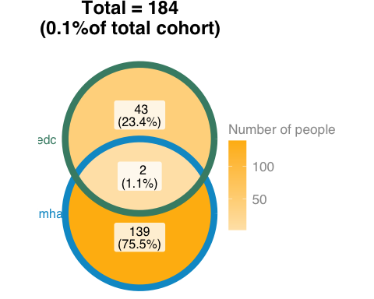

Dental caries and other dental disease
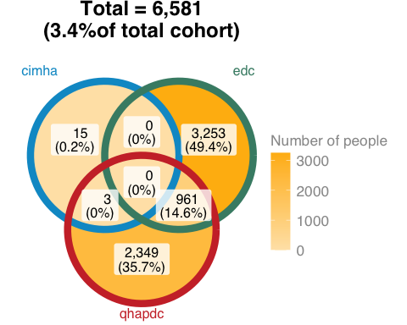

Diabetes mellitus
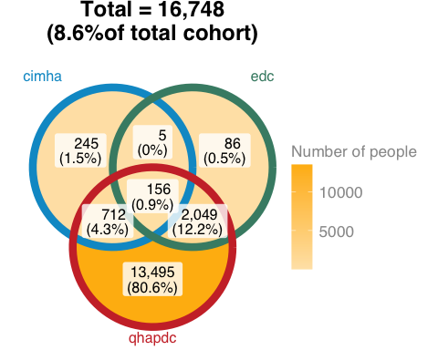

Disease of oesophagus, stomach and duodenum
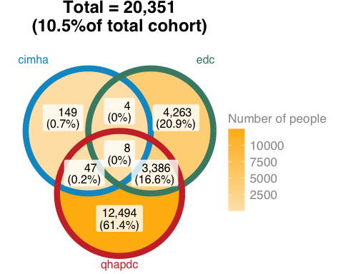

Hypertension
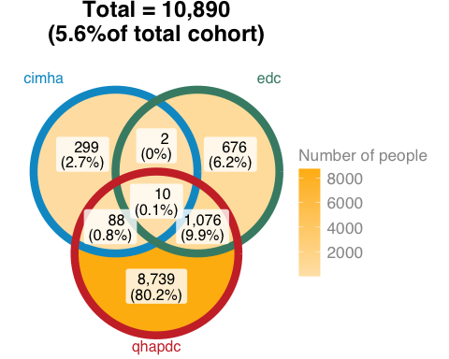

Ischaemic Heart Disease (IHD)
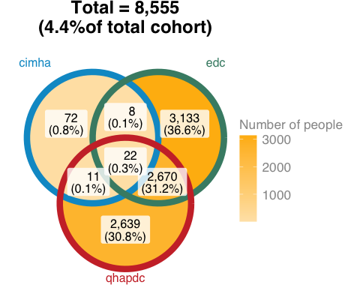

Neoplasms
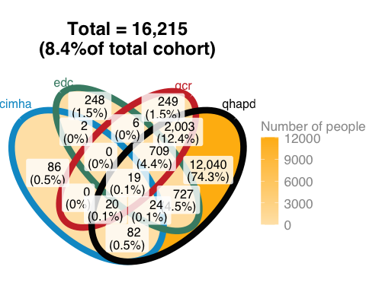

Non-alcoholic fatty liver, alcoholic and other liver disease (other than due to viral hepatitis)
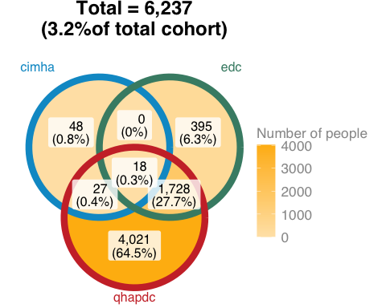

Obesity
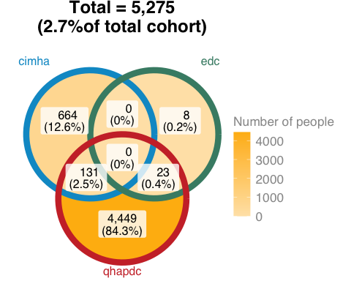

Other acute or chronic hepatitis
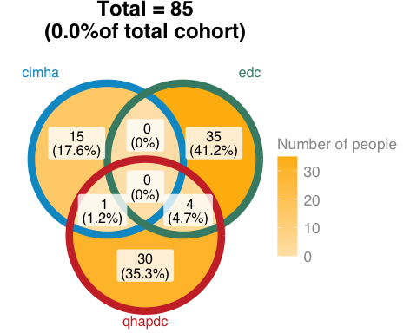

Other circulatory diseases
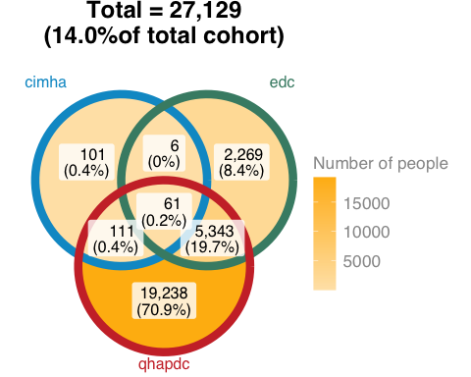

Other functional intestinal disorders, including constipation
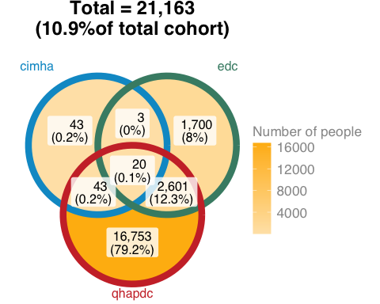

Thyroid disorders
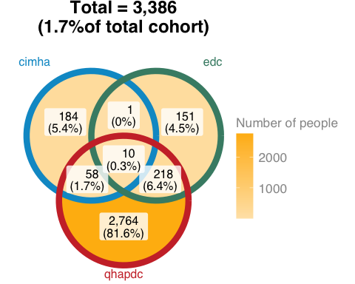

1.1.1.1.2 Mental Health
- Larger overlaps between datasets than physical healh, but still generally low. No mental health condition had close to half the people being shared in at least 2 datasets

Behavioural syndromes associated with physiological disturbances and physical factors
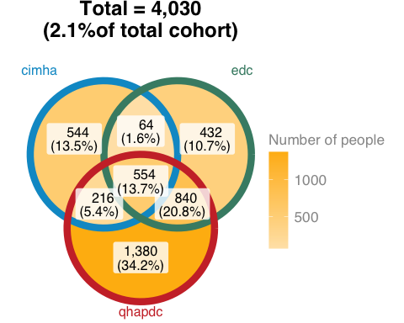

Disorders due to substance use
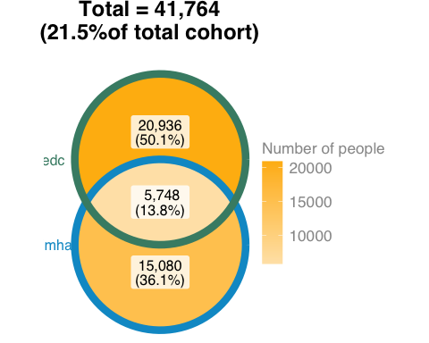

Disorders of adult personality and behaviour
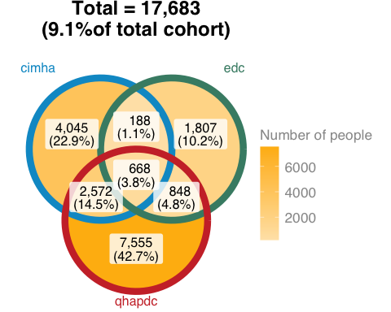

Disorders of psychological development
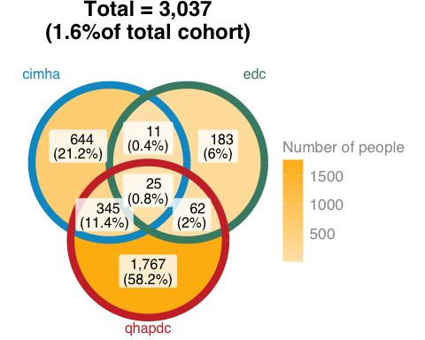

Intellectual disability
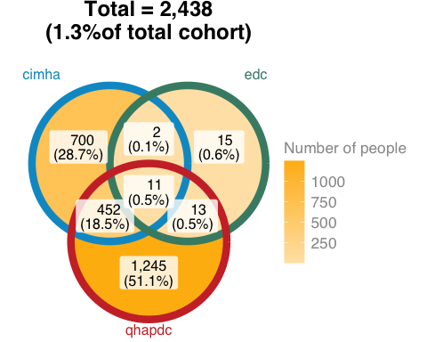

Mood (affective) disorders
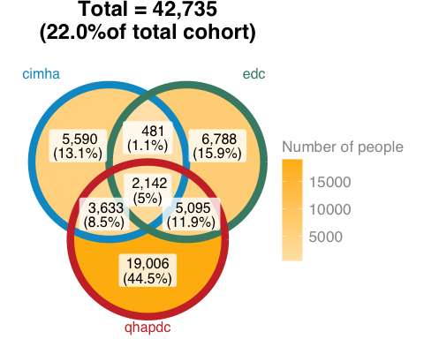

Neurotic, stress-related and somatoform disorders
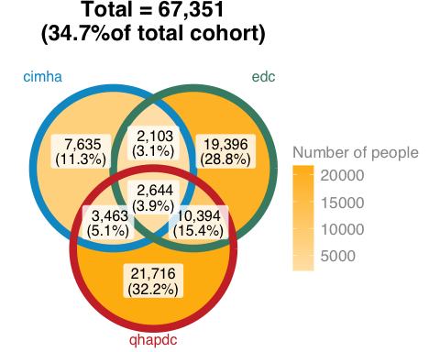

Organic, including symptomatic, mental disorders
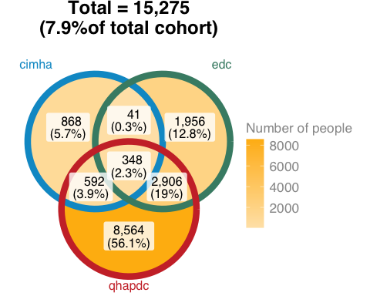

Schizophrenia, schizotypal and delusional disorders
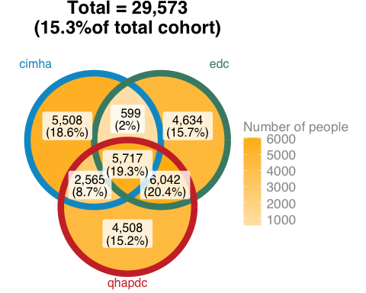

Suicidality
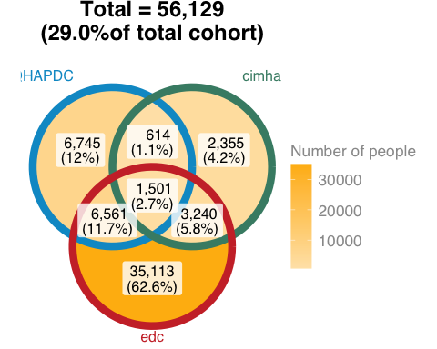

1.1.2 ICD10 vs. Other methods
Some health conditions can be identified through methods other than ICD10 codes. These conditions and their methods are tabled below. This section looks at the overlaps in identification of the health condition in the same person through each method.

1.1.2.0.1 Alternative methods for identifying health conditions

Physical
Condition | Other data source
Other circulatory diseases | Metabolic monitoring form
Diabetes mellitus | Physical health form
Hypertension | Physical health form
Obesity | Physical health form
Acute or chronic hepatitis C | NoCs
Other acute or chronic hepatitis | NoCs

Mental
Condition | Other data source
Suicidality | Triage screen / Forensic comprehensive assessment / Risk screen / Referal problem / HoNOS (Q2)
Disorders due to substance use | ASSIST / Forensic comprehensive assessment / HoNOS (Q3)
Mood (affective) disorders | HoNOS (Q7)
Disorders of adult personality and behaviour | Risk screen / Forensic comprehensive assessment

1.1.2.1 Overlaps
- Method - For each health condition that can be identified via an ICD10, we look at whether there are other comparable method for identifying the condition. If there methods in addition to ICD10 codes, we look at whether the person is identified as having the condition in both methods.
- Numbers - The counts represent the number of people identified as having the health condition in each method and the number of people identified across all methods
- Results:
  - Physical
    - Like the ICD10 codes only, there are low overlaps in the number of people between identification methods.
  - Mental
    - Higher overlaps in identification method than physical health condition
    - All conditions are consistently high. Range of 28 - 40% of cohort across all methods.

1.1.2.1.1 Physical

Obesity
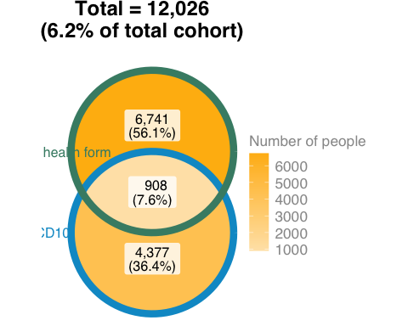

Diabetes mellitus
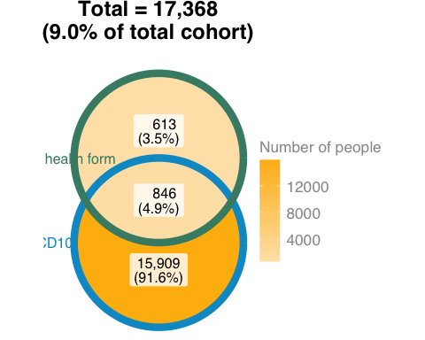

Hypertension
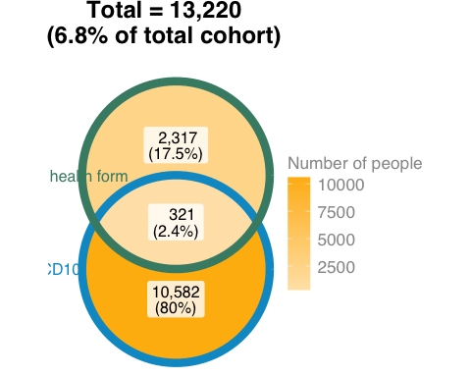

Other circulatory diseases
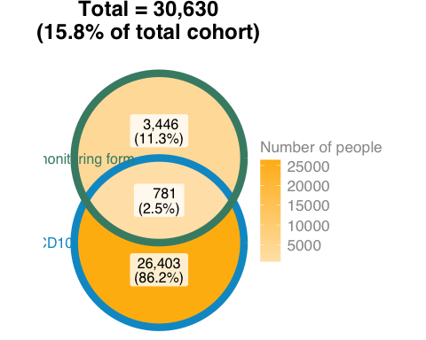

Other acute or chronic hepatitis
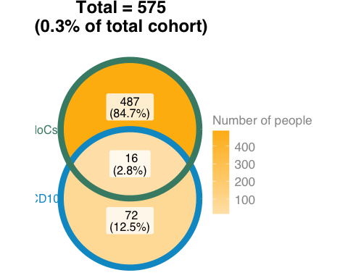

Acute or chronic hepatitis C
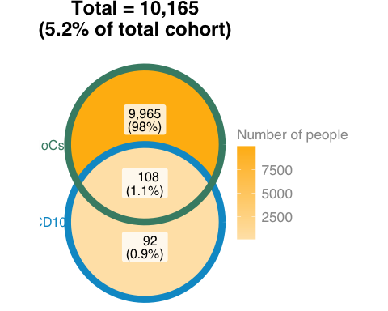

1.1.2.1.2 Mental

Suicidality
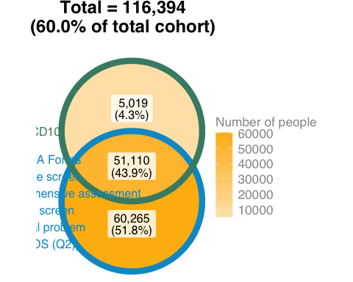

Disorders due to substance use
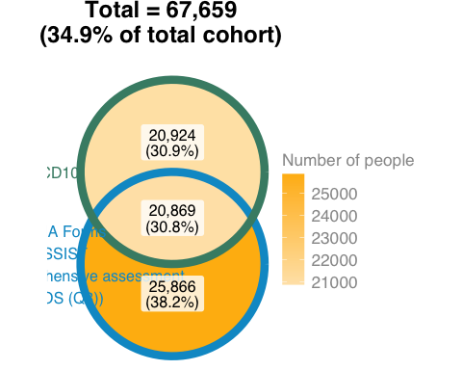

Mood (affective) disorders
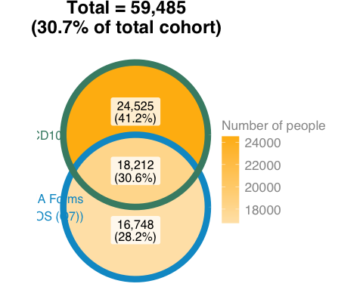

Disorders of adult personality and behaviour
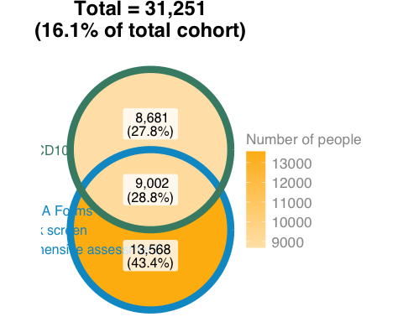

1.1.3 Bias in the completion of alternative measures
The alternative methods for identification are mostly CIMHA forms. This section looks at the overall completion rate for these forms and explores factors, such as socio-demographic characteristic that may be associated with their completion.

1.1.3.1 Completion rate for CIMHA forms
Shows proportion of people with at least one part of the forms completed.
Forms | Number of people | % of cohort
Triage screen | 121,166 | 62.5%
Health of the Nation Outcome Scale | 76,428 | 39.4%
Risk screen forms | 69,844 | 36.0%
My safety plan forms | 27,733 | 14.3%
Metabolic monitoring forms | 16,274 | 8.4%
SUABS forms | 15,660 | 8.1%
Physical health forms | 10,845 | 5.6%
Forensic comprehensive assessment forms | 9,934 | 5.1%
Audit forms | 1,057 | 0.5%

1.1.3.2 Factors associated with the completion of forms
- Method - Logistic regression to model whether the completion of each form is associated with age, aboriginal and/or torres strait islander status, sex, and hospital contact. Separate logistic regressions were fitted to each form (outcome). Predictors for all regressions were the same. Whether someone had the form completed and had a hospital record was determined by if there was a record by the end of the study period
- Results: (don’t roast on interpretation, I know it’s higher odds not likelihood as worded below. I’ll fix up later…)
  - Age
    - Statistically significant predictor for all forms
    - Small effects, mainly older are more likely to get forms completed
    - Triage, ASSIST and forensic comprehensive form were older age are associated with less likelihood of completion
  - aboriginal and/or torres strait islander status
    - Statistically significant predictor for all forms but HoNOS
    - ABSTI are more likely than neither to get all forms completed besides the triage screen
    - on triage screen, ABSTI less likely than neither to have screen
  - Sex
    - Statistically significant predictor for all forms
    - Men more likey than women to have all forms completed besides triage screen
      - Strong effect on forensic comprehensive form, men have 4 times higher odds than women to have the form completed
    - On triage screen men are less likely to have it completed than women
  - Hospital contact
    - Statistically significant predictor for all forms
    - Having a hospital contact increases the odds of having all forms completed besides the physical health and metabolic monitoring form
    - On the metabolic monitoring form and physical health form, having a hospital contact is associated with lower odds that these forms are completed
Predictor¹ | Triage screen  Odds Ratio  [95%CI] | HoNOS  Odds Ratio  [95%CI] | Risk screen  Odds Ratio  [95%CI] | Metabolic monitoring  Odds Ratio  [95%CI] | ASSIST  Odds Ratio  [95%CI] | Physical health form  Odds Ratio  [95%CI] | Forensic comprehensive form  Odds Ratio  [95%CI] | Any forms  Odds Ratio  [95%CI]
Age | 0.98  [0.98,0.98]* | 1.01  [1.01,1.01]* | 1  [1,1]* | 1.01  [1.01,1.01]* | 0.99  [0.99,0.99]* | 1.01  [1.01,1.01]* | 0.97  [0.97,0.97]* | 0.99  [0.99,0.99]*
Aboriginal and/or Torres Strait Islander origin (vs. Neither) | 0.86  [0.84,0.89]* | 1.01  [0.98,1.03] | 1.11  [1.08,1.14]* | 1.31  [1.25,1.37]* | 1.51  [1.45,1.57]* | 1.07  [1.02,1.13]* | 2.92  [2.8,3.05]* | 0.97  [0.94,1]*
Male vs (Female) | 0.84  [0.83,0.86]* | 1.02  [1,1.04]* | 1.16  [1.13,1.18]* | 1.42  [1.38,1.47]* | 1.45  [1.4,1.5]* | 1.21  [1.17,1.26]* | 4.94  [4.69,5.2]* | 1.04  [1.02,1.06]*
Hopsital contact (vs. none) | 1.72  [1.66,1.77]* | 1.4  [1.35,1.46]* | 1.34  [1.29,1.39]* | 0.86  [0.81,0.91]* | 1.25  [1.17,1.34]* | 0.83  [0.77,0.89]* | 1.48  [1.36,1.62]* | 1.08  [1.04,1.12]*
¹* indicates statistically significant at p <0.05

1.1.4 Health conditions only documented at death
- Context - The Queensland Death Registry (QDR) records ICD10 codes similar to other Queensland datasets and CIMHA.
- Method - Using only ICD-10 codes as indicators of the condition, we look at what conditions are first documented in the Queensland death registry and not previously documented in other datasets (note: dataset is compiled for records between 1/1/2021 and 30/6/2024, therefore it is possible that the condition was recorded on a date before 1/1/2021).
- Results:
  - More physical health than mental health conditions first recorded.
  - More people with physical health conditions recorded at death first than mental health conditions.

Physical
Condition | Number of people | % of people with condition¹
Ischaemic Heart Disease (IHD) | 302 | 3.4%
Neoplasms | 59 | 0.4%
Other circulatory diseases | 55 | 0.2%
Non-alcoholic fatty liver, alcoholic and other liver disease (other than due to viral hepatitis) | 18 | 0.3%
Acute or chronic hepatitis C | 16 | 8.0%
Hypertension | 13 | 0.1%
Disease of oesophagus, stomach and duodenum | 11 | 0.1%
Obesity | 10 | 0.2%
Diabetes mellitus | 7 | 0.0%
¹Proportions are calculcated out of number of people identified as having condition via ICD-10 codes across all dataset

Mental
Condition | Number of people | % of people with condition¹
Dementia | 64 | 1.9%
Alcohol use disorder | 33 | 0.2%
¹Proportions are calculcated out of number of people identified as having condition via ICD-10 codes across all dataset

2. Aim 2
To develop a health condition profile of consumers with mental and behavioural disorders
- Original plan had 2 research questions around rates to achieve aim.
- When we met last year, a point we discussed was whether a detection and prevalence rate is needed for the profile. We were leaning towards the idea that our interpretation of the aim is that it’s looking at how well EHR document the conditions of interest. The ‘profile’ then becomes a representation of what is currently documented without any adjustments to what the ‘true/real’ profile should look like. I’ve modified my analyses below in an attempt to achieve that.

2.1 RQ2 - Rate of identification
Q: What is the detection rate of health conditions among consumers with mental and behavioural disorders and how does this vary across time?
- Modified the original Q to detect new cases rather than detection as I’d need the ‘true’ number in denominator, unsure of the technical term for this, would it be incident?
- This section uses ICD10 codes in conjunction with the other methods previously examined to collectively determine the number of people identified with each health condition of interest.

2.1.1 Detection of new cases
- This is a method I went with following our discussion last year around the terminology confusions.
- Method: Started to count number of new cases for each condition 6 months after the data extraction period (2021-06-30). Recall you calling this a washout year, no underlying reason for 6 if there should be more let me know. Therefore years will represent financial years rather than calendar years.
  - Numerator = Number of new people with the condition in each year.
  - Denominator = Number of people at risk in each yaer, which is the number of people that had contact with any of the datasets during the time period. People who have previously had the disease (included in numerator) are removed from the denominator count.
  - Number in the table = After the fraction above multiplied by 100k (is this the appropriate number?)
- Results:

Physical
Condition | 2021 | 2022 | 2023
Circulatory | 10,590 | 8,850 | 9,390
Hypertension | 3,280 | 2,540 | 2,500
Other circulatory diseases | 6,950 | 6,750 | 7,490
Ischaemic Heart Disease (IHD) | 2,790 | 1,410 | 1,280
Endocrine | 8,840 | 5,440 | 5,820
Obesity | 2,690 | 2,250 | 3,060
Diabetes mellitus | 6,620 | 3,100 | 2,390
Thyroid disorders | 730 | 700 | 780
Viral hepatitis | 690 | 700 | 630
Acute or chronic hepatitis C | 650 | 670 | 600
Other acute or chronic hepatitis | 50 | 40 | 40
Digestive | 11,210 | 9,510 | 9,260
Non-alcoholic fatty liver, alcoholic and other liver disease (other than due to viral hepatitis) | 1,650 | 1,240 | 1,190
Disease of oesophagus, stomach and duodenum | 4,980 | 4,180 | 4,070
Other functional intestinal disorders, including constipation | 5,130 | 4,450 | 4,420
Dental caries and other dental disease | 1,410 | 1,380 | 1,340
Cancers | 4,080 | 3,440 | 3,160
Neoplasms | 4,080 | 3,440 | 3,160

Mental
Condition | 2021 | 2022 | 2023
Disorders due to substance use | 17,490 | 14,330 | 16,960
Other stimulant use use disorder | 2,550 | 1,520 | 1,630
Cannabinoid use disorder | 3,860 | 1,600 | 1,660
Alcohol use disorder | 7,660 | 4,930 | 4,880
Opioid use disorder | 2,680 | 780 | 690
Sedative or hypnotic use disorder | 1,200 | 780 | 760
Multiple and other drug use disorder | 4,040 | 1,830 | 2,210
Cocaine use disorder | 500 | 330 | 370
Solvent use disorder | 260 | 90 | 100
Hallucinogen use disorder | 340 | 210 | 230
Nicotine use disorder | 4,750 | 1,980 | 1,970
Suicidality | 26,080 | 28,530 | 37,590
Intentional self-harm | 22,840 | 24,130 | 31,040
Suicidal ideation | 20,480 | 21,850 | 25,910
Disorders of adult personality and behaviour | 7,870 | 5,770 | 7,230
Personality disorder | 7,540 | 5,430 | 7,010
Other disorders of personality and behaviour | 680 | 630 | 390
Mood (affective) disorders | 14,520 | 12,640 | 14,150
Depressive disorders | 12,870 | 11,650 | 13,010
Bipolar affective disorder | 3,190 | 1,730 | 1,660
Organic, including symptomatic, mental disorders | 3,710 | 2,980 | 3,190
Dementia | 840 | 670 | 710
Organic amnesic syndrome | 140 | 120 | 130
Delerium | 2,280 | 2,150 | 2,190
Other organic disorders | 1,090 | 470 | 460
Other behavioural syndromes | 350 | 230 | 210
Schizophrenia, schizotypal and delusional disorders | 11,010 | 4,480 | 4,920
Schizophrenia | 7,430 | 1,930 | 1,870
Other schizophreniform disorders | 5,640 | 3,710 | 4,070
Neurotic, stress-related and somatoform disorders | 18,700 | 13,870 | 13,570
Anxiety and obsessive-compulsive disorders | 10,810 | 7,110 | 7,040
Stress and adjustment disorders | 9,850 | 6,720 | 6,970
Dissociative, somatoform and other neurotic disorders | 4,030 | 2,860 | 630
Behavioural syndromes associated with physiological disturbances and physical factors | 1,360 | 600 | 580
Eating disorders | 1,250 | 490 | 460
Mental and behavioural disorders associated with the puerperium, not elsewhere classified | 120 | 110 | 130
Intellectual disability | 900 | 310 | 310
Intellectual disability - mild | 430 | 70 | 70
Intellectual disability - more severe | 250 | 40 | 40
Intellectual disability - other | 360 | 280 | 250
Disorders of psychological development | 940 | 460 | 510
Pervasive developmental disorders (including autism) | 840 | 390 | 420
Other disorders of psychological development | 140 | 80 | 120
Injuries and poisonings (exc. Intentional self-harm) | 8,260 | 7,540 | 6,960

2.1.2 What conditions are documented by each dataset?
- Method:
  - Numerator = Counts the number of people who have each condition (using both ICD10 and forms) recorded at least once within each dataset
  - Denominator = Total number of people with at least one contact in each dataset.
  - Time = collapsed across the entire period

Denominators
Dataset | Number of people¹
cimha | 193,855
edc | 172,304
qhapdc | 149,704
nocs | 20,612
death | 7,451
qcr | 7,451
¹With any records in the three and half year period between 1/1/2021 and 30/6/2024

Physical
Condition | QHAPDC | EDC | DEATH | CIMHA | QCR | NOCS
Digestive | 23.5%  (35,137) | 9.8%  (16,804) | 5.5%  (412) | 0.2%  (408) | - | -
Other functional intestinal disorders, including constipation | 12.9%  (19,269) | 2.5%  (4,324) | - | 0.1%  (109) | - | -
Disease of oesophagus, stomach and duodenum | 10.6%  (15,866) | 4.4%  (7,661) | 0.3%  (19) | 0.1%  (208) | - | -
Non-alcoholic fatty liver, alcoholic and other liver disease (other than due to viral hepatitis) | 3.9%  (5,771) | 1.2%  (2,141) | 5.3%  (392) | 0.0%  (93) | - | -
Dental caries and other dental disease | 2.2%  (3,275) | 2.4%  (4,214) | - | 0.0%  (18) | - | -
Circulatory | 20.9%  (31,362) | 8.1%  (13,948) | 9.8%  (727) | 3.5%  (6,880) | - | -
Other circulatory diseases | 16.4%  (24,620) | 4.5%  (7,679) | 3.5%  (260) | 2.3%  (4,470) | - | -
Hypertension | 6.6%  (9,851) | 1.0%  (1,764) | 0.4%  (32) | 1.5%  (2,974) | - | -
Ischaemic Heart Disease (IHD) | 3.6%  (5,324) | 3.4%  (5,833) | 5.8%  (435) | 0.1%  (113) | - | -
Endocrine | 14.5%  (21,696) | 1.6%  (2,691) | 3.1%  (228) | 4.8%  (9,250) | - | -
Diabetes mellitus | 10.9%  (16,379) | 1.3%  (2,296) | 2.5%  (185) | 1.2%  (2,256) | - | -
Obesity | 3.1%  (4,573) | 0.0%  (31) | 0.5%  (40) | 4.1%  (7,925) | - | -
Thyroid disorders | 2.0%  (3,026) | 0.2%  (380) | - | 0.1%  (253) | - | -
Cancers | 10.4%  (15,592) | 1.0%  (1,735) | 14.8%  (1,102) | 0.1%  (233) | 40.3%  (3,006) | -
Neoplasms | 10.4%  (15,592) | 1.0%  (1,735) | 14.8%  (1,102) | 0.1%  (233) | 40.3%  (3,006) | -
Viral hepatitis | 0.0%  (34) | 0.0%  (82) | 0.3%  (19) | 0.1%  (150) | - | 50.6%  (10,429)
Acute or chronic hepatitis C | - | 0.0%  (45) | 0.2%  (16) | 0.1%  (141) | - | 48.9%  (10,073)
Other acute or chronic hepatitis | 0.0%  (34) | 0.0%  (39) | - | 0.0%  (16) | - | 2.4%  (503)

Mental
Condition | CIMHA | EDC | QHAPDC | DEATH
Suicidality | 57.7%  (111,893) | 26.9%  (46,415) | 10.3%  (15,421) | -
Intentional self-harm | 51.3%  (99,459) | - | 10.3%  (15,421) | -
Suicidal ideation | 43.9%  (85,140) | 26.9%  (46,415) | - | -
Mood (affective) disorders | 20.8%  (40,406) | 8.4%  (14,506) | 20.0%  (29,876) | 0.1%  (11)
Depressive disorders | 19.8%  (38,446) | 6.6%  (11,349) | 16.0%  (23,889) | 0.1%  (8)
Bipolar affective disorder | 1.9%  (3,662) | 2.1%  (3,571) | 5.3%  (7,973) | -
Neurotic, stress-related and somatoform disorders | 8.2%  (15,845) | 20.0%  (34,537) | 25.5%  (38,217) | -
Anxiety and obsessive-compulsive disorders | 3.5%  (6,854) | 7.8%  (13,383) | 17.4%  (26,101) | -
Stress and adjustment disorders | 5.4%  (10,404) | 9.0%  (15,555) | 12.4%  (18,559) | -
Dissociative, somatoform and other neurotic disorders | 0.2%  (319) | 6.0%  (10,302) | 1.9%  (2,808) | -
Injuries and poisonings (exc. Intentional self-harm) | - | - | 22.7%  (33,978) | -
Disorders due to substance use | 15.9%  (30,906) | 15.5%  (26,684) | - | 1.2%  (89)
Alcohol use disorder | 7.6%  (14,682) | 9.8%  (16,850) | - | 1.1%  (80)
Nicotine use disorder | 7.5%  (14,479) | 0.0%  (32) | - | -
Cannabinoid use disorder | 6.0%  (11,713) | 0.4%  (727) | - | -
Multiple and other drug use disorder | 3.4%  (6,604) | 5.1%  (8,712) | - | -
Other stimulant use use disorder | 3.8%  (7,397) | 1.8%  (3,023) | - | -
Opioid use disorder | 3.4%  (6,499) | 0.4%  (764) | - | -
Sedative or hypnotic use disorder | 2.3%  (4,362) | 0.3%  (538) | - | -
Cocaine use disorder | 1.1%  (2,103) | 0.1%  (140) | - | -
Hallucinogen use disorder | 0.7%  (1,357) | 0.1%  (163) | - | -
Solvent use disorder | 0.5%  (884) | 0.0%  (83) | - | -
Disorders of adult personality and behaviour | 13.1%  (25,465) | 2.0%  (3,511) | 7.8%  (11,643) | -
Personality disorder | 12.9%  (25,083) | 1.3%  (2,202) | 7.5%  (11,203) | -
Other disorders of personality and behaviour | 0.4%  (823) | 0.9%  (1,533) | 0.5%  (723) | -
Schizophrenia, schizotypal and delusional disorders | 7.4%  (14,389) | 9.9%  (16,992) | 12.6%  (18,832) | 0.1%  (9)
Other schizophreniform disorders | 3.0%  (5,801) | 7.5%  (12,932) | 7.8%  (11,641) | -
Schizophrenia | 5.0%  (9,722) | 4.0%  (6,891) | 7.1%  (10,702) | 0.1%  (7)
Organic, including symptomatic, mental disorders | 1.0%  (1,849) | 3.0%  (5,251) | 8.3%  (12,410) | 2.8%  (209)
Delerium | 0.2%  (329) | 2.0%  (3,394) | 6.1%  (9,068) | -
Dementia | 0.3%  (532) | 0.5%  (784) | 1.9%  (2,841) | 2.8%  (207)
Other organic disorders | 0.5%  (974) | 0.6%  (1,114) | 1.1%  (1,710) | -
Other behavioural syndromes | 0.1%  (202) | 0.2%  (357) | 0.6%  (856) | -
Organic amnesic syndrome | - | - | 0.4%  (640) | -
Behavioural syndromes associated with physiological disturbances and physical factors | 0.7%  (1,378) | 1.1%  (1,890) | 2.0%  (2,990) | -
Eating disorders | 0.7%  (1,341) | 1.0%  (1,686) | 1.7%  (2,577) | -
Mental and behavioural disorders associated with the puerperium, not elsewhere classified | 0.0%  (37) | 0.1%  (206) | 0.3%  (432) | -
Disorders of psychological development | 0.5%  (1,025) | 0.2%  (281) | 1.5%  (2,199) | -
Pervasive developmental disorders (including autism) | 0.4%  (863) | 0.1%  (92) | 1.4%  (2,060) | -
Other disorders of psychological development | 0.1%  (217) | 0.1%  (192) | 0.1%  (212) | -
Intellectual disability | 0.6%  (1,165) | 0.0%  (41) | 1.1%  (1,721) | -
Intellectual disability - other | 0.1%  (205) | 0.0%  (39) | 0.8%  (1,257) | -
Intellectual disability - mild | 0.3%  (657) | - | 0.3%  (484) | -
Intellectual disability - more severe | 0.2%  (388) | - | 0.2%  (286) | -

2.2 RQ3 - Commonality
Q: What is the prevalence of health conditions that form multimorbidities within the population?
- Modified original Q to show commonality instead of prevalence
- Method - Uses all sources (ICD10 and alternative methods) of identifying the condition to count number of people who had the conditions at any point in the entire study period.
- Results:
  - Higher proportion of people with mental health conditions than physical health conditions
  - Most common condition is suicidality

Physical
Condition | No. of people | % of cohort
Digestive | 43,031 | 22.2%
Other functional intestinal disorders, including constipation | 21,020 | 10.8%
Disease of oesophagus, stomach and duodenum | 20,298 | 10.5%
Dental caries and other dental disease | 6,547 | 3.4%
Non-alcoholic fatty liver, alcoholic and other liver disease (other than due to viral hepatitis) | 6,234 | 3.2%
Circulatory | 41,151 | 21.2%
Other circulatory diseases | 30,525 | 15.7%
Hypertension | 13,169 | 6.8%
Ischaemic Heart Disease (IHD) | 8,843 | 4.6%
Endocrine | 28,401 | 14.7%
Diabetes mellitus | 17,347 | 8.9%
Obesity | 12,016 | 6.2%
Thyroid disorders | 3,370 | 1.7%
Cancers | 16,237 | 8.4%
Neoplasms | 16,237 | 8.4%
Viral hepatitis | 10,564 | 5.4%
Acute or chronic hepatitis C | 10,165 | 5.2%
Other acute or chronic hepatitis | 575 | 0.3%

Mental
Condition | No. of people | % of cohort
Suicidality | 116,394 | 60.0%
Intentional self-harm | 101,383 | 52.3%
Suicidal ideation | 92,552 | 47.7%
Disorders due to substance use | 67,659 | 34.9%
Alcohol use disorder | 27,231 | 14.0%
Nicotine use disorder | 14,502 | 7.5%
Multiple and other drug use disorder | 13,791 | 7.1%
Cannabinoid use disorder | 12,301 | 6.3%
Other stimulant use use disorder | 9,694 | 5.0%
Opioid use disorder | 7,032 | 3.6%
Sedative or hypnotic use disorder | 4,815 | 2.5%
Cocaine use disorder | 2,232 | 1.2%
Hallucinogen use disorder | 1,513 | 0.8%
Solvent use disorder | 950 | 0.5%
Neurotic, stress-related and somatoform disorders | 67,352 | 34.7%
Anxiety and obsessive-compulsive disorders | 38,662 | 19.9%
Stress and adjustment disorders | 37,236 | 19.2%
Dissociative, somatoform and other neurotic disorders | 12,354 | 6.4%
Mood (affective) disorders | 59,485 | 30.7%
Depressive disorders | 54,766 | 28.3%
Bipolar affective disorder | 10,266 | 5.3%
Injuries and poisonings (exc. Intentional self-harm) | 33,978 | 17.5%
Disorders of adult personality and behaviour | 31,251 | 16.1%
Personality disorder | 29,949 | 15.4%
Other disorders of personality and behaviour | 2,903 | 1.5%
Schizophrenia, schizotypal and delusional disorders | 29,575 | 15.3%
Other schizophreniform disorders | 20,468 | 10.6%
Schizophrenia | 16,606 | 8.6%
Organic, including symptomatic, mental disorders | 15,300 | 7.9%
Delerium | 10,165 | 5.2%
Other organic disorders | 3,478 | 1.8%
Dementia | 3,354 | 1.7%
Other behavioural syndromes | 1,386 | 0.7%
Organic amnesic syndrome | 641 | 0.3%
Behavioural syndromes associated with physiological disturbances and physical factors | 4,030 | 2.1%
Eating disorders | 3,461 | 1.8%
Mental and behavioural disorders associated with the puerperium, not elsewhere classified | 593 | 0.3%
Disorders of psychological development | 3,037 | 1.6%
Pervasive developmental disorders (including autism) | 2,617 | 1.3%
Other disorders of psychological development | 575 | 0.3%
Intellectual disability | 2,438 | 1.3%
Intellectual disability - other | 1,408 | 0.7%
Intellectual disability - mild | 971 | 0.5%
Intellectual disability - more severe | 574 | 0.3%

3. Aim 3
To develop a multimorbidity profile and examine key features of multimorbidity, including patterns of co-occurrence and severity
- Only modification would be dropping severity.

3.1 RQ4 - Multimorbidity
Q: What are the common clusters of multimorbidity?
- No changes to RQ

3.1.1 Network of health conditions
- Method
  - Uses all methods to identify condition and across entire study period
  - Counts the number of pairwise conditions people have.
  - Created pair wise networks for each sub groups of people rather than whole cohort.
    - Proportions are calculated using the total number of people in each subgroup as denominator.
    - Excluded pair wise counts where less than 5% of the sample had the pair.
  - Graph interpretation
    - Circles:
      - Each circle is a health condition
      - Size of the circle indicates the number of other health conditions the condition is linked to
    - Lines:
      - Connects two health conditions.
      - Thickness and darkness of the lines indicate the number of people who have the pairwise conditions. Darker and thicker lines = more people with the pairwise conditions

Substance use disorders
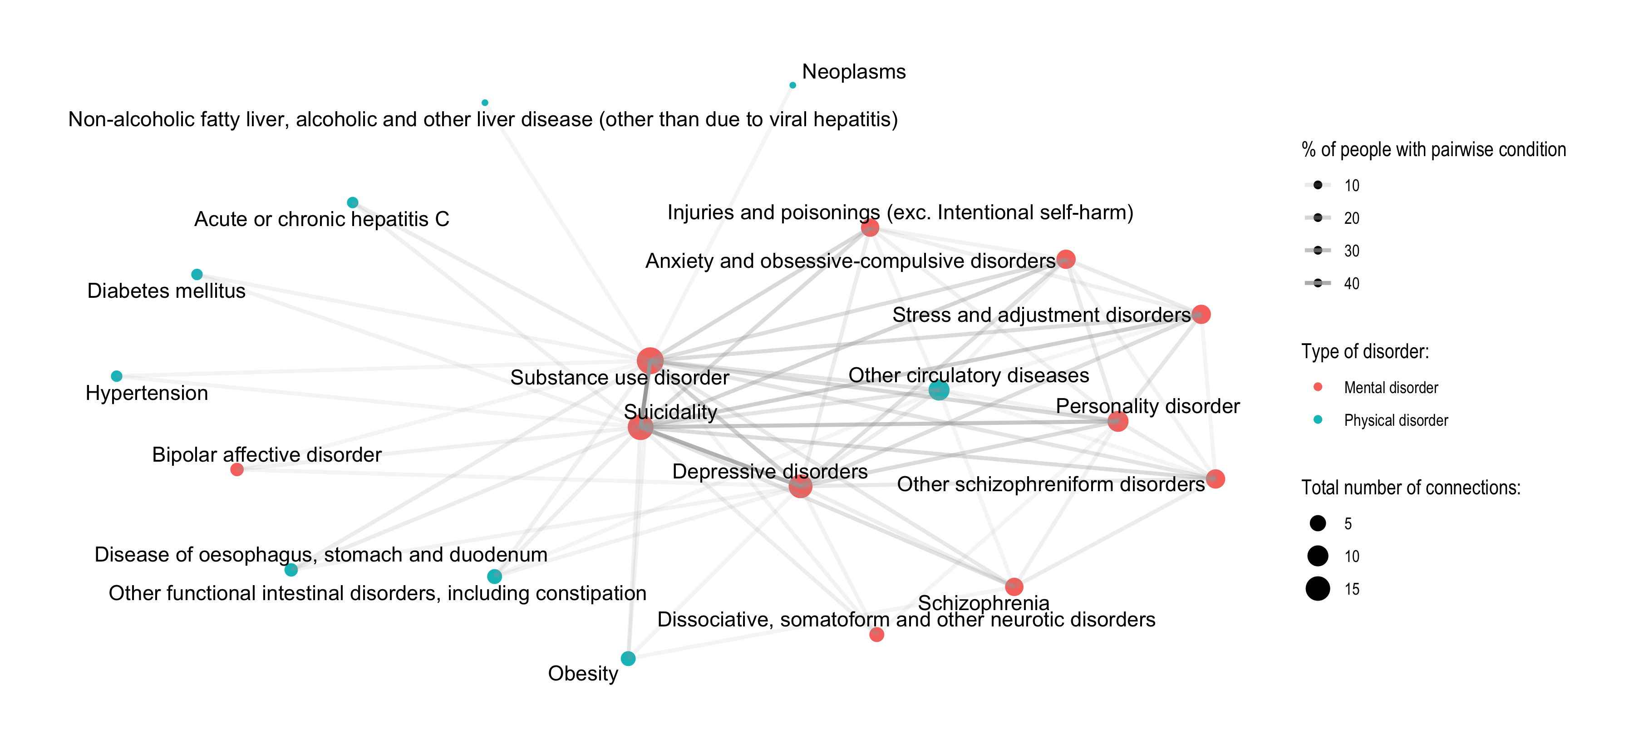

Suicide
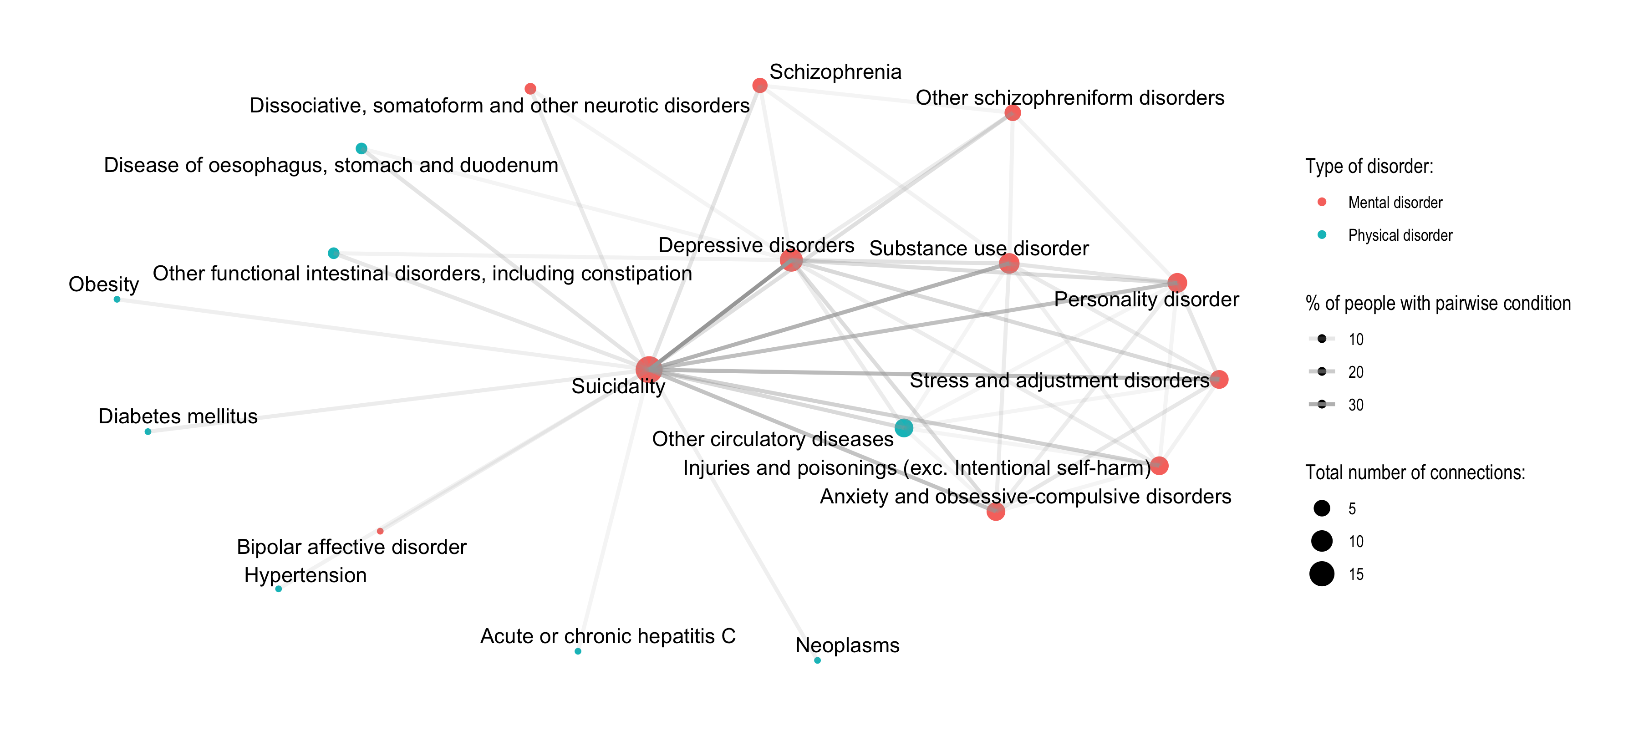

Obesity
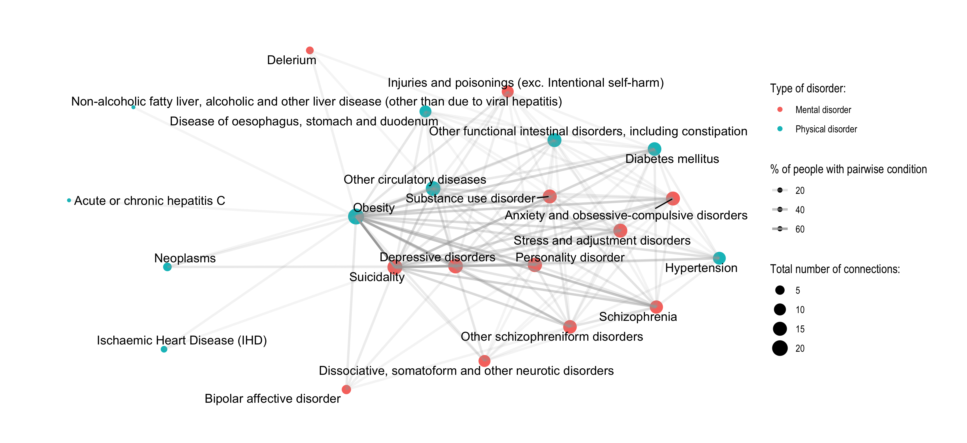

ABSTI
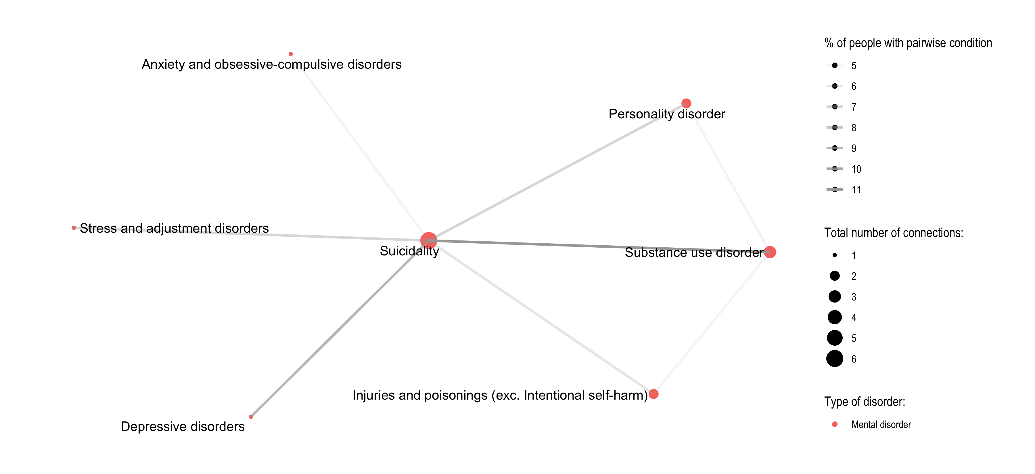

3.1.2 Frequency of pairs

Substance use disorders
Condition |  | Condition | Number of people | % of cohort
Substance use disorder | x | Suicidality | 33,239 | 49.0%
Depressive disorders | x | Suicidality | 25,028 | 37.0%
Personality disorder | x | Suicidality | 18,109 | 27.0%
Depressive disorders | x | Substance use disorder | 15,811 | 23.0%
Stress and adjustment disorders | x | Suicidality | 15,656 | 23.0%

Suicide
Condition |  | Condition | Number of people | % of cohort
Depressive disorders | x | Suicidality | 45,515 | 39.0%
Substance use disorder | x | Suicidality | 33,239 | 29.0%
Stress and adjustment disorders | x | Suicidality | 30,651 | 26.0%
Personality disorder | x | Suicidality | 27,447 | 24.0%
Anxiety and obsessive-compulsive disorders | x | Suicidality | 27,314 | 23.0%

Obesity
Condition |  | Condition | Number of people | % of cohort
Obesity | x | Suicidality | 8,425 | 70.0%
Depressive disorders | x | Obesity | 5,470 | 46.0%
Depressive disorders | x | Suicidality | 4,773 | 40.0%
Obesity | x | Schizophrenia | 4,574 | 38.0%
Obesity | x | Other circulatory diseases | 4,052 | 34.0%

ABSTI
Condition |  | Condition | Number of people | % of cohort
Substance use disorder | x | Suicidality | 8,005 | 11.0%
Depressive disorders | x | Suicidality | 6,637 | 9.0%
Personality disorder | x | Suicidality | 5,550 | 7.0%
Stress and adjustment disorders | x | Suicidality | 5,346 | 7.0%
Injuries and poisonings (exc. Intentional self-harm) | x | Suicidality | 4,661 | 6.0%

3.1.3 Frequency of triplets

Substance use disorders
Condition | Condition | Condition | Number of people | % of cohort
Depressive disorders | Substance use disorder | Suicidality | 14,394 | 21.0%
Personality disorder | Substance use disorder | Suicidality | 12,284 | 18.0%
Depressive disorders | Personality disorder | Suicidality | 11,407 | 17.0%
Depressive disorders | Stress and adjustment disorders | Suicidality | 10,552 | 16.0%
Stress and adjustment disorders | Substance use disorder | Suicidality | 10,372 | 15.0%

Suicide
Condition | Condition | Condition | Number of people | % of cohort
Depressive disorders | Stress and adjustment disorders | Suicidality | 17,437 | 15.0%
Anxiety and obsessive-compulsive disorders | Depressive disorders | Suicidality | 16,829 | 14.0%
Depressive disorders | Personality disorder | Suicidality | 16,000 | 14.0%
Depressive disorders | Substance use disorder | Suicidality | 14,394 | 12.0%
Personality disorder | Substance use disorder | Suicidality | 12,284 | 11.0%

Obesity
Condition | Condition | Condition | Number of people | % of cohort
Depressive disorders | Obesity | Suicidality | 4,773 | 40.0%
Obesity | Schizophrenia | Suicidality | 3,507 | 29.0%
Obesity | Personality disorder | Suicidality | 3,369 | 28.0%
Obesity | Substance use disorder | Suicidality | 3,159 | 26.0%
Obesity | Other schizophreniform disorders | Suicidality | 2,897 | 24.0%

ABSTI
Condition | Condition | Condition | Number of people | % of cohort
Personality disorder | Substance use disorder | Suicidality | 3,264 | 4.0%
Depressive disorders | Substance use disorder | Suicidality | 3,144 | 4.0%
Depressive disorders | Personality disorder | Suicidality | 2,931 | 4.0%
Depressive disorders | Stress and adjustment disorders | Suicidality | 2,802 | 4.0%
Stress and adjustment disorders | Substance use disorder | Suicidality | 2,524 | 3.0%

3.2 RQ5 -
Q: Do the clusters of multimorbidity vary by severity?
- Dropped given complexity with defining an agreed upon defintion of severity

4. Aim 4
To examine associations between multimorbidity and demographics, psychosocial determinants, functional impairment and disability, and service use types and HHS’s

4.1 RQ6 - Associations between multimorbidity and risk factors
Q: What are the key associations between multimorbidity, and multimorbidity clusters, and (a) demographics (b) psychosocial determinants, (c) biomarkers, (d) functional impairment and disability and (e) service use types and HHS’s
- Method:
  - Current idea is using a logistic regression to predict what factors are associated with having the conditions
  - Details of how I’ve modelled below, we could potentially do one for physical/mental or some other different cuts. Open to ideas, just have below as an example.
  - Outcome:
    - For the conditions, I have chosen the top 5 excluded suicidality (already 60% of cohort). So if people have any of the top 5 their outcome is a ‘yes’, otherwise ‘no’.
    - Time frame = if they have any of the condition by the end of the study period
  - Predictors:
    - sex, age, health service contact,Disability (NDIS), housing/living conditions,absti status,education
    - dynamic factors like living condition and housing, i take their last known recorded status
    - to do:
      - Add in predictors of service use and hospital health services (HHS) contact. Current concern is this will be problematic. This predictor would be strongly correlated with the outcome since having a contact also means you’re likely to have the outcome recorded. Thoughts?

4.1.1 Results
Reference levels:
- Highlighted blue = statistically significant effect
- Education = Primary education
- Living situation = Homelessness and/or marginalised housing
Predictors | Odds Ratio | P-Value | Lower CI | Upper CI
Male (vs. Female) | 0.82 | 0.0000 | 0.80 | 0.84
Age | 1.01 | 0.0000 | 1.01 | 1.01
NDIS once (vs.never) | 1.81 | 0.0000 | 1.71 | 1.91
Higher education (vs. Primary education) | 1.08 | 0.0133 | 1.02 | 1.15
Secondary education (vs. Primary education) | 1.01 | 0.6087 | 0.97 | 1.05
Vocational education & training (VET) & bridging level (vs. Primary education) | 0.98 | 0.4027 | 0.92 | 1.03
Hospital/residential facility (vs. Homelessness and/or marginalised housing) | 1.39 | 0.0000 | 1.23 | 1.57
Institutional housing or correctional facility (vs. Homelessness and/or marginalised housing) | 0.88 | 0.0104 | 0.79 | 0.97
Private housing (vs. Homelessness and/or marginalised housing) | 0.83 | 0.0000 | 0.76 | 0.91
Social, temporary & affordable housing (vs. Homelessness and/or marginalised housing) | 0.90 | 0.0799 | 0.81 | 1.01

5. RQ7 -
Q: Is there evidence for the directionality of association between multimorbidity, and multimorbidity clusters, and (a) psychosocial factors (b) functional impairment and disability (c) biomarkers
- Dropped given bias in completion of forms that will be used as both outcome and predictors. Questionable to establish direction of effect with the bias.

