4.

a) 7, 1, 0, 3, 2, 5, 4, 6, 9, 8, 10

b) 0, 1, 2, 3, 4, 5, 6, 7, 8, 9, 10

c) 0, 2, 4, 6, 5, 3, 1, 8, 10, 9, 7

5.

6.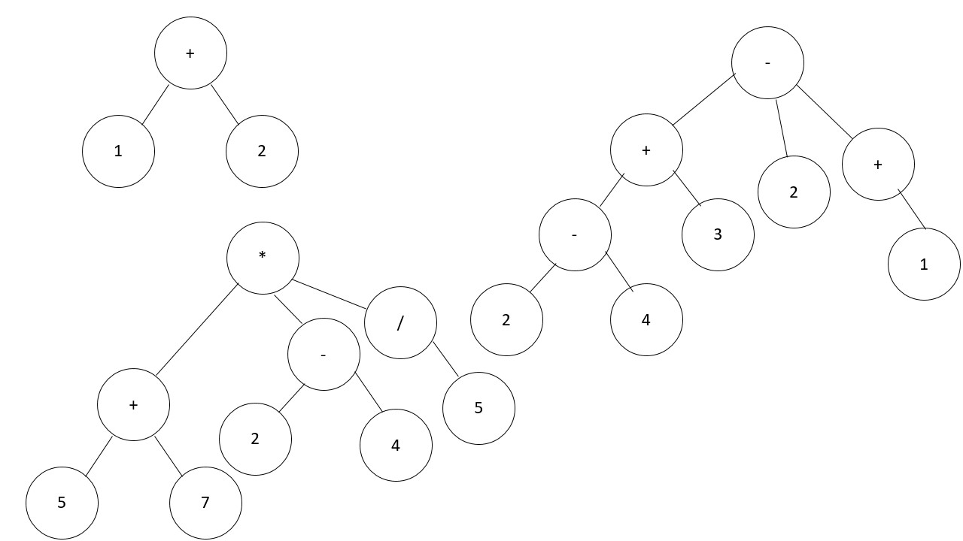

7.

8.