Type the title of your paper here
Mihail Iulian Pleșa and Maria-Carmen Pleșa
Technical College “Costin D. Nenițescu” Pitești
Military Technical Academy “Ferdinand I”
E-Mail: mihai.plesa@mta.ro
Abstract. In this paper, we study the applicability of artificial intelligence for designing mechanical components that can repair themselves. We use the Cellular Automata (CA) model implemented as a Convolution Neural Network (CNN) to simulate the automatic growth and repair of a mechanical component from a small seed. Concretely, we start with an empty 2D grid of cells. Using the CNN, the cells will learn to self-organize into the image of a mechanical component. We simulate the damage to the component by deleting some parts of the imagine and show how they are automatically regenerated.
- Introduction
For decades, humans have tried to create robots that can repair themselves. They are useful in situations where the presence of a human person is not possible. Consider for example the recent mission of NASA: Mars 2020. The mission consists of sending a rover to the planet Mars. No people have been sent to Mars to monitor the mission. What happens if a part of the robot is damaged? Currently, repairing a damage part is based on others that are still working and remote assistance. Nevertheless, there are situations in which the robot is far too damaged to be repaired without direct human intervention. This was the case of the Opportunity rover.

- The model
In the first part of this section, we give a short introduction to convolutional neural networks (CNN). We present the general architecture of a CNN and some basic examples of convolutional and max-pooling operations.
In the second part of the section, we present the cellular automata model and what role CNNs play in building it. We present the model from a mathematical perspective without giving up the intuition behind it.

Convolutional neural networks
Convolutional neural networks are a type of artificial neural networks specialized for computer vision tasks. Figure 1 shows the architecture of a CNN [1].

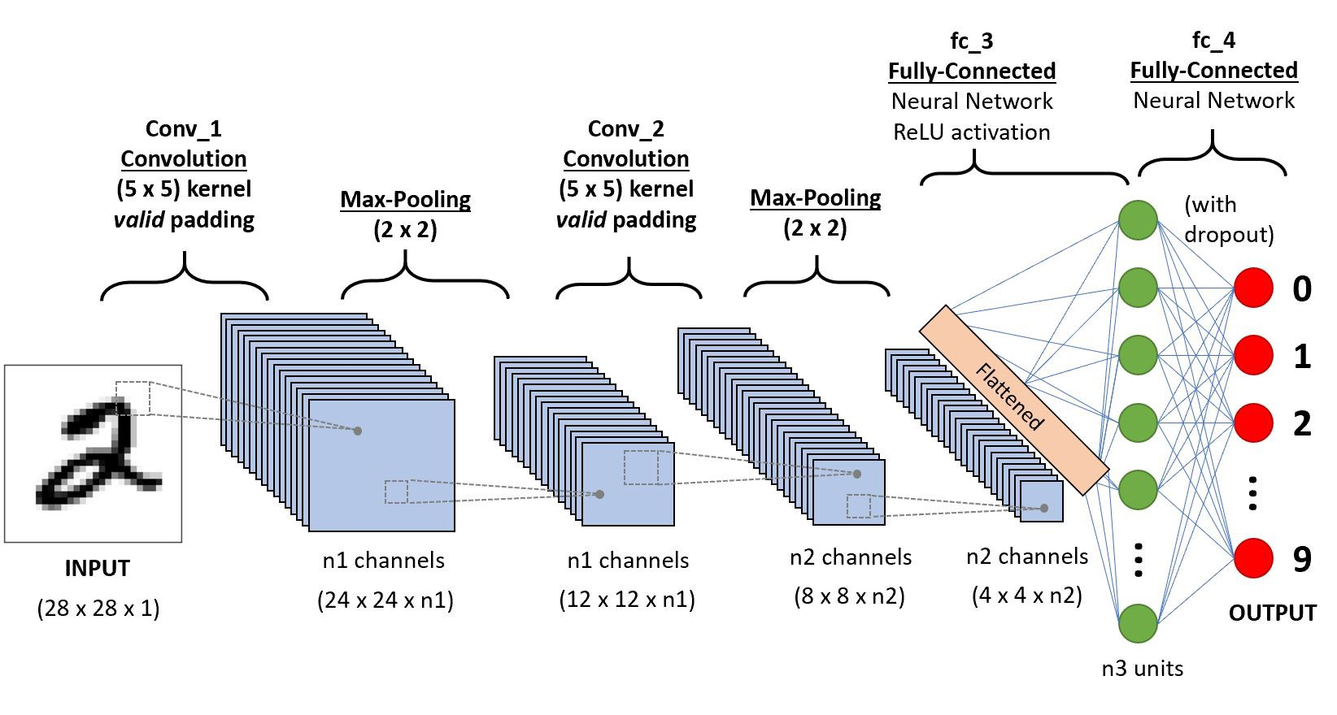
Figure 1: CNN architecture
Unlike a classical neural network, a CNN doesn’t use the input imagine directly. The input is first filtered by a number of kernels. Each kernel produces a new filtered imagine. For example, some filters may extract features about the shape, others may extract features about the colors etc. The core idea of a CNN is the convolution kernel. The input image is convoluted with a number of filters of fixed dimension. In Figure 2 is given an example of convolution between an 3x3 input and a 2x2 filter [2].

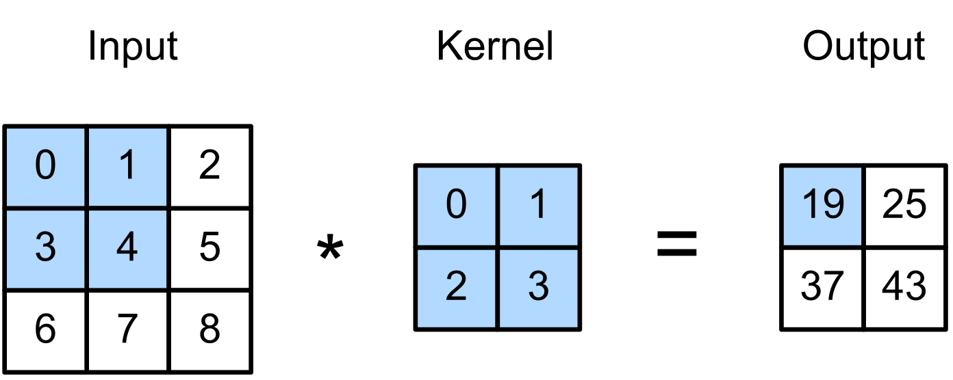
Figure 2: Example of convolution
The parameters of each kernel are learned by the network in multiple iterations using the backpropagation algorithm. As can be seen in Figure 1, there can be multiple convolutional layers. Between two such layers, a max-pooling layer is inserted. The role of this kind of layer is to reduce dimensionality by removing low impact terms. The intuition behind this strategy relies on the fact that any neural network is based on dot products so there is no point in keeping terms with low values. Figure 3 shows an example of $2x2$ max-pooling between on an input of $4x4$ [3].
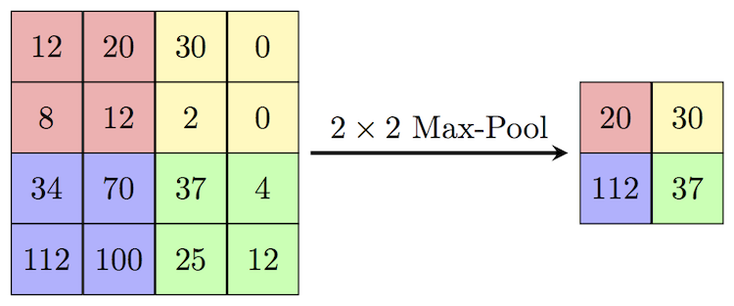
Figure 3: Max-pooling example

The cellular automata model
The model used in this paper is called cellular automata (CA). This model is inspired by the self-organization behavior of the living cells. Consider for example the process of morphogenesis in which a simple bank of cells is able to organize itself in a well-defined form. This is possible simply by the fact that each cell is able to exchange information with its immediate neighbors. Besides the fact that the cells can organize themselves into a well-defined form, this shape is also a persistent one. After the process of self-organization took place, if any damage disrupts the shape, they are able to self-repair.
In this section we present the mathematical formulation of the cellular automata model. In the real world, a cell has many physical and chemical proprieties. We model these proprieties of a cell by an array of $k$ elements. We call this array the state of the cell. A bank of cells is modeled by a grid of dimensions $nxm$. Each element of the grid is a cell i.e., an array of $k$ elements. Thus, a bank of cells is modeled by a matrix of dimensions $nxmxk$.
The process of self-organization is modeled by a number of iterations. At each iteration, the states of all cells are updated simultaneously according to the same update rule. The update rule consists of an addition between the current state of the cells and $k$ variables produced by a function $f$ applied over a neighborhood of dimension $pxp$ of that cell. The function $f$ models the exchange of information between a cell and its neighbors. More formally, let $c_{i,j}$ be the state of the cell that is on row $i$ and column $j$ of the grid:

$$c_{i,j}=\left(c_{i,j}^{1},c_{i,j}^{2},…,c_{i,j}^{k}\right)$$ | (1)

The process of self-organization can be expressed by the following algorithm:
- For each cell a neighborhood of dimension $pxp$ is considered.
- A function $f$ is applied over the states of the cells from the neighborhood. This function produces $k$ variables: $u_{i,j}=\left(u_{i,j}^{1}, u_{i,j}^{2},…, u_{i,j}^{2}\right)$
- The new state of the cell $c_{i,j}$ is obtained by adding the current state with the variables obtained in step 2:
$$c_{i,j}=c_{i,j}+u_{i,j}$$ | (2)

All we have to do now is to define the function $f$. More exactly, given a bank of empty cells, we want to learn a function $f$ so that after a number of iterations in the self-organization process, the cell will organize themselves into a well-defined form. Given the fact that we talk about visual shapes, the most natural choice for the function $f$ is a convolutional neural network (CNN).

- Related work and our contributions
Due to the rapid development of deep learning, both from a theoretical and practical perspective, several papers trying to implement and tests CA model on real scenarios have appeared. In [4], authors tried to grow an empty grid of cells to the image of a lizard emoji. The paper shows that if the size of the cell is $16$ and the CNN model contains only one convolutional composed of $128$ neurons, the imagine of the lizard can be obtained in $8000$ iterations. In [5], the authors applied the CA model to solve the problem of classifying handwritten digits. The accuracy obtained by the model is $95.3\%$ after 200 iterations. paragraph after a heading is not indented (Bodytext style). In [6], the CA model is applied to synthesize textures. Although the generated texture and the target texture are not pixel-perfect, the model generates textures that are consistent and robust.
This work is based on [4]. The main disadvantage in the original paper, is that the authors don’t provide an analysis on how CA model parameters influence the results. We extend the research done in the original work by trying different variations on the CA model. In particular, we explore different sizes of the cells and different CNN architectures. Also, we apply the model to generate images of real mechanical component not artificial created emojis in order to simulate the self-growing and the self-repairing of mechanical components. Additionally, we present a tutorial on how to implement the CA model using well-known deep learning libraries.
- Building the model
In this section we present a step-by-step tutorial on how to implement the CA model using python and keras.
To load the imagine, we write the function load_component which downloads the image from a GitHub repository and resize it to the specified dimensions:
GRID_SIZE = 64
def load_component(url):
return imread(url, GRID_SIZE)

The test imagine has dimensions of $64x64$ and it is shown is Figure 4. Greater dimensions will enhance the imagine quality but will increase the training time of the CNN.

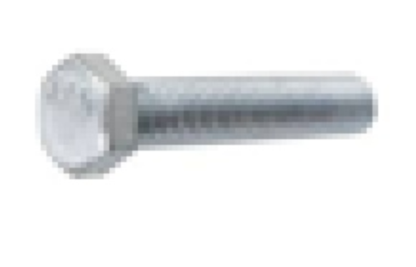
Figure 4: The image of 3/8-16 x 1-1/2 screw

We want to implement a CA model that starting from an empty grid of cells of dimensions $64x64$ will automatically develop the imagine of the screw. In this way we simulate the self-growing capability of a CA.
Next, we define the dimensions of a cell and the initialize the grid:
CELL_SIZE = 16
seed = np.zeros([1, GRID_SIZE, GRID_SIZE, CELL_SIZE], np.float32)
seed[:, GRID_SIZE//2, GRID_SIZE//2, 3:] = 1.0

The first test will use a CNN with just two convolutional layers and no max-pooling layer. The model is initialized as follows:
model = tf.keras.Sequential([
Conv2D(128, 3, padding='same', activation=tf.nn.relu),
Conv2D(CELL_SIZE, 1, kernel_initializer=tf.zeros)])

We use $128$ kernel of dimension $3x3$. The summary of the model generated with the command model.summary()is given in Figure 5.
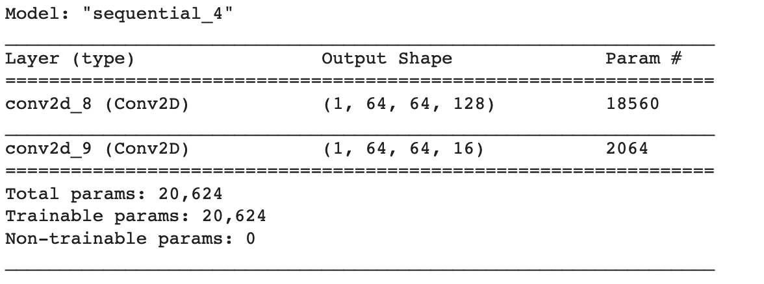
Figure 5: The summary of the model
As we have stated in section 2.2, to update the state of the cells during the self-organization process, at each iteration, we add to the current state of the cell the output of the CNN. In code, $x$ is the grid of cells, the update rule is implemented as:
NUM_OF_ITERATIONS = 16
x = seed
for i in range(NUM_OF_ITERATIONS):
x = x + model(x)

To train the model, we write the function training_step. This function executes $50$ iterations of the self-organization process, compute the loss (i.e. the difference between the grid and the target image of the screw) and updates the parameters of CNN using gradient descend algorithm.
trainer = tf.optimizers.Adam(1e-3)
loss_log = []
def training_step():
with tf.GradientTape() as g:
x = seed
for i in range(50):
x = x + model(x)
loss = tf.reduce_mean(tf.square(x[...,:3][0] - target_component))
params = model.trainable_variables
grads = g.gradient(loss, params)
trainer.apply_gradients(zip(grads, params))
return loss, x

We train the model for $1024$ epochs and show in Figure 6 the imagine generated by the CA at certain milestones:
x_show = []
for k in range(1024):
loss, x = training_step()
loss_log.append(loss.numpy())
if k%128 == 0:
x_show.append(x[...,:3][0])
print(k)
imshow(zoom(x[...,:3][0]))

As it can be seen from Figure 6 the target imagine gets better and better with each epoch. To compare the result produced by the CA model with the original target component we use PSNR metric:
def PSNR(original, compressed):
mse = np.mean((original - compressed) ** 2)
if(mse == 0):
return 100
max_pixel = 1.0
psnr = 20 * np.log10(max_pixel / np.sqrt(mse))
return psnr
The PSNR between the image generated by the CA model and the target imagine after $1024$ epochs is $37.71$ which means that two images are almost identical. The loss after each of the first $1024$ epochs is plotted in Figure 7.

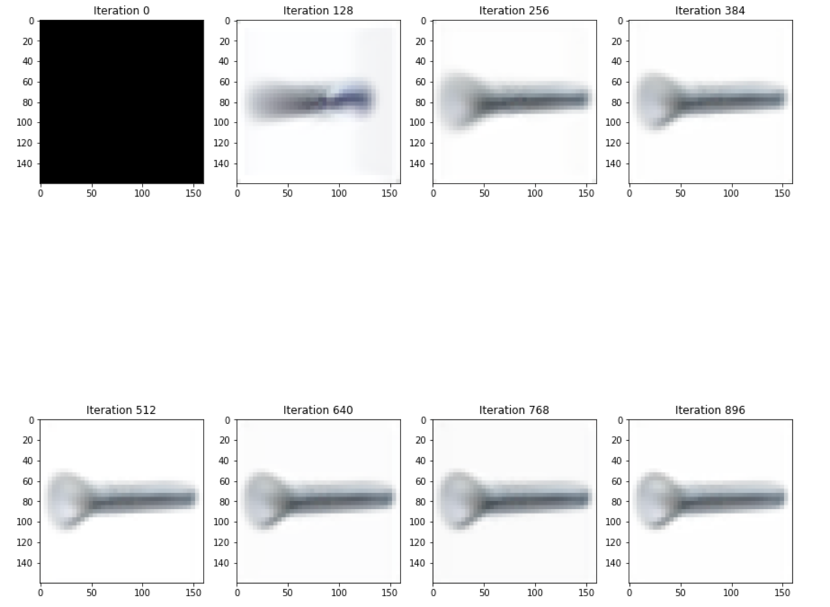
Figure 6: The evolution of the self-organizing process

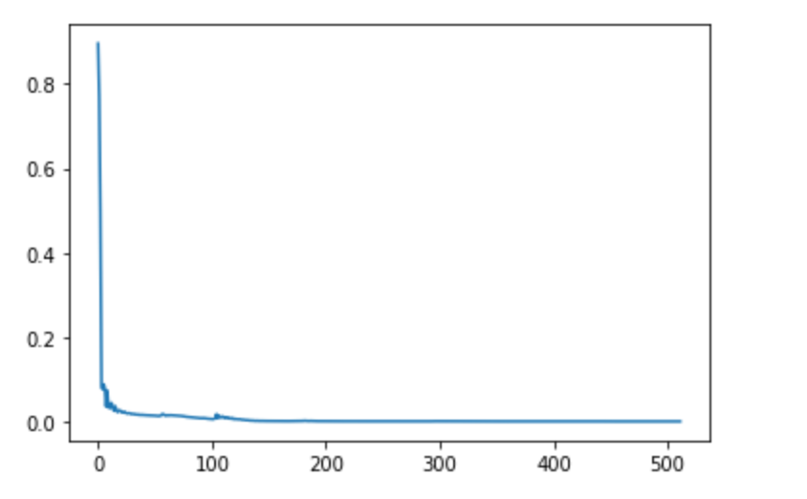
Figure 7: The loss after the first 512 epochs
- The performance of the model
In this section we will explore how different cells sizes and different CNN architectures affects the performance of the model. We also simulate the self-repairing behavior of the mechanical component by altering the seed of the cells grid.
Changing the cell size affect the PSNR between the image generated by the model and the target imagine according to the Table 1:
Cell size | PSNR
$$4$$ | $$32.54$$
$$8$$ | $$31.66$$
$$12$$ | $$19.19$$
$$16$$ | $$37.71$$
$$24$$ | $$30.13$$
$$32$$ | $$18.83$$
$$64$$ | $$17.83$$
Table 1: PSNR for different cell sizes
It is clear that we cannot make a direct link between the cell size and the performance. A bigger cell does not necessarily imply a greater PSNR. The largest PSNR was obtained for a cell size of $16$. Acceptable results were also obtained for cell sizes of $4$, $8$ and $24$.

The architecture of the CNN also has an impact on the performance of the model. Adding an extra convolutional layer with $64$ filters and keeping the cell size of $16$ results in decrease of the PSNR at $32$:
model = tf.keras.Sequential([
Conv2D(128, 3, padding='same', activation=tf.nn.relu),
Conv2D(64, 3, padding='same', activation=tf.nn.relu),
Conv2D(CELL_SIZE, 1, kernel_initializer=tf.zeros)])

Intuitively, the result must improve if we increase the size of the network. At the same time, a larger network needs more epochs to train. After another 1024 epochs, the PSNR becomes $34.79$. From Figure 8 it is clear that increasing the number of epochs results in a greater PSNR.
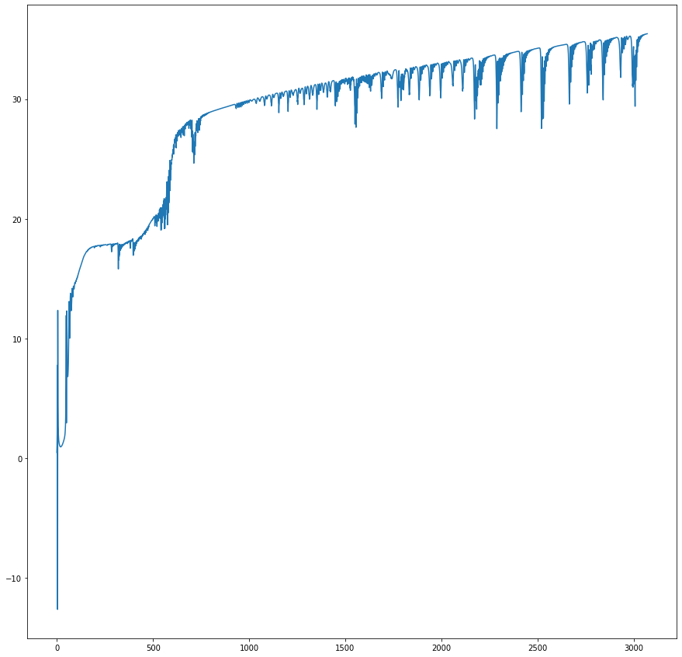
Figure 8: The evolution of PSNR depending on the number of epochs

Changing the seed to an altered image of the target component can emulate the self-repairing property of the model. After training the model is applied for a small number of iteration to a seed and as it is shown in Figure 9 the generated image simulates a self-repairing behaviour since the PSNR to the target image gets better and better:
x = seed
NUM_OF_ITERATIONS = 40
for i in range(NUM_OF_ITERATIONS):
x = x + model(x)
NUM_OF_ITERATIONS = 8
for i in range(NUM_OF_ITERATIONS):
x = x + model(x)
plt.subplot(2, 4, i+1)
plt.gca().set_title('PSNR: ' + str(PSNR(x[...,:3][0], target_component)))
plt.imshow(zoom(x[...,:3][0]))

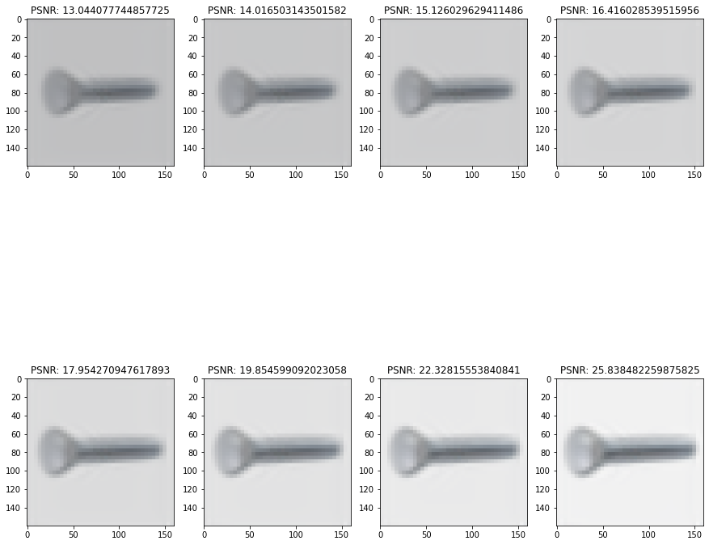
Figure 9: Self-repairing behavior

- Conclusions and further direction of research
In this paper we simulated the self-growing and the self-repairing behaviours of a mechanical component using CA model. In the first part of the paper, we presented a step-by-step tutorial for implementing a CA with convolutional neural networks using keras library. All the code is available on a google colab notebook [7]. We saw that there is no direct link between the cell size and model performance. Our experiments showed that in order to maximize the performance it is necessarily to run the model with several cell sizes and choose the best one. Adding an extra convolutional layer does not increase the PSNR between the imagine generated by the model and the target image but we showed that increasing the number of training epochs results in a better result. The self-growing behaviour implies the self-repairing propriety of the CA model by simply apply the update rule to a pre-trained model as shown in the previous section.
A further direction of research consists in using CA models to generates 3D constructions like the one used in AutoCAD. This achievement could be much closer to the final target of building self-repairing robots without human assistance. The biggest challenge in doing this kind of simulation represents the computational power required to train and deploy a CNN large enough to produce CA models with high performance.

References
- https://editor.analyticsvidhya.com/uploads/90650dnn2.jpeg
- https://d2l.ai/chapter_convolutional-neural-networks/conv-layer.html
- https://computersciencewiki.org/index.php/Max-pooling_/_Pooling
- https://distill.pub/2020/growing-ca/
- https://distill.pub/2020/selforg/mnist/
- https://distill.pub/selforg/2021/textures/
- https://colab.research.google.com/drive/1YnSA1uR38zsMTgUzrV0zjNOCA4I91fkq?usp=sharing

