COMP.CE.350 Project 2

Miika Kulmala

292288

miika.kulmala@tuni.fi

 | Sobel3x3 (ms) | phaseAndMagnitude (ms) | nonMaxSupression (ms) | edgeTracing (ms) | Total (ms)
Original | 977,658 | 603,8 | 514,532 | 71,627 | 2167,616
"+ Optimizations" | 58,495 | 443,831 | 164,395 | 36,129 | 702,85
"+ Vectorization" | 61,569 | 455,419 | 160,413 | 37,627 | 715,027
"+ FP relaxation" | 58,545 | 42,282 | 157,887 | 32,021 | 290,736
"+ O3” | 44,078 | 42,05 | 157,109 | 38,9 | 282,21
"+ OpenMP" | 16,606 | 65,26 | 23,05 | 25,83 | 130,7
OpenCL | 0.326 | 2.016 | 0.472 | 27.021 | 29.835

Table 1: Performance measurements. Running compiled code ./canny -B 10

Time taken for writing input buffer to device: 3.750ms
Time taken for reading output buffer from device: 6.925ms

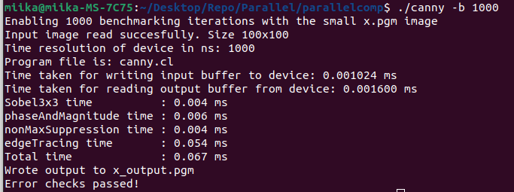

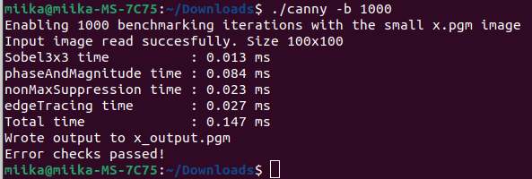

Approximately how many hours did it take to complete this exercise part

(Part 1)?

2.5 hours

