## The Goal

An internet operator plans to connect a business park to the optical fiber network. The area to be covered is large and the operator is asking you to write a program that will calculate the minimum length of optical fiber cable required to connect all buildings.

## Rules

For the implementation of the works, the operator has technical constraints whereby it is forced to proceed in the following manner:

A main cable will cross through the park from the West to the East (from the position x of the most westerly building to the position x of the most easterly building).  
  
For each building, a dedicated cable will connect from the building to the main cable by a minimal path (North or South), as shown in the following example:

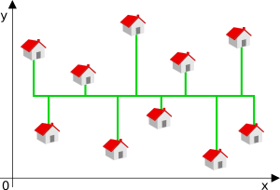

In this example, the green lines represent the cables.

The minimum length will therefore depend on the position of the main cable.

## Game Input

Input

Line 1: The number N of buildings that need to be connected to the optical fiber network

On the N following lines: The coordinates x and y of the buildings

Output

The minimum length L of cable required to connect all of the buildings. In other words, the length of the main cable plus the length of the cables dedicated to all the buildings.  
  
Note: the buildings with the same position x should not in any case share the same dedicated cable.

Constraints

0 < N ≤ 100000  
0 ≤ L ≤ 263  
-230 ≤ x ≤ 230  
-230 ≤ y ≤ 230