Report Based on Research Papers for AMTF-IA made by:

Ayush Khade 1811087

Mihir Mehta 1811093

Kaushik Ba Metha 1811094

Saurabh Nambiar 1811099

Ajay Bhan 1811128

Paper 1 Title:

CNN based Traffic Sign Classification using Adam Optimizer

Smit Mehta, Chirag Paunwala, Bhaumik Vaidya

Paper Link: [Sci-Hub | CNN based Traffic Sign Classification using Adam Optimizer. 2019 International Conference on Intelligent Computing and Control Systems (ICCS) | 10.1109/ICCS45141.2019.9065537 (sci-hub.se)](https://sci-hub.se/https://ieeexplore.ieee.org/document/9065537)

Introduction:-

Traffic sign detection is considered to be one of the most important parts in the advanced driver assistance system as it is necessary to detect traffic signs and classify them. Traffic signs are designed with definite shape and color to provide the information like traffic rules, directions and different road conditions to drivers for safe driving.The main objective of designing the advanced driver assistance system is to reduce the number of road accidents and wrong decisions.

The paper proposes an approach based on the deep convolutional network for classifying traffic signs. The Belgium traffic sign dataset (BTSD) is used for evaluation of the model. Different activations and optimizers are used to evaluate the performance of proposed architecture and it is observed that Adam (Adaptive Moment Estimation) optimizer and softmax activation performs well.

The detection and recognition of traffic signs has a variety of important applications which includes advanced driver assistance systems, road surveying, autonomous driving, vehicle navigations system and surveillance.

Methodology:

Various image processing techniques including thresholding and segmentation, machine learning algorithms like support vector machines and random forest were explored earlier. On their analysis, these methods were found to be poor with respect to accuracy and efficiency.

The researchers proposed an approach for traffic sign classification using Convolutional Neural Networks. The experimentation shows that the CNN model works efficiently and gives better accuracy.

A convolutional neural network is a feed forward neural network widely used for image based classification, object detection and object recognition which uses convolution to produce filtered feature maps.

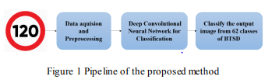

* Dataset

The Dataset used is the BTSD dataset. Traffic sign images in the BTSD database are extracted from the video sequences. The database does not take account of the disturbance of motion blur,foggy or rainy weather.

Number of training images: 4575

Number of test image: 2520

Number of Class Labels: 62

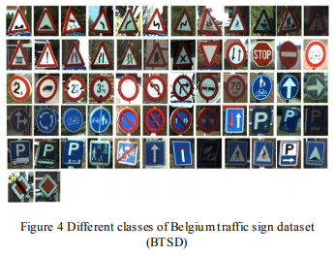

* CNN Architecture

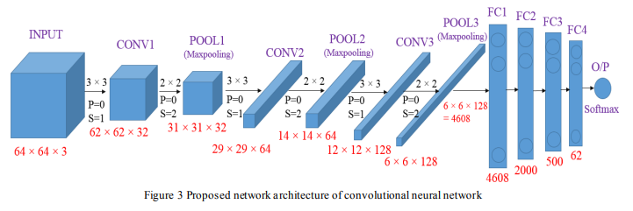

The above model has been proposed to classify traffic signs from the BTSD dataset. The input image size for the network is 64x64x3. The network consists of three convolution layers each followed by a max-pooling layer. Two hidden layers are used in between the Flatten and the output layer. The output layer will classify the input image into one of the 62 traffic signs using the softmax activation function. The output shape of each layer can be calculated using the following formula:

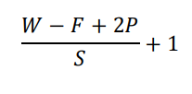

W is the size of input,

F is the size of filter,

S is the value of stride used in maxpooling layer,

P is the amount of zero padding

* Experimental Setup
  + Intel (R) Core (TM) i5–7500 CPU @ 3.40 GHz
  + 8 GB RAM
  + 64 bit OS
  + Adam (Adaptive Moment Estimation) optimizer
  + Activation function: Relu, Softmax
  + Loss function: Sparse Categorical Entropy
* Results

Total Parameters trained by the network are 13,89,543. The ReLu activation function is used between hidden layers as it does not activate all the neurons at the same time. Now, the following table shows initial results of the model proposed so far.

|  |  |  |  |
| --- | --- | --- | --- |
| **Dataset** | **Training Accuracy** | **Testing Accuracy** | **Epochs** |
| BTSD | 98.26 | 92.18 | 10 |

As we can see, the training accuracy is significantly higher than the testing accuracy. This condition is known as overfitting. To prevent overfitting of the model, the researchers made use of the Dropout layer which gave the following results

|  |  |  |  |
| --- | --- | --- | --- |
| **Dataset** | **Training Accuracy** | **Testing Accuracy** | **Epochs** |
| BTSD | 96.61 | 97.06 | 10 |

The various optimizers used by the researchers in the proposed model are:

|  |  |  |  |  |  |
| --- | --- | --- | --- | --- | --- |
| **Dataset** | **Training Accuracy** | **Testing Accuracy** | **Epochs** | **Optimizer** | **Dropout** |
| BTSD | 82.95 | 87.26 | 10 | SGD | 0.2 |
| BTSD | 97.40 | 96.31 | 10 | Adam | 0.2 |
| BTSD | 85.73 | 90.40 | 10 | SGD | 0.3 |
| BTSD | 96.61 | 97.06 | 10 | Adam | 0.3 |

The various activation functions used by the researchers in the proposed model are:

|  |  |  |  |  |  |
| --- | --- | --- | --- | --- | --- |
| **Dataset** | **Training Accuracy** | **Testing Accuracy** | **Epochs** | **Activation** | **Dropout** |
| BTSD | 95.08 | 94.68 | 10 | Sigmoid | 0.3 |
| BTSD | 96.61 | 97.06 | 10 | Softmax | 0.3 |

As we can see, the ADAM optimizer along with the Dropout layer and softmax activation function gives better accuracy as compared to other configurations.

The ADAM optimization algorithm uses following formulas to update the weights of the neurons in the model:



where, 𝝰 → learning rate and 𝜷 → The exponential decay rate.

The final training and testing results are as follows:

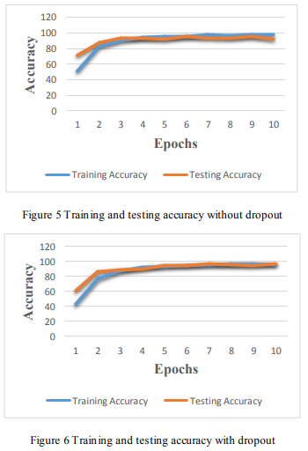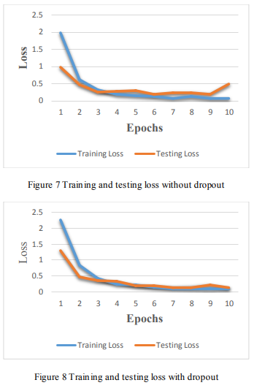

Conclusion

In this paper, the researchers proposed a CNN model to classify the traffic signs using the Belgium traffic sign dataset. The proposed architecture uses Adam optimizer for training weights and softmax activation for classification along with dropout to avoid overfitting. As seen in the results, the training accuracy of 96.61% and testing accuracy of 97.06% is the best possible outcome which is obtained using Adam optimizer coupled with the Relu and softmax activation functions and the dropout layer.

Future Work

We find that the dataset on which the studies were carried out was not diverse in lighting and weather conditions. Future generations of researchers should conduct their work on such datasets to put the traffic sign detection system into practical use.

Paper 2 Title:

Automated detection of COVID-19 cases using deep neural networks with

X-ray images

Tulin Ozturk, Muhammed Talo, Eylul Azra Yildirim, Ulas Baran Baloglu, Ozal Yildirim ,

U. Rajendra Acharya

Paper Link: [Sci-Hub | Automated detection of COVID-19 cases using deep neural networks with X-ray images | 10.1016/j.compbiomed.2020.103792 (scihubtw.tw)](https://sci-hub.scihubtw.tw/10.1016/j.compbiomed.2020.103792)

INTRODUCTION

The outbreak of the novel coronavirus 2019 (COVID-2019) has and continues to cause a devastating effect on both daily lives, public health, and the global economy. To prevent its spread further it is critical to detect positive cases as soon as possible. Studies on radiology imaging techniques suggest that such images contain crucial information about the COVID-19 virus. The researchers find that AI paired with radiological imaging helps in early detection of the disease. In the study, a new model for automatic COVID-19 detection using raw chest X-ray images is presented. The problem is viewed as binary classification (COVID vs. No-Findings) and multi-class classification (COVID vs. No-Findings vs. Pneumonia).

The most common test technique currently used for COVID-19 diagnosis is a real-time reverse transcription-polymerase chain reaction (RT-PCR). Chest radiological imaging such as computed tomography (CT) and X-ray have vital roles in early diagnosis and treatment of

this disease.

Due to the low RT-PCR sensitivity of 60%–70%, even if negative results are obtained, symptoms can be detected by examining radiological images of patients. It is stated that CT is a sensitive method to detect COVID-19 pneumonia, and can be considered as a screening tool with RT-PCR.

In order to overcome certain disadvantages of RT-PCR such as insufficient number of available RT-PCR test kits, test costs, and waiting time, Artificial Intelligence models have been developed to increase accuracy and efficiency. Some of the proposed models are as follows.

* COVIDX-Net:
  + comprises of seven CNN models.
* COVID-Net
  + deep learning model used for COVID19 detection
  + Accuracy: 92.4%.

In this paper, a deep learning model is proposed for the automatic diagnosis of COVID-19. The proposed model has an end-to-end architecture without using any feature extraction methods, and it requires raw chest X-ray images to return the diagnosis.

Materials and Methods

1. Dataset

Two different sources are used for sourcing the images used to train the proposed model.

* A COVID-19 X-ray image database developed by Cohen JP using images from various open access sources.
  + 127 Total Images
  + 43 female
  + 82 male
  + 26 COVID-19 positive subjects
* ChestX-ray8 database provided by Wang et al
  + Normal and pneumonia images
  + 500 Normal
  + 500 pnuemonia

1. Proposed DarkCovidNet Model

Instead of developing the entire model from scratch, the researchers chose to use Darknet-19 as a starting point. Darknet-19 is the classifier model that forms the basis of a real-time object detection system named YOLO (You only look once). This system has the state-of-the-art architecture designed for object detection. The researchers however have used fewer number of layers and filters in comparison to the Darknet model.

DarkNet-19

DarkNet-19 consists of 19 convolutional layers and five pooling layers, using Maxpool. These layers are typical CNN layers with different filter numbers, sizes, and stride values. Let the letter C denote a convolutional layer, and M denote a Maxpool layer. As C1 is taken as the input layer, Darknet-19 has a layer layout as follows.

C1-M1-C2-M2-C3-C4-C5-M3-C6-C7-C8-M4-C9-C10-C11-C12-C13-M5-C14-C15- C16-C17-C18-C19

For input signal X (image) and kernel K, the two-dimensional convolution operation can be defined as follows.

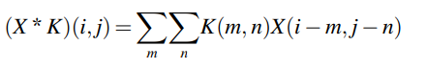

where * represents the discrete convolution operation.

The Leaky ReLu is used as an activation function in the DarkNet architecture.

Softmax activation function is used to produce the output.

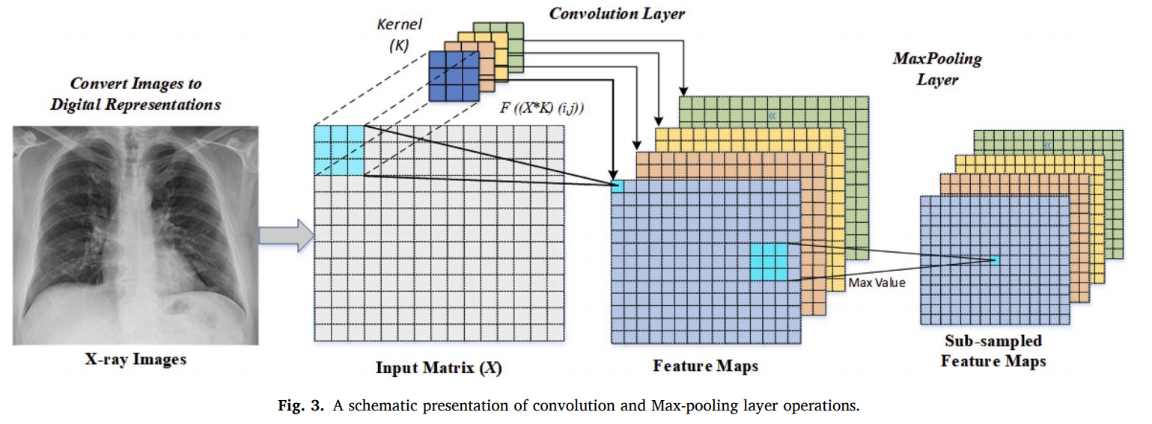

DarkCovidNet

Architecture

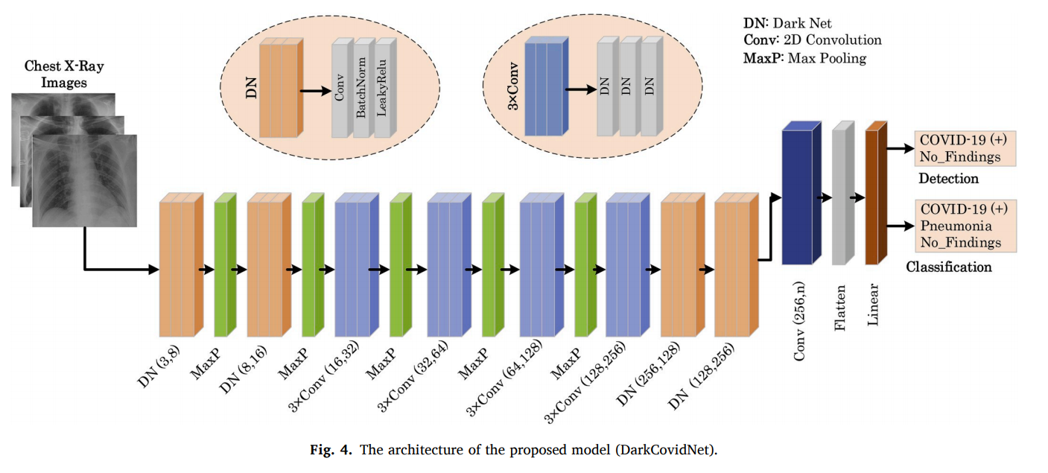

The proposed DarkCovidNet model consists of 17 convolutional layers. Each DarkNet layer has one convolutional layer followed by Batch Normalization and LeakyRelu Operations. Each 3*convolution has same setup repeated three times. The batch normalization operation is used to standardize the inputs whereas LeakyRelu is a variation of the Relu operation used to prevent dying neurons. Similar to the DarkNet model, the researchers also use Max Pooling which downsizes the image by taking max of a particular region. This proposed model can perform both classification and detection both. Specifications of proposed model are:

* Number of parameters: 1,164,434 parameters
* Optimizer: Adam
* Loss Function: Cross Entropy Loss
* Learning rate: 3e⁻³

1. Experimental Results

The researchers have trained the DarkCovidNet model to classify X-ray images into three categories: COVID-1, No-Findings, Pneumonia. Secondly, the DarkCovidNet model is trained to detect two classes: COVID-19 and No-Findings categories. The performance of the proposed model is evaluated using the 5- fold cross-validation procedure for both the binary and triple classification problem. The validation split is 0.2 and the experiments are repeated five times for 100 epochs as shown in the figure below.

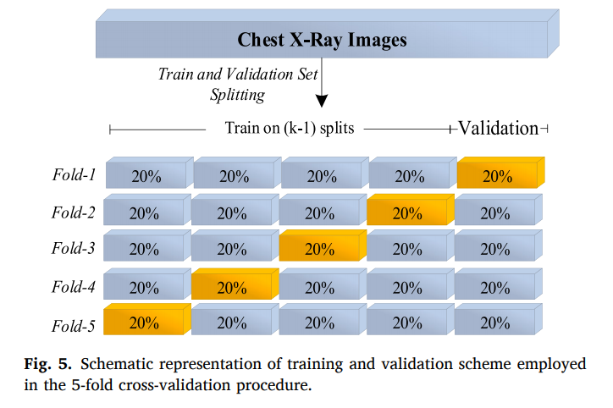

The training and validation loss graphs of the multi-class classification and validation accuracy graphs are shown for the Fold-1.

It can be noted from Fig. 6 that there is a significant increase in loss values in the beginning of the training, which decrease substantially in the later stage of the training. The main reason for this sharp increase and decrease is attributed to the number of data in the COVID-19 class, which is far less than the other two (Pneumonia and No-Findings) classes.

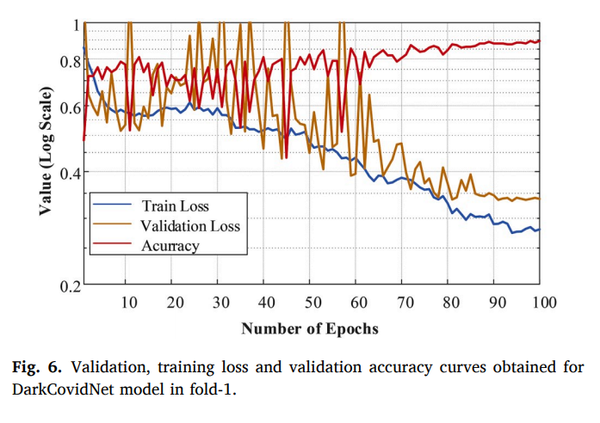

The multi-class classification performance of the DarkCovidNet model has been evaluated for each fold, and the average classification performance of the model is calculated. The overlapped as well as each separate confusion matrix (CM) for classification and detection are as shown in figures below.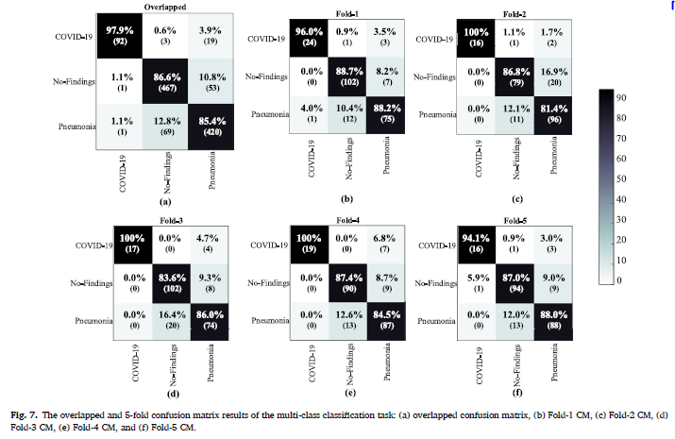

The DarkCovidNet model achieved an average classification accuracy of 87.02% to classify: no findings, COVID-19, and Pneumonia categories.

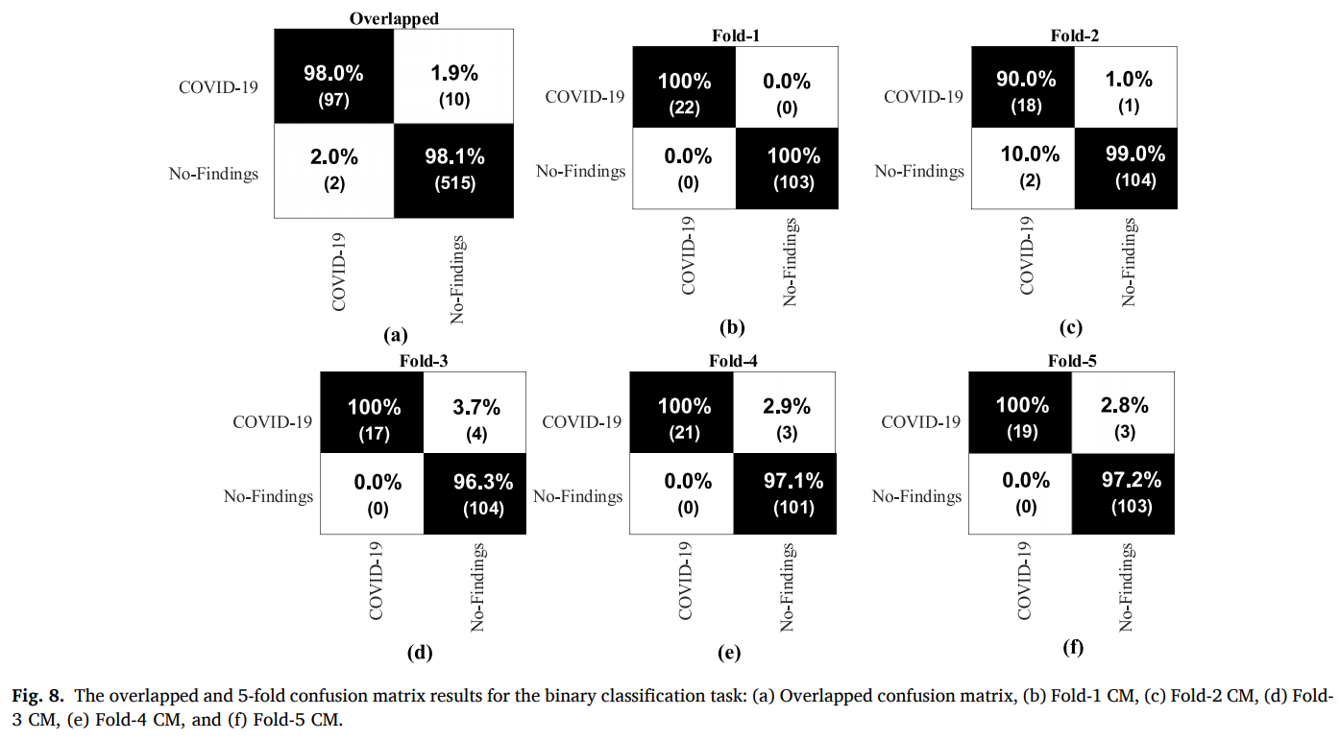

It can be noted from the above confusion matrix that the average accuracy of COVID19 detection is 98.08%.

1. Evaluation of model output by radiologist

The DarkCovidNet model’s output is reviewed by expert radiologists in health centers to provide a second opinion. It significantly reduces the workload of clinicians and assist them to make an accurate diagnosis in their daily routine work.

For the radiologist to effectively review the work, the researchers share top prediction errors of the model and the actual labels of the X-ray dataset with radiologists. They also generated heatmaps for the respective X-ray images which would then highlight the parts of X-ray which the model emphasizes. Based on this data, the radiologist give their review on the model’s accuracy and efficiency.

Heatmap for given X-ray

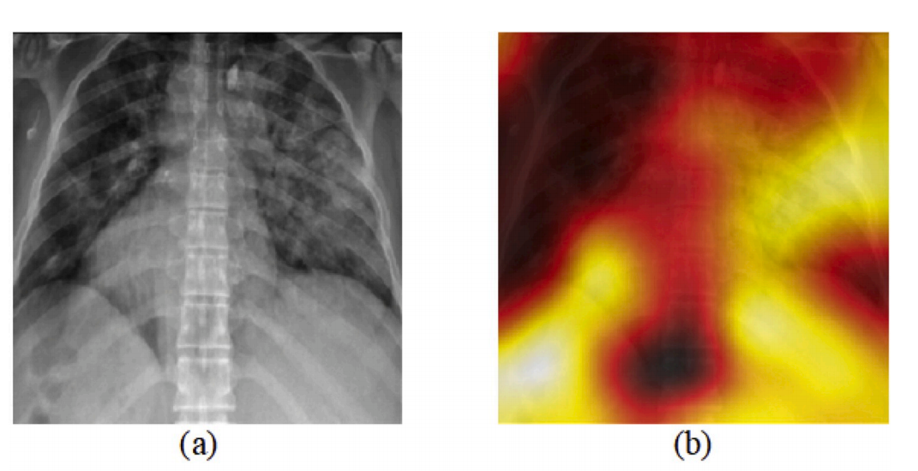

Output received by Radiologist

1. The model performs well for both the classification and detection task.
2. As the dataset also contains pneumonia images, the model evaluated patients with COVID-19 as pneumonia. Since COVID-19 pneumonia is a subset of pneumonia diseases evaluated by the model, the diagnosis is correct, although the interpretation seems to be incorrect.
3. The model is sensitive in detecting pneumonia disease.
4. The model made the incorrect predictions in poor quality X-ray imagery and in patients with acute respiratory distress syndrome
5. The model is useful to detect COVID-19 with the presence of a heat map in normal subjects.
6. Related Work

Hemdan proposed COVIDX-Net to diagnose COVID-19 in X-ray images. They have obtained 90% accuracy rate using 25 COVID-19 positive and 25 normal images. Wang and Wong designed COVID-Net, a deep learning-based model, for COVID19 detection which achieved a 92.4% success rate using a total of 16, 756 radiography images. Similarly, Ioannis used 224 approved COVID-19, 700 pneumonias, and 504 normal radiology images. They achieved a 98.75% performance for the 2-class and 93.48% performance for the 3-class problem. Sethy and Behera used CNN models to extract image features and then classified them using the SVM classifier. Narin employed three different CNN models (ResNet50, InceptionV3, and InceptionResNetV2) using 50 open access COVID-19 chest X-ray images and 50 normal images. Similarly, there are many other models that have been proposed with varying accuracies.

So, as we can see most of the discussed models use common techniques such as VGG and ResNet. However, the proposed new model is based on the DarkNet method. The main advantages of the model are as follows:

* The model classified chest X-ray images without using a feature extraction technique.
* It is an effective approach that can assist experts for diagnosis.
* The heat maps produced by the model are evaluated by an expert radiologist.

1. Future Work

It is recommended to use X ray images with this model as the amount of radiation received by the patient in CT is more as compared to the X ray images and also it is more costly than X ray.

In the future, the researchers want to validate the proposed model by incorporating more images. This developed model can be placed in a cloud to provide diagnosis instantly and to help rehabilitate affected patients immediately. This should reduce clinician workload significantly. The researchers also aim to explore using CT images for COVID19 detection.

Conclusion:

In this study, a deep learning based model is proposed to detect and classify COVID-19 cases from X-ray images. The model is fully automated with an end-to-end structure without the need for manual feature extraction. The developed system is able to perform binary and multi-class tasks with an accuracy of 98.08% and 87.02% respectively.

A limitation of the study is the use of a limited number of COVID-19 X-ray images.