**CIIC has supported 10 startups as part of Global Investor Meet Roadshow**

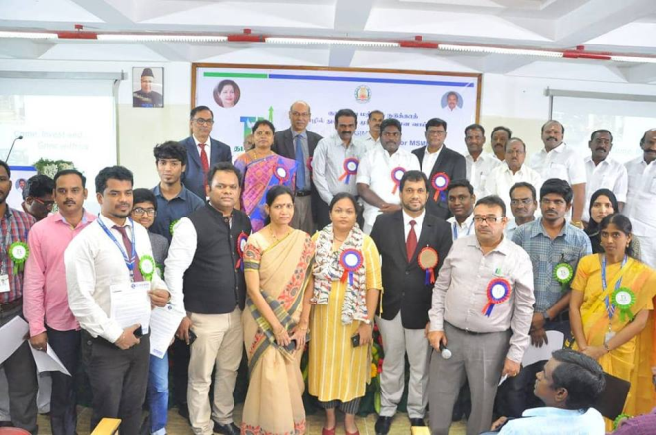

**Venue : B.S. ABdur Rahman University**

**Dept : Crescent Innovation & Incubation Council**

**Date : December 29th,2018**