**Herbal Entrepreneurship**

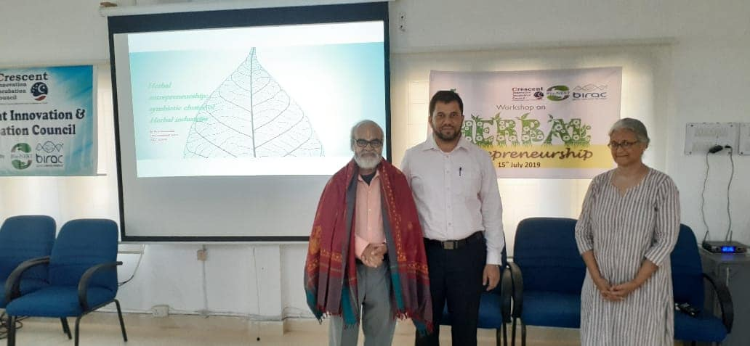 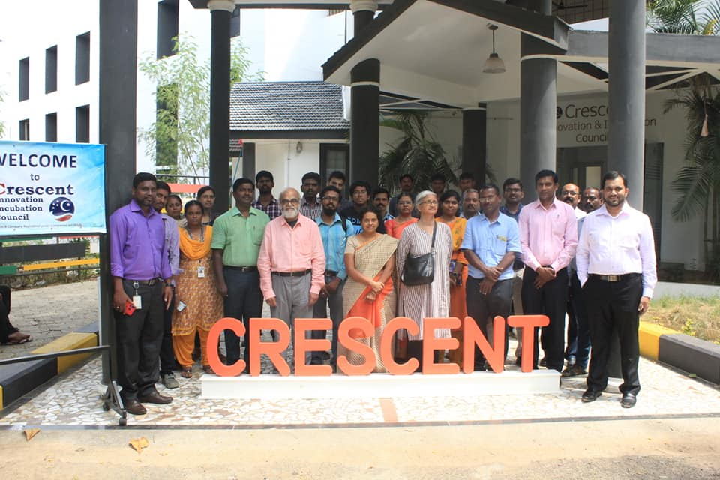

CIIC hosted a "Herbal Entrepreneurship" workshop by Dr.Narasimhan, herbal veteran and founder of Asthagiri Herbal Research Foundation. Many herbal enthusiasts participated and deliberated on the ideas for incubation.

**Venue : B.S. ABdur Rahman University**

**Dept : Crescent Innovation & Incubation Council**

**Date : July 12th,2019**