**Launch of CIIC Incubation Policy and Application for Startups.**

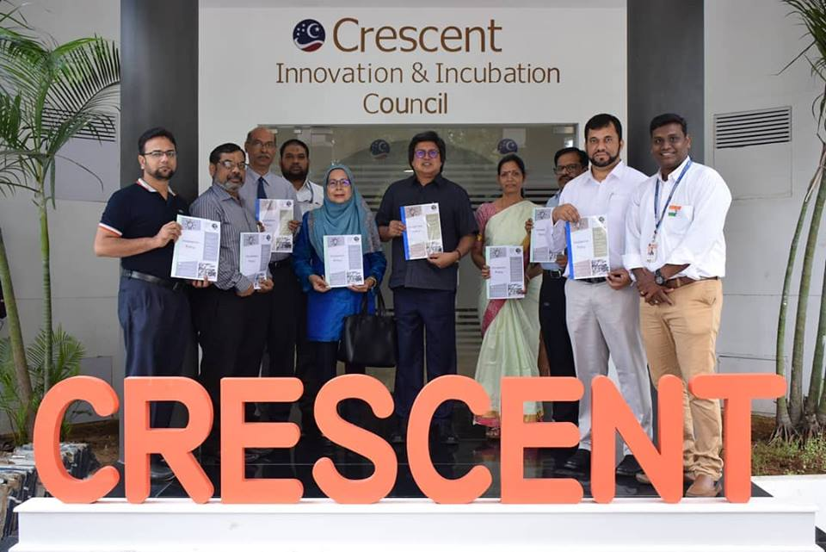

**Our Vice Chancellor Tan Sri Dato Sri Prof.Sahol Hamid Bin Abu Bakar launched the CIIC Incubation Policy and Application for Startups.**

**Venue : B.S. ABdur Rahman University**

**Dept : Crescent Innovation & Incubation Council**

**Date : January 26th,2019**