**Road show on throttling the oil & gas startup Initiative**

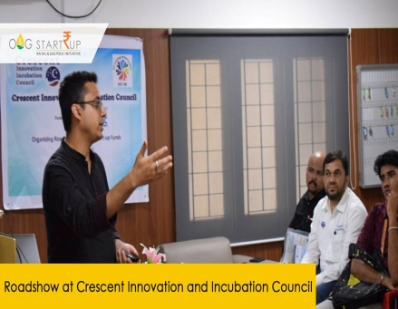

**Venue : B.S. ABdur Rahman University**

**Dept : Crescent Innovation & Incubation Council**

**Date : April 8th,2019**