**Workshop on Digitalizing the Medical world**

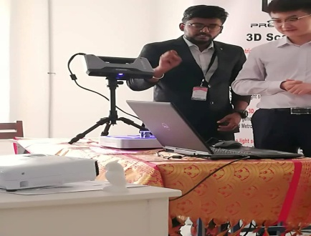

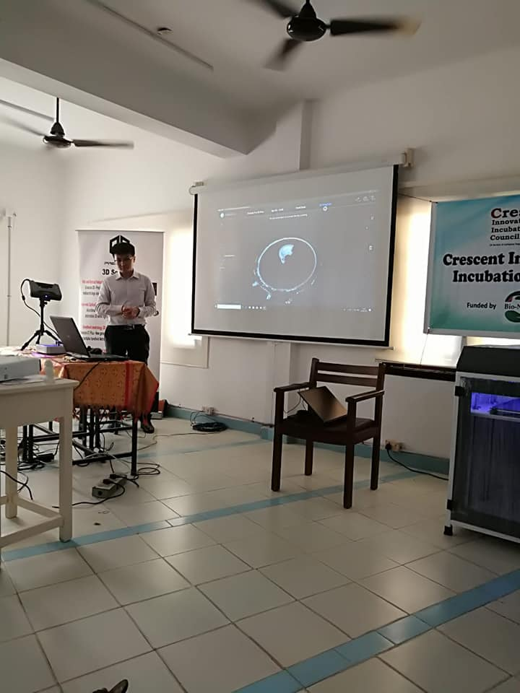

Precise 3D Metrology and Design solutions Pvt .Ltd, Provides comprehensive digital manufacturing solution, which includes 3D scanning ,digital reverse engineering,3D printing and digital inspection for automotive and engineering industries.

**Venue : B.S. ABdur Rahman University**

**Dept : Crescent Innovation & Incubation Council**

**Date : April 24th,2019**