**3D Printing Workshop**

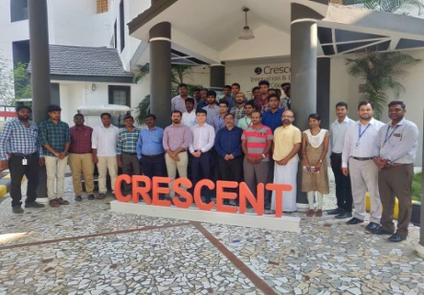

**Venue : B.S. ABdur Rahman University**

**Dept : Crescent Innovation & Incubation Council**

**Date : April 25th,2019**