**Artificial Intelligence Summit**

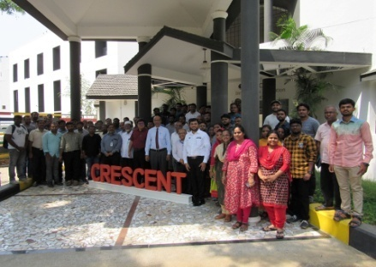

**Venue : B.S. ABdur Rahman University**

**Dept : Crescent Innovation & Incubation Council**

**Date : May 11th,2019**