**City camp on Essentials of Scientific Entrepreneurship**

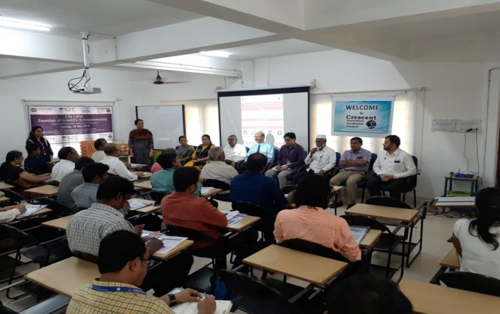 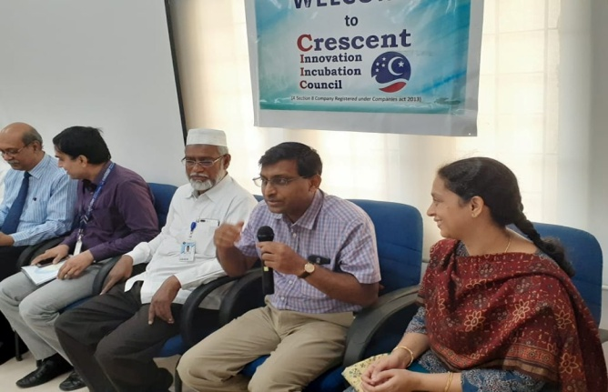

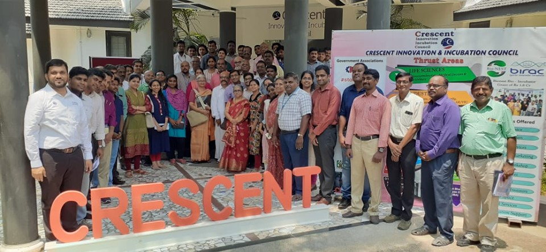

Essentials of Scientific Entrepreneurship, jointly organised by CIIC and Venture Center, Pune. Funded by BIRAC Regional Bio innovation Center. 75+ entrepreneurs, startups across Tamilnadu participated in this program. Thanks to **Dr.Premnath** and Venture Center.

**Venue : B.S. ABdur Rahman University**

**Dept : Crescent Innovation & Incubation Council**

**Date : May 28th,2019**