**C-CAMP**

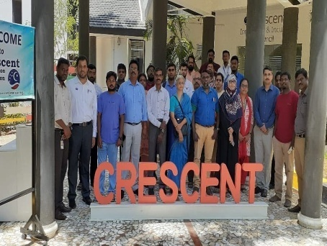

CIIC partnered with CCAMP  to host awareness camp on BIG (Biotech Ignition Grant) scheme of Rs.50 lacs support to startups and faculty  on 12th July Friday at 9.30 am at CIIC Seminar Hall.

**Venue : B.S. ABdur Rahman University**

**Dept : Crescent Innovation & Incubation Council**

**Date : July 12th,2019**