**TIE-Chennai**

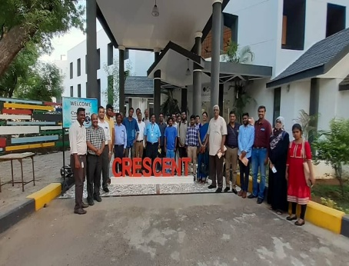

Thanks to TIE Chennai team, CIIC hosted wonderful panel discussion today and many startups were benefited.

**Venue : B.S. ABdur Rahman University**

**Dept : Crescent Innovation & Incubation Council**

**Date : July 12th,2019**