**“International conference on Advances in Design, Materials, Manufacturing and Surface Engineering for Mobility (ADMMS 2017)**

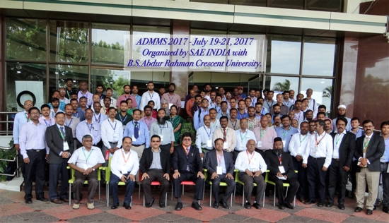

The department organizes the national level student’s symposium “Confluence” every year. Varieties of competitive events like paper presentation, Design contest, Quiz programme, Water Rocketry, Robo Golf are organized.

**Venue : B.S. ABdur Rahman University**

**Dept of Mechanical Engineering**

**Date : – July 19-21, 2017**