**One day workshop on "Big Data Anayltics using Hadoop**"

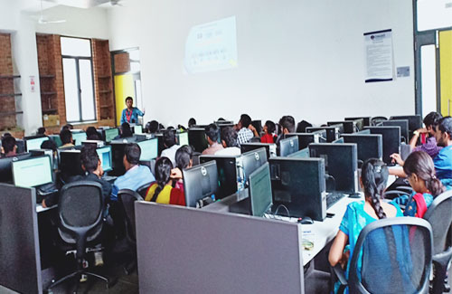

**Session : Concepts and techniques used for big data and analytics, which includes Hadoop, Sqoop,**

**Pig and Apache Hive**

**Venue : Department of Information Technology**

**Date : 12.09.2018**

**Presenter : Mr.Sukumar, Project Lead, SANDS (India) Pvt Ltd, Chennai.**