**One day workshop on “Android and iOS programming”**

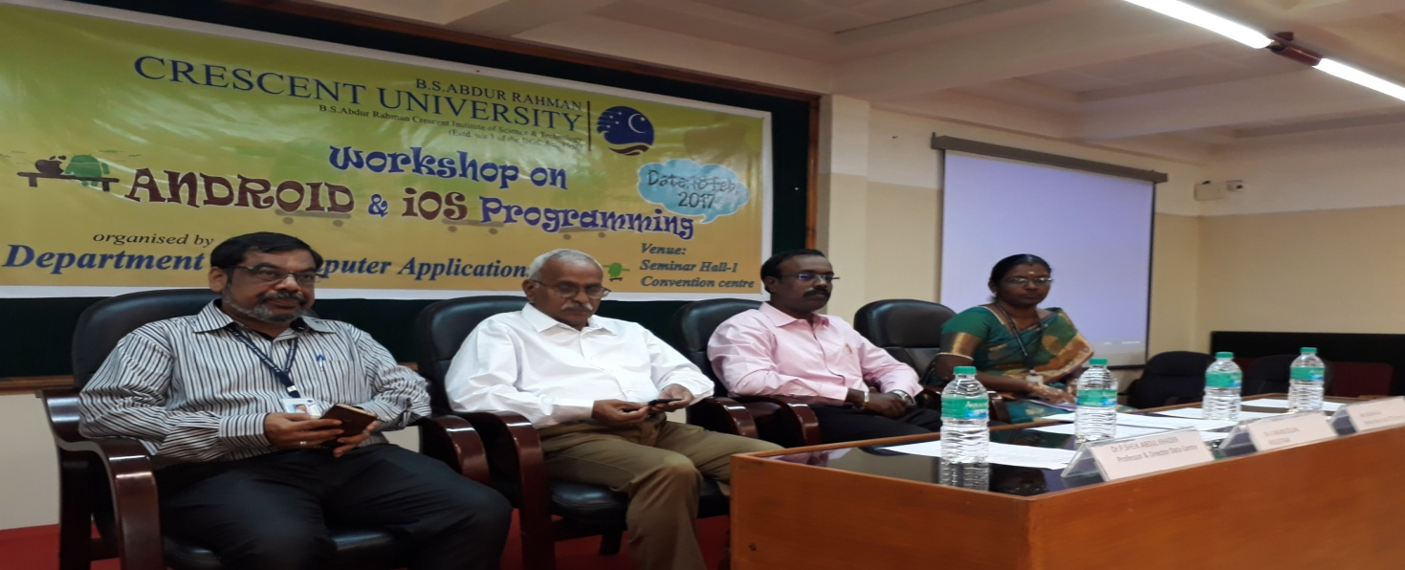

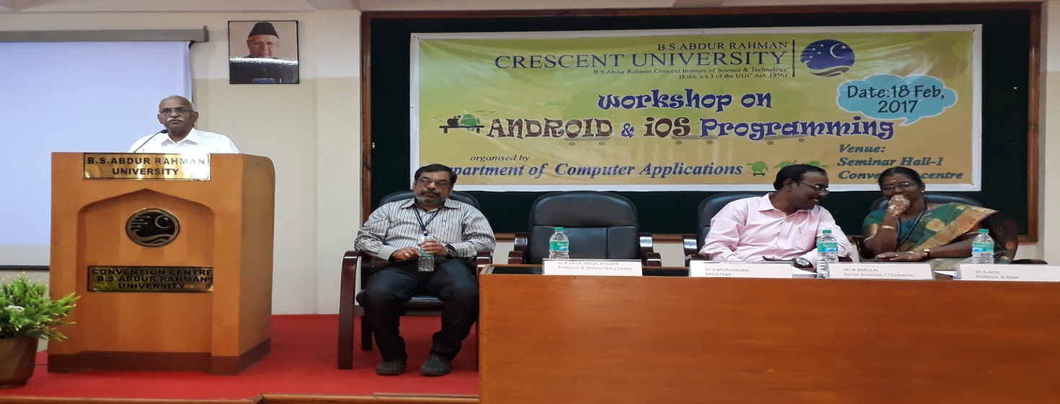

**Date : 18th Feb 2017**

**Venue: BSA University**