**Workshop on Online Trading**

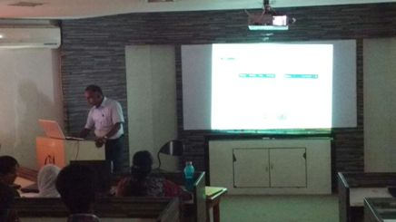

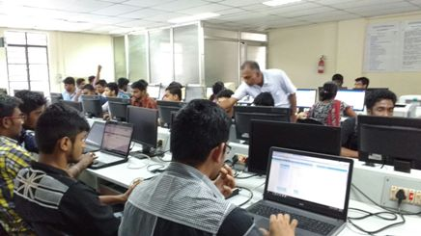

**Resource Person : Mr.Ramesh Shankar, SEBI**

**Date : 15th February, 2016**

**Venue : BSA University**