**MMA Workshop - You – The Brand**

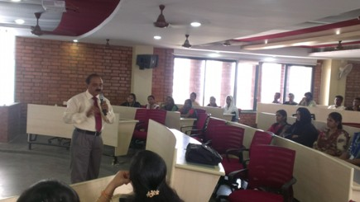

**Resource Person : GP Capt Dr. R. Venkataraman, General Manager, Madras Management Association**

**Date : 22nd December 2016**