**Workshop on “Multicolor Flowcytometry with the Cytoflex-Flowcytometer” was organized in association with Beckman Coulter, USA**

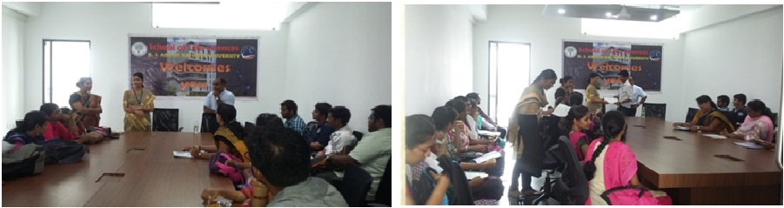

**Date : September 2-3, 2015**

**Venue : Dept of Life Science, BSAU**