One day Workshop on “Intrinsically Safe Instrumentation”

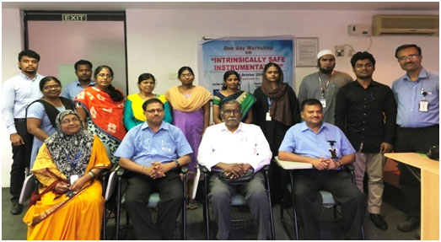

Venue: EATON MTL Instruments, Sholinganallur, Chennai

Date: 26.10.2018

Participants : The Department of Electronics and Instrumentation Engineering- BSAU