**Water Conclave’ Organized By - The Indian Express & Nippon Paint**

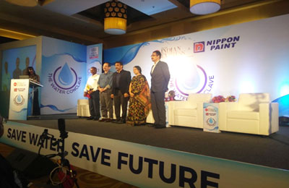

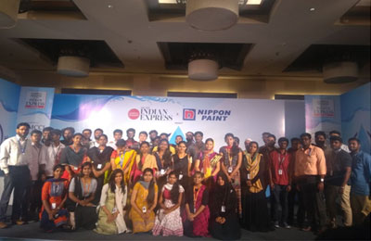

Venue: Radisson Blue

Date: 22nd March 2018

Participation: Faculty & Students of BS Abdur Rahman University