**Workshop Relevance of Mathematics in Scientific Computing & Engineering Discipline**

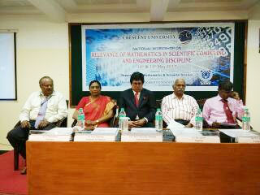

Venue : BSA University

Date: 12th & 13th May 2017